RenoRisk Biomarker Validation
Pooled analysis of the 5-gene panel C4BPB, COL13A1, HABP2, CFH and CFI across 13 public GEO kidney-biopsy transcriptomic datasets
Results report — Stages 1 to 5 (through the mega-analysis)
Project Lead: Amela Jusic, PhD, MSc — Translational Research Lead, Quant Biomarkers, Basel
Execution Lead: Stojanko Tudjarski — Data Analysis Execution Specialist
Reference protocol: CKD Biomarker Pooled Analysis Plan, Version 2.0 (July 2026)
Report date: 14 October 2026
Analysis software: R 4.5.2; limma 3.66.0, WGCNA 1.74, metafor 5.2-1, nlme 3.1-169, uwot 0.2.5
Confidential

Contents
Executive summary 3
1. Data selection and Stage 1 (raw processing) 4
1.1 Stage 1 — status 4
1.2 Dataset selection (PRISMA) 4
1.3 Included cohorts 4
2. Stage 2 — Target gene mapping 6
3. Stage 3 — Batch correction 7
3.1 Model 7
3.2 Effectiveness of correction 7
3.3 Residual spread 8
3.4 Harmonised expression 9
4. Stage 4 — Multi-factor statistical modelling 10
4.1 Model 10
4.2 Results 10
5. Stage 5 — Pooling strategy: meta-analysis and mega-analysis 13
5.1 Random-effects meta-analysis 13
5.2 Mega-analysis within platform tiers 19
6. Cross-method synthesis 21
6.1 Per-gene conclusions 22
7. Limitations and deviations from the plan 23
7.1 Limitations 23
7.2 Deviations from the analysis plan 23
8. Next steps 24
Appendix A. Reproducibility and output inventory 25
A.1 QC figure: per-cohort alignment after correction 26

Executive summary
This report presents the results of the RenoRisk pooled analysis from data selection through Stage 5, the plan §5 pooling strategy (random-effects meta-analysis complemented by mega-analysis within platform tiers). The machine-learning validation of plan §6 (leave-one-dataset-out classification, ElasticNet regression) is not yet implemented and is outside the scope of this report.
Data. 16 datasets were listed in the curated inventory; the 3 RNA-Seq series carry no expression data in their GEO series matrices and were excluded, leaving 13 microarray datasets (11 Affymetrix, 1 Illumina, 1 Agilent). After splitting GSE30122 by compartment these form 14 batch units and 894 sample profiles (glomerular 636, tubulointerstitial 116, whole biopsy 142). 44 profiles are counted twice, because GSE30528 and GSE30529 are subsets of GSE30122; they are retained by design and tested in a sensitivity analysis.
Main findings
- The tubulointerstitium carries the signal. In tubulointerstitial tissue, all three methods (Stage 4 WLS model, meta-analysis and mega-analysis) find CFH up-regulated in disease (Stage 4 log2FC 0.93, FDR 1.4×10⁻⁷; pooled Hedges' g 1.51) and C4BPB down-regulated (log2FC −0.18). CFI and HABP2 are also up-regulated in tubulointerstitium (meta-analysis FDR 7.7×10⁻⁴ and 0.017).
- COL13A1 is the most consistent gene overall: it is the only gene with a significant pooled effect across all 14 units (g = 0.57, 95% CI [0.26, 0.89], FDR 0.002). The effect is the same in direction in every compartment, the compartment moderator test is null (p = 0.86), and the effect survives leave-one-out deletion of any unit.
- Glomerular effects are small and heterogeneous. In 9 glomerular units no gene reaches FDR < 0.05 in the meta-analysis or the mega-analysis. Stage 4 detects small glomerular shifts (COL13A1 +0.10 log2), but they are small (0.05–0.20 log2 units).
- The methods agree. Mega-analysis and meta-analysis log2FC estimates correlate at r = 0.997 (10/10 same sign, maximum difference 0.064 log2). Stage 4 and the meta-analysis agree at r = 0.993 per study unit and r = 0.960 after pooling.
- Heterogeneity is high. Across all units I² is 60–81% (Hedges' g), so the 95% prediction intervals for every gene include zero. Effects depend on indication. For example, CFI is down-regulated in membranous nephropathy glomeruli (g = −1.22, FDR 2×10⁻⁴) but up-regulated in DKD tubulointerstitium (g = +0.72).
- Sex is a confounder for HABP2. Expression is lower in males (log2FC −0.44, FDR 5.2×10⁻¹⁷), so analyses of HABP2 need to adjust for sex.
Principal caveats. All values are submitter-processed by five different pipelines, because Stage 1 re-quantification was retired. Three cohorts are per-gene centred, so their absolute expression is lost. The tubulointerstitial stratum contains only two independent patient series. None of the 13 series matrices records eGFR, %TIF, proteinuria or age, so the clinical-endpoint analyses in the plan cannot be done with these data.

1. Data selection and Stage 1 (raw processing)

1.1 Stage 1 — status
Stage 1 of the plan (re-quantification from raw CEL/FASTQ: RMA for Affymetrix, GRCh38 alignment for RNA-Seq) was retired by decision on 2026-10-07. The analysis therefore starts from the submitter-processed values in the GEO series matrices (Data/Raw_filtered/). This has two consequences:
- No RNA-Seq data are used. The three RNA-Seq series (GSE137570, GSE142025, GSE219185) contain no expression rows in their series matrices, so ComBat-seq and DESeq2 (plan Stage 3 and §8) are not applicable.
- Input provenance is heterogeneous. Values were produced by five pipelines (GeneSpring, Expression Console, a modified Affy package, Illumina quantile normalisation, Agilent Feature Extraction), and every downstream result inherits this limitation.

1.2 Dataset selection (PRISMA)
Table 1. Dataset flow from the curated inventory to the analysed set.
PRISMA step | Datasets
Listed in dataset inventory | 16
Excluded (no expression data) | 3
Included | 13
The plan text refers to “32 datasets”; that is the search total, not the selection count. The curated inventory lists the same 16 accessions as plan Annex 2.
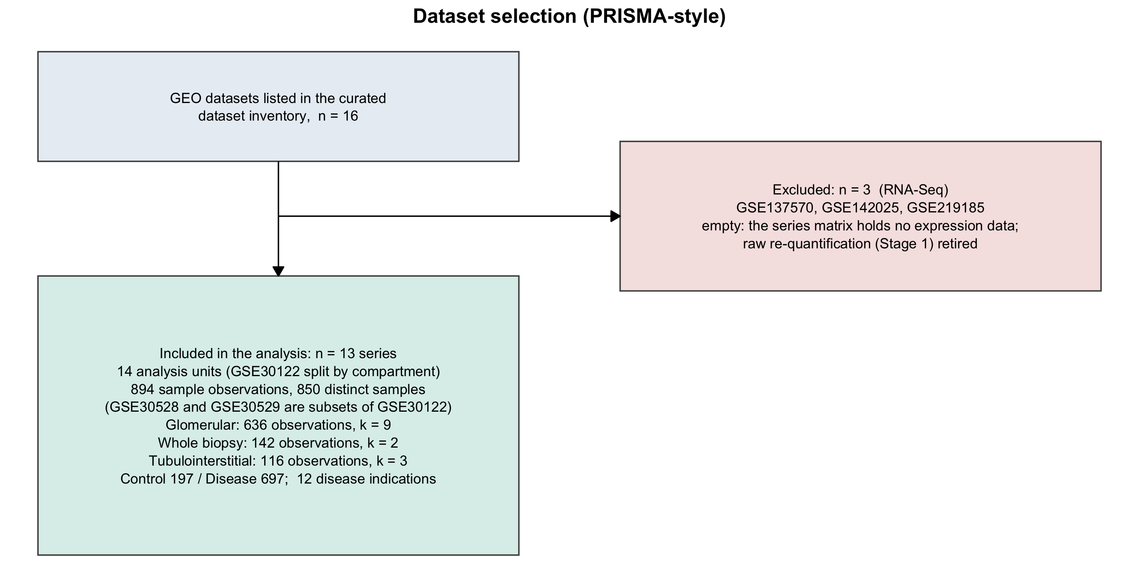
Figure 1. PRISMA flow diagram of dataset selection.

1.3 Included cohorts
Table 2. The 13 analysed datasets.
Dataset | Tissue / content | Platform | Scale as deposited | Control | Disease | Total
GSE104948-GPL22945 | ERCB glomeruli | Affymetrix (custom CDF, GPL22945) | log2 | 21 | 50 | 71
GSE104954-GPL22945 | ERCB tubulointerstitium | Affymetrix (custom CDF, GPL22945) | log2 | 21 | 39 | 60
GSE108109 | Glomeruli | Affymetrix (custom CDF) | log2 | 6 | 105 | 111
GSE200828 | Glomeruli | Affymetrix (custom CDF) | log2 | 6 | 147 | 153
GSE99339-GPL19184 | Glomeruli | Affymetrix (custom CDF, GPL19184) | log2 | 8 | 125 | 133
GSE121233 | Glomeruli | Affymetrix HTA 2.0 | log2 | 5 | 5 | 10
GSE129973 | Glomeruli | Affymetrix HTA 2.0 | log2 | 20 | 20 | 40
GSE96804 | Glomeruli (DKD) | Affymetrix HTA 2.0 | log2 | 20 | 41 | 61
GSE30122 | Glom. + tubuli (DKD) | Affymetrix HG-U133A 2.0 | per-gene centred | 50 | 19 | 69
GSE116626 | Whole biopsy (IgAN, other GN) | Illumina HumanHT-12 v4 / WG-DASL | per-gene centred | 7 | 74 | 81
GSE66494 | Whole biopsy (CKD) | Agilent 4×44K (G4112A) | linear → log2 | 8 | 53 | 61
GSE30528 | Glomeruli (subset of GSE30122) | Affymetrix HG-U133A 2.0 | per-gene centred | 13 | 9 | 22
GSE30529 | Tubuli (subset of GSE30122) | Affymetrix HG-U133A 2.0 | per-gene centred | 12 | 10 | 22
Total (incl. 44 duplicated profiles) |  |  |  | 197 | 697 | 894
ERCB = European Renal cDNA Bank. GSE30528 and GSE30529 are wholly contained in GSE30122 and are kept by instruction. In ERCB, living donors and tumour-nephrectomy samples are both controls (21 per compartment).
Disease labels are recorded in a different metadata field in each cohort (diagnosis, subject status, sample type, description or source_name_ch1). They were mapped per cohort and then grouped into indications (Table 3).
Table 3. Sample profiles per compartment and indication.
Compartment | Indication | Profiles
Glomerular | Control | 125
 | MN | 116
 | FSGS | 108
 | DKD | 73
 | MCD | 48
 | Other GN | 46
 | ANCA vasculitis | 37
 | Lupus nephritis | 30
 | IgAN | 26
 | Hypertensive nephropathy | 18
 | FSGS/MCD | 6
 | Thin membrane disease | 3
Tubulointerstitial | Control | 57
 | DKD | 27
 | ANCA vasculitis | 21
 | FSGS/MCD | 4
 | MCD | 4
 | FSGS | 3
Whole biopsy | CKD (unspecified) | 53
 | IgAN | 52
 | Other GN | 22
 | Control | 15
MN = membranous nephropathy; MCD = minimal change disease; GN = glomerulonephritis. Counts include the GSE30528/GSE30529 duplicates.

2. Stage 2 — Target gene mapping
Each series matrix was parsed directly (sample metadata and expression table, with no GPL download). Probes were mapped to the five panel genes through four identifier routes:
- Entrez custom CDF (<entrez>_at): GSE104948, GSE104954, GSE99339, GSE108109, GSE200828.
- hta20transcriptcluster.db: GSE121233, GSE129973, GSE96804.
- hgu133a2.db: GSE30122, GSE30528, GSE30529.
- illuminaHumanv4.db (GSE116626) and hgug4112a.db (GSE66494).
Where a gene had several probes, they were collapsed with WGCNA::collapseRows(method = "MaxMean"), keeping the probe with the highest mean expression, as the plan specifies. GSE66494 (Agilent) was deposited on a linear scale and was log2-transformed; it is the only cohort that needed this. All 13 cohorts map all 5 genes.
Table 4. Stage 2 cohort QC (cohort_qc.xlsx).
Dataset | Genes mapped | n | Control | Disease | Median panel expression
GSE104948-GPL22945 | 5/5 | 71 | 21 | 50 | 6.80
GSE104954-GPL22945 | 5/5 | 60 | 21 | 39 | 5.85
GSE108109 | 5/5 | 111 | 6 | 105 | 3.22
GSE200828 | 5/5 | 153 | 6 | 147 | 3.10
GSE99339-GPL19184 | 5/5 | 133 | 8 | 125 | 6.80
GSE121233 | 5/5 | 10 | 5 | 5 | 4.65
GSE129973 | 5/5 | 40 | 20 | 20 | 4.52
GSE96804 | 5/5 | 61 | 20 | 41 | 4.93
GSE30122 | 5/5 | 69 | 50 | 19 | 0.00
GSE116626 | 5/5 | 81 | 7 | 74 | 0.00
GSE66494 | 5/5 | 61 | 8 | 53 | 1.48
GSE30528 | 5/5 | 22 | 13 | 9 | 0.00
GSE30529 | 5/5 | 22 | 12 | 10 | 0.00
A median of exactly 0 marks the per-gene-centred cohorts (GSE30122 family, GSE116626). Their absolute expression level cannot be recovered, so any shared-axis plot of these cohorts shows relative values.

3. Stage 3 — Batch correction

3.1 Model
Batch effects were removed with one `limma::removeBatchEffect` model fitted to all 894 samples. The batch factor is the 14 study × compartment units (GSE30122 split into glomerular and tubulointerstitial). The design matrix contains an intercept plus a Disease effect for each compartment, so the disease signal is protected from removal. Compartment main effects are not in the design because they are aliased with batch: compartment is nested within study for most cohorts. A qr() rank check confirms that no batch coefficient is silently set to zero. As a result, level differences between compartments are removed, and expression should be compared only within a compartment.
ComBat-seq (plan Stage 3) does not apply because there are no RNA-Seq counts. Stage 4, the meta-analysis and the mega-analysis model the uncorrected values with study as a factor, as limma recommends; the corrected values are used for visualisation.

3.2 Effectiveness of correction
Table 5. Share of principal-component variance explained by batch unit and by condition, before and after correction (pca_batch_r2.xlsx).
 | PC | Variance explained | R² batch unit | R² condition
Before correction | PC1 | 88.7% | 0.984 | 0.023
Before correction | PC2 | 6.8% | 0.890 | 0.028
After correction | PC1 | 33.2% | 0.082 | 0.033
After correction | PC2 | 22.0% | 0.008 | 0.031

Before correction, batch explains 98% of PC1. After correction it explains 8% of PC1 and 0.8% of PC2. The mean UMAP silhouette width of the batch units falls from 0.134 to −0.213, meaning the units no longer form separate clusters. This silhouette understates the original batch effect, because cohorts on the same platform cluster together and GSE30122/30528/30529 are the same samples.
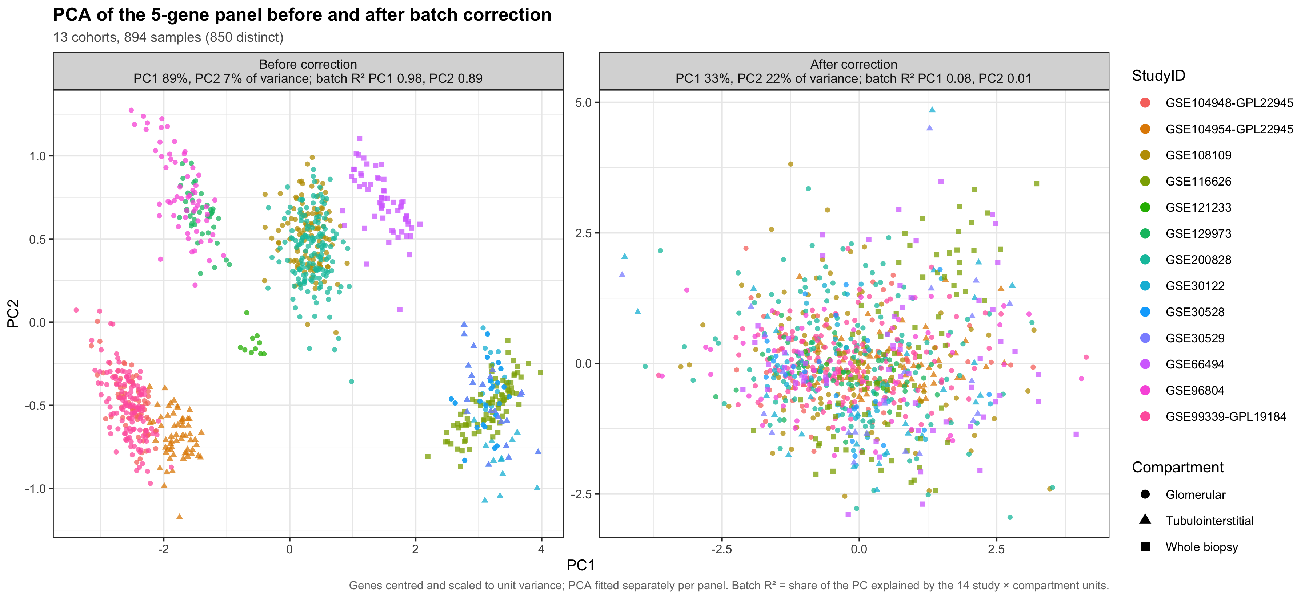
Figure 2. PCA of the 5-gene panel before and after batch correction (plan §7, Plot 1).
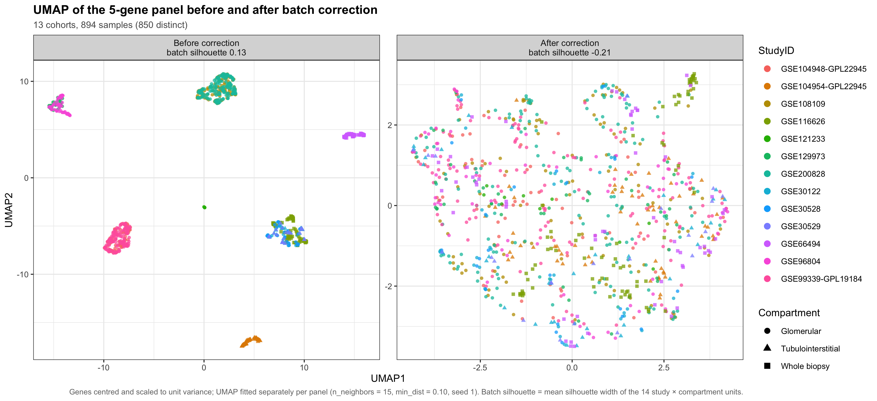
Figure 3. UMAP of the 5-gene panel before and after batch correction (plan §7, Plot 1).

3.3 Residual spread
removeBatchEffect aligns the location of each study but not its spread. Within a compartment, the residual per-gene SD still differs up to 6.7-fold between studies (Table 6). For this reason Stage 4 uses inverse-variance weights, the meta-analysis uses a scale-free Hedges' g, and the mega-analysis models a separate residual variance for each study.
Table 6. Between-study ratio of residual per-gene SD after correction (residual_sd_ratio.xlsx).
Compartment | Gene | Min SD | Max SD | Max/min
Glomerular | C4BPB | 0.06 | 0.40 | 6.7
Glomerular | COL13A1 | 0.07 | 0.45 | 6.4
Tubulointerstitial | COL13A1 | 0.13 | 0.54 | 4.2
Glomerular | CFH | 0.32 | 1.29 | 4.1
Tubulointerstitial | CFI | 0.37 | 1.26 | 3.4
Glomerular | CFI | 0.34 | 1.00 | 2.9
Whole biopsy | C4BPB | 0.21 | 0.55 | 2.7
Glomerular | HABP2 | 0.43 | 1.08 | 2.5
Whole biopsy | CFI | 0.47 | 1.04 | 2.2
Tubulointerstitial | CFH | 0.69 | 1.39 | 2.0
Whole biopsy | CFH | 0.49 | 0.90 | 1.8
Tubulointerstitial | C4BPB | 0.18 | 0.25 | 1.4
Tubulointerstitial | HABP2 | 0.78 | 1.01 | 1.3
Whole biopsy | COL13A1 | 0.46 | 0.52 | 1.1
Whole biopsy | HABP2 | 0.91 | 0.91 | 1.0

3.4 Harmonised expression
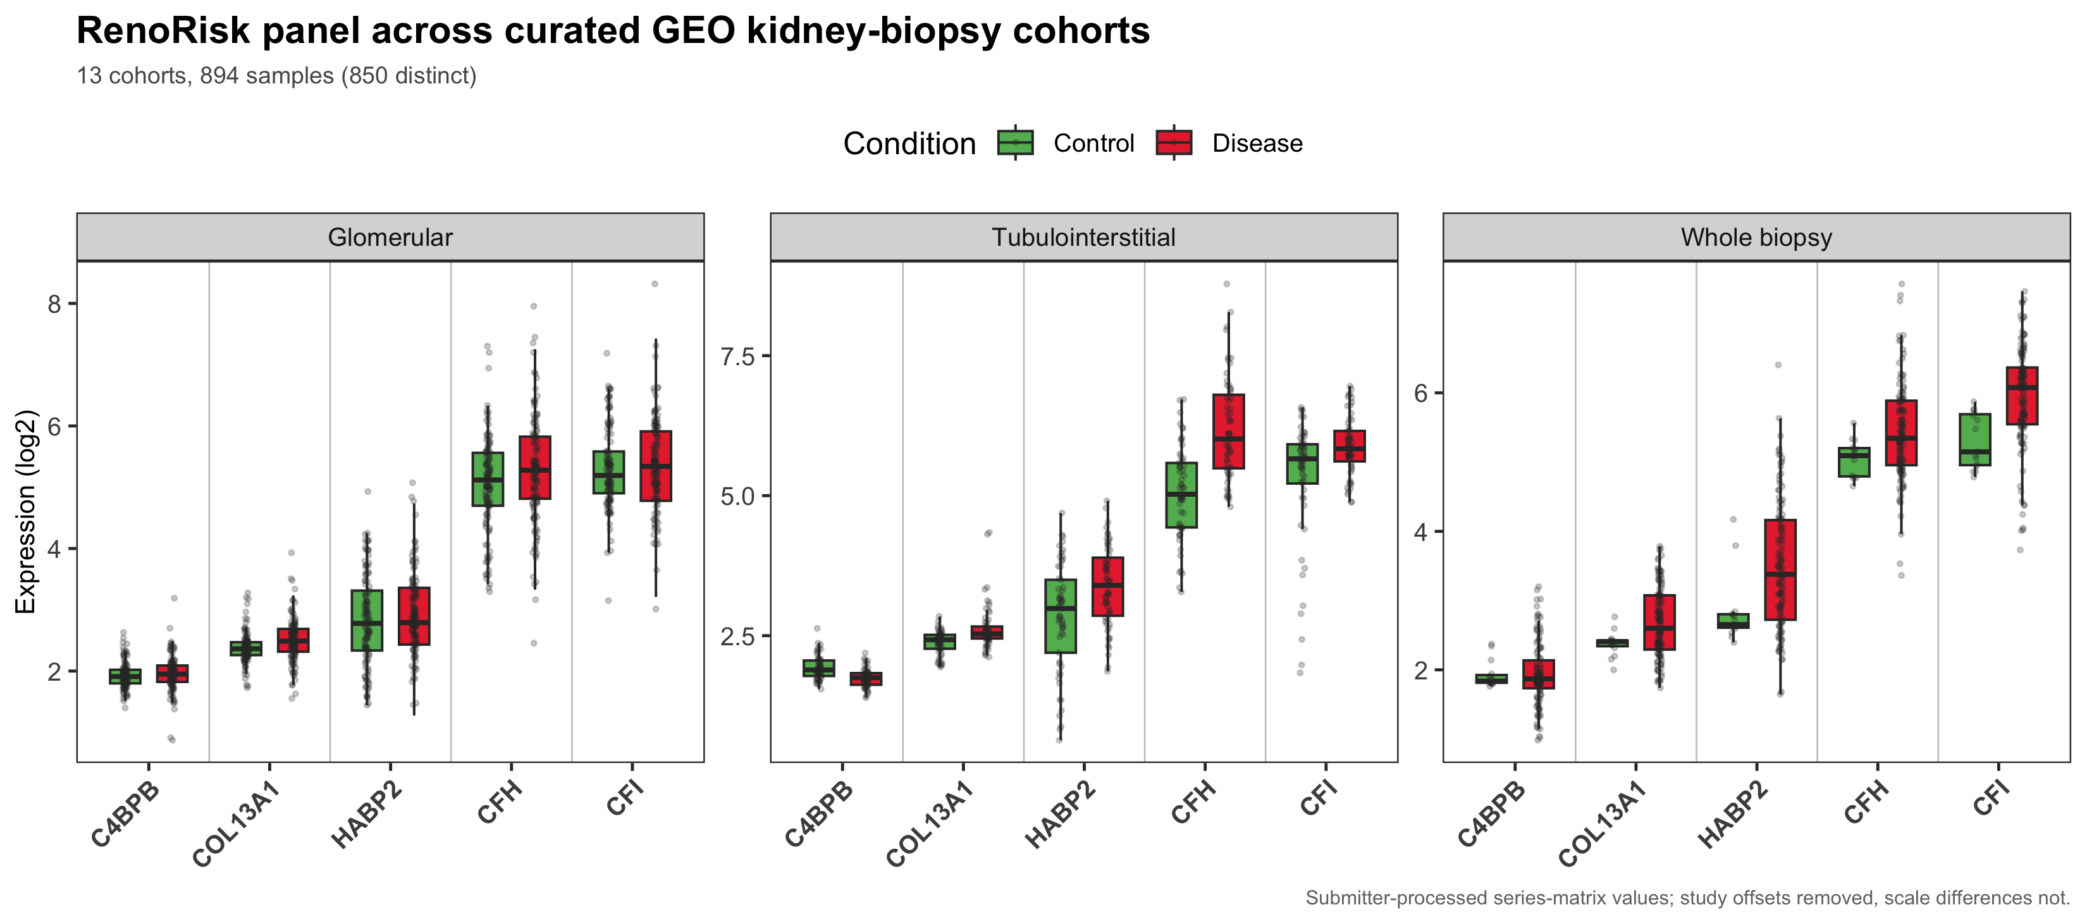
Figure 4. Batch-corrected expression of the 5 panel genes, Control vs Disease, by compartment (deliverable figure). Values are relative: four cohorts are per-gene centred, and between-compartment level differences are removed by design.

4. Stage 4 — Multi-factor statistical modelling

4.1 Model
For each gene, a weighted least-squares model was fitted to the uncorrected Stage 2 values: Expression ~ 0 + Batch + Disease:Compartment + Sex. The weights are 1 / residual variance of the sample's batch unit. The model estimates the disease effect within each compartment and the differences of that effect between compartments. Compartment main effects are absorbed by the batch terms. The Benjamini–Hochberg correction is applied within each family of tests (Disease, compartment difference, Sex). Residual df = 876.
Covariates. Sex is the only patient covariate available. None of the 13 series matrices contains eGFR, %TIF, proteinuria or age; for ERCB and GSE66494 these values are held in Nephroseq, not GEO. Sex was taken from the metadata where reported (GSE116626, GSE129973, GSE96804) and inferred from XIST versus 5 Y-chromosome genes elsewhere. The inference agreed with reported sex in 40/40 (GSE129973) and 60/61 (GSE96804) samples. For GSE116626 the inference was rejected because its WG-DASL chip lacks XIST, and the reported sex was used.
Table 7. Sex assignment per dataset (sex_by_cohort.xlsx).
Dataset | n | Male | Female | Source | Concordance with reported
GSE104948-GPL22945 | 71 | 32 | 39 | Inferred (XIST / Y genes) | –
GSE104954-GPL22945 | 60 | 29 | 31 | Inferred (XIST / Y genes) | –
GSE108109 | 111 | 71 | 40 | Inferred (XIST / Y genes) | –
GSE116626 | 81 | 52 | 29 | Reported (inference rejected) | –
GSE121233 | 10 | 8 | 2 | Inferred (XIST / Y genes) | –
GSE129973 | 40 | 24 | 16 | Reported; inference checked | 100.0%
GSE200828 | 153 | 103 | 50 | Inferred (XIST / Y genes) | –
GSE30122 | 69 | 27 | 42 | Inferred (XIST / Y genes) | –
GSE30528 | 22 | 9 | 13 | Inferred (XIST / Y genes) | –
GSE30529 | 22 | 7 | 15 | Inferred (XIST / Y genes) | –
GSE66494 | 61 | 36 | 25 | Inferred (XIST / Y genes) | –
GSE96804 | 61 | 43 | 18 | Reported; inference checked | 98.4%
GSE99339-GPL19184 | 133 | 74 | 59 | Inferred (XIST / Y genes) | –
Total | 894 | 515 | 379

4.2 Results
Table 8. Stage 4 multi-factor WLS results (stage4_multifactor_results.xlsx).
Gene | Family | Term | log2FC | SE | t | p | FDR
C4BPB | Disease | Glomerular | 0.053 | 0.019 | 2.81 | 0.005 | 0.013
 | Disease | Tubulointerstitial | −0.182 | 0.037 | −4.87 | 1.3×10⁻⁶ | 6.6×10⁻⁶
 | Disease | Whole biopsy | 0.039 | 0.073 | 0.54 | 0.593 | 0.593
 | Sex | Sex (M vs F) | 0.012 | 0.014 | 0.86 | 0.390 | 0.487
 | Difference | Tubulointerstitial − Glomerular | −0.234 | 0.042 | −5.61 | 2.7×10⁻⁸ | 4.0×10⁻⁷
 | Difference | Whole biopsy − Glomerular | −0.013 | 0.076 | −0.18 | 0.860 | 0.860
 | Difference | Whole biopsy − Tubulointerstitial | 0.221 | 0.082 | 2.69 | 0.007 | 0.033
COL13A1 | Disease | Glomerular | 0.098 | 0.018 | 5.38 | 9.5×10⁻⁸ | 7.1×10⁻⁷
 | Disease | Tubulointerstitial | 0.081 | 0.043 | 1.87 | 0.062 | 0.084
 | Disease | Whole biopsy | 0.292 | 0.129 | 2.26 | 0.024 | 0.036
 | Sex | Sex (M vs F) | −0.002 | 0.015 | −0.14 | 0.893 | 0.893
 | Difference | Tubulointerstitial − Glomerular | −0.018 | 0.047 | −0.37 | 0.709 | 0.805
 | Difference | Whole biopsy − Glomerular | 0.194 | 0.130 | 1.49 | 0.138 | 0.206
 | Difference | Whole biopsy − Tubulointerstitial | 0.211 | 0.136 | 1.55 | 0.121 | 0.202
HABP2 | Disease | Glomerular | 0.117 | 0.077 | 1.51 | 0.132 | 0.152
 | Disease | Tubulointerstitial | 0.482 | 0.148 | 3.26 | 0.001 | 0.003
 | Disease | Whole biopsy | 0.659 | 0.247 | 2.67 | 0.008 | 0.017
 | Sex | Sex (M vs F) | −0.439 | 0.050 | −8.76 | 1.0×10⁻¹⁷ | 5.2×10⁻¹⁷
 | Difference | Tubulointerstitial − Glomerular | 0.365 | 0.167 | 2.19 | 0.029 | 0.087
 | Difference | Whole biopsy − Glomerular | 0.542 | 0.259 | 2.10 | 0.036 | 0.091
 | Difference | Whole biopsy − Tubulointerstitial | 0.177 | 0.288 | 0.61 | 0.538 | 0.695
CFH | Disease | Glomerular | 0.201 | 0.087 | 2.31 | 0.021 | 0.035
 | Disease | Tubulointerstitial | 0.931 | 0.161 | 5.79 | 9.5×10⁻⁹ | 1.4×10⁻⁷
 | Disease | Whole biopsy | 0.314 | 0.171 | 1.83 | 0.067 | 0.084
 | Sex | Sex (M vs F) | −0.198 | 0.051 | −3.90 | 1.0×10⁻⁴ | 2.6×10⁻⁴
 | Difference | Tubulointerstitial − Glomerular | 0.730 | 0.183 | 4.00 | 6.9×10⁻⁵ | 5.2×10⁻⁴
 | Difference | Whole biopsy − Glomerular | 0.113 | 0.192 | 0.59 | 0.556 | 0.695
 | Difference | Whole biopsy − Tubulointerstitial | −0.617 | 0.235 | −2.63 | 0.009 | 0.033
CFI | Disease | Glomerular | 0.079 | 0.086 | 0.93 | 0.353 | 0.379
 | Disease | Tubulointerstitial | 0.337 | 0.097 | 3.49 | 5.1×10⁻⁴ | 0.002
 | Disease | Whole biopsy | 0.398 | 0.168 | 2.37 | 0.018 | 0.034
 | Sex | Sex (M vs F) | −0.107 | 0.047 | −2.30 | 0.022 | 0.036
 | Difference | Tubulointerstitial − Glomerular | 0.258 | 0.129 | 2.00 | 0.046 | 0.099
 | Difference | Whole biopsy − Glomerular | 0.319 | 0.189 | 1.69 | 0.091 | 0.171
 | Difference | Whole biopsy − Tubulointerstitial | 0.061 | 0.194 | 0.32 | 0.751 | 0.805
Disease rows give Disease vs Control within a compartment. Difference rows compare the disease effect between compartments. Sex is male vs female. Highlighted cells have FDR < 0.05.
Interpretation
- Tubulointerstitium: four of five genes change significantly. CFH 0.93 log2 (FDR 1.4×10⁻⁷), HABP2 +0.48, CFI +0.34, and C4BPB −0.18.
- Glomeruli: small but significant increases in COL13A1 (+0.098, FDR 7.1×10⁻⁷), C4BPB (+0.053) and CFH (+0.20).
- Whole biopsy: COL13A1 (+0.29), HABP2 (+0.66) and CFI (+0.40).
- Compartment differences: the disease effect differs between tubulointerstitium and glomeruli for CFH (+0.73, FDR 5.2×10⁻⁴) and C4BPB (−0.23, FDR 4.0×10⁻⁷). These two genes therefore behave differently by compartment, while COL13A1 does not.
- Sex: males have lower HABP2 (−0.44), CFH (−0.20) and CFI (−0.11).
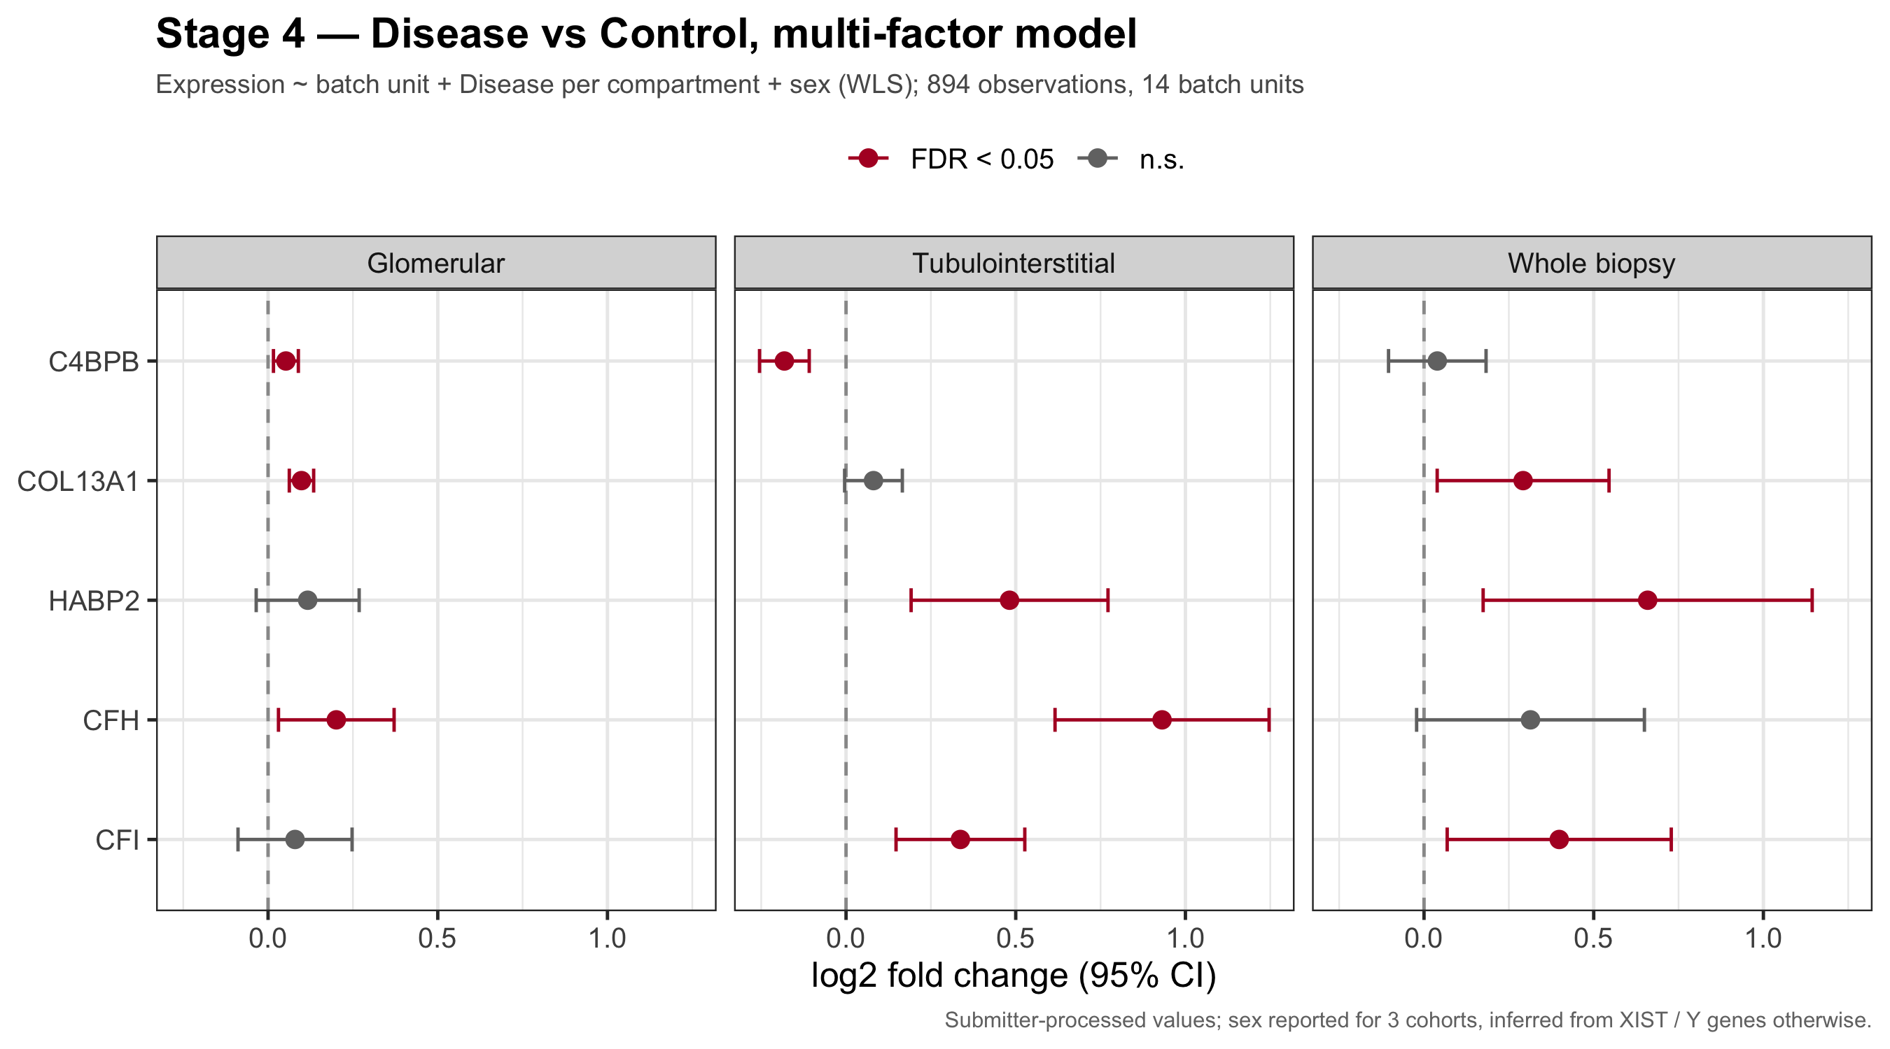
Figure 5. Stage 4 disease effects (log2FC ± 95% CI) per gene and compartment.

5. Stage 5 — Pooling strategy: meta-analysis and mega-analysis
Plan §5 sets a summary-level random-effects meta-analysis as the primary framework, complemented by a mega-analysis within platform tiers. Both use the uncorrected Stage 2 values, because their effects are estimated within each study.

5.1 Random-effects meta-analysis

Method
For each of the 14 batch units and each gene, the Disease vs Control effect was computed with metafor::escalc. The primary measure is Hedges' g (standardised mean difference). It is scale-free, which matters because four cohorts are per-gene centred. The log2 fold change (raw mean difference) is a secondary measure. Effects were pooled with DerSimonian–Laird random effects (rma(method = "DL")) overall and per compartment. The analysis reports Cochran's Q, I², τ² and 95% prediction intervals, a compartment moderator test (mods = ~ Compartment), leave-one-out influence, a control-tissue sensitivity analysis and an indication-stratified analysis. FDR is the Benjamini–Hochberg value within measure.

Pooled estimates
Table 9. DerSimonian–Laird pooled Disease vs Control effects (pooling_estimates.xlsx).
Gene | Subset | k | g | 95% CI | 95% PI | I² | FDR (g) | log2FC | FDR (log2FC)
C4BPB | All units | 14 | −0.08 | [−0.51, 0.36] | [−1.57, 1.42] | 80% | 0.733 | −0.02 | 0.589
 | Glomerular | 9 | 0.27 | [−0.15, 0.70] | [−0.84, 1.39] | 67% | 0.522 | 0.05 | 0.228
 | Tubulointerstitial | 3 | −1.30 | [−2.62, 0.03] | [−3.81, 1.22] | 88% | 0.055 | −0.24 | 0.044
 | Whole biopsy | 2 | 0.09 | [−0.45, 0.63] | [−0.45, 0.63] | 0% | 0.746 | 0.02 | 0.707
COL13A1 | All units | 14 | 0.57 | [0.26, 0.89] | [−0.37, 1.52] | 60% | 0.002 | 0.13 | 0.003
 | Glomerular | 9 | 0.50 | [0.05, 0.96] | [−0.72, 1.72] | 71% | 0.156 | 0.09 | 0.228
 | Tubulointerstitial | 3 | 0.73 | [0.04, 1.43] | [−0.45, 1.91] | 63% | 0.048 | 0.29 | 0.136
 | Whole biopsy | 2 | 0.60 | [0.06, 1.15] | [0.06, 1.15] | 0% | 0.048 | 0.28 | 7.2×10⁻⁶
HABP2 | All units | 14 | 0.38 | [0.04, 0.71] | [−0.67, 1.43] | 66% | 0.070 | 0.35 | 0.056
 | Glomerular | 9 | 0.20 | [−0.25, 0.65] | [−1.01, 1.41] | 71% | 0.647 | 0.15 | 0.622
 | Tubulointerstitial | 3 | 0.62 | [0.17, 1.08] | [0.05, 1.20] | 20% | 0.017 | 0.61 | 0.037
 | Whole biopsy | 2 | 0.72 | [0.18, 1.27] | [0.18, 1.27] | 0% | 0.038 | 0.73 | 7.2×10⁻⁶
CFH | All units | 14 | 0.41 | [−0.04, 0.87] | [−1.17, 1.99] | 81% | 0.126 | 0.34 | 0.056
 | Glomerular | 9 | 0.05 | [−0.51, 0.61] | [−1.53, 1.64] | 81% | 0.931 | 0.05 | 0.813
 | Tubulointerstitial | 3 | 1.51 | [0.31, 2.72] | [−0.74, 3.77] | 85% | 0.023 | 1.37 | 0.044
 | Whole biopsy | 2 | 0.47 | [−0.07, 1.01] | [−0.07, 1.01] | 0% | 0.107 | 0.34 | 0.173
CFI | All units | 14 | 0.29 | [−0.09, 0.66] | [−0.95, 1.52] | 73% | 0.170 | 0.17 | 0.397
 | Glomerular | 9 | 0.02 | [−0.48, 0.53] | [−1.37, 1.42] | 77% | 0.931 | −0.07 | 0.813
 | Tubulointerstitial | 3 | 0.77 | [0.37, 1.16] | [0.37, 1.16] | 0% | 7.7×10⁻⁴ | 0.56 | 0.044
 | Whole biopsy | 2 | 0.72 | [0.14, 1.31] | [0.07, 1.38] | 13% | 0.038 | 0.60 | 0.180
g = Hedges' g; PI = prediction interval; k = number of batch units. Highlighted cells have FDR < 0.05. Whole-biopsy estimates rest on only 2 units, each from a different platform.
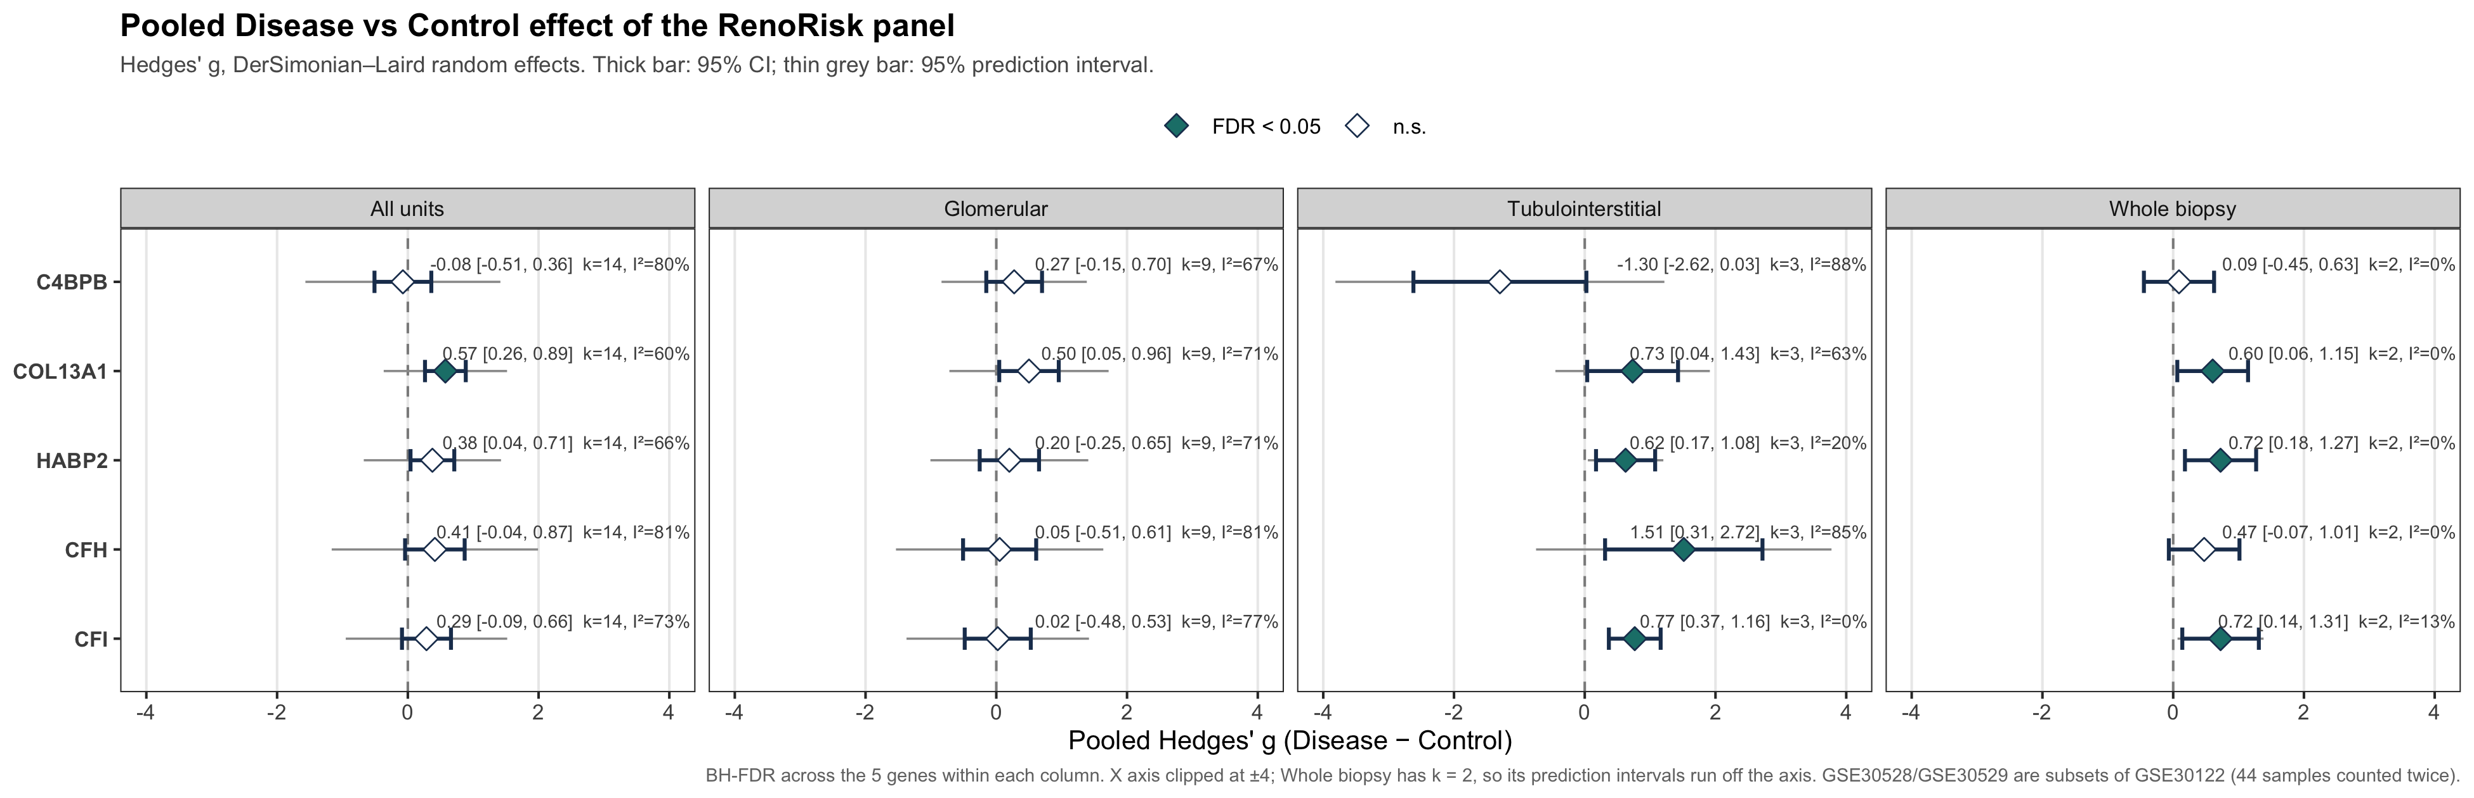
Figure 6. Summary forest plot: pooled Hedges' g with 95% CI and prediction interval for every gene × compartment.

Heterogeneity and compartment moderation
Between-study heterogeneity is substantial: I² across all units ranges from 60% (COL13A1) to 81% (CFH). Part of it is explained by compartment. The moderator test is significant for C4BPB (both measures) and for CFH on the log2FC scale, which agrees with the compartment differences found in Stage 4.
Table 10. Compartment as moderator of the disease effect (pooling_compartment_moderator.xlsx).
Gene | Measure | QM (df = 2) | p | Residual I² | FDR
C4BPB | g | 9.29 | 0.010 | 73% | 0.048
C4BPB | log2FC | 13.48 | 0.001 | 72% | 0.006
COL13A1 | g | 0.30 | 0.862 | 66% | 0.862
COL13A1 | log2FC | 3.14 | 0.208 | 81% | 0.208
HABP2 | g | 2.19 | 0.334 | 64% | 0.418
HABP2 | log2FC | 3.73 | 0.155 | 76% | 0.208
CFH | g | 6.22 | 0.044 | 80% | 0.111
CFH | log2FC | 8.51 | 0.014 | 89% | 0.036
CFI | g | 3.78 | 0.151 | 69% | 0.252
CFI | log2FC | 3.49 | 0.174 | 91% | 0.208

Robustness
Table 11. Leave-one-out influence on the all-units Hedges' g (pooling_leave1out.xlsx).
Gene | Range of pooled g (one unit omitted) | Largest p after omission
C4BPB | −0.16 to 0.07 | 0.998
COL13A1 | 0.48 to 0.62 | 0.002
HABP2 | 0.30 to 0.46 | 0.072
CFH | 0.28 to 0.52 | 0.195
CFI | 0.23 to 0.40 | 0.247
COL13A1 stays significant whichever unit is removed. The other genes are non-significant overall before any omission.
Control-tissue sensitivity. Studies differ in their control tissue: living donor (ERCB restricted to its living donors, GSE108109, GSE200828, GSE116626) or tumour nephrectomy (GSE99339, GSE129973, GSE96804, GSE121233). Control type was tested as a moderator in glomeruli, the only compartment with enough studies (3 vs 4). No gene differs (all FDR ≥ 0.32), so the choice of control tissue does not drive the results.
Table 12. Glomerular disease effect by control type (pooling_control_type_test.xlsx).
Gene | k LD | k TN | Δg (TN − LD) | 95% CI | p | FDR
C4BPB | 3 | 4 | 0.25 | [−0.81, 1.32] | 0.641 | 0.641
COL13A1 | 3 | 4 | −0.40 | [−1.55, 0.75] | 0.493 | 0.616
HABP2 | 3 | 4 | −0.34 | [−0.97, 0.30] | 0.297 | 0.495
CFH | 3 | 4 | 0.73 | [−0.46, 1.92] | 0.227 | 0.495
CFI | 3 | 4 | 0.97 | [−0.06, 2.01] | 0.064 | 0.321
LD = living donor; TN = tumour nephrectomy.
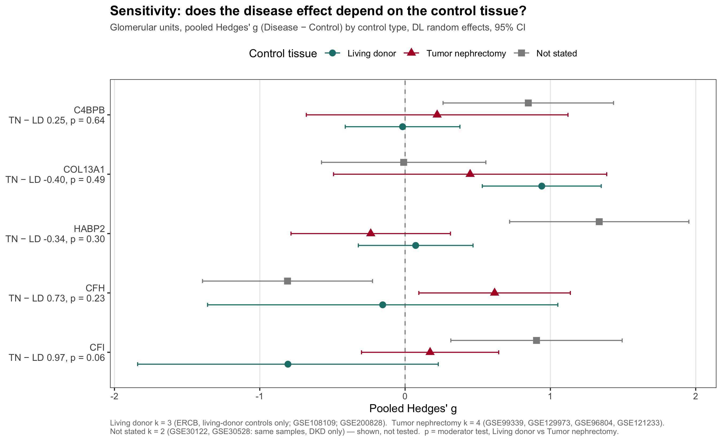
Figure 7. Control-type sensitivity analysis (glomeruli).

Indication-stratified effects (plan §7, Plot 4)
Each indication was compared with the controls of its own study, and the results were pooled where an indication appears in more than one unit. The effects with FDR < 0.05 are listed below. The direction of the CFI effect depends on indication: it is down-regulated in glomeruli in membranous nephropathy and up-regulated in tubulointerstitium in DKD and ANCA vasculitis. This dependence on indication explains much of the overall heterogeneity.
Table 13. Indication-specific effects with FDR < 0.05 (pooling_by_indication.xlsx; full table has 95 rows).
Gene | Compartment | Indication | k | n disease | g | 95% CI | FDR
CFH | Tubulointerstitial | DKD | 3 | 27 | 1.74 | [1.00, 2.48] | 2.2×10⁻⁴
CFI | Glomerular | MN | 3 | 116 | −1.22 | [−1.75, −0.70] | 2.2×10⁻⁴
COL13A1 | Glomerular | FSGS/MCD | 1 | 6 | 2.15 | [1.08, 3.23] | 0.003
CFI | Tubulointerstitial | ANCA vasculitis | 1 | 21 | 1.30 | [0.64, 1.97] | 0.003
COL13A1 | Tubulointerstitial | DKD | 3 | 27 | 0.94 | [0.45, 1.43] | 0.003
C4BPB | Glomerular | Lupus nephritis | 1 | 30 | −1.49 | [−2.34, −0.64] | 0.009
C4BPB | Glomerular | Hypertensive nephropathy | 1 | 18 | −1.37 | [−2.28, −0.46] | 0.039
CFI | Tubulointerstitial | DKD | 3 | 27 | 0.72 | [0.25, 1.20] | 0.039
Single-unit (k = 1) estimates come from one study and need replication.
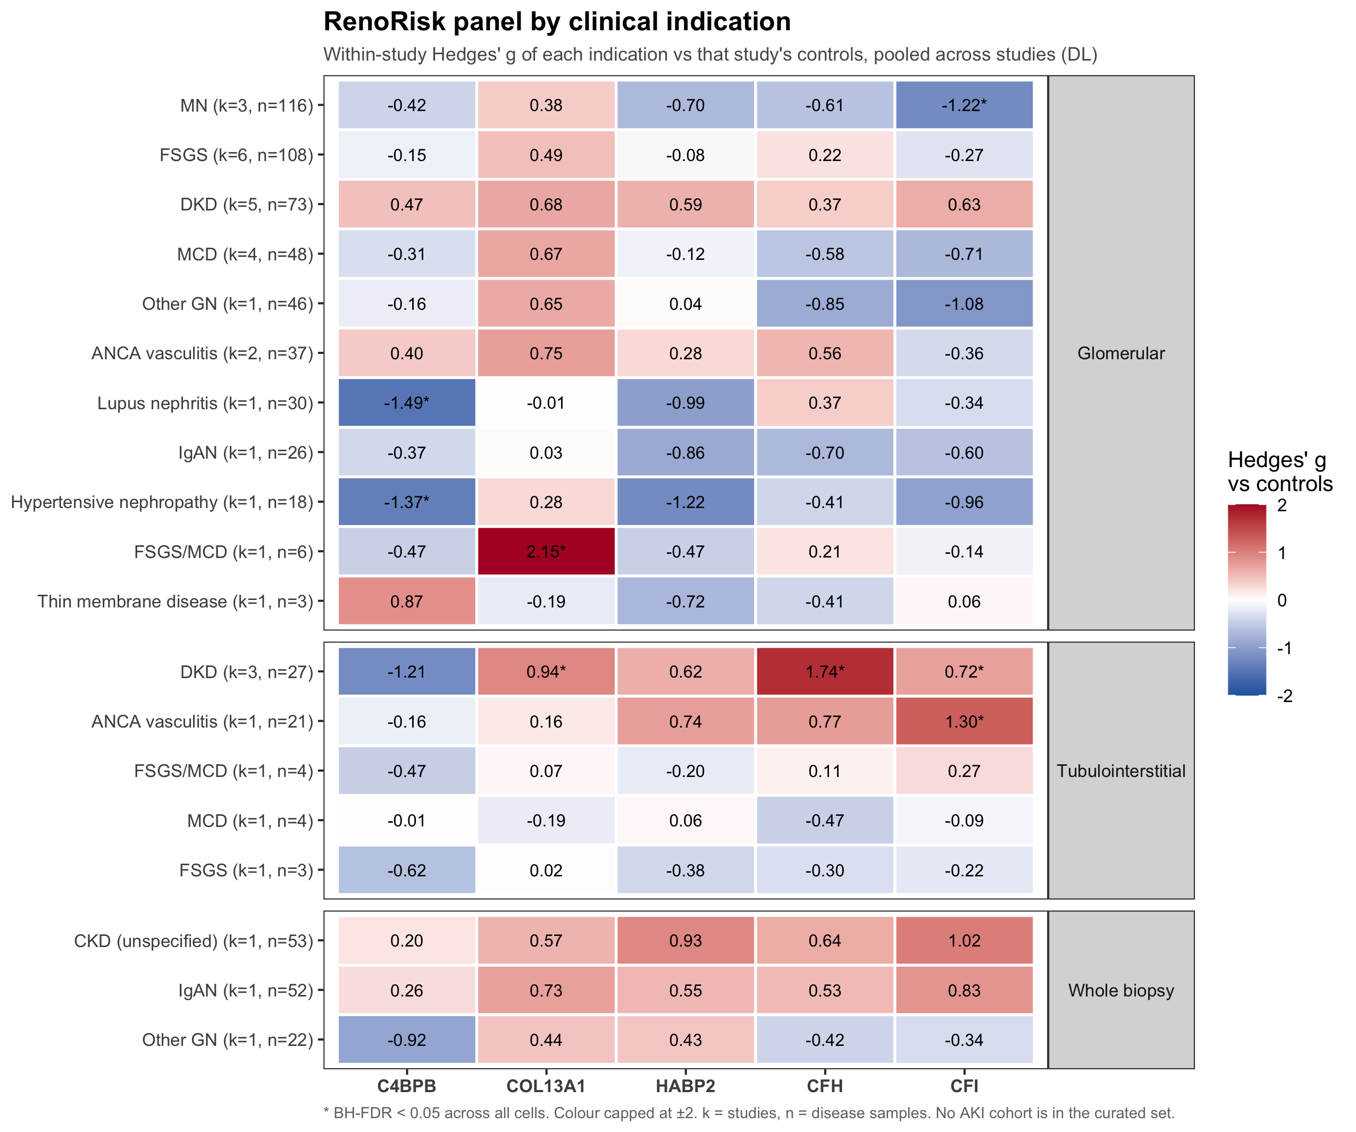
Figure 8. Hedges' g by indication and compartment for the 5 panel genes.

Per-gene forest plots (plan §7, Plot 2)
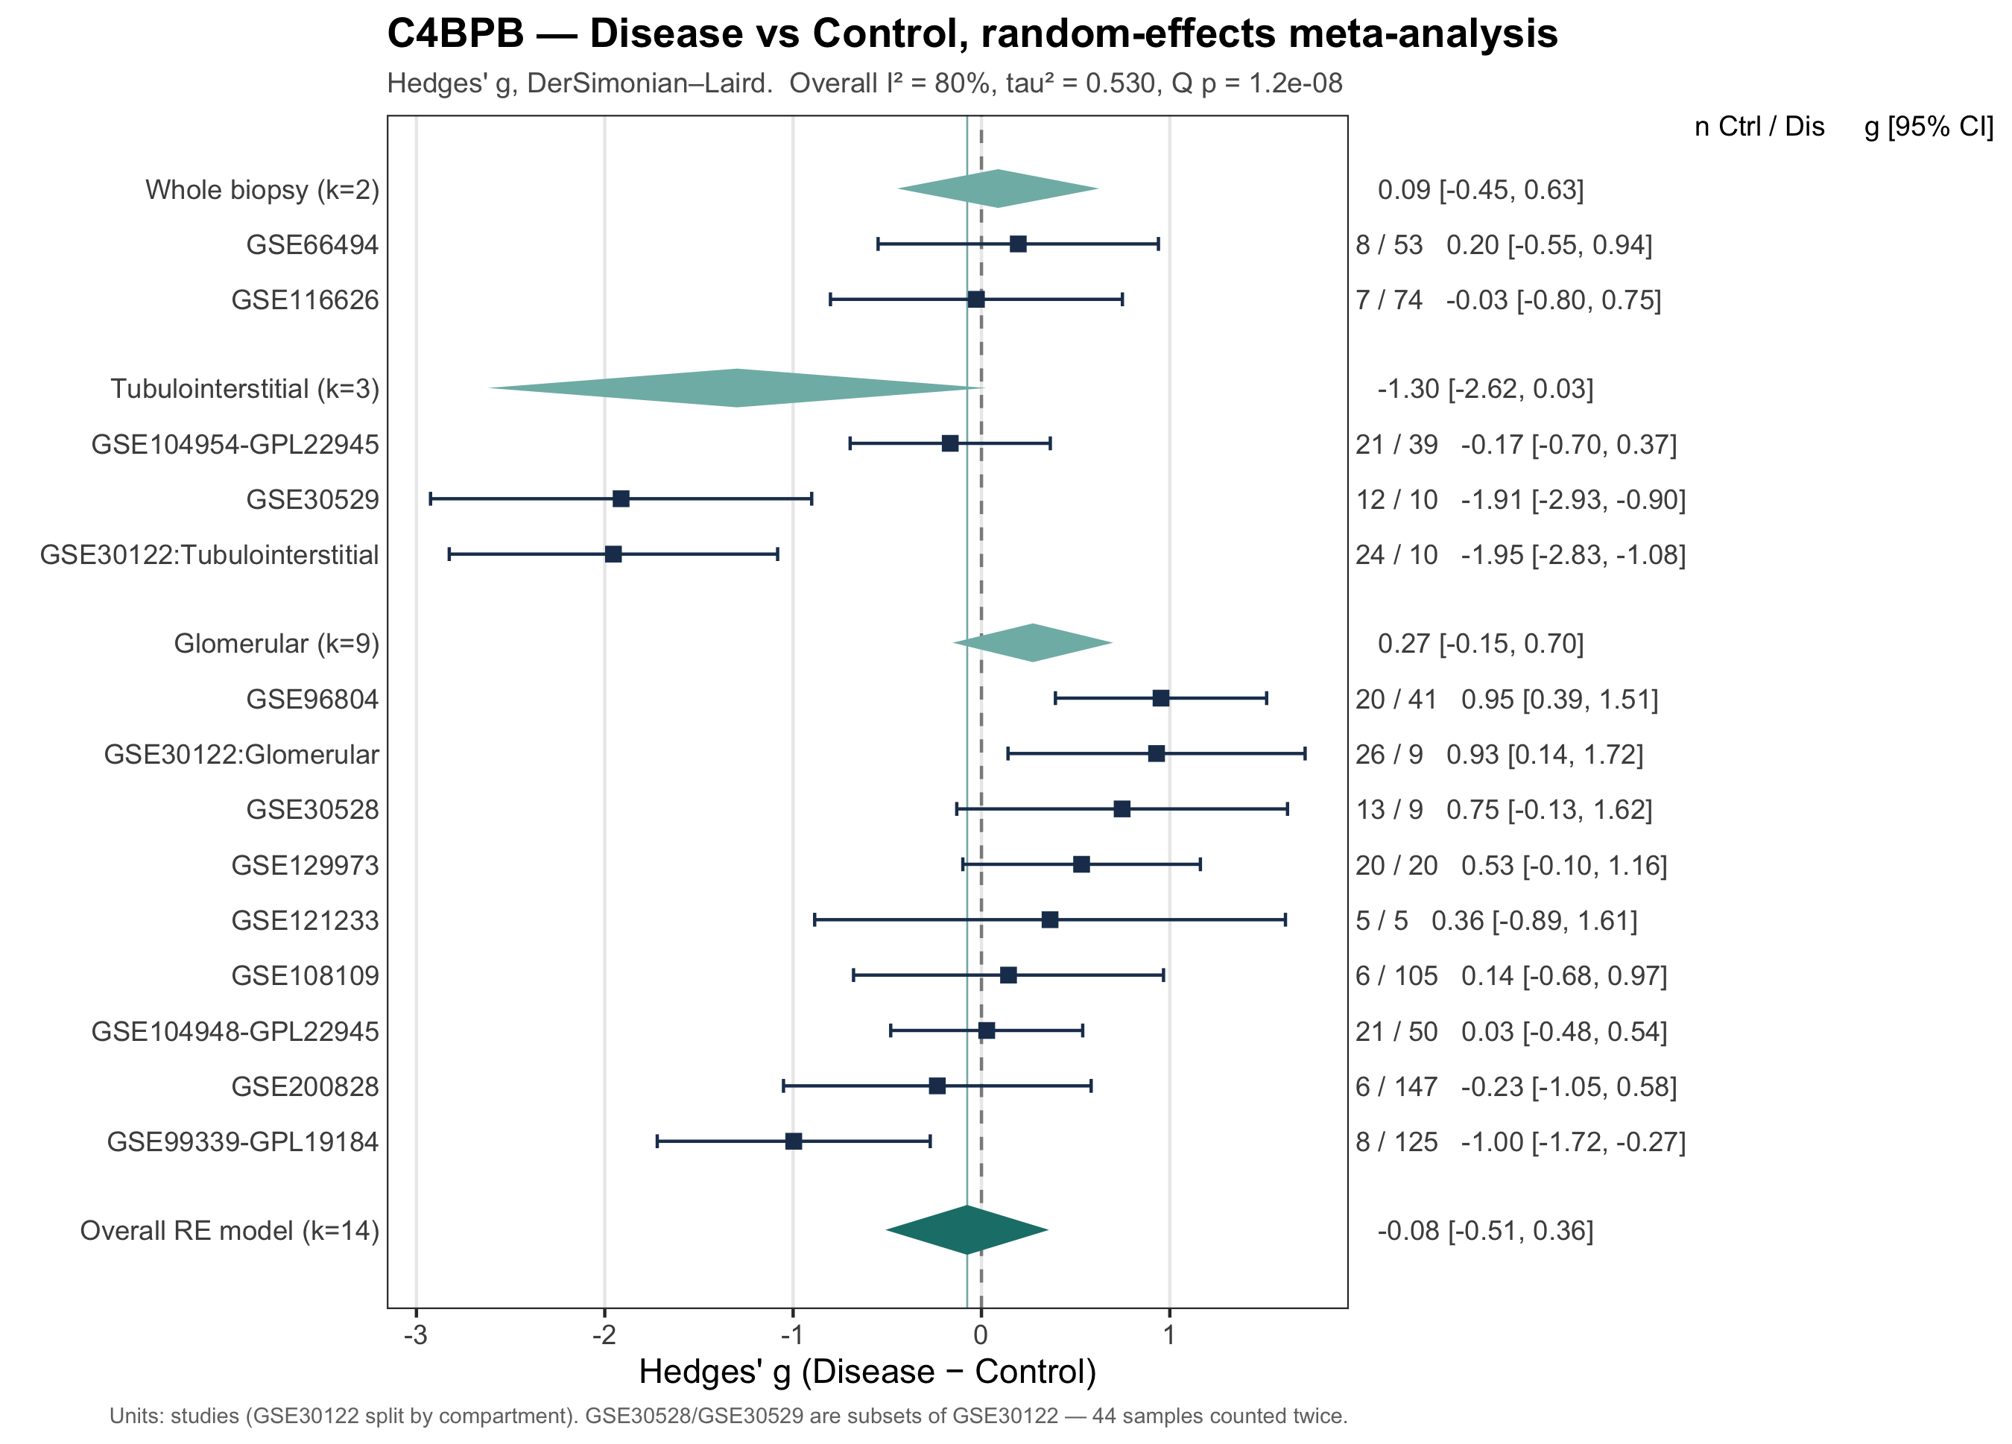
Figure 9. Forest plot for C4BPB: per-unit Hedges' g and pooled random-effects estimates by compartment.
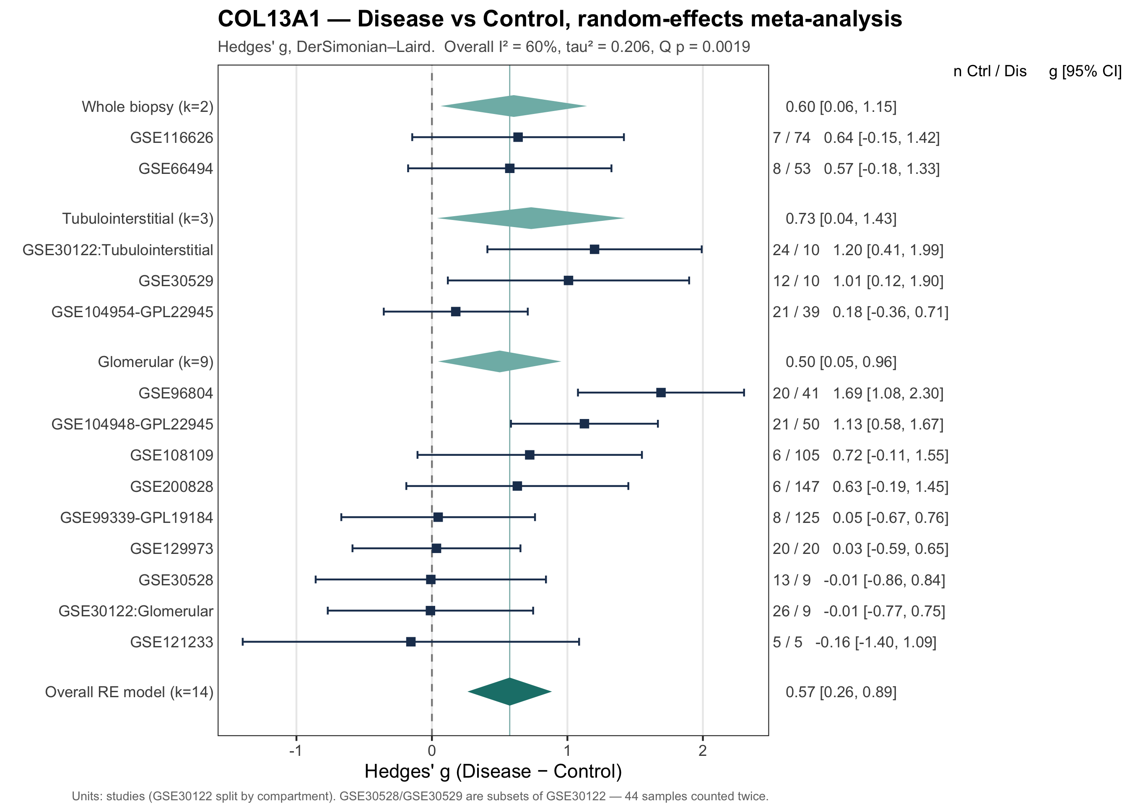
Figure 10. Forest plot for COL13A1: per-unit Hedges' g and pooled random-effects estimates by compartment.
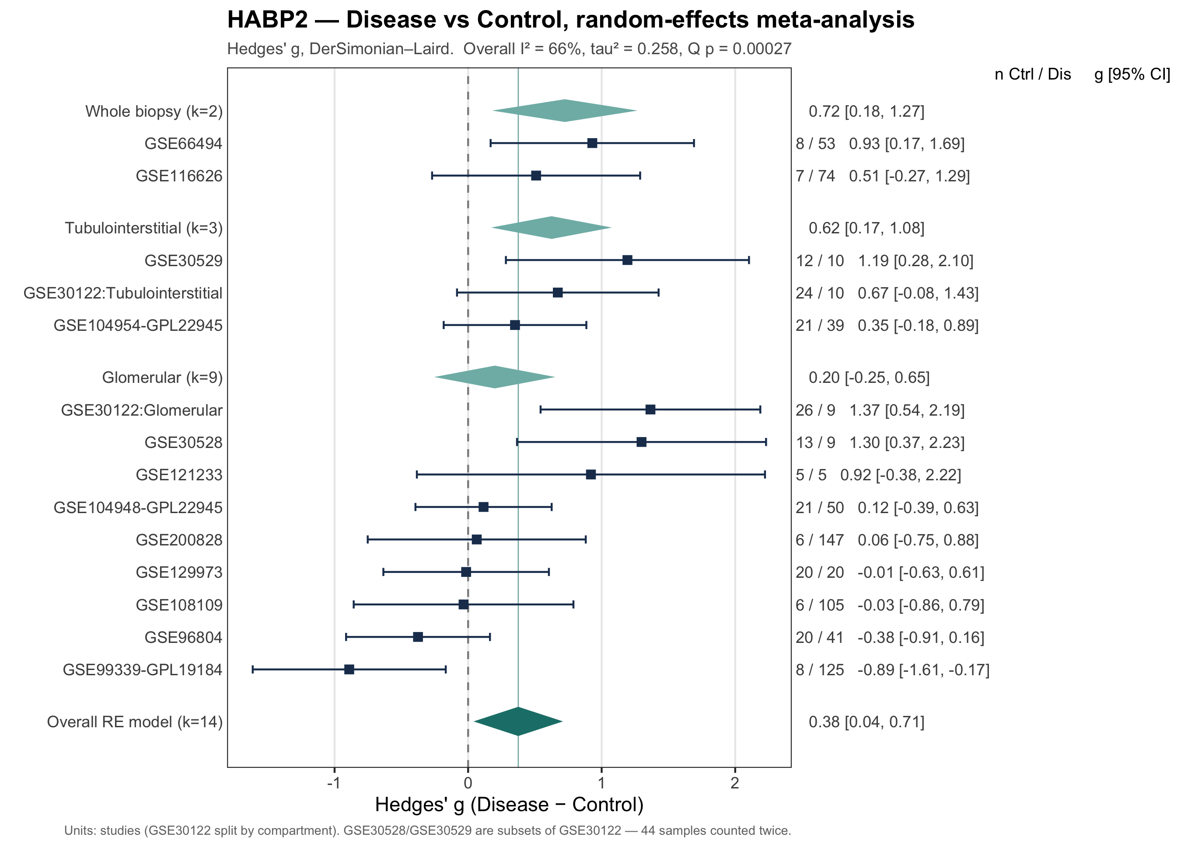
Figure 11. Forest plot for HABP2: per-unit Hedges' g and pooled random-effects estimates by compartment.
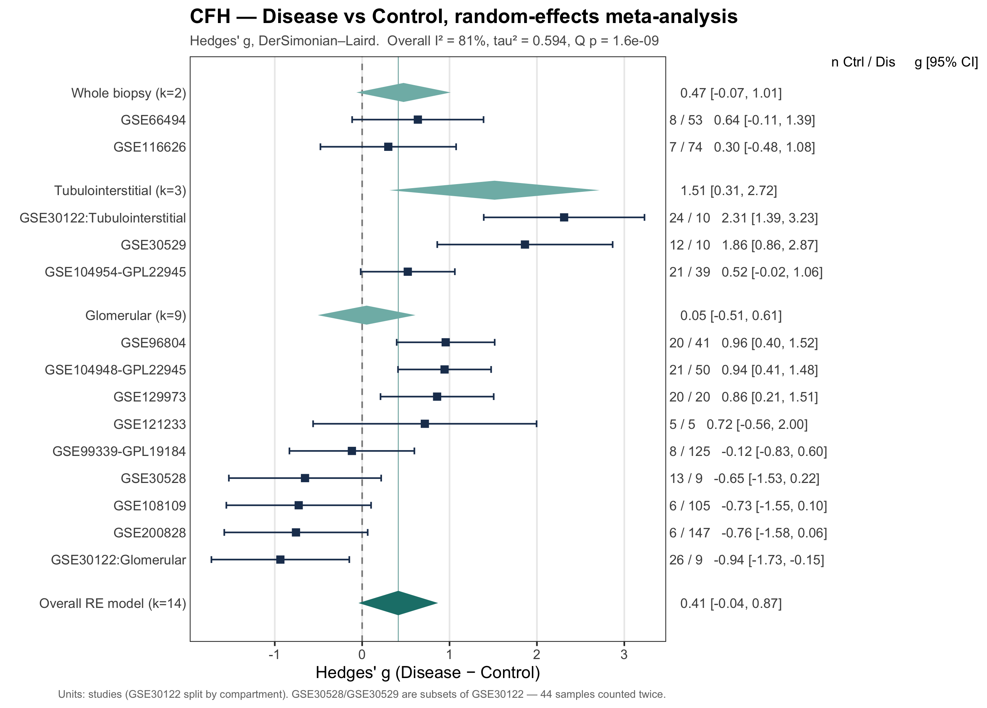
Figure 12. Forest plot for CFH: per-unit Hedges' g and pooled random-effects estimates by compartment.
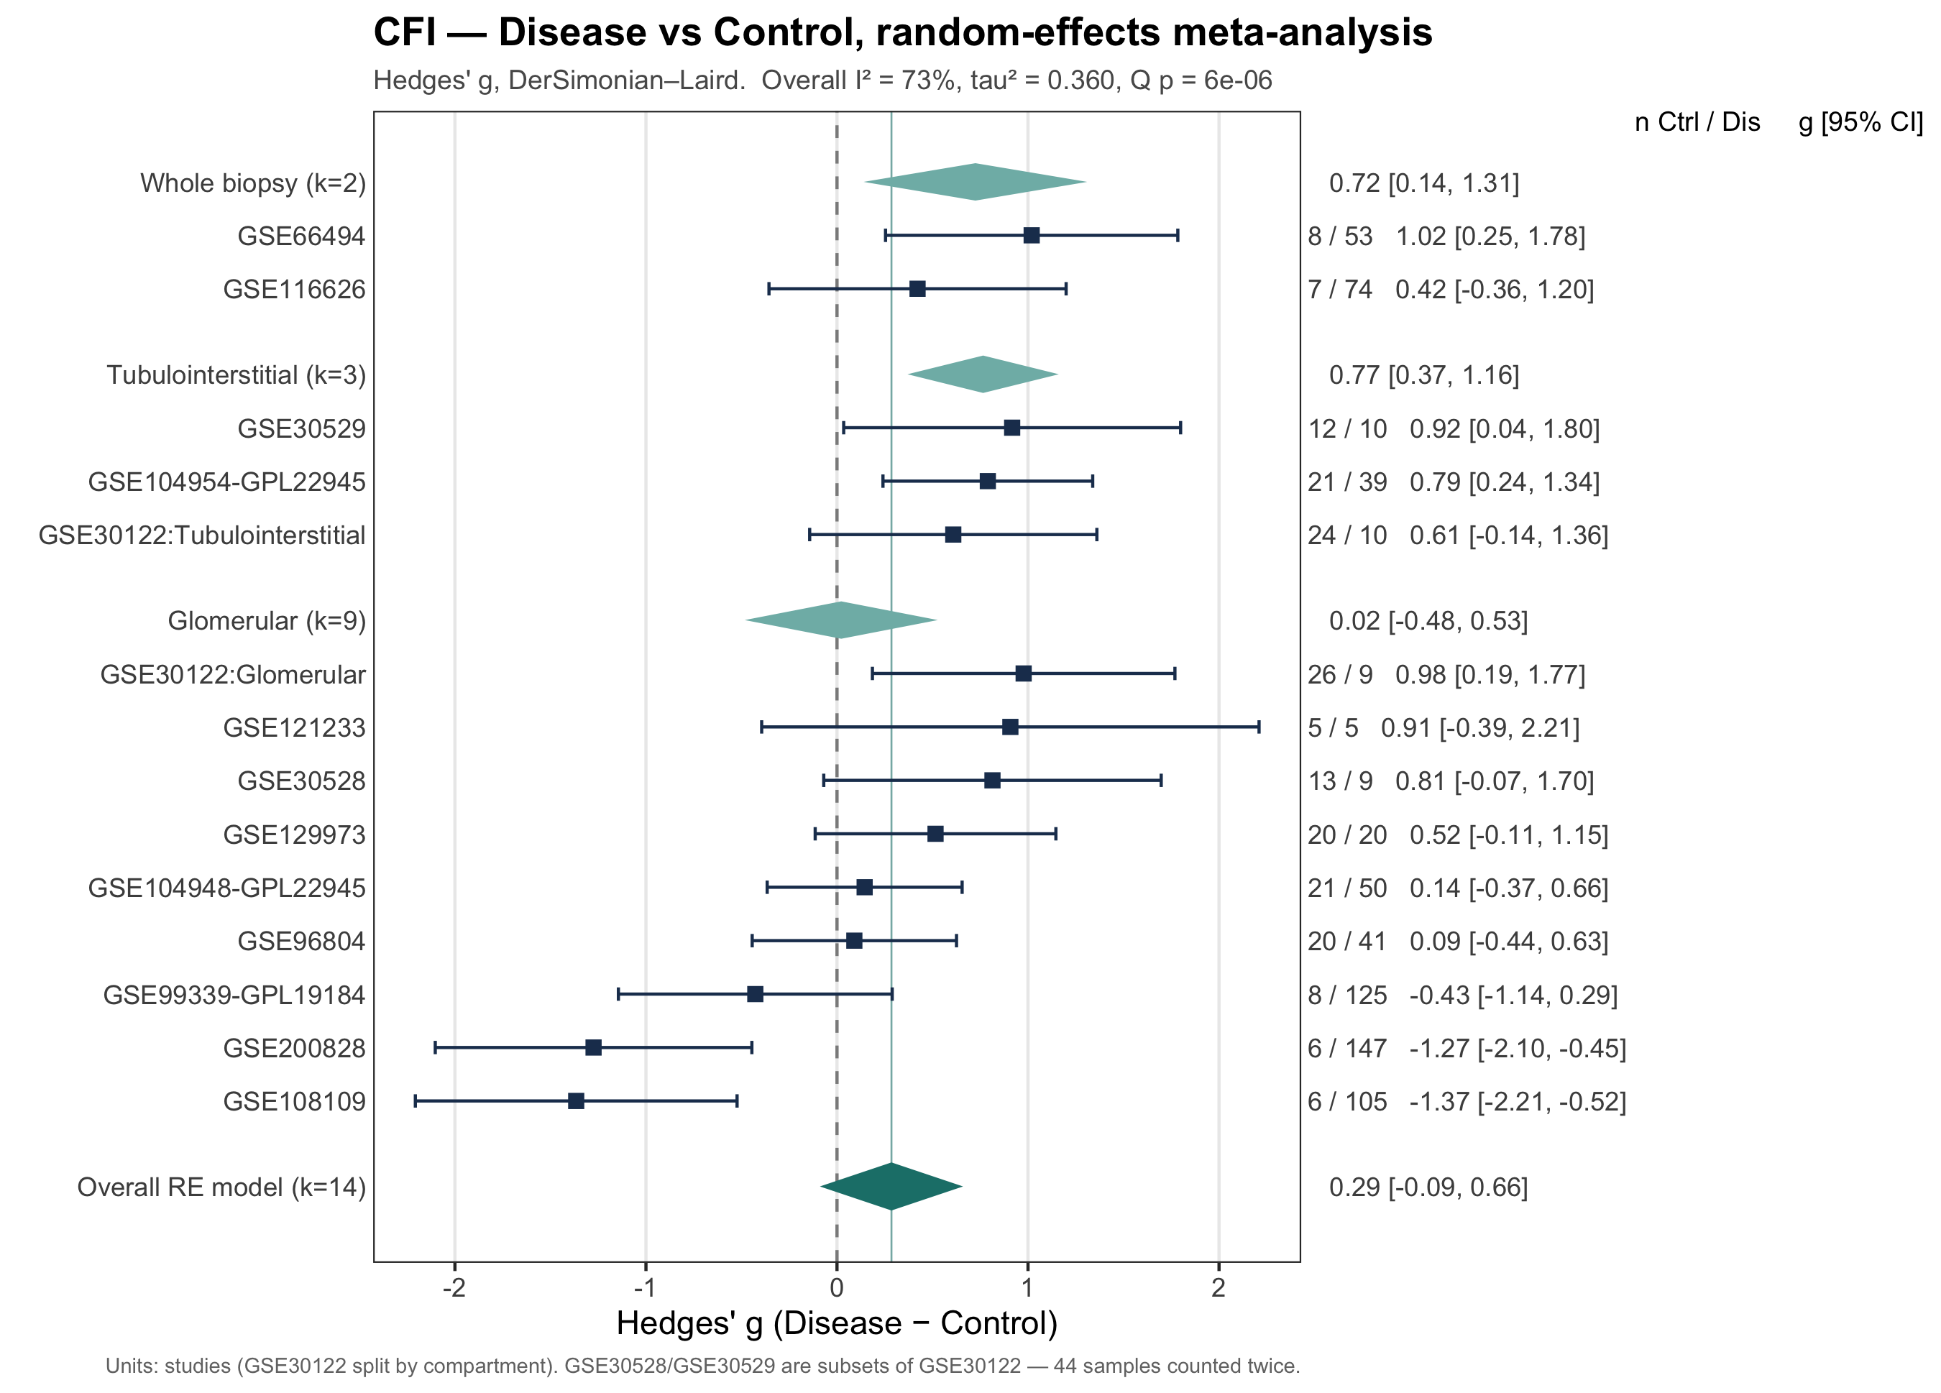
Figure 13. Forest plot for CFI: per-unit Hedges' g and pooled random-effects estimates by compartment.

5.2 Mega-analysis within platform tiers

Method
The sample-level data were pooled within each platform tier. For each tier × gene, a linear mixed model (nlme::lme) was fitted to the uncorrected log2 values. It has a fixed Disease effect per compartment, a random study intercept, a random disease slope (pdDiag), and a separate residual variance for each study (varIdent). Only the Affymetrix tier contains more than one study, so it is the only tier that is pooled. The Illumina and Agilent tiers each hold one study and are fitted with a fixed-effects linear model. A z-scored version was tried and discarded: z-scoring by each study's total SD reduces the between-study disease variance to zero.
Table 14. Platform tiers (mega_tiers.xlsx).
Tier | Batch units | Studies | Samples | Compartments
Affymetrix | 12 | 11 | 752 | Glomerular, Tubulointerstitial
Illumina | 1 | 1 | 81 | Whole biopsy
Agilent | 1 | 1 | 61 | Whole biopsy

Results
Table 15. Mega-analysis Disease vs Control estimates (mega_estimates.xlsx).
Tier | Gene | Compartment | k | n | log2FC | 95% CI | FDR | τ disease | Sensitivity: without GSE30528/30529
Affymetrix | C4BPB | Glomerular | 9 | 636 | 0.047 | [−0.05, 0.14] | 0.549 | 0.12 | 0.034 (FDR 0.719)
Affymetrix | C4BPB | Tubulointerstitial | 3 | 116 | −0.235 | [−0.39, −0.08] | 0.008 | 0.12 | −0.181 (FDR 0.153)
Affymetrix | COL13A1 | Glomerular | 9 | 636 | 0.094 | [−0.01, 0.20] | 0.412 | 0.13 | 0.102 (FDR 0.316)
Affymetrix | COL13A1 | Tubulointerstitial | 3 | 116 | 0.231 | [0.03, 0.44] | 0.045 | 0.13 | 0.168 (FDR 0.223)
Affymetrix | HABP2 | Glomerular | 9 | 636 | 0.178 | [−0.16, 0.52] | 0.549 | 0.44 | 0.070 (FDR 0.719)
Affymetrix | HABP2 | Tubulointerstitial | 3 | 116 | 0.625 | [0.01, 1.24] | 0.057 | 0.44 | 0.434 (FDR 0.225)
Affymetrix | CFH | Glomerular | 9 | 636 | 0.054 | [−0.43, 0.54] | 0.990 | 0.69 | 0.120 (FDR 0.719)
Affymetrix | CFH | Tubulointerstitial | 3 | 116 | 1.343 | [0.49, 2.19] | 0.008 | 0.69 | 1.221 (FDR 0.140)
Affymetrix | CFI | Glomerular | 9 | 636 | −0.002 | [−0.38, 0.37] | 0.990 | 0.50 | −0.074 (FDR 0.719)
Affymetrix | CFI | Tubulointerstitial | 3 | 116 | 0.609 | [−0.09, 1.30] | 0.086 | 0.50 | 0.451 (FDR 0.281)
Illumina | C4BPB | Whole biopsy | 1 | 81 | −0.015 | [−0.45, 0.42] | 0.946 | – | unchanged
Illumina | COL13A1 | Whole biopsy | 1 | 81 | 0.331 | [−0.07, 0.74] | 0.475 | – | unchanged
Illumina | HABP2 | Whole biopsy | 1 | 81 | 0.466 | [−0.25, 1.18] | 0.475 | – | unchanged
Illumina | CFH | Whole biopsy | 1 | 81 | 0.147 | [−0.24, 0.53] | 0.559 | – | unchanged
Illumina | CFI | Whole biopsy | 1 | 81 | 0.199 | [−0.17, 0.57] | 0.475 | – | unchanged
Agilent | C4BPB | Whole biopsy | 1 | 61 | 0.041 | [−0.12, 0.20] | 0.604 | – | unchanged
Agilent | COL13A1 | Whole biopsy | 1 | 61 | 0.264 | [−0.08, 0.61] | 0.163 | – | unchanged
Agilent | HABP2 | Whole biopsy | 1 | 61 | 0.826 | [0.16, 1.49] | 0.040 | – | unchanged
Agilent | CFH | Whole biopsy | 1 | 61 | 0.569 | [−0.10, 1.24] | 0.157 | – | unchanged
Agilent | CFI | Whole biopsy | 1 | 61 | 1.016 | [0.27, 1.76] | 0.040 | – | unchanged
τ disease = SD of the random disease slope across studies. Highlighted cells have FDR < 0.05 in the primary analysis. The sensitivity analysis drops the duplicated GSE30528/GSE30529 profiles, which affects only the Affymetrix tier.
In the Affymetrix tier the tubulointerstitial results match the meta-analysis: CFH +1.34 (FDR 0.008), C4BPB −0.24 (FDR 0.008) and COL13A1 +0.23 (FDR 0.045). HABP2 and CFI point the same way but do not reach significance. No glomerular effect is significant. In the single-study Agilent tier (GSE66494, CKD whole biopsy), HABP2 and CFI are up-regulated.
Duplicate sensitivity. Without GSE30528/GSE30529, the tubulointerstitial stratum keeps only 2 units (ERCB and GSE30122). CFH stays up-regulated with a similar effect size (+1.22, p = 0.028) but is no longer significant after FDR correction (0.140). The tubulointerstitial signal is consistent but rests on only two independent patient series. Its significance is partly inflated by counting the duplicated samples twice.

Agreement with the meta-analysis
Across the 10 gene × compartment cells estimated by both methods (Affymetrix tier vs the all-tier meta-analysis, log2FC scale), the estimates correlate at r = 0.997. All 10 have the same sign, and the largest absolute difference is 0.064 log2 units. Summary-level and sample-level pooling therefore give the same answer.
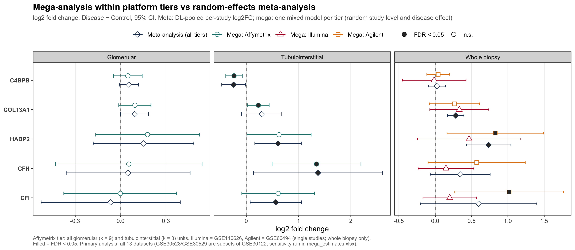
Figure 14. Mega-analysis (by platform tier) vs random-effects meta-analysis: log2FC with 95% CI per gene and compartment.

6. Cross-method synthesis
The three estimation approaches use different assumptions: Stage 4 is a single fixed-effects WLS model, the meta-analysis pools summary statistics with random effects, and the mega-analysis is a mixed model on individual samples. Stage 4 and the meta-analysis agree at r = 0.993 per study unit (slope 1.04, 96% same sign) and r = 0.960 for the pooled compartment estimates.
Table 16. Disease vs Control effect across the three methods.
Gene | Compartment | Stage 4 log2FC (FDR) | Meta g (FDR) | Meta log2FC | Mega log2FC (FDR) | Methods FDR < 0.05
C4BPB | Glomerular | 0.05 (0.013) | 0.27 (0.522) | 0.05 | 0.05 (0.549) | 1/3
 | Tubulointerstitial | −0.18 (6.6×10⁻⁶) | −1.30 (0.055) | −0.24 | −0.24 (0.008) | 2/3
 | Whole biopsy | 0.04 (0.593) | 0.09 (0.746) | 0.02 | n/a (no pooled tier) | 0/2
COL13A1 | Glomerular | 0.10 (7.1×10⁻⁷) | 0.50 (0.156) | 0.09 | 0.09 (0.412) | 1/3
 | Tubulointerstitial | 0.08 (0.084) | 0.73 (0.048) | 0.29 | 0.23 (0.045) | 2/3
 | Whole biopsy | 0.29 (0.036) | 0.60 (0.048) | 0.28 | n/a (no pooled tier) | 2/2
HABP2 | Glomerular | 0.12 (0.152) | 0.20 (0.647) | 0.15 | 0.18 (0.549) | 0/3
 | Tubulointerstitial | 0.48 (0.003) | 0.62 (0.017) | 0.61 | 0.63 (0.057) | 2/3
 | Whole biopsy | 0.66 (0.017) | 0.72 (0.038) | 0.73 | n/a (no pooled tier) | 2/2
CFH | Glomerular | 0.20 (0.035) | 0.05 (0.931) | 0.05 | 0.05 (0.990) | 1/3
 | Tubulointerstitial | 0.93 (1.4×10⁻⁷) | 1.51 (0.023) | 1.37 | 1.34 (0.008) | 3/3
 | Whole biopsy | 0.31 (0.084) | 0.47 (0.107) | 0.34 | n/a (no pooled tier) | 0/2
CFI | Glomerular | 0.08 (0.379) | 0.02 (0.931) | −0.07 | −0.00 (0.990) | 0/3
 | Tubulointerstitial | 0.34 (0.002) | 0.77 (7.7×10⁻⁴) | 0.56 | 0.61 (0.086) | 2/3
 | Whole biopsy | 0.40 (0.034) | 0.72 (0.038) | 0.60 | n/a (no pooled tier) | 2/2
Mega = Affymetrix tier. Whole biopsy has no pooled mega-analysis tier because each platform holds one study (see Table 15 for the single-study fits).
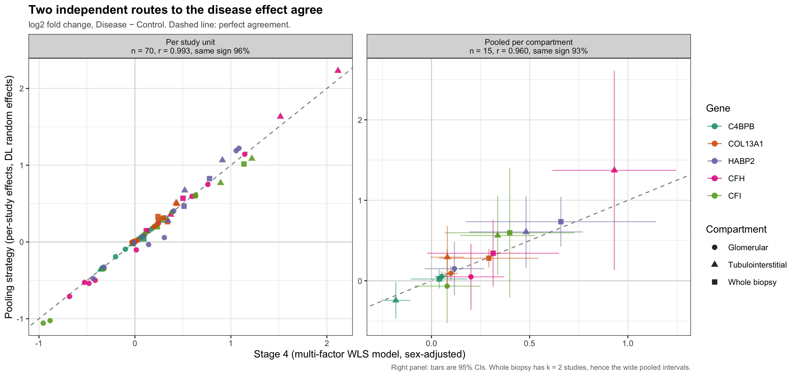
Figure 15. Agreement between Stage 4 and the meta-analysis, per study unit and pooled per compartment.

6.1 Per-gene conclusions
- COL13A1 — the most robust marker. Its effect is positive in every compartment, it is the only gene significant across all units, compartment does not modify it, and it is stable under leave-one-out deletion. The fold change is modest (+0.1 log2 in glomeruli, about +0.3 in tubulointerstitium and whole biopsy).
- CFH — the largest effect, specific to the tubulointerstitium (about +1.3 log2, g ≈ 1.5) and driven by DKD (g = 1.74). It is near zero in glomeruli and the moderator test is significant. The effect is very heterogeneous and rests on two independent series.
- CFI — up-regulated in tubulointerstitium (homogeneous, I² = 0%) and whole biopsy, but its direction depends on indication in glomeruli: significantly down in membranous nephropathy (and in the same direction in MCD and other GN), up in DKD. Its glomerular pooled effect is therefore null.
- HABP2 — up-regulated in tubulointerstitium and whole biopsy. It has a strong sex effect (lower in males) that must be adjusted for.
- C4BPB — down-regulated in tubulointerstitium and possibly slightly up in glomeruli. The direction differs by compartment (significant moderator test), and C4BPB is down-regulated in lupus nephritis and hypertensive nephropathy glomeruli.

7. Limitations and deviations from the plan

7.1 Limitations
- Submitter-processed input. Stage 1 was retired, so the values come from five different processing pipelines rather than one uniform RMA re-quantification. Platform-specific processing is part of the between-study heterogeneity.
- Loss of absolute scale. GSE30122 (and its subsets GSE30528/GSE30529) and GSE116626 were deposited per-gene centred. Their absolute expression cannot be recovered, and every figure that shares an axis with them shows relative values.
- Duplicated samples. 44 profiles (GSE30528, GSE30529) are counted twice by instruction, so these patients carry double weight. The mega-analysis sensitivity analysis shows the effect on the tubulointerstitial stratum, which has only 2 independent series.
- Small strata. Tubulointerstitium has k = 3 units (2 independent) and whole biopsy has k = 2 (on two platforms). DerSimonian–Laird τ² is imprecise at such small k, so these estimates are hypothesis-generating.
- No clinical covariates. No dataset contains eGFR, %TIF, proteinuria or age in GEO. Stage 4 adjusts only for sex. The ElasticNet regression (plan §6, Task 2) and the eGFR/%TIF scatter plots (plan §7, Plot 5) have no outcome variable.
- Heterogeneous controls. Controls are living donors, tumour-nephrectomy tissue, or (GSE66494) reference RNA replicates. The glomerular control-type test found no effect, but it has low power (3 vs 4 studies).
- Batch correction removes between-compartment levels, so corrected values can be compared only within a compartment.

7.2 Deviations from the analysis plan
Table 17. Deviations from the CKD Biomarker Pooled Analysis Plan v2.0.
Plan item | As executed | Reason
“32 datasets” | 16 listed, 13 analysed | 32 is the search total. The 3 RNA-Seq series have no expression data in GEO.
Stage 1: RMA / GRCh38 re-quantification | Retired; submitter-processed values used | Project decision, 2026-10-07
Stage 3: ComBat-seq for RNA-Seq | Not applicable | No RNA-Seq counts in the analysed set
Stage 3: ~ StudyID + Condition | removeBatchEffect with 14 study × compartment units and Disease per compartment | Compartment is nested in study; the design must be full rank
Stage 4: clinical covariates | Sex only (reported or inferred) | eGFR, %TIF, proteinuria and age are absent from GEO
§5: Microarray and RNA-Seq tiers | Affymetrix, Illumina and Agilent tiers | Microarray-only data set
§6 LODO ML; §7 Plots 3 and 5 | Not yet implemented | Next phase; the regression task has no target variable

8. Next steps
- Implement plan §6 Task 1: LODO (LeaveOneGroupOut, grouped by study) logistic regression, random forest and SVM classification of Disease vs Control on the five genes, and plan §7 Plot 3 (ROC-AUC of single genes vs the panel).
- Decide how to handle plan §6 Task 2 (eGFR / %TIF regression). This needs clinical data from Nephroseq for ERCB and GSE66494, or it should be dropped.
- Consider tubulointerstitial-specific panels (CFH, CFI, HABP2, C4BPB) separately from a COL13A1-anchored panel that works across compartments.
- Optionally reopen Stage 1 (raw CEL re-quantification) to remove the provenance limitation. This needs explicit approval.

Appendix A. Reproducibility and output inventory
All stages are self-contained Rscripts that take no arguments and run in sequence. Each one writes its tables (.xlsx), figures (.png) and an R sessionInfo() record to its own Results/ subfolder. The random seed is set.seed(1).
Table 18. Pipeline scripts and outputs.
Stage | Script | Output folder | Key outputs
2–3 Mapping, batch correction | stage23_panel_boxplots.R | Results/Stage23 | cohort_qc, panel_uncorrected_long, panel_harmonised_long, pca_batch_r2, residual_sd_ratio, sample_indication; PCA/UMAP and boxplot figures
4 Multi-factor model | stage4_MF_stat_mod.R | Results/Stage4 | stage4_multifactor_results, stage4_per_study_effects, sex_by_cohort, sex_by_sample; stage4_disease_effects.png
5 Meta-analysis | pooling_strategy.R | Results/PoolingStrategy | pooling_estimates, pooling_study_effects, pooling_compartment_moderator, pooling_leave1out, pooling_by_indication, pooling_control_type_*; forest and heatmap figures
5 Mega-analysis | mega_analysis.R | Results/MegaAnalysis | mega_estimates, mega_tiers, mega_vs_meta, mega_vs_meta_agreement; mega_vs_meta.png
Summary | summary_figures.R | Results/Summary | prisma_counts, method_agreement(_stats); prisma_flow.png, method_agreement.png

Software: R 4.5.2 (aarch64-apple-darwin20); limma 3.66.0; WGCNA 1.74; metafor 5.2-1; nlme 3.1-169; uwot 0.2.5; ggplot2 4.0.3; data.table 1.18.2.1; readxl 1.5.0.1; writexl 2.0.1; annotation packages hgu133a2.db, hta20transcriptcluster.db, illuminaHumanv4.db, hgug4112a.db.

A.1 QC figure: per-cohort alignment after correction
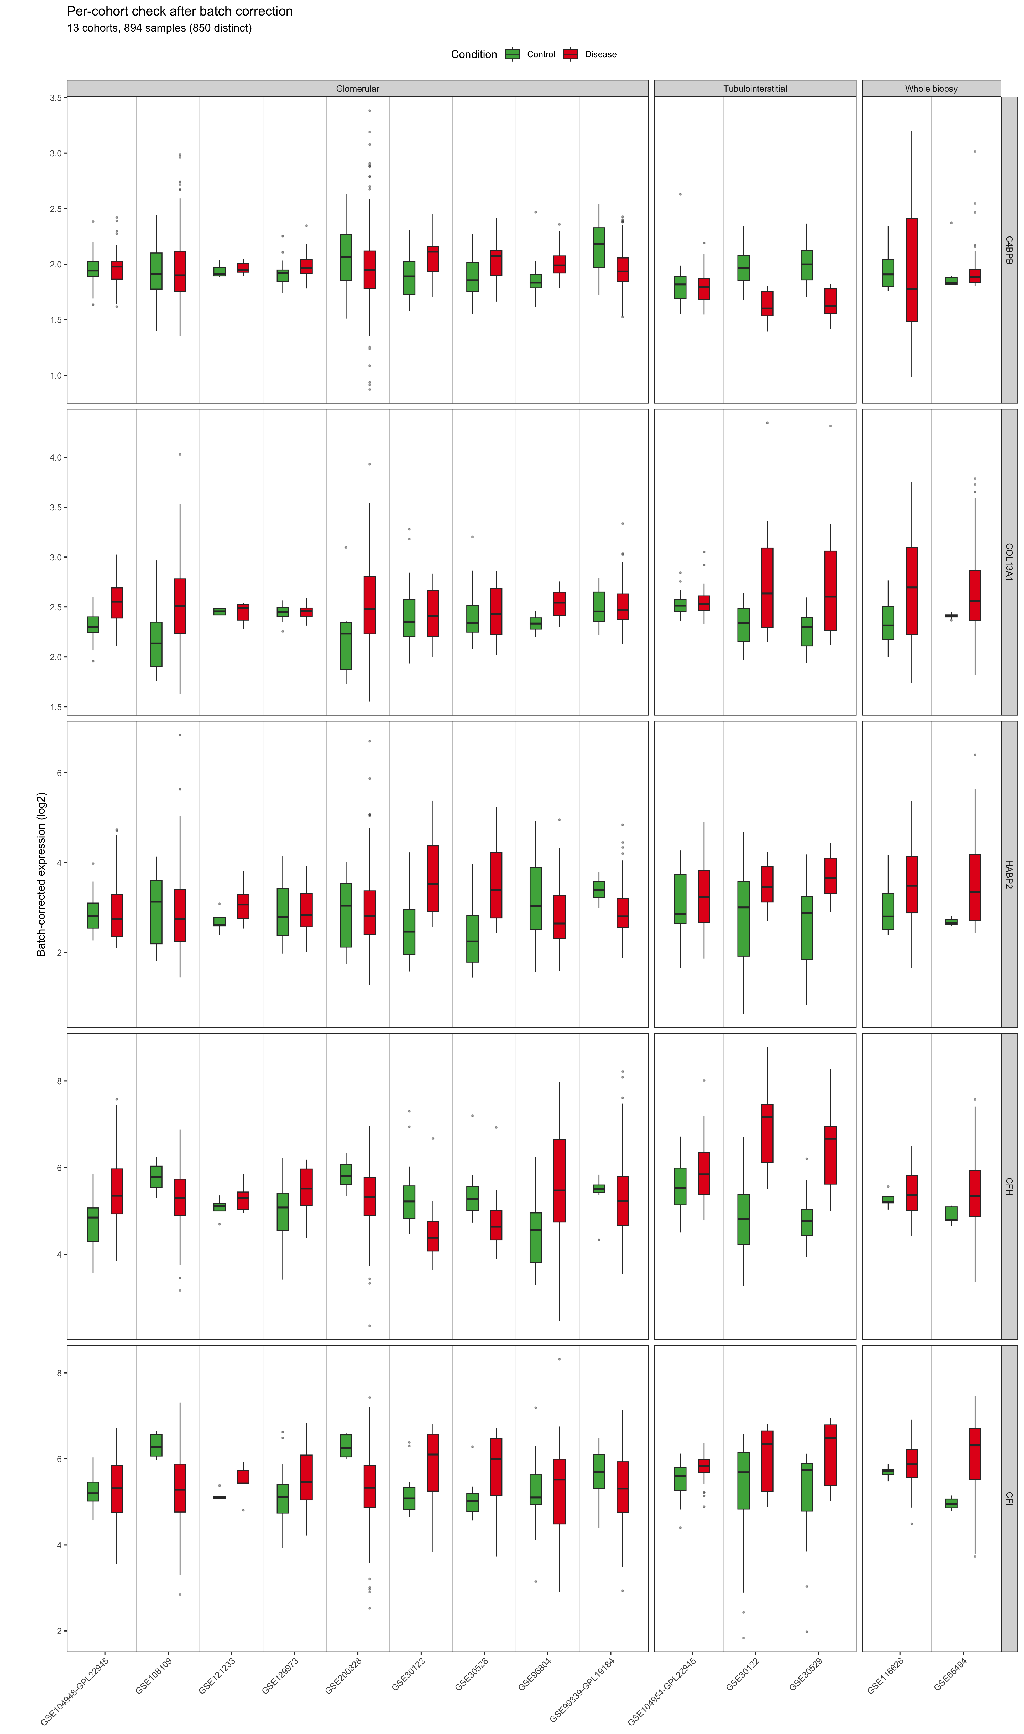
Figure 16. Batch-corrected expression per cohort and gene (QC: the cohorts should sit at a common level for each gene).

