██████╗░██╗░░░██╗███╗░░██╗░█████╗░████████╗░█████╗░██╗░░░██╗██████╗░██╗░░░██╗░██████╗

██╔══██╗╚██╗░██╔╝████╗░██║██╔══██╗╚══██╔══╝██╔══██╗██║░░░██║██╔══██╗██║░░░██║██╔════╝

██████╔╝░╚████╔╝░██╔██╗██║██║░░██║░░░██║░░░███████║██║░░░██║██████╔╝██║░░░██║╚█████╗░

██╔═══╝░░░╚██╔╝░░██║╚████║██║░░██║░░░██║░░░██╔══██║██║░░░██║██╔══██╗██║░░░██║░╚═══██╗

██║░░░░░░░░██║░░░██║░╚███║╚█████╔╝░░░██║░░░██║░░██║╚██████╔╝██║░░██║╚██████╔╝██████╔╝

╚═╝░░░░░░░░╚═╝░░░╚═╝░░╚══╝░╚════╝░░░░╚═╝░░░╚═╝░░╚═╝░╚═════╝░╚═╝░░╚═╝░╚═════╝░╚═════╝░

**..................................................**

**..................................................**

**...................(///////////*..................**

**.. #(*#............*///////////#............#*((..**

**...../(%%#(/////#/*///////////////&/////(#%%(*....**

**.........%%&&&&&&@@/////////////@@&&&&&&%#........**

**.................@@ %#&@@@@@@@& @@................**

**...................@@@@@@@@@@@@@..................**

**.........(/@@@@@@@@%@@@@@@@@@@@@@@@@@@@@@@........**

**.....#@,.((& %#@@@@#@@@#@@@%@@@@@@@@&&,.&&/#@ ....**

**.....#@#@@@@%@%@@@&&@@@@@@@@@&@@@@@@@@/@@@@@@ ....**

**.....,((&@&&%@&@@@@@@@%@@@@#@@@@@@@@@&&@@&((,.....**

**.......&&&%@@@%@@@@@@@@@@@@@@@@@@@@@@@@@@@&&......**

**..........****/..*/&&@&@&@@@@@&@/*,,*****/........**

**....................%@@@@&&@@@@&..................**

**....................# ,&@@@@@@/ ..................**

**...................% *@&@@@@@#. %.................**

**...................* .(@@@@@&@%, .................**

**..................% ,#@@@@@@@%* #.................**

**.................., ./&@@@@@@@&(. #...............**

**----- TEAM 1H2-2 -----**

**NICHOLAS WILSON KURNIAWAN**

**CHENG SUM**

**LI WAN YAU**

**QIAO LECHONG**

**Table of Contents**

**Introduction** **3**

**Basic Game Rules** **4**

Number of players 4

What will each player get before starting the game? 4

What's the objective of the game? 4

How long does it take to finish a game? 4

**Game Map** **5**

Players 6

Walls 6

Winning Position 6

Minotaur 6

**Gameplay** **7**

Moving Pieces 7

Rolling Dice 7

Bot Players 7

**Gamemodes** **8**

Classic Mode 8

Custom Gamemode 8

1. Maps 8

2. Dice 8

3. Minotaur Steps 8

Game Speed 9

Number of Players 9

Player Name 9

**Development Process** **10**

**Summary** **11**

# 

# 

# **Introduction**

The mighty Minotaur, a mythical creature, protects a secret temple hidden deep inside a 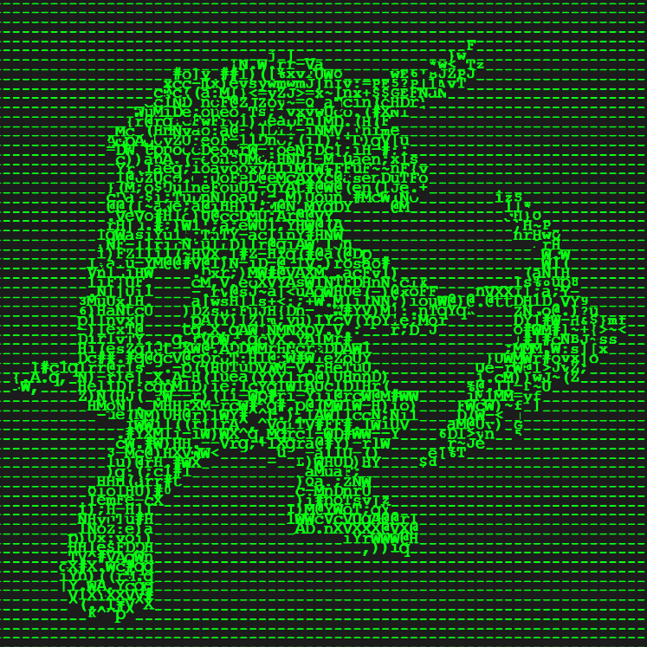labyrinth. Be the first to lead your troops to the temple, avoiding the Minotaur and cleverly placing walls to block your opponents.

Pynotaurus is a python-terminal board game created by team “1H2-2”. It can be played in single-player or local multiplayer mode with up to 4 players in total.

The game's development is heavily inspired by a lego board game, the Lego Minotaurus.

# **Basic Game Rules**

## 

## **Number of players**

The game is played by 2-4 players. It also supports single-player against the bots.

## 

## **What will each player get before starting the game?**

Each player will be given 3 troops with the same color, which are blue, red, yellow, and white respectively.

## 

## **What's the objective of the game?**

Players need to move all of their troops to the middle of the map at the '⁘' position. When a player's troop is directly standing above the '⁘' location, the troop will then disappear. As mentioned, once all of one's troops are gone, the player wins.

## 

## How long does it take to finish a game?

The duration of the game may take 10-30 minutes depending on the total number of players and the chosen game speed before the game starts.

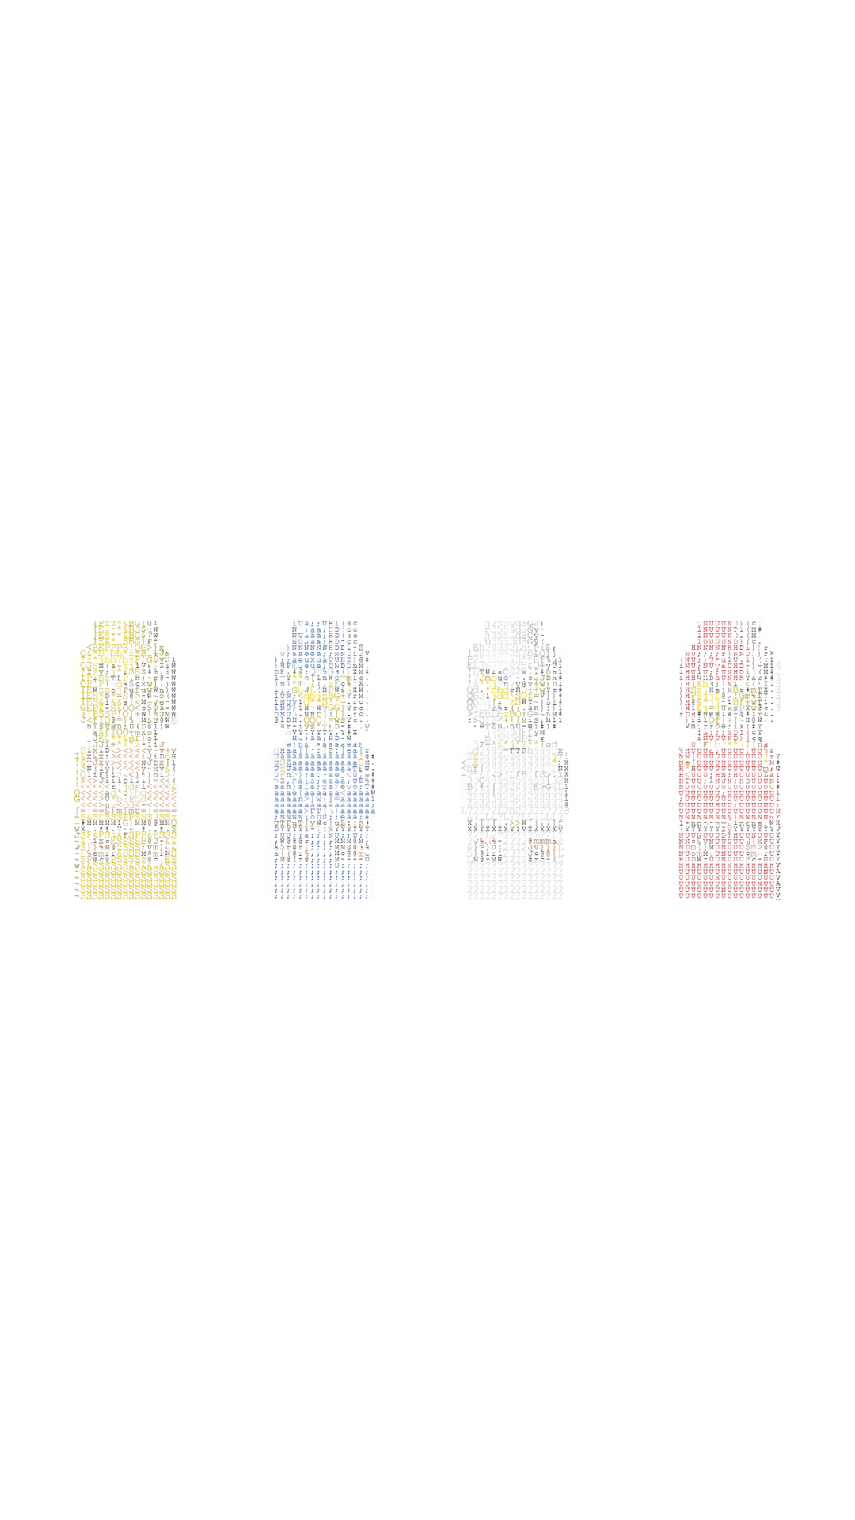

# **Game Map**

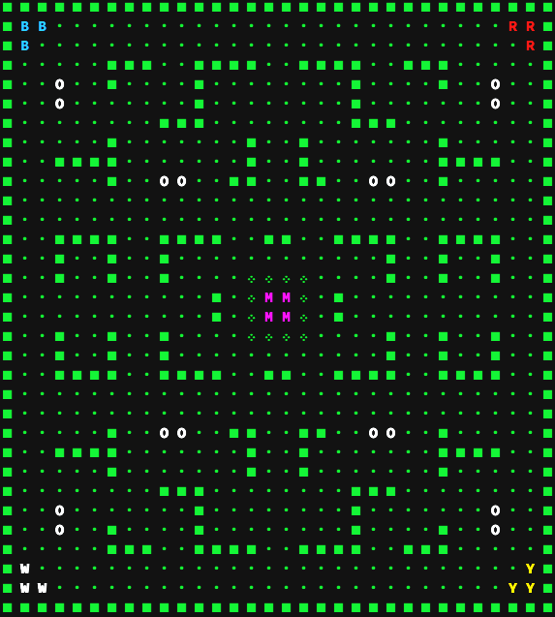

**Classic Map**

## Players

In respective order of turns:

* B = Player 1 (Blue)
* R = Player 2 (Red)
* Y = Player 3 (Yellow)
* W = Player 4 (White)

## 

## Walls

There are 2 types of walls:

* **▢** = Immovable wall, cannot be removed.
* O = Moveable wall, also known as a gray wall, can be removed.

## 

## Winning Position

The [ ⁘ ], which is the winning position, is located in the middle of the map.

## 

## Minotaur

* The Minotaur is located in the middle surrounded by [ ⁘ ].
* When a player gets a “Minotaur” after rolling a dice,

the player can move the Minotaur up to 8 spaces.

* The Minotaur starts moving on empty space [ **•** ] adjacent to the winning position [ ⁘ ]

**OR** from its current location if it did not start from the middle of the map.

* If the Minotaur runs into a troop, the troop will return to its base (at the corner), and the Minotaur returns to the center of the board,

surrounded by [ ⁘ ].

* *Only the base of each player and the winning position is safe from the Minotaur.*

# **Gameplay**

## 

## Moving Pieces

* Players can only move horizontally or vertically.
* Players cannot move diagonally.
* Players cannot trespass any walls or other characters.

## 

## Rolling Dice

* At the start of a player's turn, the player has to roll a dice.
* When the player rolls a number, the player can choose one of their troops and start moving in a classic WASD movement (W = upwards, A = left, S = downwards, D = right). The player can then choose the direction of the movement and move, or pass the turn as they wished. After a player's turns are used up or the player chooses to pass, the next player might proceed to such action, until one of the players wins.
* When the player rolls "Wall", the player can choose to place 1 set of gray walls to possibly block players' troops' movement, or remove 1 set of them for their good. 1 set of gray walls is equal to 2 blocks of gray walls.
* When the player rolls "Minotaur", they may command the minotaur and make it move to the directions and place they desire, whether the player wants the minotaur to attack other players, or to keep a distance from that said player simply.

## 

## Bot Players

* Players can choose (up to 3) bot players to play with them.
* When the bot rolls a number, the bot will move one of its troops to the center of the map with the shortest path. If there are no possible moves, the bot will pass its turn.
* When the bot rolls a “Wall”, the bot will attempt to block any characters closer to the map's center. Or, the bot will try to remove 1 set of gray walls if all of its troops’ paths are being blocked.
* When the bot rolls a “Minotaur”, it will move the Minotaur to the closest troops, excluding its troops.

# **Gamemodes**

Before playing the game, the users will choose between 2 different gamemodes.

## **Classic Mode**

Players will play on a classic map with default dice and steps.

## **Custom Gamemode**

When the player selects Custom mode, players can change the map and adjust the rules of the game, such as the number of dice, including the number of steps for all characters.

### **Maps**

The game consists of 4 maps in total: 1 classic map and 3 custom maps (the custom maps are shown below).

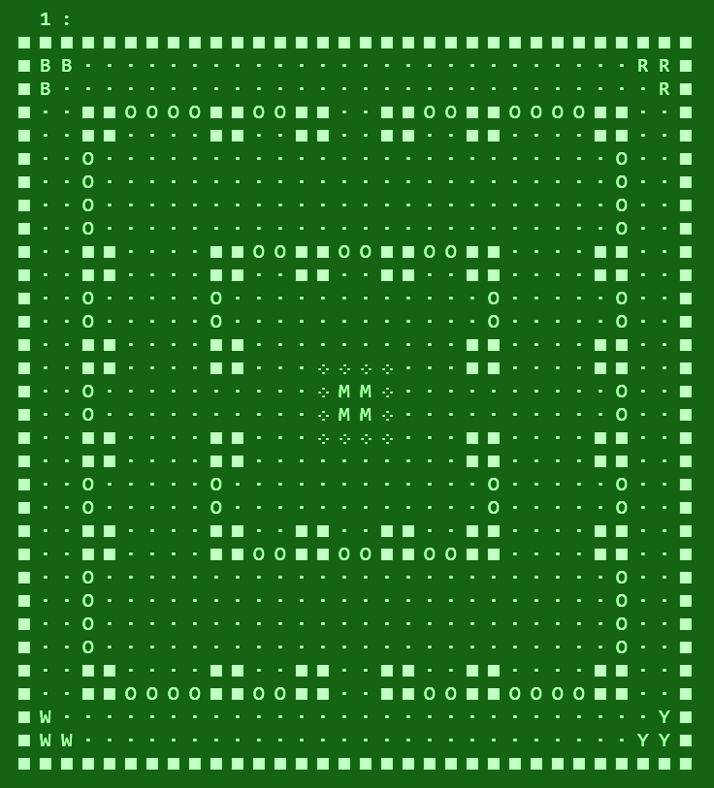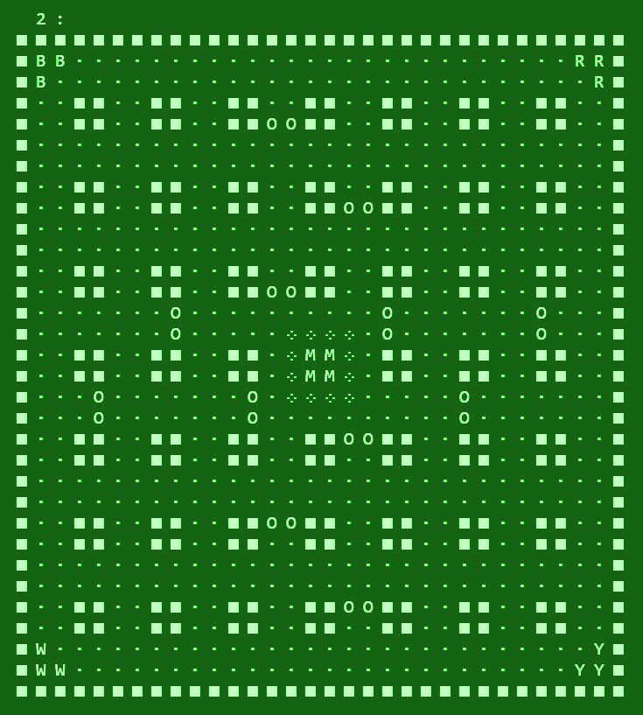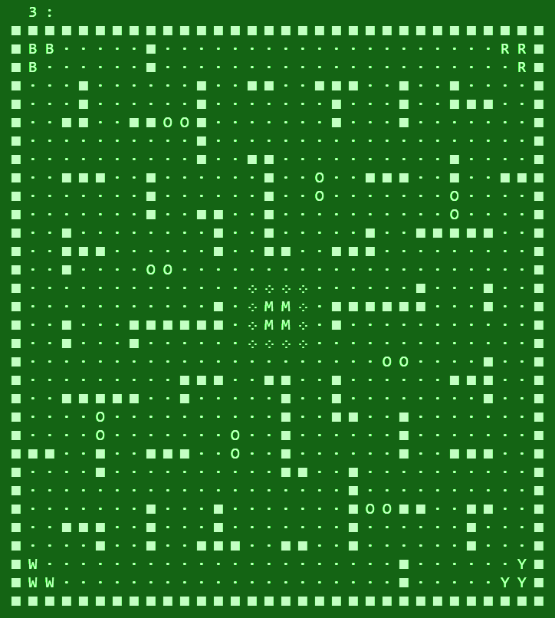

### **Dice**

A dice for the game has 6 different sides and will give a random output each time a player rolls the dice. The default is [3, 4, 5, 6, ‘Wall’, ‘Minotaur’]. The sides of the dice can be freely customized into any valid numbers from 0 to infinite, walls, or Minotaur.

### Minotaur Steps

While the default of the movement is 8, the Minotaur’s number of steps can be changed from 1 to infinite.

## Game Speed

* SLOW, each player starts with 3 troops.
* MEDIUM, each player starts with 2 troops.
* FAST, each player starts with 1 troop.

## 

## Number of Players

The game requires at least 2 players and at most 4 players. If there’s only one available player, the player can try to compete against the bots.

## 

## Player Name

Before the game starts, each player is allowed to input their name for the game, excluding the bot player.

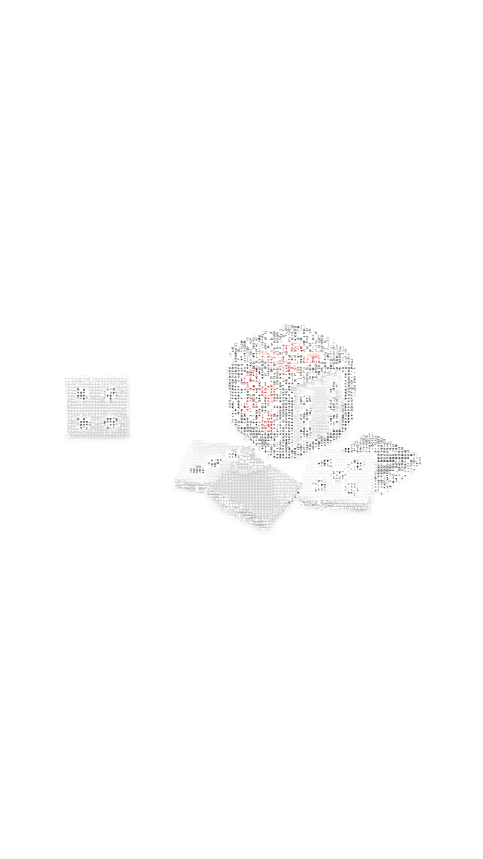

# **Development Process**

The development of the game took 3 weeks in total with more than 2500 lines of code (including in-game comments and empty lines to make it easier to read). We used built-in modules, such as random, time, os, datetime, and colorama, to make the game fun.

During the first week, we tried to brainstorm some uncommon ideas. We came up with an old board game and tended to remaster the game. After deciding on the game to be developed, we then started by doing some research on the old board game and listing some additional features to be implemented in the game. Next, we started by working on the classic map first. After that, we created the movement system for each player’s troops and the Minotaur, continued by the gray wall placing/removal mechanics and the winning system. After we finished the main script of the game, we started working on the screens and text coloring.

In the second week, we tend to create something more on the game to make it fun and engaging. So, we decided to create a custom gamemode with changeable settings. Moreover, since the minimum number of players to play the game is 2, we pondered if it can be made playable for one person. As a result, we decided to work on the bot players. We spent some time working on both pathfinding and gray wall placing/removal for bots, which are the most challenging part of the development.

During the third week and after we managed to create the bot system with an acceptable percentage of pathfinding accuracy, we started working on some additional features that are important for a game, such as the home screen before playing the game, including some pages for instructions, credits, map list, and game logs. After that, we focus more on the small details to perfect the game. Lastly, we did the testing and debugging stage to ensure there aren’t any potential bugs in the game.

# 

# **Summary**

We hope that this document can provide a clear and detailed explanation of the perfect game. Hopefully, the game that we have developed for three weeks can attract various players to play this game.

1H2-2

