****** Categorize your issues!!*******

- accessibility

- instructor creation, modification

- backup, 1 document for all

- pedagogical

- feedback (instuctor -> student)

- flexibility for student

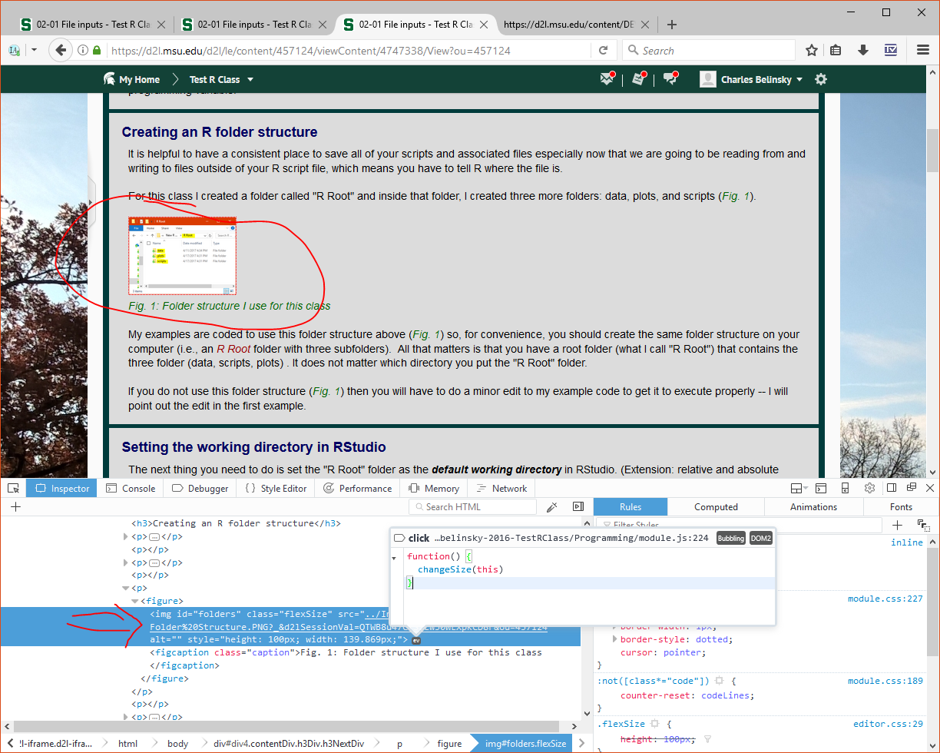

- D2L Editing vs Robust Editing

Jill-Brianna

Check from OSU

payment for 2 Canadians

/* Issues:

- you can make a relative link to the file for a class but not the content. The difference is

that, when you link the file, the file will load in the iframe but the rest of the page

will still reflect the original content. So, hyperlinks to the content will break if taken

out of context.

- hideEmptyTables needs to check both the primary and secondary pages for content -- right

now it is just checking primary (I think - not tested)

- change [pre] in code only if it does not have its own class already

- instructors still have to put in hash tag hyperlinks in HTML

-- set an ID and do in JS (or did I do title??)

- change absolute links in D2L back to relative links

- D2L autogenerates figcaptions

- test script and css in header: does the link change in file or just when loaded by D2L?

- D2L <span> does allow for classes inside

- black <address> lines do not show in the editor

- get rid of JQuery in this script

- sk to save changes in D2L Editor

- set width of table to content

- float tables and code in print

- insert lessons

Change styles for:

1) an inline section <span>

2) a single block item <p>

3) several block items <p>...<p>

4) a whole section

Why <br> should not be used (including <pre>)

- check if in D2L before doing previous and next links

Change figcaption to a <p> with class "caption" -- could have JS change into a <figcaption>

*/

/* Class issues:

- use ; at end of every lines

- surround script with { } -- develop code blocks concept

if()

{

} else

{

}

- add style for partial code

- add prog/alg/experimental (data?)/stat variable

- remove unused pics

- rename pic appropriately

- variable types: programming, algebra, experimental (data), statistical (type?)

- avoid "run" use "source" or "execute"

- R defulat to string on input

- R defaults to factor on string vector

Accessibility issues:

- Headers to create Div structure

- Images and Caption caonvert to figure/figcaption

- print CSS

1.1: link to CSS should download

1.1: blank <p class="linkTo"> needs to be deleted in JS

1.X: switch to temperature examples

1.9: you am (mult times)

1.9: Fig 6 ??

1.9: N vs north or S vs South

2.1: Figure 5 missing

2.1,2,3,4: separate csv files

2.2: 2D vs 1D data

2.2: row (2D Data Frame with 1 value) vs column (vector)

1.4: KE = 1/2(mv)2 FIX to (1/2)mv2

1.5: "10" is not 10

add 1.10: ((this || this) && (this || this))

debug unit 1.10

highlight color in code 🡪 convert to highlight in pdf

2.4: numNA: count value

2.4: do outliers (numOfOutliers)

2.5: do NA

|  |  |  |  |  |
| --- | --- | --- | --- | --- |
|  | type | On enter | On Copy/paste within |  |
| H1 – H6 | block | P (clean) | Breaks old |  |
| Address | block | P? (clean) | Nests |  |
| P | block | P (same style) | ?? |  |
| Pre | block | <br> (same style?) | ?? |  |

|  |  |  |  |
| --- | --- | --- | --- |
|  | Point selection  (block/ inline) | Whole Selection (block/ inline) | Mult-Item Selection  (block/ inline) |
| P |  |  |  |
| Addr |  |  |  |
| H1-H6 |  |  |  |
| Pre |  |  |  |
| Inline Item |  |  |  |

Which items

Issues:

Cannot create customized block elements

Cannot customize inline elements

Cannot create hyperlink within page

No auto backup

Cannot set style for editing page

Can get trapped in a <pre> (essentially, using <br> is impossible)

Some object unexpectedly nest (<address>)

Copy/Paste copies some style (which ones??)

D2L Stripping JavaScript Events

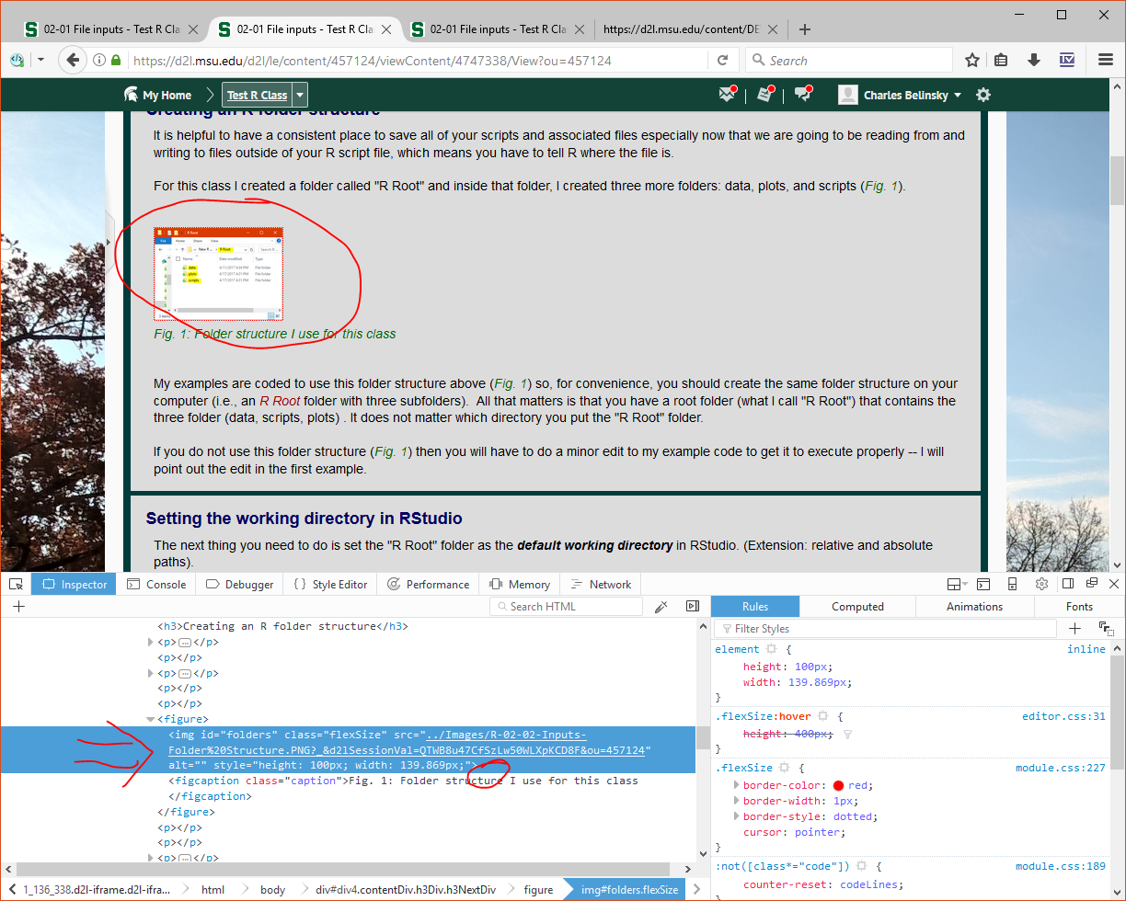

The following code can be created in the D2L editor but the linkTo class is hidden from the user.

<p class="linkTo"><span style="color: #000000;">Note to Mac Users: The <span style="color: #990000;">Editor Font</span> in your Appearance Window is probably "Monaco".&nbsp; Monaco is a Mac-specific font and is perfectly fine as a default font.</span></p>

Added font filter for print/pdf

Bug in D2L

<div aria-hidden="true" style="position: fixed; top: 0px; width: 100px; height: 100px; overflow: hidden; opacity: 0; left: -100000px;" class="ephox-sloth-bin ephox-sloth-bin_14039113411495040818568" contenteditable="true">

<p>Now there will be two Data Frames:</p>

<p>1) newWeatherData that contains the new ordering of the columns</p>

2) weatherData that contains the original ordering of the columns</div>