The following instruction are designed to set up your computer set up properly for the GGPlot Animation Workshop on February 4, 2021. If you have any issues, please contact Charlie Belinsky at [belinsky@msu.edu](mailto:belinsky@msu.edu) at least a few days ***before the workshop***. We do not have the time to troubleshoot installation at the workshop.

These instructions have been tested on Windows 10 and Mac Catalina (10.15.X). They have not been tested on Mac Big Sur (11.1.X).

There are four files in the folder:

1. ***Instructions.docx***: this document
2. ***PreWorkshop-Example.R***: script file that creates the animation
3. ***LansingNOAA2016-3.csv***: data frame used in the script file
4. ***PreWorkshop.Rproj***: an RStudio Projects link

**Instructions**

1. Install R version 4.0.X (if needed):

* Windows: <https://cran.r-project.org/bin/windows/base/>
* Mac: <https://cran.r-project.org/bin/macosx/>

1. Install RStudio version 1.3.X (if needed):

* <https://rstudio.com/products/rstudio/download/#download>

1. Run (double-click) the ***PreWorkshop.Rproj*** file – it should open in RStudio
2. In RStudio (Image 1)
3. Click on the ***File*** tab (if not already open) and click on ***PreWorkshopExample.R***
   * ***PreWorkshopExample.R*** will open in an editor window in the top-left frame
4. The editor window will display a message if you do not have all the packages required for the script (in this case: ***ggplot2***, ***gganimate***, ***av***, ***gifski***, and ***transformr***).
   * Click ***Install*** to install the packages.
   * This will take a while as ***ggplot2*** has over 40 dependencies.
5. Restart RStudio (this is only needed after you first install ***av*** and ***gifski***)
6. Reopen RStudio by running the ***PreWorkshop.Rproj*** file (Image 2)
7. Click ***Source*** to execute the code. The execution will take a minute or two.
8. Click on the ***Viewer*** tab (if not already open) and make sure an animation is running.
9. Click on ***Files*** tab
   * there should be two new files: ***anim_example.gif*** and ***anim_example.mp4***
10. Click on ***anim_example.gif*** – this should open a *Humidity vs Temperature* animated gif file
    * On a Mac, this opens a ***Preview*** that shows the static frames on the animation. If you want to see the frames animated you need to go into the ***PreWorkshop*** folder, right-click on ***anim_example.gif*** and choose ***Quick Look***
11. Click on ***anim_example.mp4*** – this should open a *Humidity vs Temperature* video

**If you can see the animated gif and mp4 video, then you are all set for the workshop!**

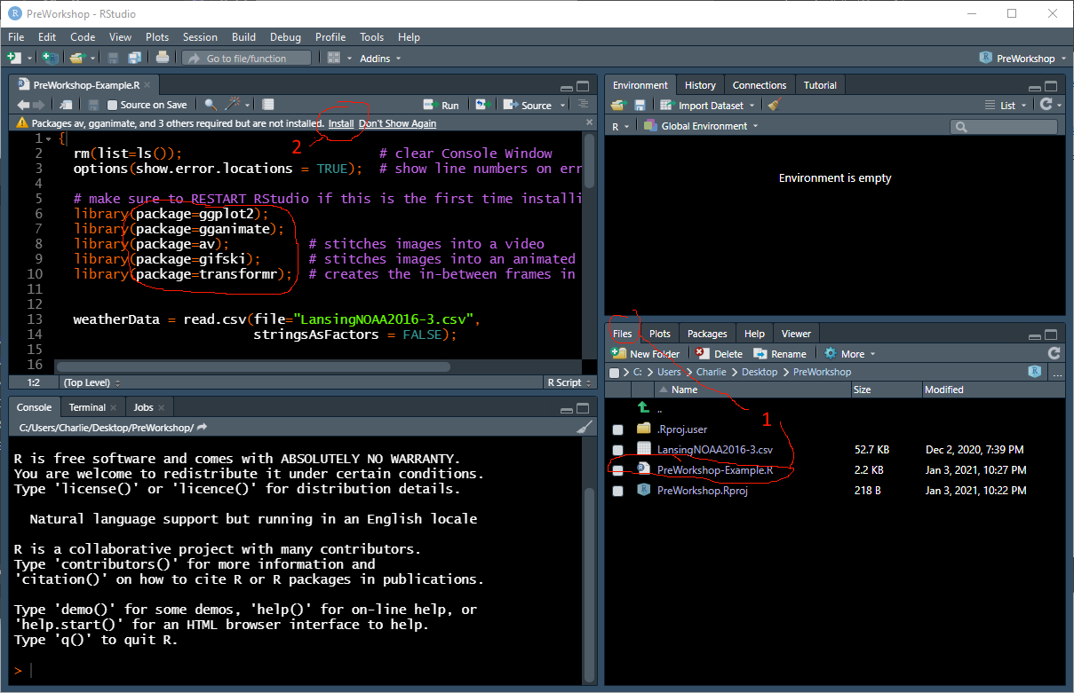

Image 1: Opening script file and installing packages

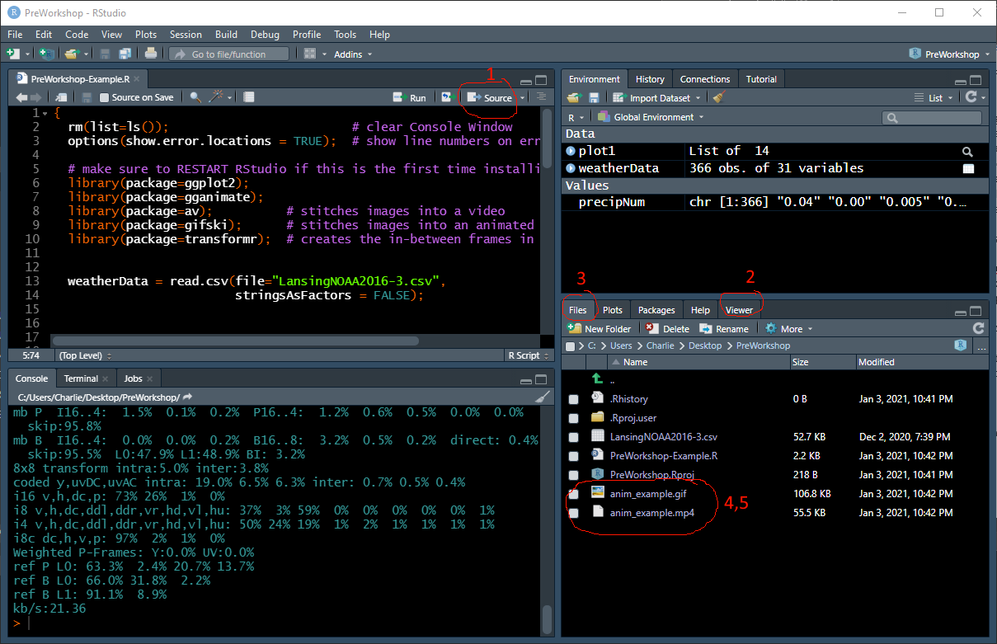Image 2: Executing the animation script and viewing the animated gif and video