Documentation of US_county_household_income.dta
1. Cases, time and variables
The data focus on household income distribution of 3,142 counties in the last 12 months. There are 3,142 observations and 21 variables in data. A brief description of the variables is shown as below:
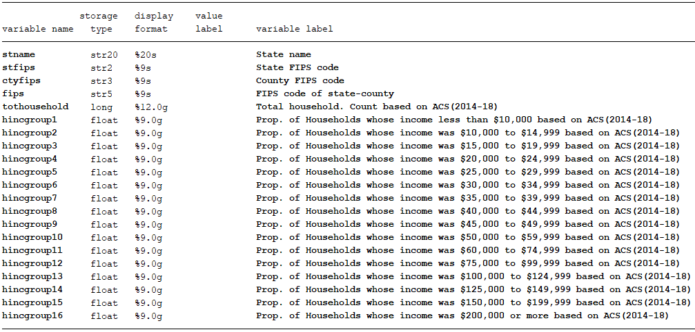
2. Data source
Raw tables used to generate our data was copied from:
https://www.arcgis.com/home/webmap/viewer.html?useExisting=1&layers=9bb063b40e824c4299ccb26d72519922
After opening this website, go to “ACS Household Income Distribution Variables – Boundaries – County, and click “show tables”, then statistics on county level will show up. You have to copy statistics state by state and remember roll down scroll bar to bottom to make sure all counties will be included.

3. Raw table and our data
Raw table looks like follow:
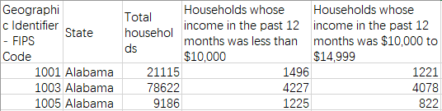
The columns can be selected by filter, I just select one fips code column and then keep all statistic columns. You can make choice by yourself. The proportion of each household income group can be get via divide number of household, which is American Community Survey (ACS) 2014-2018 5-year estimates, in the group by total households.

