Document of US_county_poverty.dta
- Cases and variables
The data focus on proportion of people below poverty line in 3,139 counties based on American Community Survey (ACS) 2014-2018 5-year estimates, just except Kalawao county in Hawaii. King county in Texas and Rio Arriba county in New Mexico. There are 6 variables in data. A brief description of the variables is shown as follow:
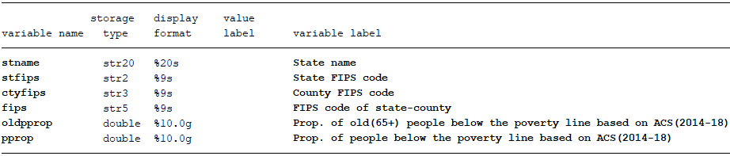

- Data source
Raw tables used to generate our data was copied from:
https://www.arcgis.com/home/webmap/viewer.html?useExisting=1&layers=44883cd255c14e6386199acb802e1dbd
After open the website, choose “ACS Percent People Below Poverty - COUNTY” and click show tables, then statistics on county level will show. You need copy statistics state by state and remember to roll down scroll bar to bottom to make sure all counties in the state will be copied.

- Structure of raw table
Raw table looks like follow:
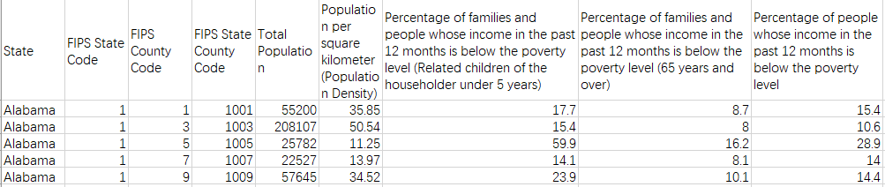
You can choose columns by yourself and proportion of people under poverty line can be get by divide percent to 100.

