Document of US_county_social_determinants.dta
- Cases and variables
The data focus on social determinant factor of Covid-19 in 3,142 counties. There are 12 variables in data. A brief description of the variables is shown as follow:
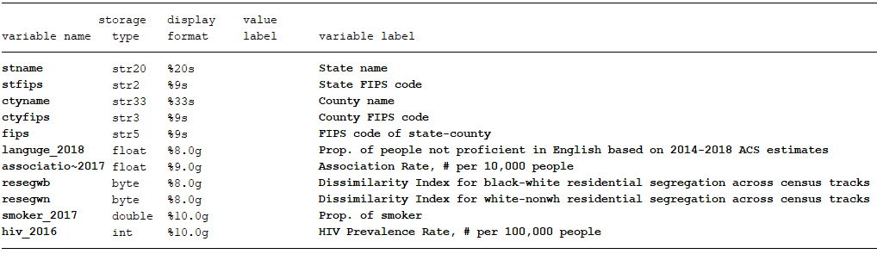

- Data source
Our raw data mainly come from https://www.countyhealthrankings.org, and different variable located in different page. After open this website, click follow buttons in order: Explore health rankings ➔ Measures & Data Sources ➔ county-health-rankings-model ➔ health-factors, and then find out what you need.
Besides, statistics of HIV come from the other website:
https://gis.cdc.gov/grasp/nchhstpatlas/main.html?value=atlas

- Structure of raw data
The data come from https://www.countyhealthrankings.org are available in the individual state by state data sets, users must compiled each set of data state by state and put them together eventually. Our works looks like follow:
