Documentation of US_county_housing_density.dta
- Cases, time and variables
The data focus on the number of housing unit and housing per person in 3,142 counties from 2010 to 2019. There are 3,142×9 =28,278 county-year observations and just 8 variables in data. A brief description of the variables is shown as follow:
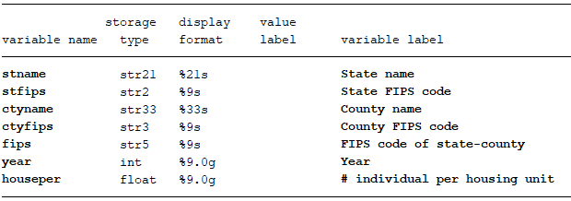

- Data source
Raw tables used to generate our data can download from:
https://www.census.gov/content/census/en/data/tables/time-series/demo/popest/2010s-total-housing-units.html
After open the website, and click any one hyperlink named by state except “United States” to download zip file under:
Annual Estimates of County Housing Units for States: 2010 to 2018
Note: there are 51 hyperlink named by state, but they link to the same files. So you needn’t to click each hyperlink and download state by state. Within the zip folder, we just need use the file PEP_2018_PEPANNHU_with_ann.csv to generate our data.

- Structure of raw tables
Raw table looks like follow:
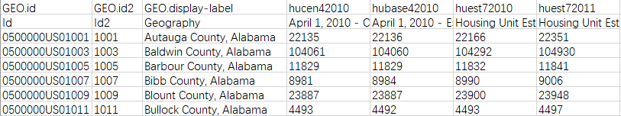
The second row is useless. FIPS code is contained in GEO.id, name is contained in GEO.display-label. Housing unit account in each county is organized as a wide data, we just need to reshape it as a long data. The number of individual per housing is constructed by divide number of total population by number of housing unit, so need merge it with US_county_Pop.dta at first.

