Document of US_county_tax_filling.dta
- Cases and variables
The data focus on proportion of 8 adjusted gross income groups and 1 group without tax filing in 3,141 counties at 2017, just except Kalawao county in Hawaii. There are 14 variables in data. A brief description of the variables is shown as follow:
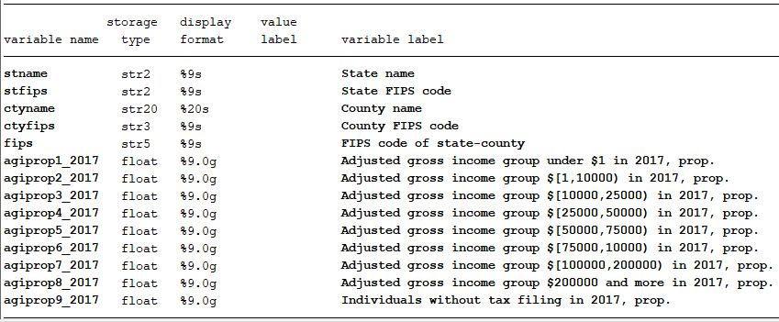
- Data source
Raw tables used to generate our data can download from:
https://www.irs.gov/statistics/soi-tax-stats-county-data-2017
After open the website, click the hyperlink in “2017 (all States, includes AGI) ” under County data .csv Files.

- Structure of raw table
Raw table looks like follow:
STATEFIPS | STATE | COUNTYFIPS | COUNTYNAME | agi_stub | N1 | mars1 | MARS2 | MARS4
1 | AL | 1 | Autauga County | 1 | 200 | 110 | 80 | 0
1 | AL | 1 | Autauga County | 2 | 3050 | 2430 | 240 | 360
1 | AL | 1 | Autauga County | 3 | 5340 | 2830 | 740 | 1660
1 | AL | 1 | Autauga County | 4 | 5620 | 2450 | 1600 | 1340
1 | AL | 1 | Autauga County | 5 | 3540 | 1030 | 1900 | 500
1 | AL | 1 | Autauga County | 6 | 2520 | 390 | 1930 | 170
1 | AL | 1 | Autauga County | 7 | 3400 | 230 | 3080 | 80
1 | AL | 1 | Autauga County | 8 | 480 | 30 | 440 | 0
At first, state name and state fips code, county fips code are different to our common format, we need to adjust it and keep consistent on fips code and name of state or county.
Second, to construct proportion of each adjusted gross income (AGI) group, we need to reshape the data as a wide data, then merge with US_county_Pop.dta to get the number of population ages 15+. Meanwhile, we also get the number of individuals without tax filling from population ages 15+ by minus total number of 8 AGI groups and treat it as the 9th group. Then:
Prop. of AGI group=Pop. of AGI / Pop. ages 15+.
Besides, there are three counties with more tax filling people than population ages 15+, their situation shows in below figure.
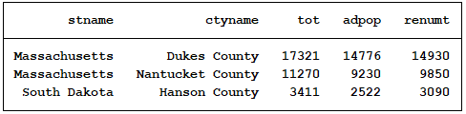
We have to adjust our dominator to total number of 8 AGI to make sure that the sum of proportion of all groups equal to 1, and the proportion of the 9th group for these three counties equal to 0.

