Documentation of US_state_uninsured.dta
- Cases, time and variables
The data focus on the proportion without health insurance of 51 states on only 2013, 2016 and 2017, and medic-aid eligibility expansion of 51 states from Jan 1 2014 to Jan 1 2017. There are 51×3 =153 state-year observations and just 5 variables in data. A brief description of the variables is shown as below:
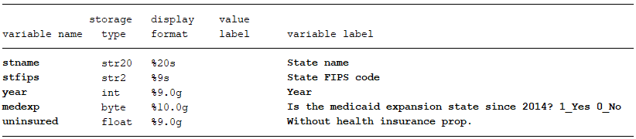

- Data source
Raw tables used to generate our data can download from:
https://www.census.gov/data/tables/2018/demo/health-insurance/p60-264.html
When open this website, download table6 under:
Health Insurance in the United States: 2017 – Tables

- Structure of raw tables
Raw table looks like follow, state name is here already.
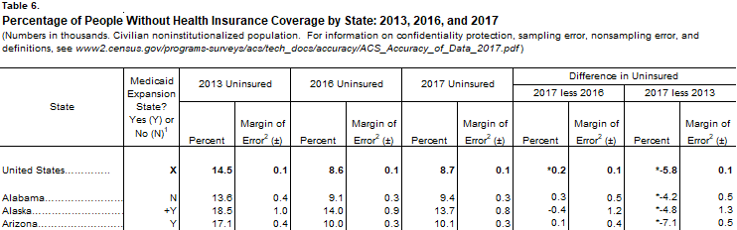
We just use column 1, 2, 3, 5 and 7. Medicaid expansion state are confirmed by if the state expanded medicaid eligibility after Jan 1 2014 (till to Jan 1 2017). We reshape column 3, 5, and 7 to get a state-level panel data. FIPS code of state can be get by merge with FIPS code file.

