Documentation of US_county_unemployment.dta
1. Cases, time and variables
The data focus on gdp of 3,142 counties from 2015 to 2018 yearly. There are 3,142×4=12,568 county-year observations and 7 variables in data. A brief description of the variables is shown as below:
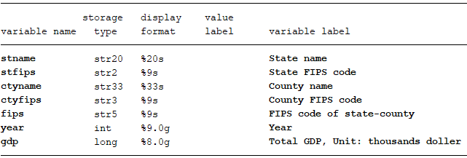

2. Data source
Raw tables used to generate our data was download from:
https://www.bea.gov/news/2019/local-area-gross-domestic-product-2018
After opening this website, go to related materials and click “Tables Only”, then table file will be download automatically.

3. Raw table and our data
Raw table looks like follow:
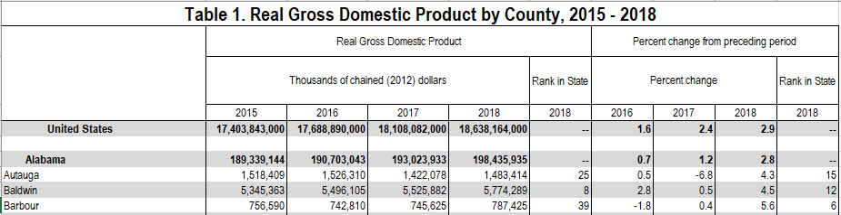
We just use GDP statistics from 2015 to 2018 and give up rank and percent change values. There are 53 counties whose GDP is calculated in combination with other counties. In order to separate these counties and estimate their individual GDP, we use information from US_county_Pop.dta. We assume that GDP was mainly created by working age population, and their average GDP output are same if their counties are combined in statistics. Then we just make the proportion of working age population of each county in their combination working age population as its proportion of GDP in their combination GDP. We define age group 4 to group 13 (ages 15 to 64) in US_county_Pop.dta as our working age population.

