Documentation of US_county_Pop_density.dta
- Cases and variables
The data focus on population density of 3,142 counties from 2010 to 2018. We made it as a wide form data. There are 3,142 observations and 14 variables in data. A brief description of the variables is shown as below:
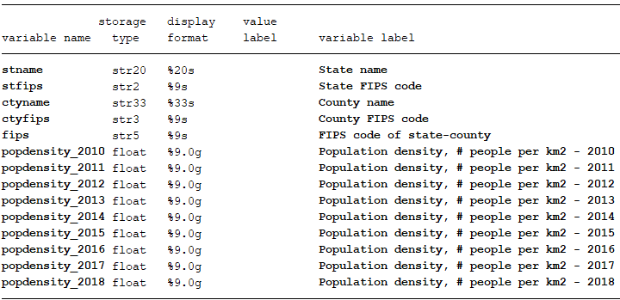

- Data source
The land area of each county is come from statistics in:
https://www.arcgis.com/home/webmap/viewer.html?useExisting=1&layers=3cfa5a57e21b4cd899cbfcd8da540e98
After open this website, choose “ACS Population Variables – Boundaries – County” and click show tables, then statistics on county level will show up. You have to copy statistics state by state, and remember to roll down scroll bar to bottom to make sure all counties in state could be selected.

- Structure of raw tables
The result of county area calculation looks like follow:
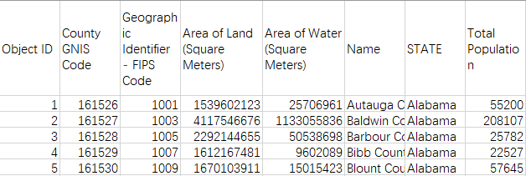
You can select columns by filter. I just use “Area of land” to calculate population density. And population on each year come from US_county_Pop.

