Documentation of US_county_migration.dta
1. Cases, time and variables
The data focus on migration among 3,140 counties (Kenedy County and Terrell County are not included in the statistics) from 2013 to 2017. There are 7 variables in data. A brief description of the variables is shown as below:
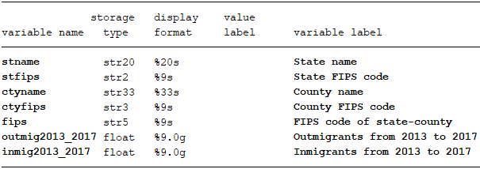

2. Data source
Raw tables used to generate our data was download from:
https://www.census.gov/content/census/en/data/tables/2017/demo/geographic-mobility/county-to-county-migration-2013-2017.html
After open this website, download “In-, Out-, Net, and Gross Migration .csv” under “County-to-County Migration Flows: 2013-2017”. Besides, there are separated inflow and outflow excel file too.
Note: This year’s migration flows are deviate from previous years, so the statistics are based on 5-year 2012-2016 ACS.

3. Raw table and our data
Raw table looks like follow:
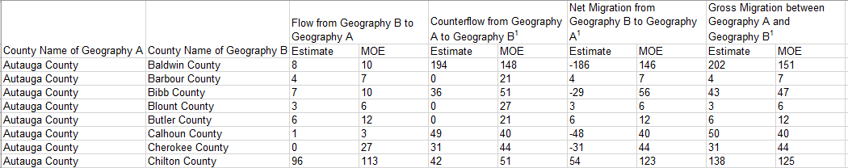
Many variables are prepared in the raw table, like fips code and name of state and county, we need to generate 5-digit fips code by combine state fips code and county fips code. To get total count number of in-migrants to one county, or out-migrants from one county could be get by sum up all flows to or from specific county. I give up number of margin of error (MOE) based on 90% confidence interval, net migration and gross migration statistics.

