Documentaion of US_county_neighbor.dta
1. Cases and variables
The data focus on neighbors of 3,142 counties. For each county, it has at most 13 neighbors defined by common border (not include common vertex), and some counties, always are island counties, have no neighbor county, for example, Hawaii county. There are 14 variables and brief description shows as follow:
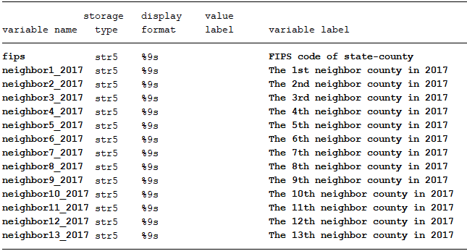

2. Data source
Raw geo data used to generate our data was download from:
https://www2.census.gov/geo/tiger/TIGER2017/COUNTY/
After opening this website, click “tl_2017_us_county.zip”, then geographic files will be download automatically.

3. How to get neighbor from geographic files
We need open tl_2017_us_county.dbf via Geoda at first, change property of STATEFP, select counties with STATEFP<=56 and save as .csv files. Generate fips code in the .csv files and then open tl_2017_us_county.shp in Geoda. Secondly, we need click weights manager to find neighbor of counties. We select one-order rook contiguity to confirm neighbors and then generate a .gal file. Results is the file shows as below. Rows 2, 4 and so on shows object county and number of its neighbor, rows 3, 5 and so on shows fips code of its neighbor.
