Documentation of unemployment.dta
1. Cases, time and variables
The data focus on employment situations of 3,141 counties (Kalawao County is not included in the statistics) from Jan 2019 to Feb, 2020 monthly. We made each statistic of each month as one variable, and then get a 3,141 observations and 33 variables wide data. A brief description of the variables is shown as below:
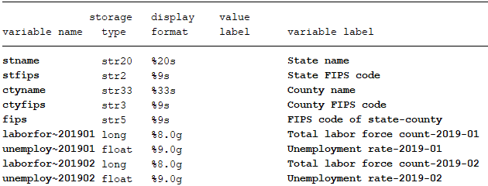

2. Data source
Raw tables used to generate our data was download from:
https://www.bls.gov/lau/tables.htm
When open this website, click zip after “Labor force data by county, not seasonally adjusted, latest 14 months”

3. Raw table and our data
Raw table looks like follow:
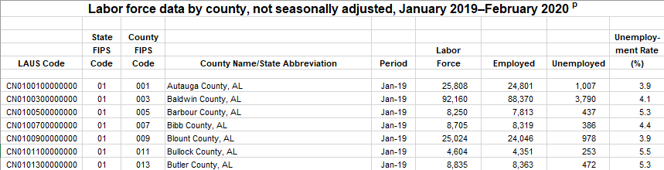
Many variables are prepared in the raw table, and we need to generate 5-digit fips code by combine state fips code and county fips code (or substring from LAUS Code). Period was decomposed to year and month, stname and ctyname can be get by match with US_county_Pop.dta. We just need to keep labor force and unemployment rate as our finally variable.

