QFIN Trading Team 4

Authors:

Chris WALTER

Cameron NGUYEN

Adi KOHLI

Range Trading Report

Organisation: University of Western Australia

Table of Contents

**Executive Summary3**

**Range Trading**4

**Indicators**4

Relative Strength Index (RSI)4

Bollinger Bands4

Mac D 4

**Trading Strategy5**

RSI Parameters5

Bollinger Bands: Support and Resistance Lines 5

Trading Strategy5

**Results6**

**Discussion7**

Executive Summary

The aim of this report is to gain an understanding of how range trading can heavily influence the market using investigated strategies. The strategy that this report analyzes and proposes consists of researching multiple different indicators to see if using at least two would result in higher profits. Upon further investigation, although using more indicators may sound safer and more promising, due to the rarity of over two conditions being satisfied to signal either a long or a short; using a strategy consisting of two indicators was found to be more effective in almost every case. This report shows how the algorithm made for this range trading investment strategy can lead to reasonable profits when used in vertical markets but isn’t as effective in securities that have horizontal patterns.

Range Trading

Range trading is an active investing strategy that identifies a range which indicate either a buy or sell. This investing strategy is very effective when dealing with a market that fluctuates consistently within a scale of highs or lows as it can potentially signal the trader whether a stock is being either over or underbought. The strategy we have used proposes the use of combining two different indicators together to create a trading range which fully utilizes a type of machine learning that can read a markets trends factoring in things like volume or even significant economic events. The trading strategy we have developed utilizes a momentum oscillator, the RSI (Relative Strength Index) in conjunction with it, it also incorporates Bollinger bands and investigates a Mac D indicator but is not used as it doesn’t compliment the other two indicators well.

Indicators

Relative Strength Index (RSI)

The RSI indicator is a momentum oscillator that tells a trade at which point in the market are considered to be overbought or underbought to signal buy and sells. An RSI is calculated at each interval through looking and comparing recent price gains against recent price losses over a given period. Using an RSI provides protection against sudden market crashes as this indicator relies on an EMA but when there’s a steep change in its value, it signals a potential crash.

Bollinger Bands

Bollinger bands are known as lagging indicators and therefore instead of predicting the future of the stock price its gives an indication of the value of the current stock price. Bollinger bands are based on the metrics of prices and volatility. It's defined by a dynamic set of trendlines. These trendlines are plotted by two standard deviations above and below the moving average (20-day SMA) of the stock's price. The basic methodology of using Bollinger bands is identifying whether the stock is currently overbought or underbought - an indication that the stock is overbought is to identify whether the security is trading near the upper trendline and an indication of underbought is to identify whether the security is trading near the lower trendline.

MAC D indicator

MAC D is also known as moving average convergence/divergence. This indicator shows the relationship between two exponential moving averages. 26-day EMA – 12-day EMA = MAC D line. A nine-day EMA of the MACD called the "signal line," is then plotted on top of the MACD line. From these two lines traders can implement a buy and sell strategy. Traders will buy the security when the MACD crosses above its signal line and sell the security when the MACD crosses below the signal line

Trading Strategy

RSI parameters:

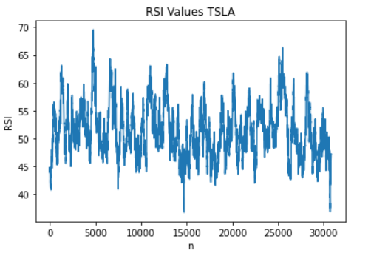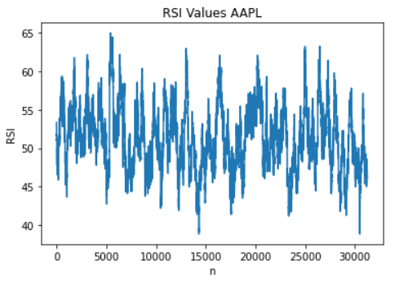

We conducted analysis on three securities to formulate a range for the RSI. On average 83.42% of the data resided between ranges 40 – 60. Furthermore, through a Bayesian calculation we came to the conclusion that the optimal RSI is greater than 40 (refer to the binomial tree below). With the combination of these two statistics, we used a RSI lower boundary of 40 and a RSI upper boundary of 60.

Bollinger bands: Support and resistance lines

Through investigating a strategy using Bollinger bands we saw that it significantly underperformed the buy – hold strategy. As its very unlikely that the stock will reach levels close to two standard deviations of the mean (95% Confidence intervals).

As a result, we used a combination of the Bollinger bands and creating our own support and resistance lines. Support and resistance lines were created through cumulating 5 days’ worth of data – the support line is the bottom decile and the resistance line is the top decile. This strategy was more effective which can be seen later in our report.

Trading strategy:

After effectively creating parameters on the RSI and creating efficient support and resistance lines we came to a trading strategy. Refer to the strategy below:

**Price Intersects Support or Resistance**

RSIs > 40

RSIs < 60

**Price > Lower Bollinger**

**Price > Upper Bollinger**

BUY

SELL

Results

|  |  |  |
| --- | --- | --- |
| Security | Returns | Graph |
| TSLA | 28.5% |  |
| AAPL | -3.35% |  |
| XLU | 0.11% |  |
| XLF | -3.30% |  |

The trading strategy was tested on a range of securities that displayed varying degrees of volatility in their historic prices to observe how the strategy performed under different scenarios. In order of volatility, the securities tested on were TSLA (Tesla shares), AAPL (Apple shares), XLF (Financial Select Sector SPDR Fund), and XLU (Utilities Select Sector SPDR Fund). A summary of the results is pictured above.

Discussion

Overall, the strategy displayed mixed results after back testing. The volume of trades on each security appears positively correlated with the volatility of the securities, as demonstrated by positive returns on TSLA and the underperformance on the other securities. The strong uptrend in share prices over the testing period resulted in the support level rarely being reached whereas the resistance level was reached much more frequently, meaning that almost all trades were shorts. This result indicates that the returns on the trading strategy are likely uncorrelated with the performance of the overall market, which is unsurprising for a range trading strategy.

Where the strategy primarily failed was its difficulty in deter­mining which trades have a high enough expected return to overcome trading fees, resulting in many trades with small returns that failed to meet this threshold. The strategy could perhaps be improved by refining indicator parameters as well as other information above price movements to determine the probability of each trade generating sufficient returns, helping to avoid non-profitable trades, while also determining appropriate stop losses based on probabilities derived from price movements. It could also benefit from understanding the characteristics of the security it is trading on, such as relative volatility, and adjust trading parameters accordingly to generate better expected returns.