Shandong University of Technology

Assignment Report

Course Name： Computer Science
College ： Shan Dong University of Technology
Course ： Software Testing and Inspection
Name ： Haolong Qi, Xiaozhou Liu
ID ： 22110543060, 22110543053

2024 .10.3

Assignment Report Page 1
Team mates name and ID: Haolong Qi齐浩龙22110543060, Xiaozhou Liu刘孝宙 22110543053 Score:
Course name: Software Testing and Inspection
Project Code | 210518136 | Course Instructor | Ming Zhu
Purpose | Structural Testing.
equipment | PC, windows, C, Java
1. Objective
In this assignment, you will use EclEmma for the test coverage of an open source project.

EclEmma https://www.eclemma.org/resources.html

2. About The Supplied Code

The codes provided are exerted from a java project related to various algorithms, which are used for math, sorting, and searching. You can download the codes from the course web site.

3. Assignment Description

Q1. Determine the number of unit tests required for 5 methods (number of lines >10) to ensure that all statements, all branches and 100% cyclomatic complexity coverages will be achieved. For questions from Q1 to Q6, testing should be performed and concerned in terms of method.
Methods which are selected:
Searches: LinearSearch, TernarySearch, BinarySearch
Sorts: CocktailShakerSort, MergeSort

- Binary Search
public class BinarySearchTest {
private BinarySearch bs = new BinarySearch();

@BeforeEach
void setUp() throws Exception {
}

//使用多个以@Test为注解的测试样例，可以保证其中一个测试样例抛出异常时，其他样例依旧可以正常测试，效果等同于try...catch

Integer [] test1 = {2,4,6,8,10};//第一次进else，median+1，第二次进if返回-1
Integer [] test2 = {1,3,5};//第一次进else-if，median-1，第二次进if返回median
Integer [] test8 = {1, 3, 4, 6, 8, 9, 11};
//statement、branch coverage
@Test
public void testBinarySearch_normal_statementCoverage(){ //正常测试样例1
bs.find(test1, 1);
bs.find(test2, 1);
bs.find(test8, 7);
}

//basis coverage
Integer [] test3 = null;//不可执行覆盖，进入方法find()后，必进方法search()
Integer [] test4 = {1, 3, 4, 6, 8, 9, 11};//直接实现if返回-1
Integer [] test5 = {1, 3, 6, 8, 9};//直接实现if返回median
Integer [] test6 = {2,4,6,8,10,12,14};//第一次实现else-if，第二次实现if返回median
Integer [] test7 = {1, 3, 4, 6, 8, 9, 11};//第一次执行else，第二次实现if返回median
@Test
public void testBinarySearch_normal_basisCoverage(){ //正常测试样例2
bs.search(test4,6,3,2);//如果使用方法find（）无法实现100%覆盖，仅能使用方法search（）
bs.find(test5,6);
bs.find(test6,1);
bs.search(test7,12,0,6);//如果使用方法find（）无法实现100%覆盖，仅能使用方法search（）
}

@Test
public void testBinarySearch_fault(){ //异常测试，直接传入空数组和空值，获取异常
//asserThrows用于获取预期异常，需要先指定异常类型，然后在后续调用的函数中获取，最终得到异常信息
assertThrows(Exception.class, ()->bs.find(test3, null));
}

}
- Statement Coverage
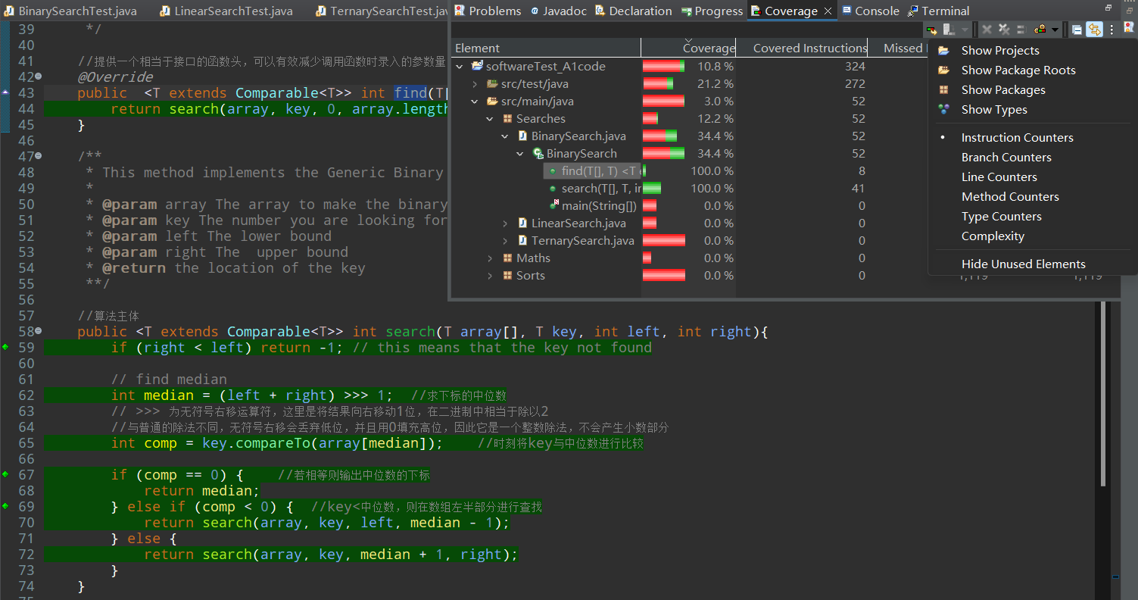
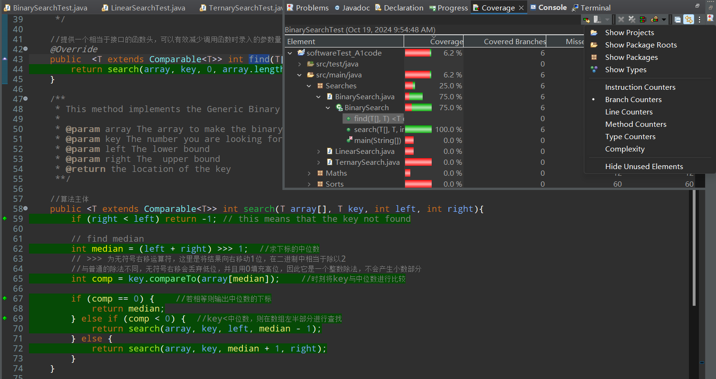
- Branch Coverage
- Basis Paths Coverage

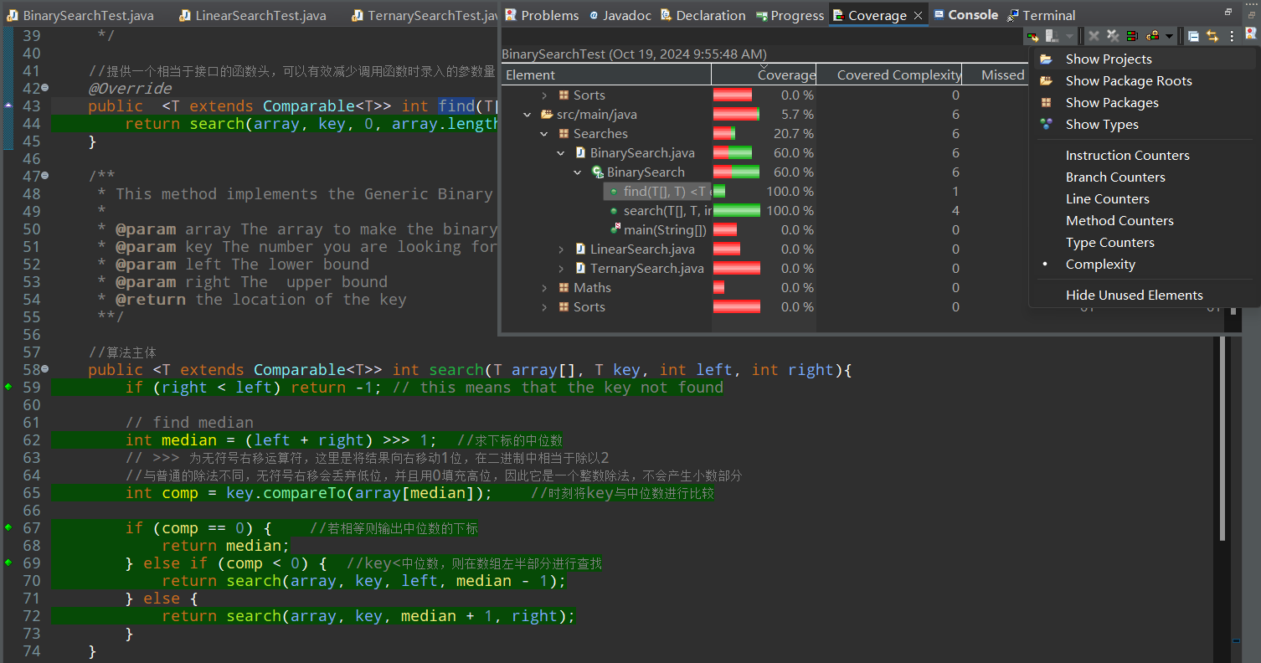
- Linear Search
class LinearSearchTest {
private LinearSearch ls=new LinearSearch();

@BeforeEach
void setUp() throws Exception {
}

//statement、branch coverage
Integer [] test1= {5, 3, 4, 6, 8};//直接执行至return i
Integer [] test2= {1, 2, 3, 4, 5, 6, 7, 8, 9, 10};//直接执行至return -1
@Test
public void testLinearSearch_normal_statementCoverage() {
ls.find(test1, 5);
ls.find(test2,11);
}

//basis coverage
Integer [] test3= {5, 3, 4, 6, 8};//直接执行至return i
Integer [] test4= {};//跳过for循环直接执行return -1
Integer [] test5= {1, 2, 3, 4, 5, 6, 7, 8, 9, 10};//直接执行至return -1
@Test
public void testLinearSearch_normal_basisCoverage() {
ls.find(test3, 5);
ls.find(test4, 1);
ls.find(test5, 11);
}

@Test
public void testLinearSearch_fault() {
assertThrows(Exception.class,()->ls.find(test2,7));
}

}
- Statement Coverage
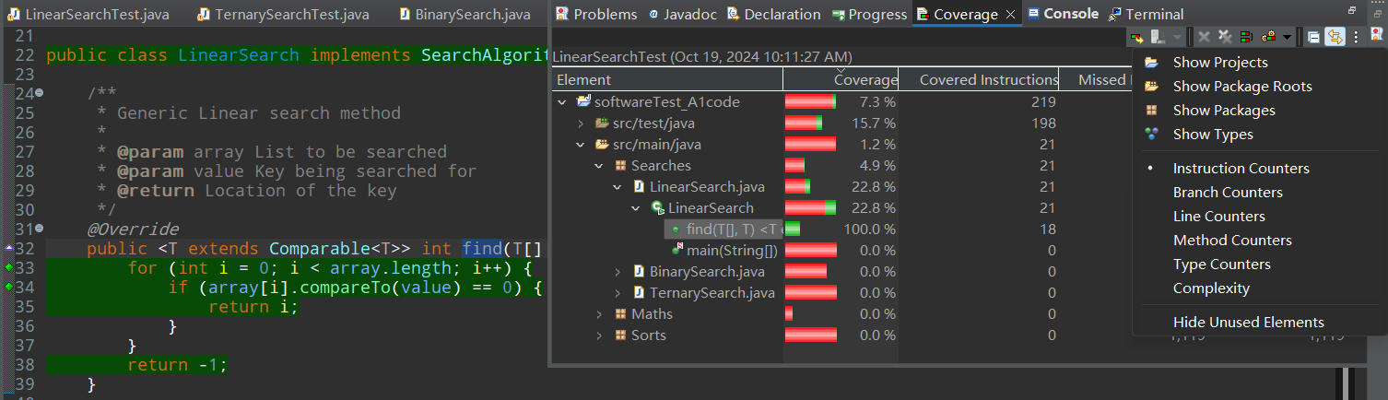
- Branch Coverage
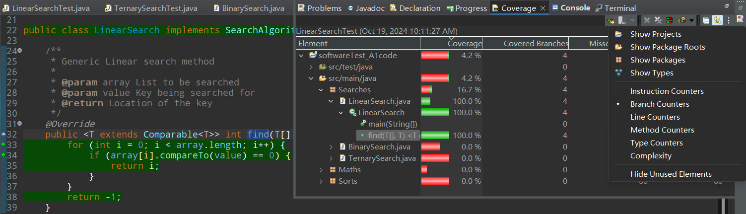
- Basis Paths Coverage
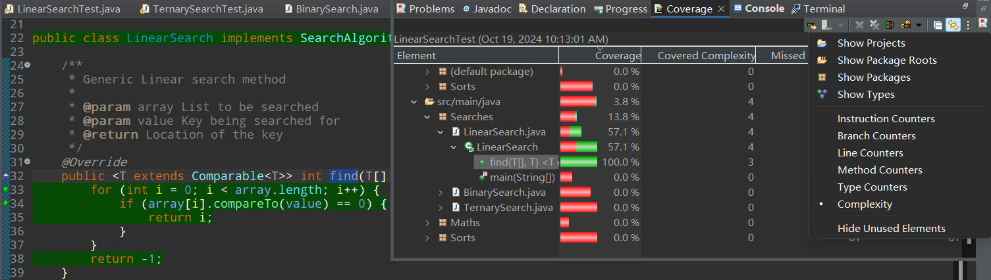

- Ternary Search
class TernarySearchTest {
TernarySearch ts=new TernarySearch();

@BeforeEach
void setUp() throws Exception {
}

//statement 、branch coverage
Integer [] test1 = {0,1,2,4,5};//第一次key值小于mid1,第二次start>end值
Integer [] test2 = {0,1,2,3};//第一次key值大于mid2，第二次key=mid1
Integer [] test3 = {1,2,3,4,5,6,7};//第一次属于else，第二次key=mid2
@Test
public void testTernarySearch_normal_statementCoverage() {
ts.find(test1,-1);
ts.find(test2, 3);
ts.find(test3, 4);
}

//basis coverage
Integer [] test4 = null;//不可实现，进入方法find（）后必须进方法ternarySearch（）
Integer [] test5 = null;//第一次进入直接进if，返回-1
Integer [] test6 = {0,1,2,3};//第一次进入key=array[mid1]
Integer [] test7 = {0,1,2,3};//第一次进入key=array[mid2]
Integer [] test8 = {0,1,2,4,5};//第一次key<array[mid1],第二次进入if返回-1
Integer [] test9 = {1,2,3,4,5};//第一次key>array[mid2],第二次进入if返回-1
Integer [] test10 = null;//第一次进入else，第二次无法进入if返回-1，除非进入else-if
@Test
public void testTernarySearch_normal_basisCoverage() {
ts.find(test1,-1);
ts.find(test2, 3);
ts.find(test3, 4);
ts.find(test5, 0);
ts.find(test6, 1);
ts.find(test7, 2);
ts.find(test8, -1);
ts.find(test9, 6);
}

Integer [] test11= {};
@Test
public void testLinearSearch_fault() {
assertThrows(Exception.class,()->ts.find(test2,10));
}

}

- Statement Coverage

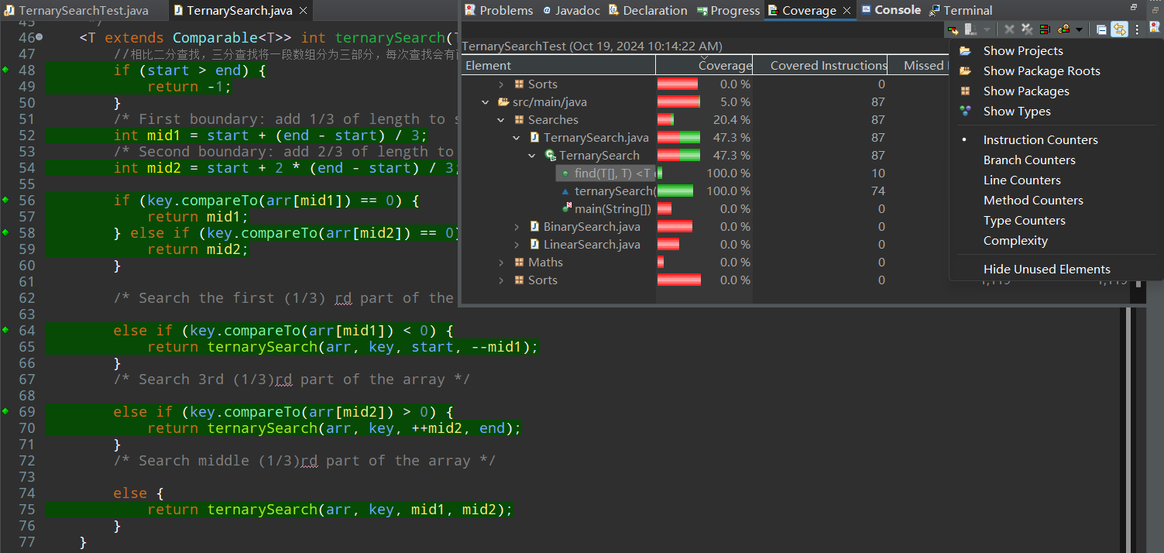
- Branch Coverage
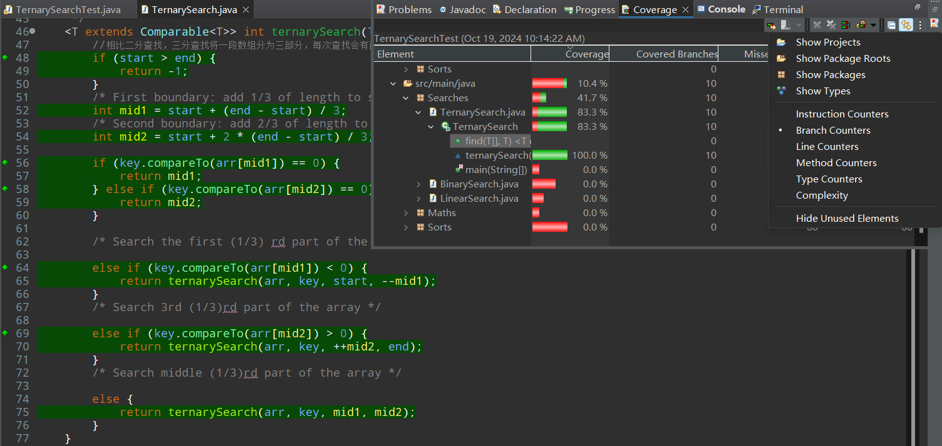
- Basis Paths Coverage

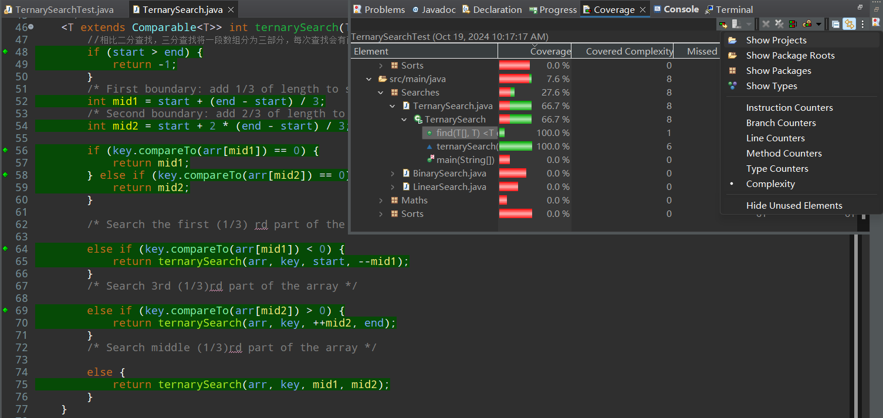
- Cocktail Shaker Sort
class CocktailShakerSortTest {
private CocktailShakerSort css = new CocktailShakerSort();

@BeforeEach
void setUp() throws Exception {
}

Integer[] t1 = {2, 3, 0, 1};
@Test
void test_normal_StatementCoverage() { //正常测试-Statement Coverage
css.sort(t1);
}

Integer[] tt1 = {3, 2, 1}; //两个if均只走true
Integer[] tt2 = null; //由于算法特性，无法做到两个if都只走一次false，故将其中一条路径拆分为下面两条路径
Integer[] tt2_1 = {3, 2, 2}; //第一个if走一次true,第二个if走一次false
Integer[] tt2_2 = {1, 2}; //第一个if走false,第二个for走false
@Test
void test_normal_BranchCoverage() { //正常测试-Branch Coverage
css.sort(tt1);
//计算出的路径仅支持80% Branch Coverage
css.sort(tt2_1);
css.sort(tt2_2);
}

Integer[] ttt1 = {1}; //第一个while走false
Integer[] ttt2 = null; //第一个for->false,第二个for->false 算法不可达路径，当数组元素个数>=2时，一定会进入while并执行第一个for
Integer[] ttt3 = {1, 2}; //第一个if->false, 第二个for->false
Integer[] ttt4 = {2, 1}; //第一个if->true,第二个for->false
Integer[] ttt5 = null; //第一个for->false,第二个if->false 算法不可达路径
Integer[] ttt6 = null; //第一个for->false,第二个if->true 算法不可达路径
Integer[] ttt_extra1 = {1, 2, 1}; //第二个if->false
Integer[] ttt_extra2 = {3, 2, 1}; //第二个if->true
@Test
void test_normal_BasisPathsCoverage() { //正常测试-Basis Paths Coverage
css.sort(ttt1);
css.sort(ttt3);
css.sort(ttt4);
// //画出的Basis Paths仅支持到Complexity 66.7% Coverage
css.sort(ttt_extra1);
css.sort(ttt_extra2);
}

Integer[] test = {};
@Test
void test_exception() { //异常测试
assertThrows(Exception.class, ()->css.sort(test));
}

}

- Statement Coverage
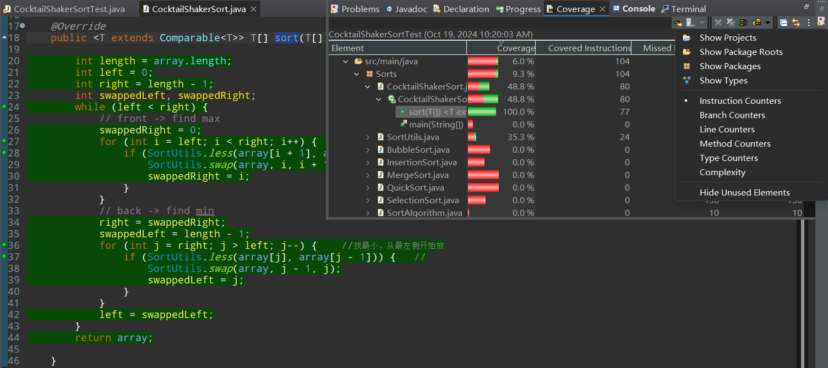
- Branch Coverage

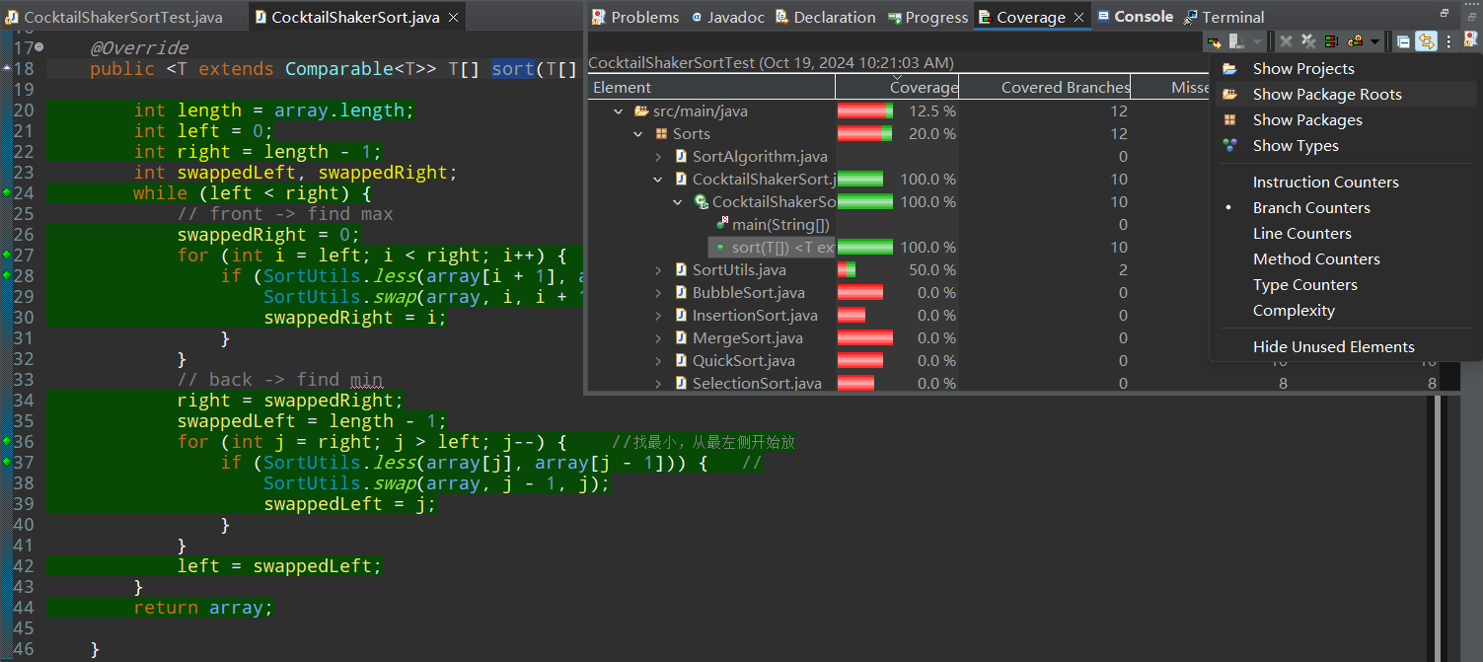
- Basis Paths Coverage
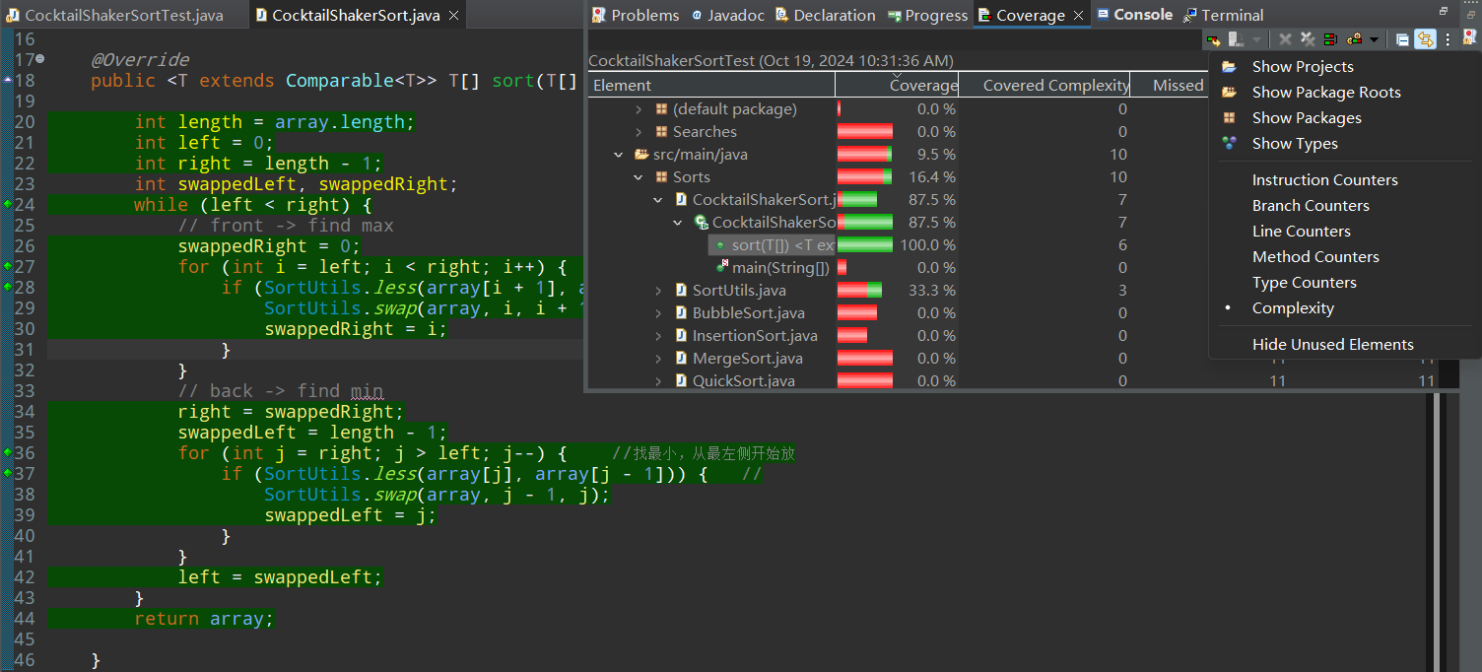

- Merge Sort
class MergeSortTest {
private MergeSort ms = new MergeSort();

@BeforeEach
void setUp() throws Exception {
}

Integer[] t1 = null; //merge()中的if->true 算法不可达，若该if结构只走一边，则后续补全另一分治的数组时一定不会执行if结构中走过的分支处理的数组
Integer[] t2 = null; //merge()中的if->false 算法不可达
Integer[] t_extra1 = {1,1}; //merge()中if->true,第二个while->false,第三个while->true
Integer[] t_extra2 = {2,1}; //merge()中if->false,第二个while->true,第三个while->false
@Test
void test_normal_StatementCoverage() {
//计算出的路径均无法找到对应的实际测试样例
ms.sort(t_extra1);
ms.sort(t_extra2);
}

Integer[] tt1 = {}; //merge()中的if->true
Integer[] tt2 = null; //doSort()中只调用第一个doSort()然后第二次遇到if->false 算法不可达，doSort()中的三个函数属于并列关系，只能被全部调用或全不调用
Integer[] tt3 = null; //doSort()中调用前两个doSort()然后第二次遇到if->false 算法不可达
Integer[] tt4 = {1,1}; //merge()中if->true,第二个while->false,第三个while->true
Integer[] tt5 = {2,1}; //merge()中if->false,第二个while->true,第三个while->false
@Test
void test_normal_BranchCoverage() {
ms.sort(tt1);
ms.sort(tt4);
ms.sort(tt5);
}

Integer[] ttt1 = null; //只执行sort() 算法不可达，sort()中必定会调用doSort()
Integer[] ttt2 = {}; //merge()中的if->true
Integer[] ttt3 = null; //doSort()中只有第一个doSort()调用两次 算法不可达
Integer[] ttt4 = null; //doSort()中前两个doSort()调用两次 算法不可达
Integer[] ttt5 = null; //doSort()中调用merge()而不进入merge()函数体 算法不可达
Integer[] ttt6 = null; //merge()中所有while->false 算法不可达
Integer[] ttt7 = null; //merge()中第一个while->true,if->false,后两个while->false 算法不可达，只要进入merge()便会有分组，一定会有未分配完的组
Integer[] ttt8 = null; //merge()中第一个while->true,if->true,后两个while->false 算法不可达
Integer[] ttt9 = null; //merge()中后两个while->false 算法不可达
Integer[] ttt10 = null; //merge()中后两个while->false 算法不可达
Integer[] ttt_extra1 = {1,1};
Integer[] ttt_extra2 = {2,1};
@Test
void test_normal_BasisPathsCoverage() {
ms.sort(ttt2);
//计算出的路径仅支持2/9 = 22.2% Complexity Coverage
ms.sort(ttt_extra1);
ms.sort(ttt_extra2);
}

Integer[] test = {};
@Test
void test_exception() {
assertThrows(Exception.class, ()->ms.sort(test));
}

}

- Statement Coverage
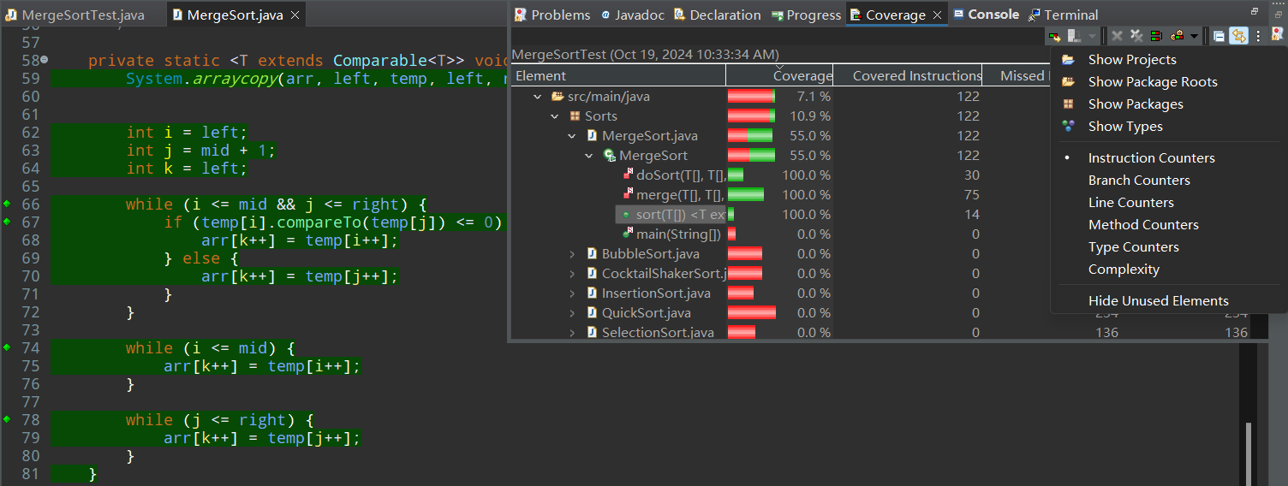
- Branch Coverage
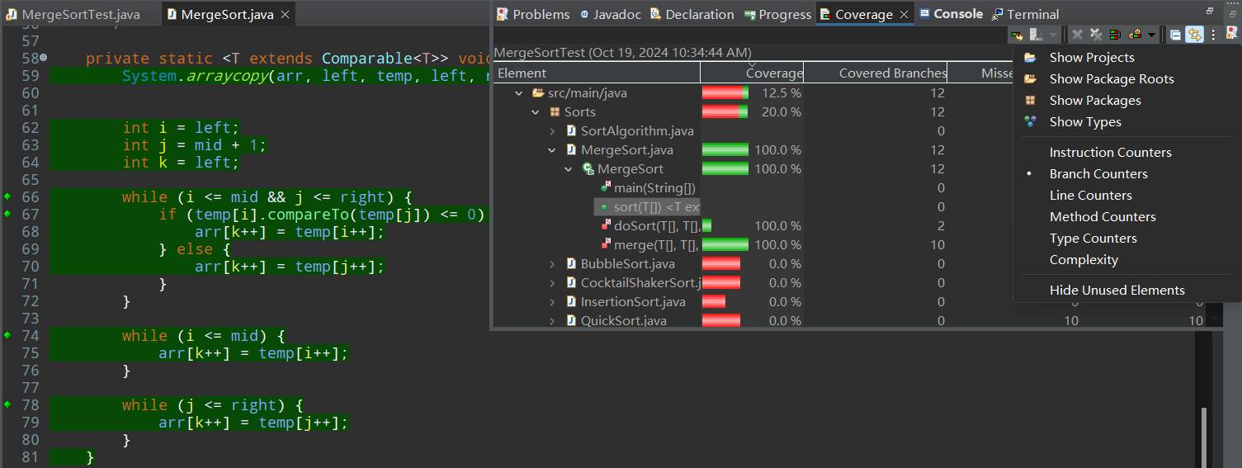

- Basis Paths Coverage

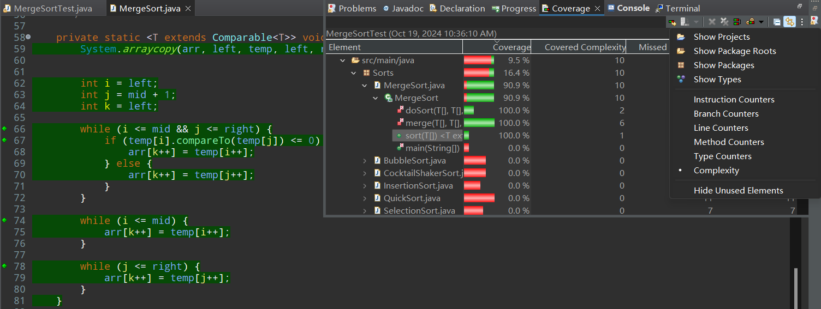

Q2. Develop an effective test suite using the unit test cases identified in Q1. Justify the effectiveness of your test suite.
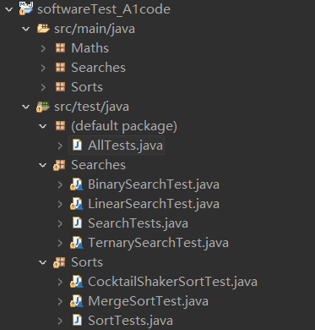
We create two region test suite named SearchTests and SortTests to contain methods correspondingly, then create a total test suite to contain region test suite named AllTests that can run all scattered methods in one time.

SearchTests.java
@Suite
@SelectClasses({ BinarySearchTest.class, LinearSearchTest.class ,TernarySearchTest.class})
public class SearchTests{

}
SortTests.java
@Suite
@SelectClasses({MergeSortTest.class, CocktailShakerSortTest.class})
public class SortTests {

}
AllTests.java
@Suite
@SelectClasses({SearchTests.class, SortTests.class})
public class AllTests {

}

Q3. Determine the number of source lines, which contain nodes that have been covered during testing. Note that a node is an atomic unit of code, comments and blank lines contain no nodes.

Q4. Determine the number of branches that have been covered during testing. Note that a branch is an edge that either comes directly out of a decision or is the entry into a module; every module has at least one branch.

Q5. Determine the number of linearly independent paths are covered during the testing.

BinarySearch:

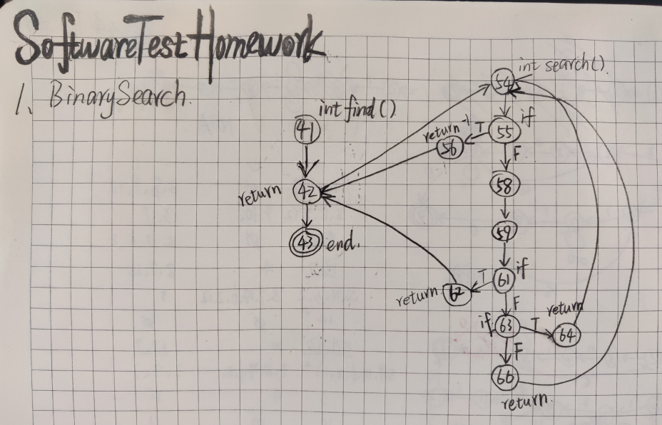

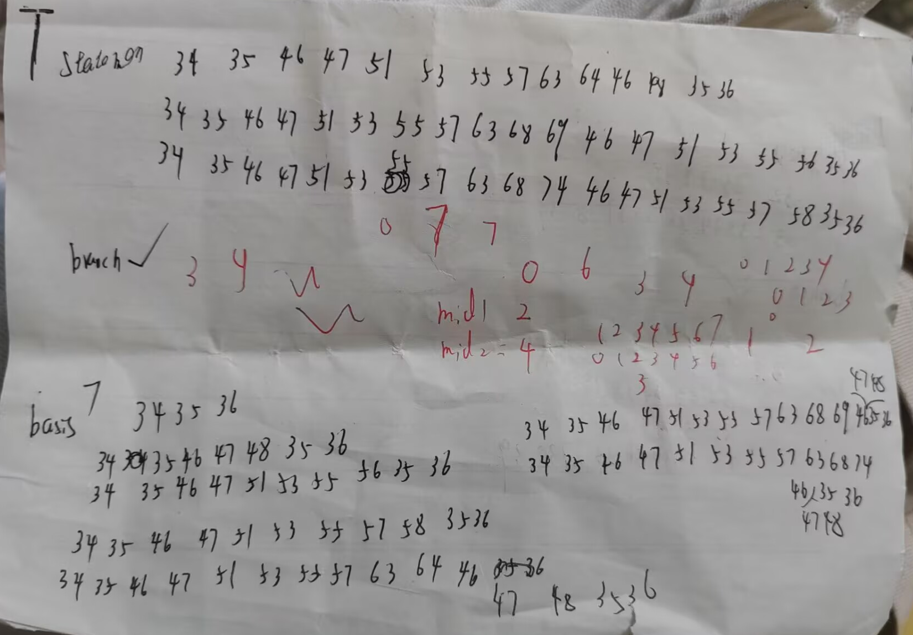
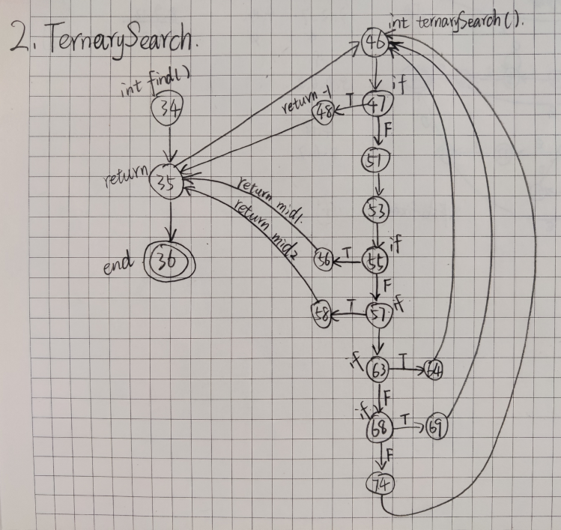
TernarySearch:

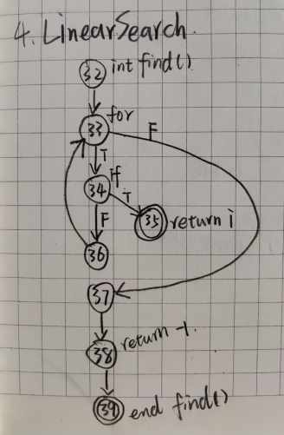
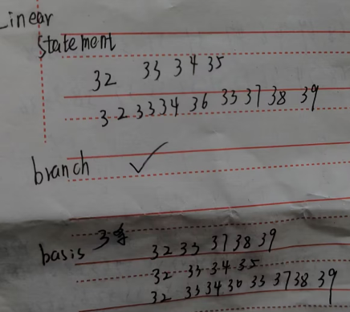
LinearSearch:

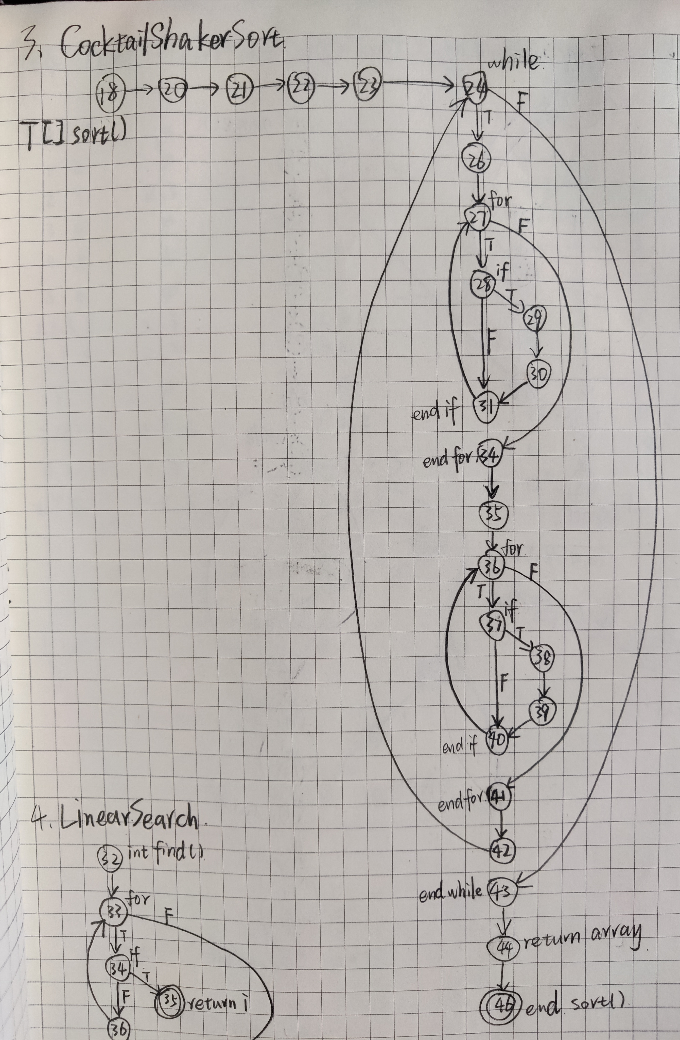
CocktailShakerSort:

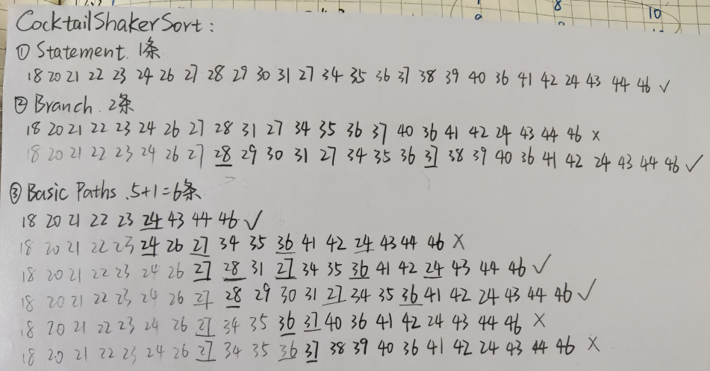

MergeSort:
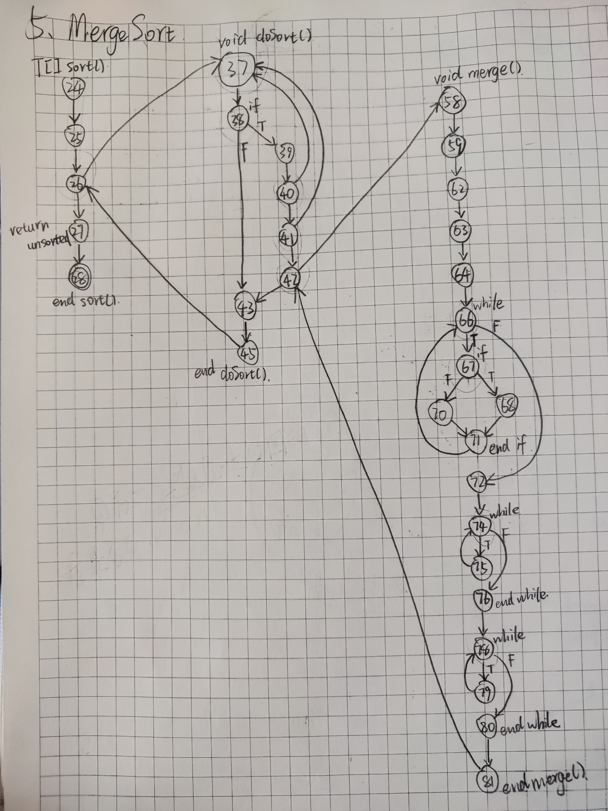

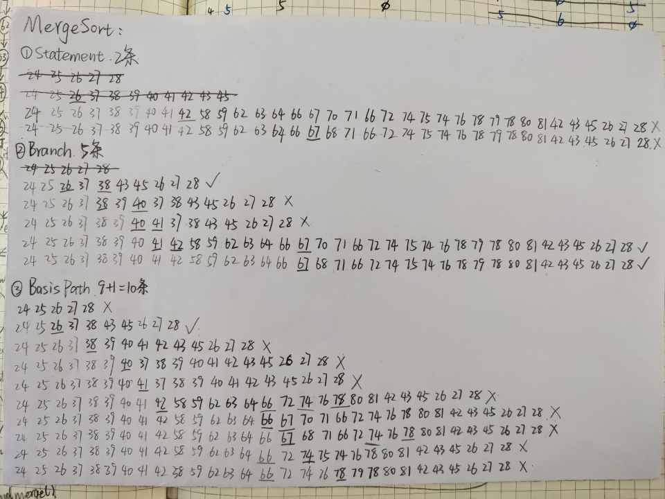

Q6. Generate test result reports

Q7. Discuss the following topic:
If all the methods in the source code that are tested and 100% All-Branch coverage is achieved, is it still possible for the program to fail?
If you agree, state some best practices to mitigate the risk of program failure.
Agree. It’s still possible to fail in program. Some methods to mitigate the risk are followed:
- Reminding the user to pay attention to the limitation of input in any GUI style.
- Reject the invalid data user input. Only accept the input if user input a valid data.
- Strengthening the robustness of program. Using more try-catch structure to find exceptions as more, and make them reminding the programmer with relative warning information in time.

4. Deliverables:

Report: Write a technical report that includes your answers to questions 1-6. Note that in addition to the correctness of your answers, the structure and quality of the report itself will also be evaluated.

Source code with test cases: Export your Eclipse project (including the source code and your JUnit tests) as a zip file.

5. Submission:

Archive both deliverables into a single zip file.

Name of the lab：Computing Center 2024.09.22

