this is a personal project, just to show my knowledge in HTML, CSS, JAVASCRIPT, REACT.

Currently this app has only two function, Todos & Blogs. I am focus on functions not looks of the website, therefore, the website looks bored.

Page views

Home page:

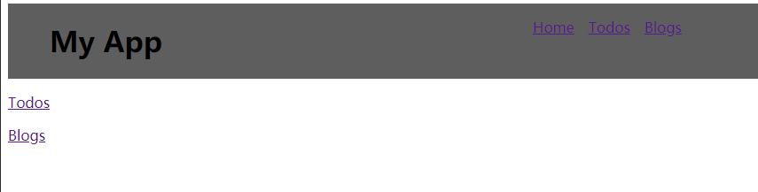

/todos

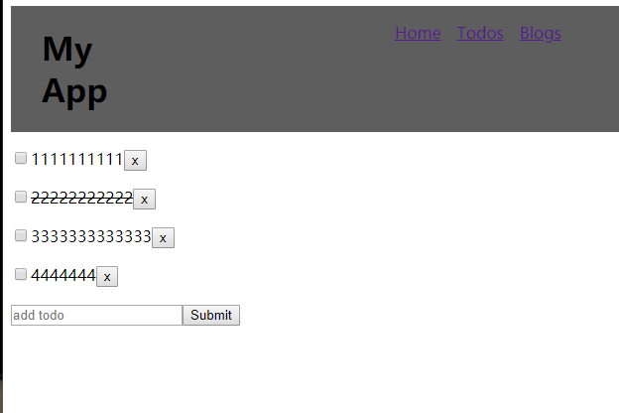

/blogs

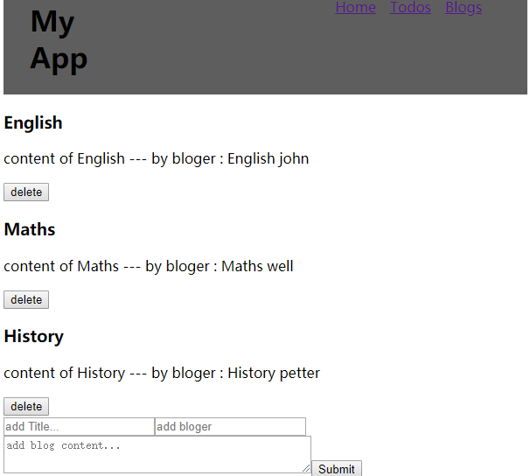

Functions

Add todos

Mark todos if completed

Delete todos

Add blog

Delete blog

Submit form

Improvement:

I will add a log in system later, so user has name for blogs make it reasonable to create blogs with blogger name.