HTML

1. css：cursor
2. 範本：<http://www.cnblogs.com/clwydjgs/p/10078065.html>

Android Studio

1. ERROR: This version of Android Studio cannot open this project, please retry with Android Studio 3.4 or newer

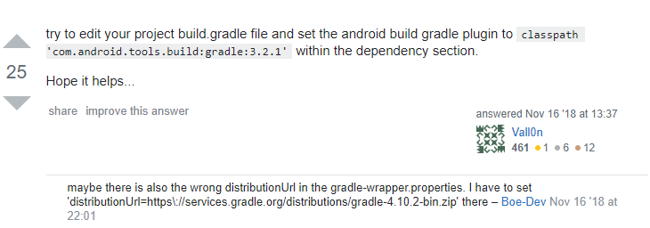

C:\Users\E901\Desktop\HW2\build.gradle

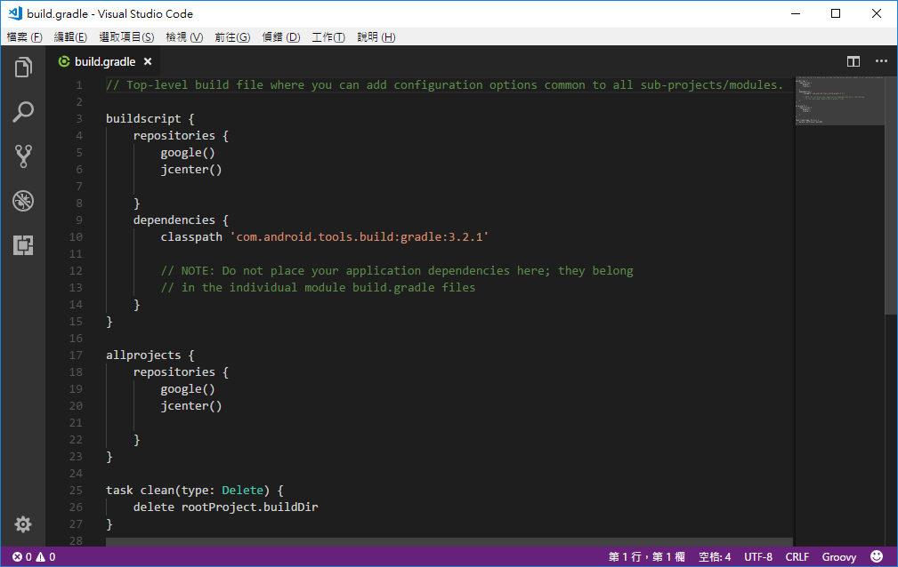

1. 自動排版

Ctrl+alt+L

1. 問題

tallyBook2_106行

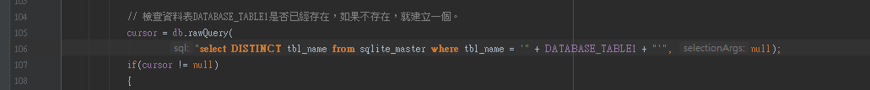

1. Simple_list_item_1

Android 內建的Layout，專門用於ListView的 Item

<http://aiur3908.blogspot.com/2015/06/android-listview.html>

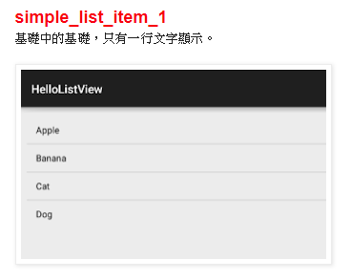

1. Java String.matches

檢查 A 字串 是否存在 B字串 -> a.matches(b) 回傳 T/F

git

1. git config --global user.name "QINGSHURUNINDEXINGMING"

git config --global user.email “[A6409001@g.pccu.edu.tw](mailto:A6409001@g.pccu.edu.tw)”

assembler language

1. install

C:\Users\E901\AppData\Local\DOSBox

mount c: C:\masm611

c:

1. debug

<http://www.mediafire.com/file/bopdmu16tav8thg/debug.zip>

1. Dosbox

<https://www.dosbox.com/>

1. All

<https://www.dosbox.com/wiki/Basic_Setup_and_Installation_of_DosBox>

<http://diy123.blogspot.com/2007/08/dosbox2.html>

Microsoft

1. 路徑：C:\Users\Luffy\AppData\Local\Packages\Microsoft.MicrosoftEdge_8wekyb3d8bbwe\TempState\Downloads

名詞

1. API&SDK

<https://blog.jyny.tw/2013/01/api-sdk.html>

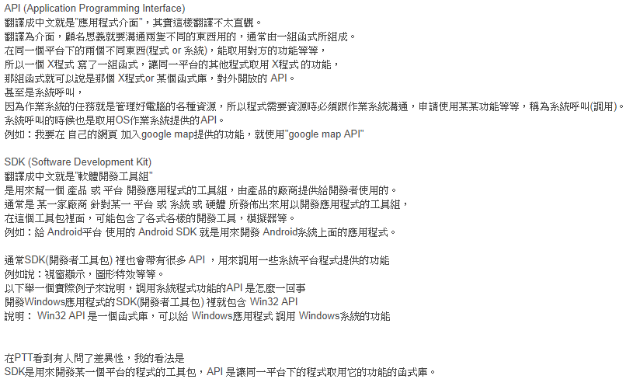

Algorithms



C#

1. D 或 d  十進位數字  
   Console.Write("{0:D5}", 25); //00025

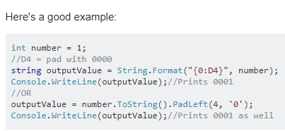

<https://blog.xuite.net/im2122/twblog/126234523-Asp.net+-+C%23+%E7%9A%84String.Format%E8%88%89%E4%BE%8B...>

<https://stackoverflow.com/questions/4325267/c-sharp-convert-int-to-string-with-padding-zeros>

<https://docs.microsoft.com/en-us/dotnet/standard/base-types/standard-numeric-format-strings#DFormatString>

<https://docs.microsoft.com/zh-tw/dotnet/api/system.string.format?view=netframework-4.8>

C#_MVC

1. Add column in table with ASP.NET identity

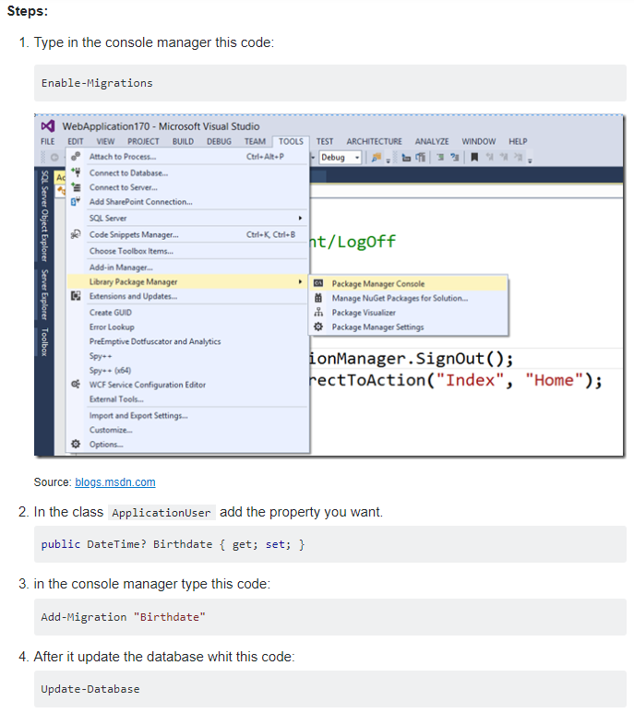

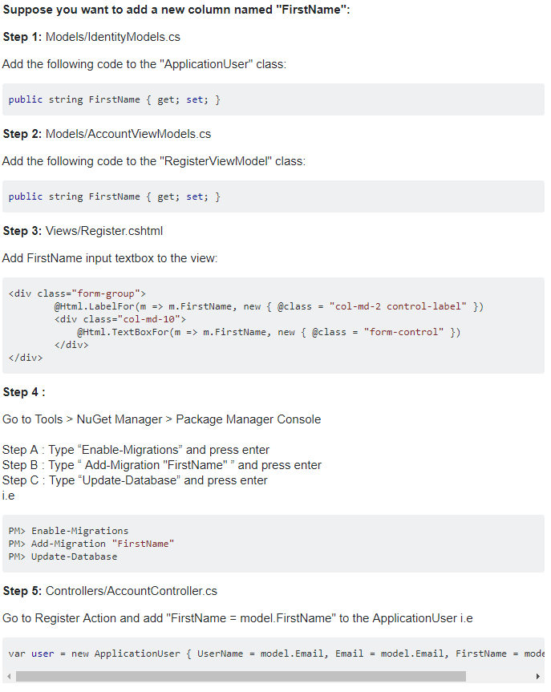

<https://stackoverflow.com/questions/33518872/add-column-in-table-with-asp-net-identity>

1. Hide or show the partial views based on roles

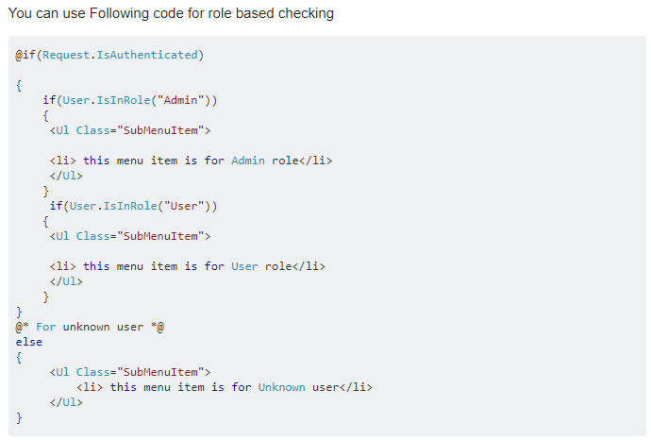

<https://stackoverflow.com/questions/11829937/how-to-show-or-hide-controls-based-on-roles-asp-net-mvc-4-razor>