HTML

1. css：cursor

Android Studio

1. ERROR: This version of Android Studio cannot open this project, please retry with Android Studio 3.4 or newer

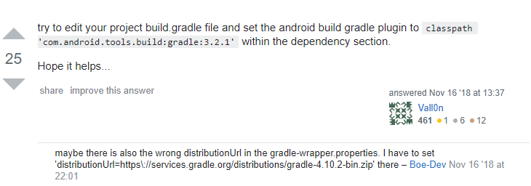

C:\Users\E901\Desktop\HW2\build.gradle

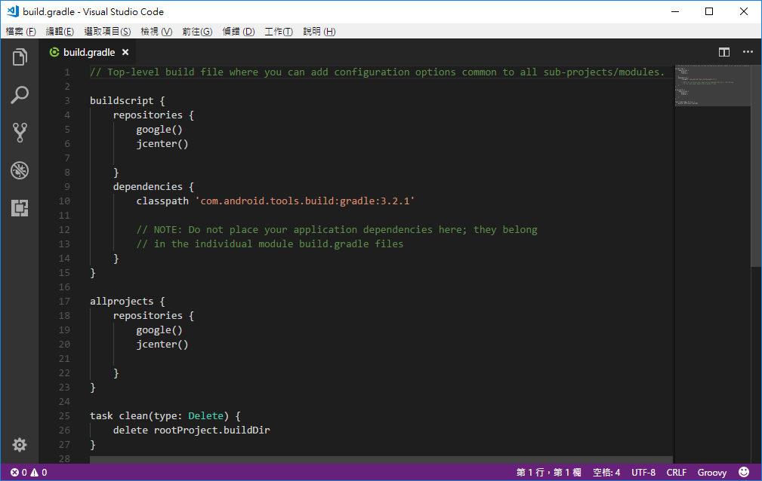

1. 自動排版

Ctrl+alt+L

1. 問題

tallyBook2_106行

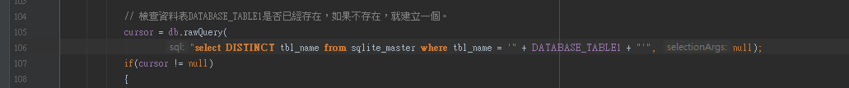

1. Simple_list_item_1

Android 內建的Layout，專門用於ListView的 Item

<http://aiur3908.blogspot.com/2015/06/android-listview.html>

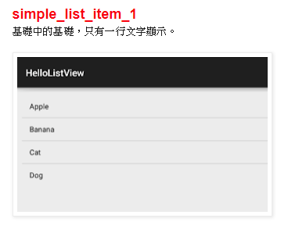

1. Java String.matches

檢查 A 字串 是否存在 B字串 -> a.matches(b) 回傳 T/F

git

1. git config --global user.name "QINGSHURUNINDEXINGMING"

git config --global user.email “[A6409001@g.pccu.edu.tw](mailto:A6409001@g.pccu.edu.tw)”