Data flow diagram (DFD) for hospital management

0.0

Hospital

management

system

Staff/Doctors

Administrator

Patient

Patient's Diagnosis

List of patients

Modified patients

details

Diagnosis

information

Patients

information

Patients

information

Discharge bill

0 level DFD for hospital management system

Patients information

Patient

**Database**

Patients information

**Database**

Appointment

info

Doctor

Patient's Diagnosis & medicine prescription

Update

1.1

Registration

1.2

Login

1.3

Appointment

1.4

Prescription

Verify

fetch

Admin

1.5

Payment

Admin login

Payment requests/verification

Bills/receipts

Doctor logs in

Update

Makes payment

1.6

Cancle

appointment

Update

1 level DFD for hospital management system

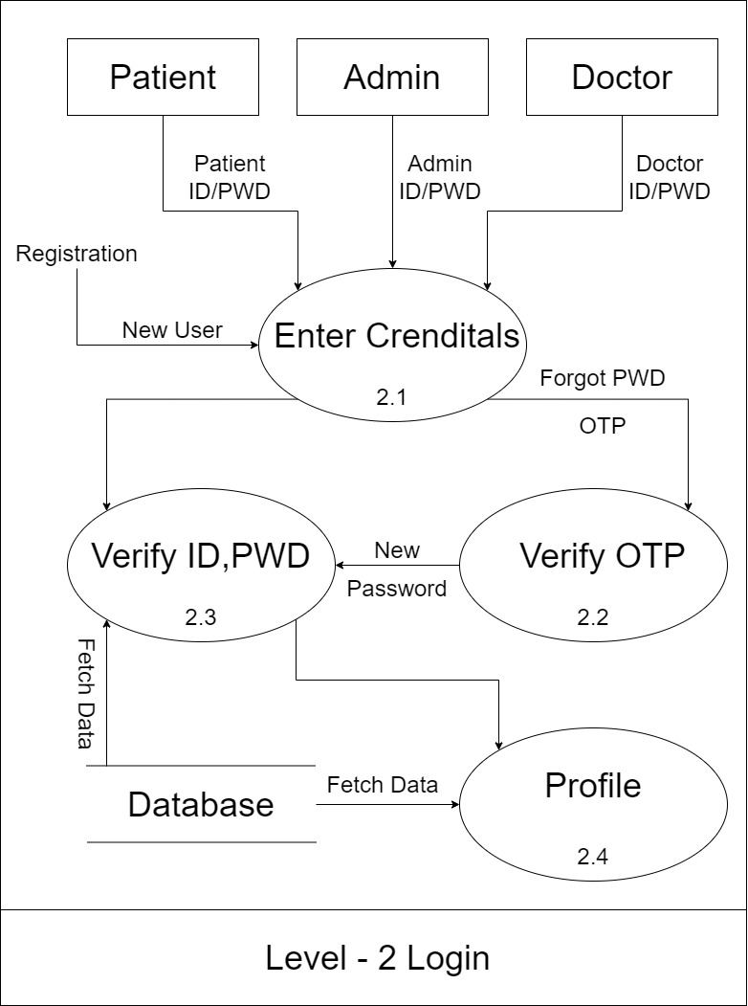

level 2 for Login

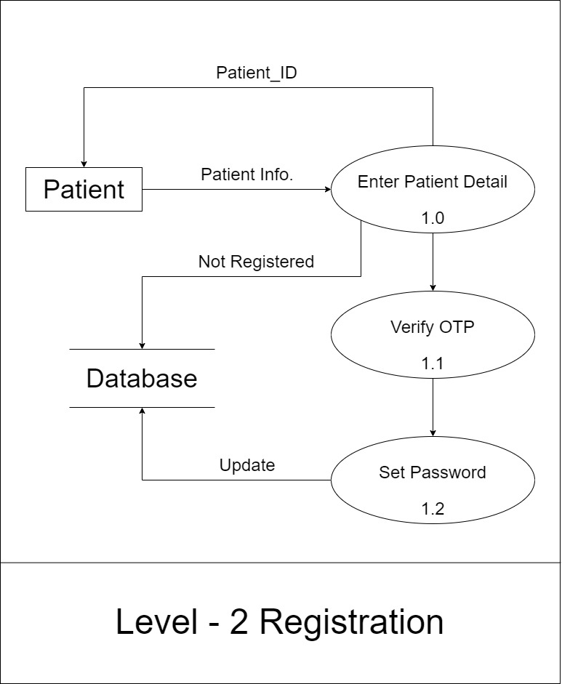

level 2 for Registration

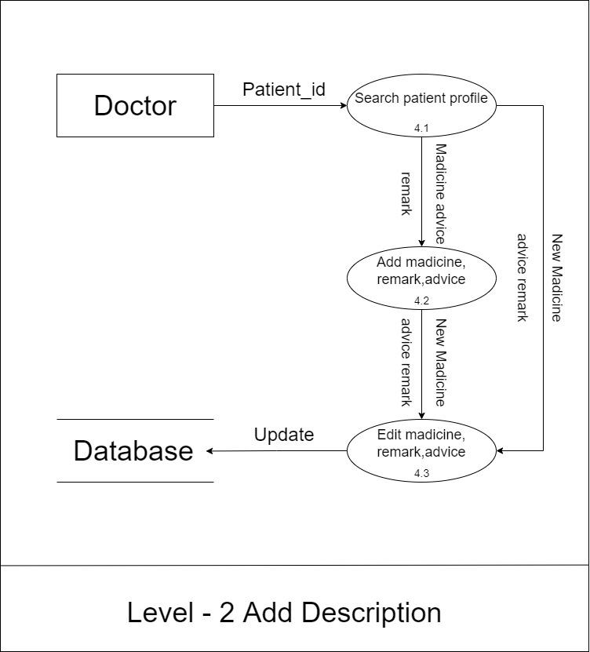

level 2 for Description

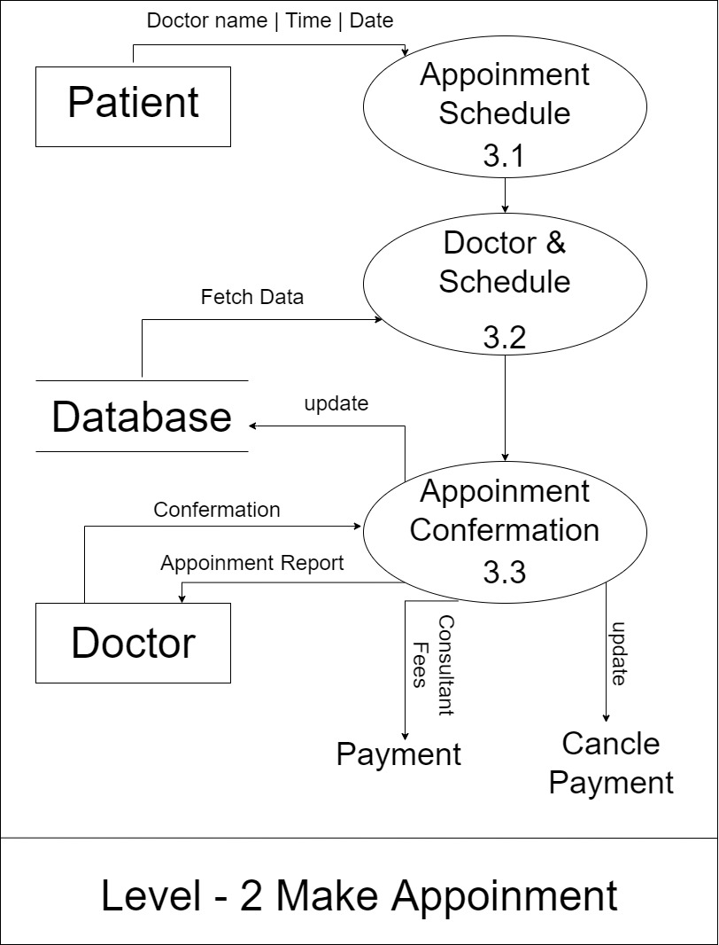

level 2 for Appointment

Data Dictionary of hospital management

Patient Information :

|  |  |
| --- | --- |
| Name | Patient |
| Alias | **-** |
| Where and how use | Patient info (input and output) |
| Description | Name + Age + phono + gender[male|female] |
| Format | Alphanumeric |

Doctor Information :

|  |  |
| --- | --- |
| Name | Doctor |
| Alias | **-** |
| Where and how use | Doctor info (input and output) |
| Description | Name + Age + phono + gender[male|female] + staff_id + (specialist) |
| Format | Alphanumeric |

Appointment:

|  |  |
| --- | --- |
| Name | Doctor |
| Alias | **-** |
| Where and how use | Appointment info (Input, Output) Doctor Management (Input, Output) |
| Description | Appointment info = inquiry_id + patient_id + date + doctor_id |
| Format | Alphanumeric |

Payment:

|  |  |
| --- | --- |
| Name | Payment |
| Alias | **-** |
| Where and how use | Bills/receipts |
| Description | Payment _info = Payment_id + patient_id + amount |
| Format | Alphanumeric |