Report

1.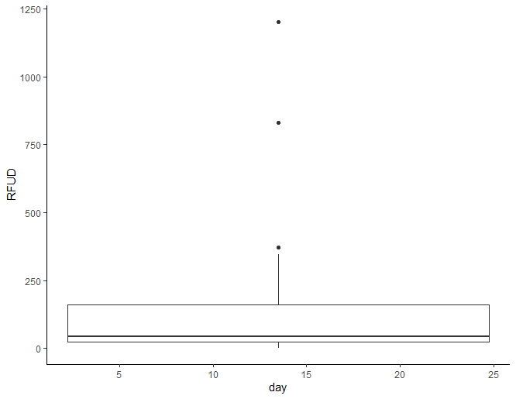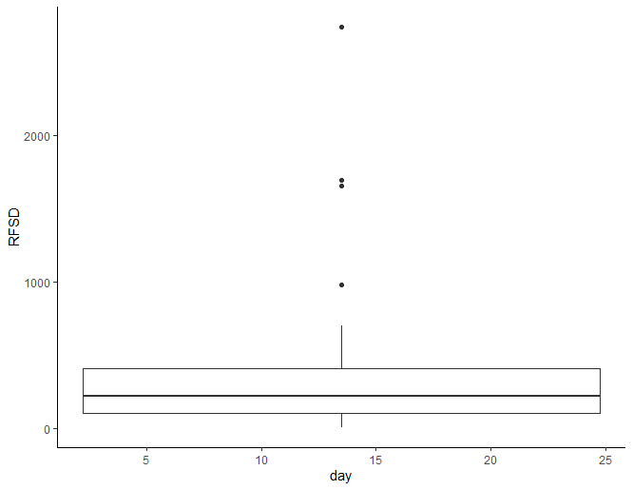

未播种降雨量主要集中在100以下，播种后雨量明显提升

1.2

Df Sum Sq Mean Sq F value Pr(>F)

RFSD 1 1808684 1808684 335.3 1.31e-15 ***

Residuals 24 129461 5394

---

Signif. codes:

0 ‘***’ 0.001 ‘**’ 0.01 ‘*’ 0.05 ‘.’ 0.1 ‘ ’ 1

云播种

2.1

Bone_type OIC_mean

<chr> <dbl>

1 Distal caudal 12.2

2 Dorsal vertebra 11.2

3 Femur 11.9

4 Gastralia 11.6

5 Metatarsal 11.8

6 Mid-caudal 11.6

7 Phalange 11.8

8 Proximal caudal 11.1

9 Rib 16 11.3

10 Tibia 11.8

1.2

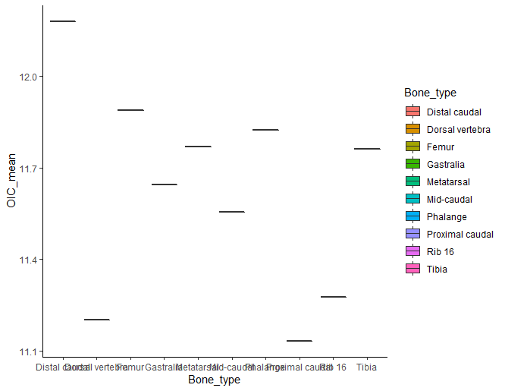Df Sum Sq Mean Sq F value Pr(>F)

RFSD 1 1808684 1808684 335.3 1.31e-15 ***

Residuals 24 129461 5394

---

Signif. codes:

0 ‘***’ 0.001 ‘**’ 0.01 ‘*’ 0.05 ‘.’ 0.1 ‘ ’ 1

猜测这种恐龙是恒温动物。

3．

people_type zine_mean

<chr> <dbl>

1 "" NA

2 "Nonpregnant vegetarians" 179.

3 "Pregnant nonvegetarians" 178

4 "Pregnant vegetarians" 177.

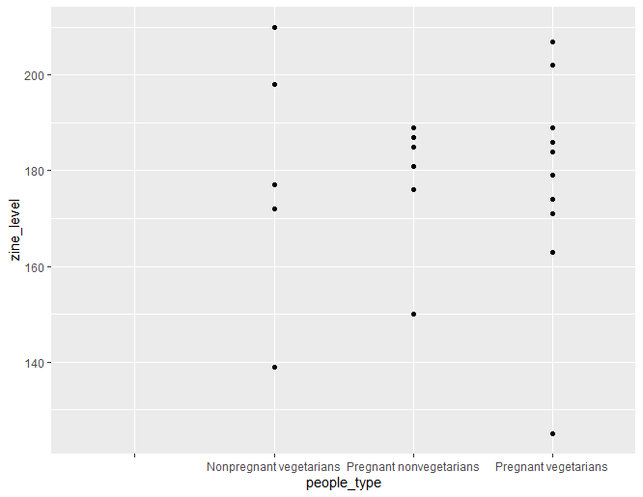

锌差异不是很明显

4

Call:

lm(formula = y ~ x)

Residuals:

Min 1Q Median 3Q Max

-1.71254 -0.25668 0.07508 0.27763 1.72303

Coefficients:

Estimate Std. Error t value Pr(>|t|)

(Intercept) 15.124887 0.948282 15.950 3.86e-06 ***

x -0.009312 0.001670 -5.577 0.00141 **

---

Signif. codes:

0 ‘***’ 0.001 ‘**’ 0.01 ‘*’ 0.05 ‘.’ 0.1 ‘ ’ 1

Residual standard error: 1.04 on 6 degrees of freedom

Multiple R-squared: 0.8383, Adjusted R-squared: 0.8113

F-statistic: 31.1 on 1 and 6 DF, p-value: 0.001411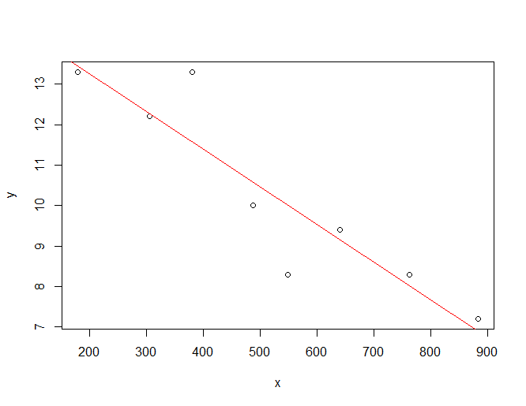

5.

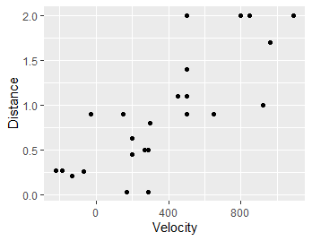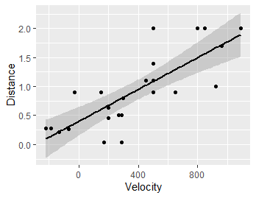

Call:

lm(formula = y ~ x)

Residuals:

Min 1Q Median 3Q

-1.71254 -0.25668 0.07508 0.27763

Max

1.72303

Coefficients:

Estimate Std. Error

(Intercept) 15.124887 0.948282

x -0.009312 0.001670

t value Pr(>|t|)

(Intercept) 15.950 3.86e-06 ***

x -5.577 0.00141 **

---

Signif. codes:

0 ‘***’ 0.001 ‘**’ 0.01 ‘*’ 0.05

‘.’ 0.1 ‘ ’ 1

7.使用R语言自带数据框plantgrowth

7.1 ctr1，trt1两种处理方式对树的生长影响大吗

Welch Two Sample t-test

data: ctr1_w and trt1_w

t = 1.1913, df = 16.524, p-value

= 0.2504

alternative hypothesis: true difference in means is not equal to 0

95 percent confidence interval:

-0.2875162 1.0295162

sample estimates:

mean of x mean of y

5.032 4.661

Residual standard error: 1.04 on 6 degrees of freedom

Multiple R-squared: 0.8383, Adjusted R-squared: 0.8113

F-statistic: 31.1 on 1 and 6 DF, p-value: 0.001411

7.2 trt1，trt2两种处理方式对树的生长影响大吗

Df Sum Sq Mean Sq F value

trt2_w 1 0.11 0.1098 0.158

Residuals 8 5.56 0.6949

Pr(>F)

trt2_w 0.701

Residuals

7.3

ctr1，trt2两种处理方式对树的生长影响大吗

Call:

lm(formula = y ~ x)

Residuals:

Min 1Q Median 3Q

-1.71254 -0.25668 0.07508 0.27763

Max

1.72303

Coefficients:

Estimate Std. Error

(Intercept) 15.124887 0.948282

x -0.009312 0.001670

t value Pr(>|t|)

(Intercept) 15.950 3.86e-06 ***

x -5.577 0.00141 **

---

Signif. codes:

0 ‘***’ 0.001 ‘**’ 0.01 ‘*’ 0.05

‘.’ 0.1 ‘ ’ 1

Residual standard error: 1.04 on 6 degrees of freedom

Multiple R-squared: 0.8383, Adjusted R-squared: 0.8113

F-statistic: 31.1 on 1 and 6 DF, p-value: 0.001411

