1.1

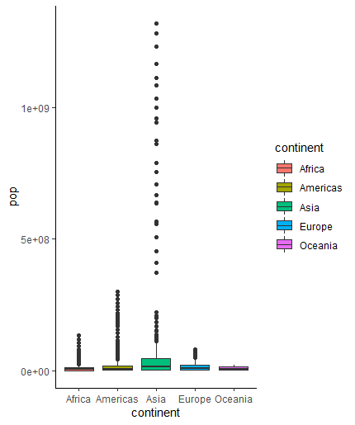

1.2

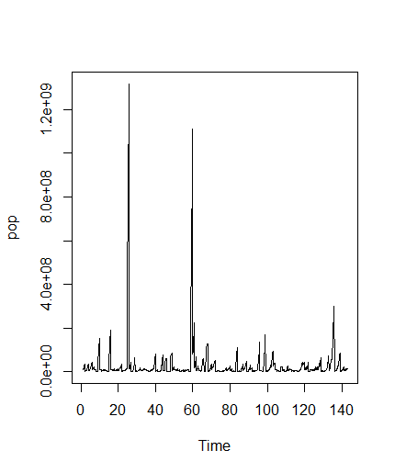

1.3

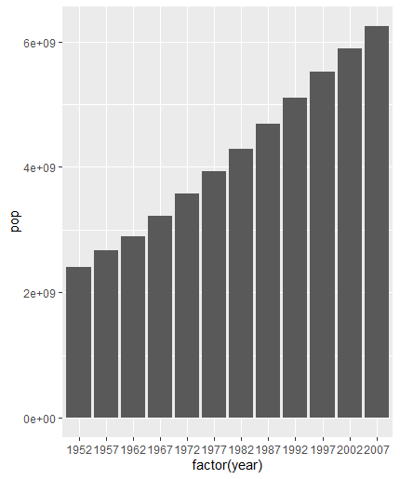

1.4

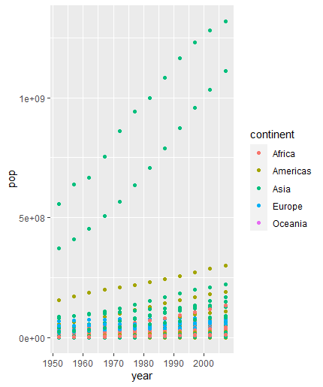

1.5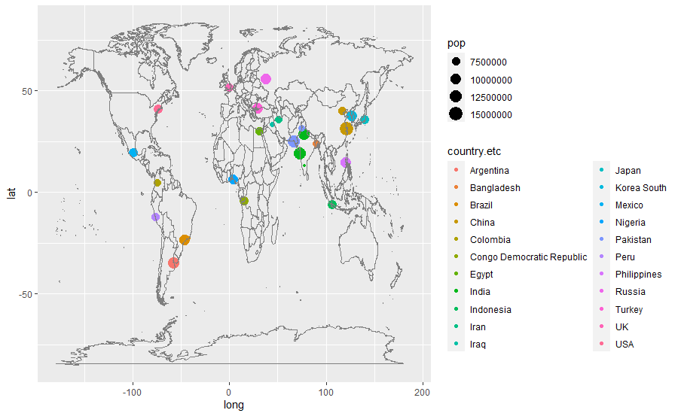

2.1

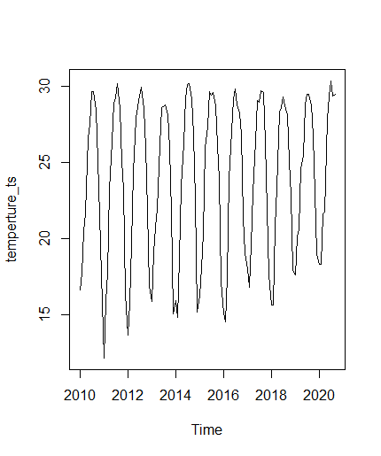

1.2

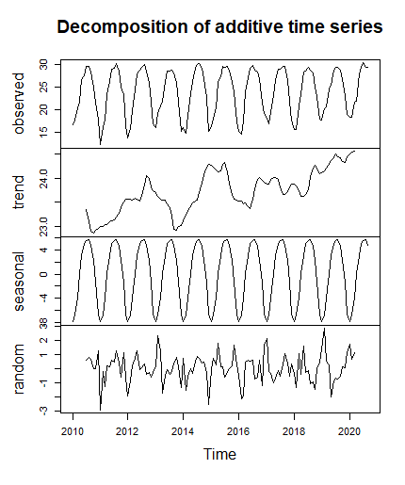

1.3

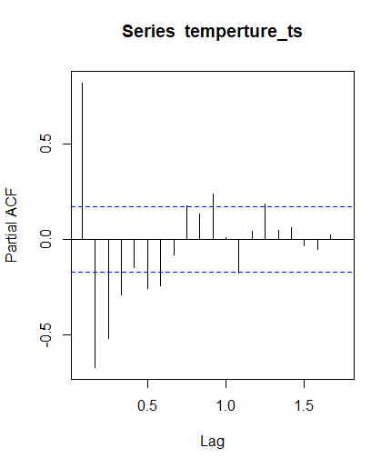

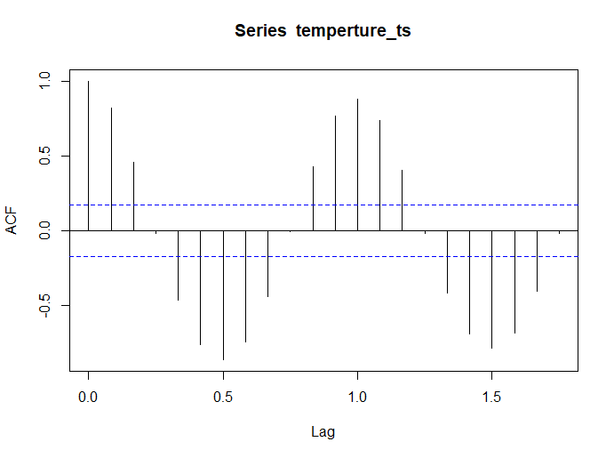

Series: temperture_ts

ARIMA(2,0,2)(0,1,2)[12] with drift

Coefficients:

ar1 ar2 ma1 ma2 sma1 sma2

1.2292 -0.7277 -1.0179 0.5665 -0.9055 0.0378

s.e. 0.2782 0.1642 0.3084 0.2005 0.1570 0.1231

drift

0.0088

s.e. 0.0028

sigma^2 estimated as 1.21: log likelihood=-182.18

AIC=380.37 AICc=381.7 BIC=402.46

PACF有明显拖尾，根据自拟合结果，选用sma2模型。

2.4

