En orange: les modifications effectuées le 24/04/2014

# Check of all Pv’s per Country vs Circumscription

## Issue 1 – The sum of the votes are not equal

**Description:** We noted by testing that the amount of votes that have been casted are not correctly displayed in the PV. On Figure 1 you can see a summary of what we voted in Singapore. When we look at the results on WEB2 (Figure 2), we can state that there are 4 votes for Citroen. However when we take a closer look at the PV (Figure 4) we see that the total amount of votes is 4, but only 3 votes are displayed in the detailed view.

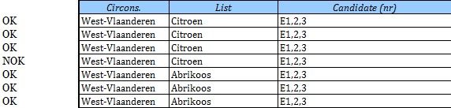

Figure 1

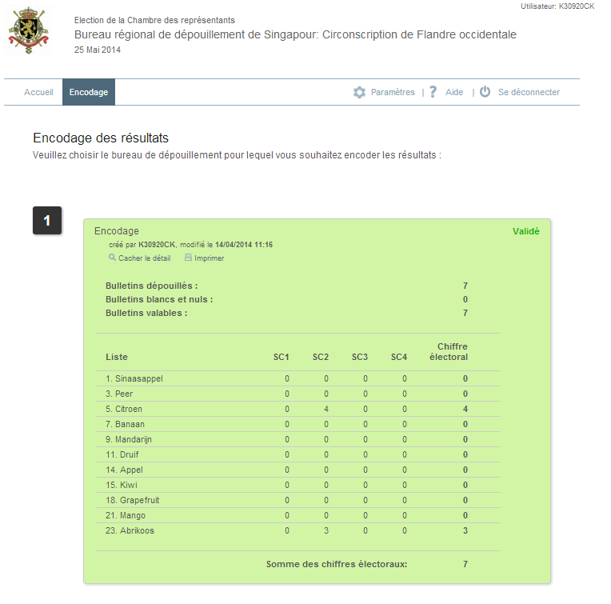

Figure 2

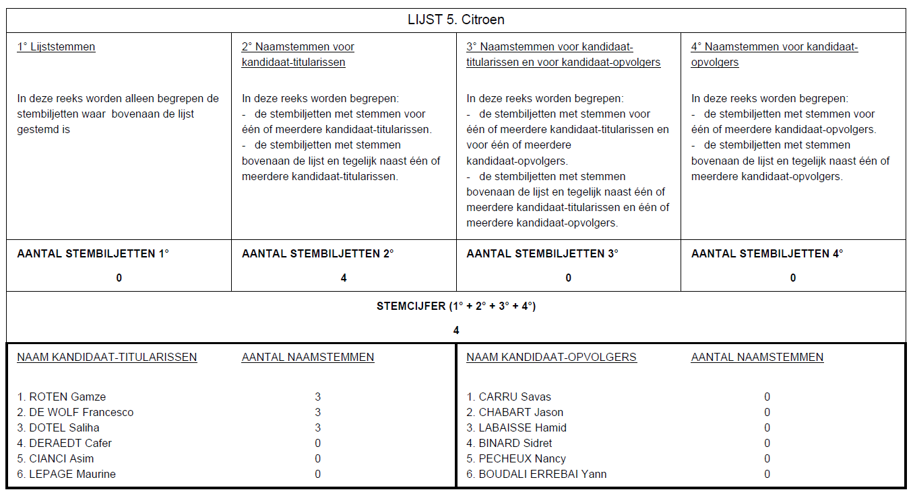

Figure 3

No modifications needed

## Issue 2 – Votes have been casted once the final PV was generated

### Location: Singapore

On Figure 4 we can see that the final PV was generated on 14/04/2014 at 14:44. When we look in the WEB 2 (Figure 5) we can see that there have been adjustments around 16:25 which should not be possible.

Finally on Figure 6 we see the results on which votes have been casted in Hainaut (Mandarine).

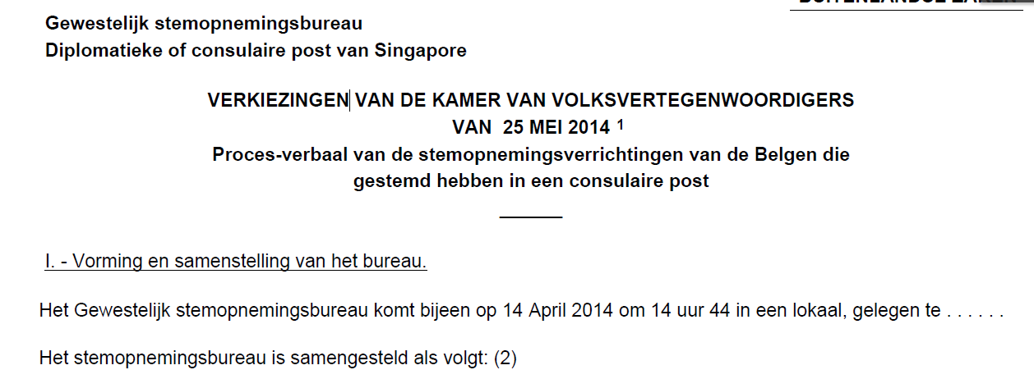

Figure 4

De resultaten voor Henegouwen werden blijkbaar nog eens aangepast omstreeks 16:25

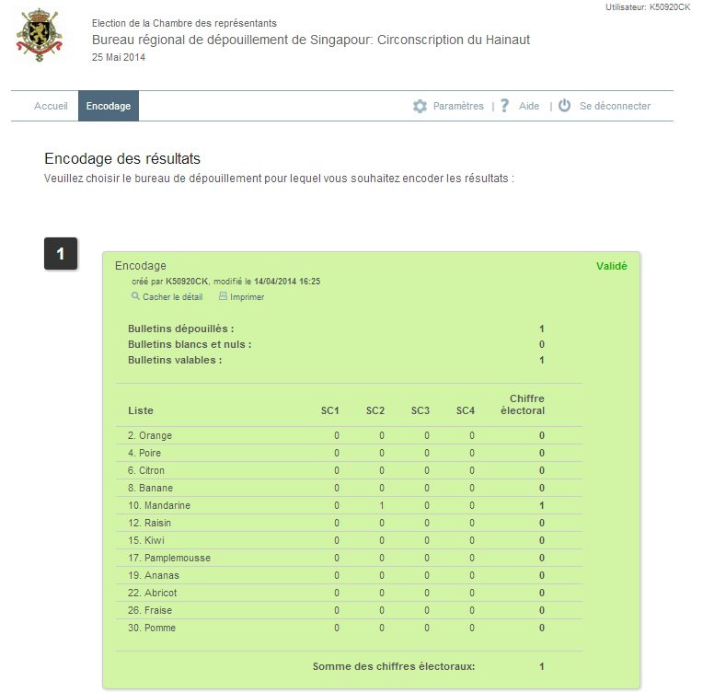

Figure 5

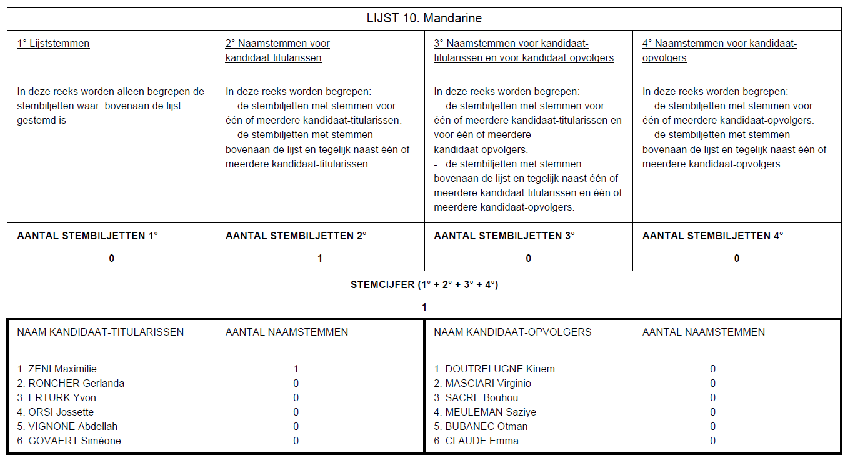

Figure 6

### Location: Kanton Brussel

The same issue is present for Kanton Brussels where the votes are not being displayed in the PV whilst votes have been casted. See (Figure 7,8)

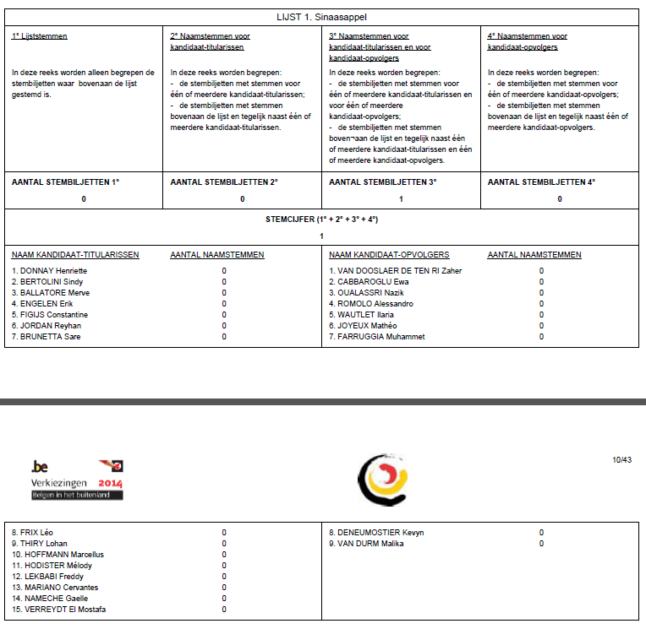

Figure 7

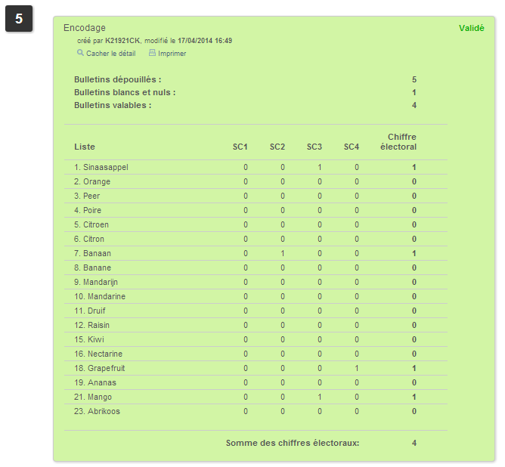

Figure 8

No modifications needed

## Issue 3 – All circumscriptions are in Antwerp.

We noted that all circumscription in the PV’s are ‘Antwerp’.

See Figure 9, 10, 11

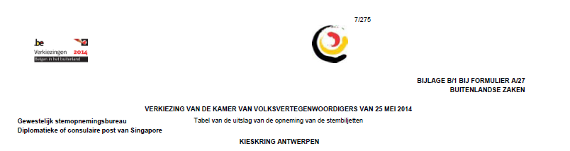

Figure 9

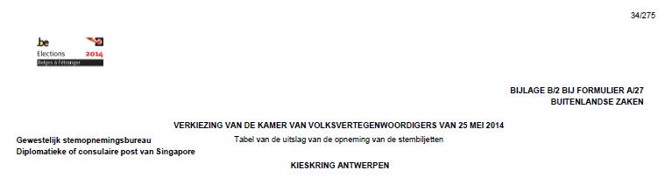

Figure 10

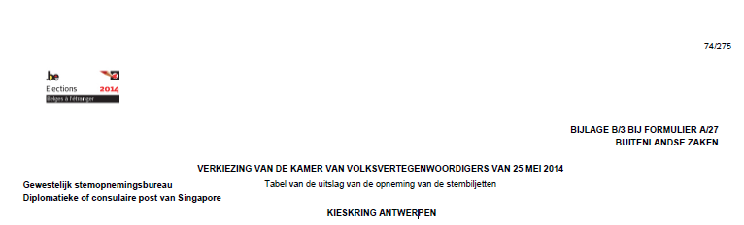

Figure 11

form/form-A27-fr.php: 427, 868

form/form-A27-nl.php: 431, 872

form/form-A28-fr.php: 83, 715

form/form-A28-nl.php: 83, 715

## Issue 4 – All 1K files are generated in ALGIERS

While reviewing the 1K files that we received from Henri Louvigny on 22/04/2014 at 10:13 we noted that all the 1K files were generated in Algiers (see Figure 12,13,14)while these should only be generated in Belgium



Figure 12



Figure 13



Figure 14

library/FormatF.php: 868, 881-884