(g)

The new optimal solution is 154 which matches my answer to part e.

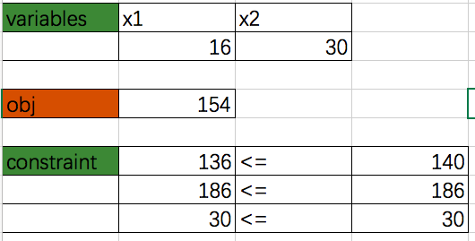

(h)

The new optimal solution is 173.71429, which increased by 23.71429. This results from the $∈$ is no longer smaller than what part f stated, which is 30.

