**GO**

USER MANUAL TEAM 1 (Christian Collier, Qingyue Li, Mark Ozdemir)

**Welcome to Go!** This is a two-player, turn-based game where each player has the opportunity to lay down one stone on an empty intersection during his or her turn. A player wins the game by successfully connecting five stones of his or her color in an unbroken horizontal, vertical, or diagonal line before the other player does. Colors are randomly assigned at the beginning of the game. Black moves first.

To launch the game client, run the command *java GoServer*, followed by the server connection information and the mode in which you wish to play.

Connecting to the game server: Type your IP address, followed by a space, and then the port number 11732.

Playing in human mode: To play against another human player, type *human* after the connection information. If there is already a human player waiting for an opponent, you will be matched with that player. Otherwise, your game will wait to begin until after another human player has connected to the server.

*Example command with IP address 141.161.133.140:* 141.161.133.14011732 human

Playing in AI mode: To watch two AIs play against each other, type *ai* after the connection information. Like in human mode, the game will commence after two separate clients have connected to the server.

*Example command with IP address 141.161.133.140:* 141.161.133.14011732 ai

How the Game Runs: Our particular Go program makes it so that the person who is assigned the black circles goes first. The values as to which user gets assigned which color are displayed in the screen as received: /white or received: /black, where black and white are the respective colors. The game then proceeds with users placing their respective pieces on the remaining free spaces on the board. In order to place a stone on the board, the user must click where a horizontal and vertical line intersect, like in the image below. This process continues until a winning board is found, which is whenever there is a pattern of five-in-a-row pieces horizontally, vertically or diagonally. When a winner is found, the results are then displayed in the window with either You Win or You Lose. Otherwise, the plays are sent back and forth between players.

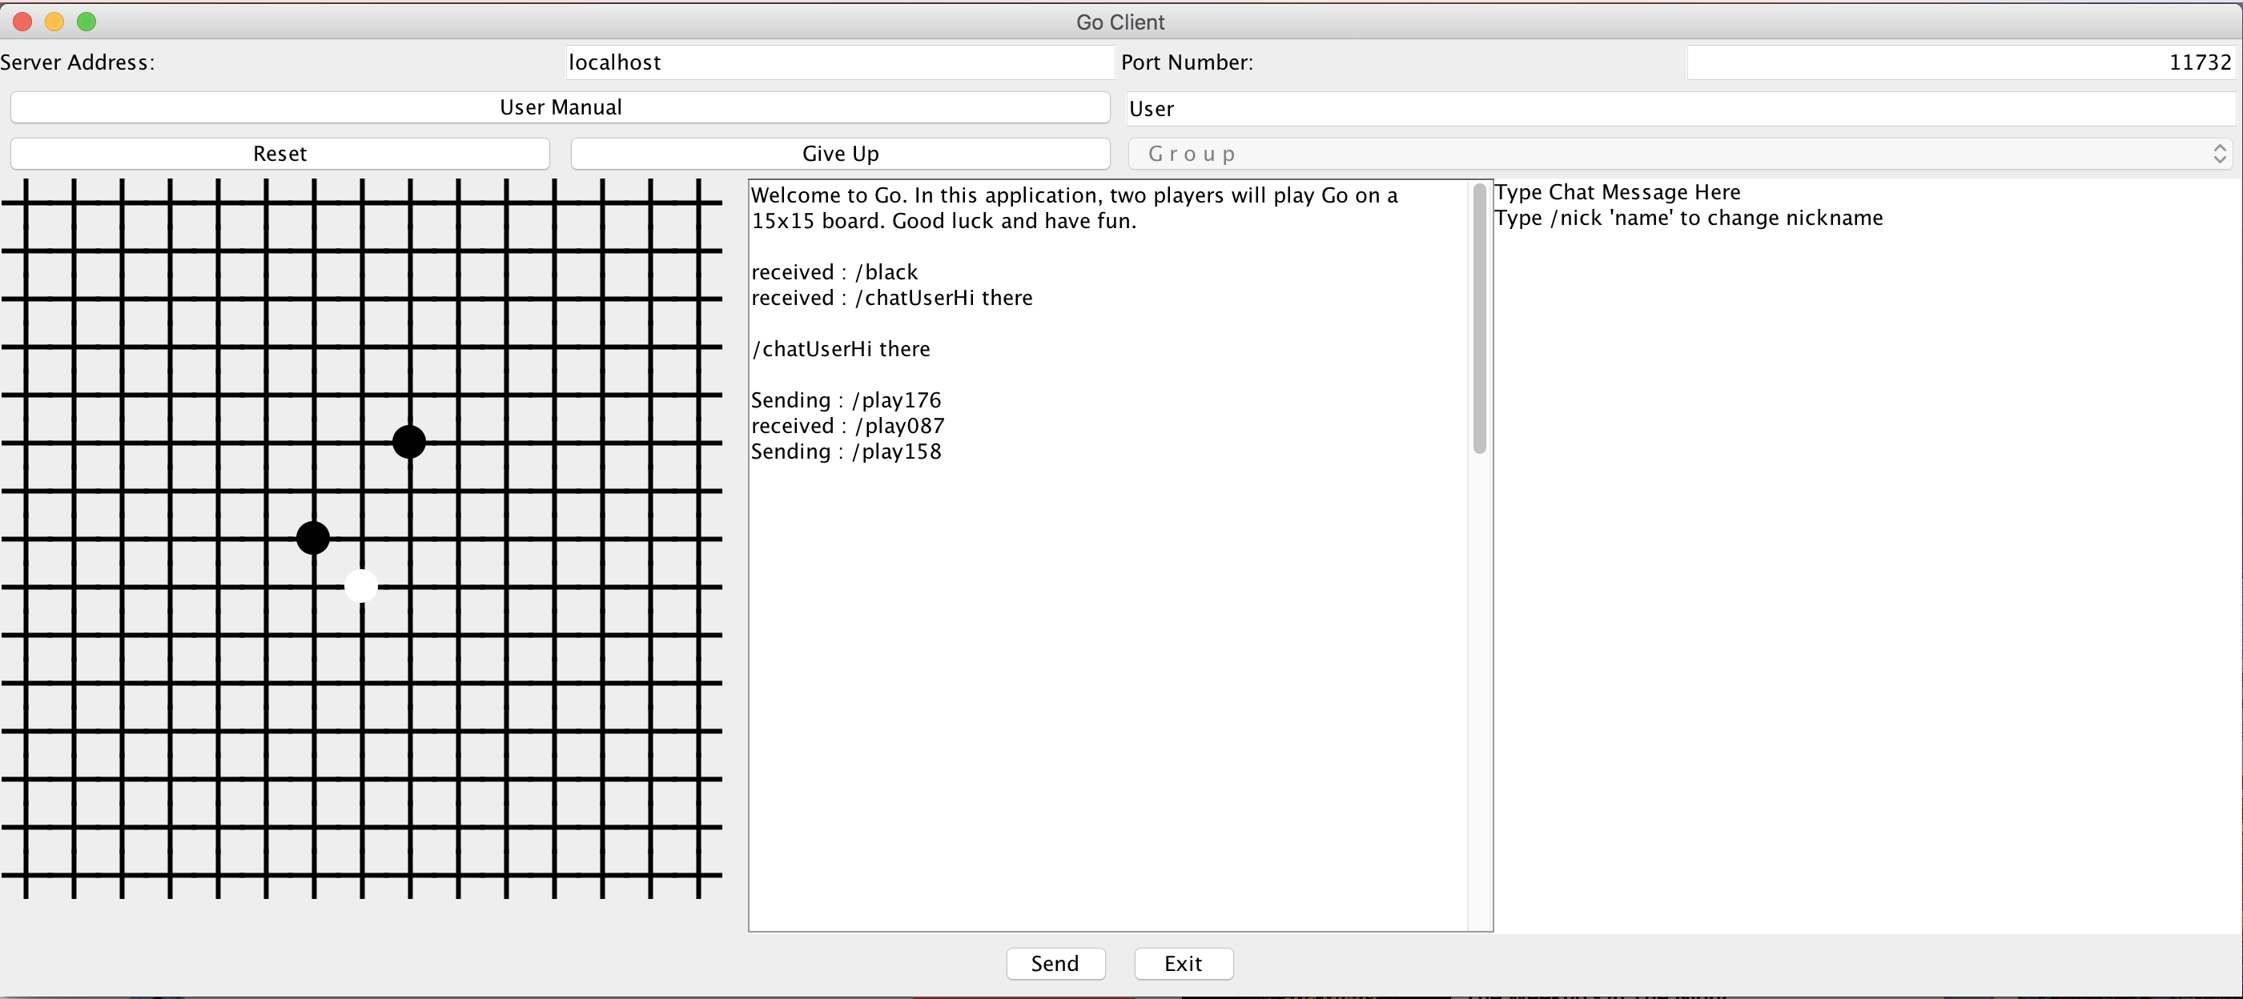

For the human users, if a user wants to chat with their respective opponent at any point in the match, they can enter text in the text window to the right. Once they type what they want to say, they press enter, and the message will appear in the chat window. The text box can also be used to change a human user’s nickname when playing against another human user.

Moreover, at any point in the game, a user can click the “Give Up” button and effectively end the game and leave the users idle. Alternatively, a user can also press the “Reset” button, which will start the game over again for the two users. Note, this only works if both opponents press the Reset button to reset a game and this will only work in human mode.