Team 2: Java Project

MSDS / HazMat Management Program

Object Oriented Programming 3324 - Prof. Alihan

April 30th, 2021

Overview:

Material Safety Data Sheets are documents used to inform users about hazards such as flammability or reactivity and how to use the product safely. They are standardized record system for government, professional or industrial work environment where serious events can happen quickly and being able to reference them quickly to reduce further damage.

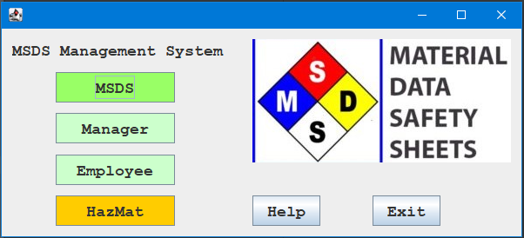

Figure

MSDS Entry:

Our Java program uses Swing for the application side. The MSDS functions show a display of a sample workplace's items, and in tabular form shows the various parts of an MSDS sheet. In this, the sample .csv is displayed.

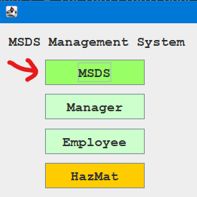

Figure

*Figure 2* MSDS can be accessed by clicking the MSDS button on the main application form after executing.

The MSDS Table shown in *Figure 3* can Load Entries from the CSV file as well as Create New Entries, Remove Entries, and Save the changes back to the original CSV file. Depending on the current log in only the Manager and the Issuer have the ability Create, Remove, and Save. All others can only load and view the data. 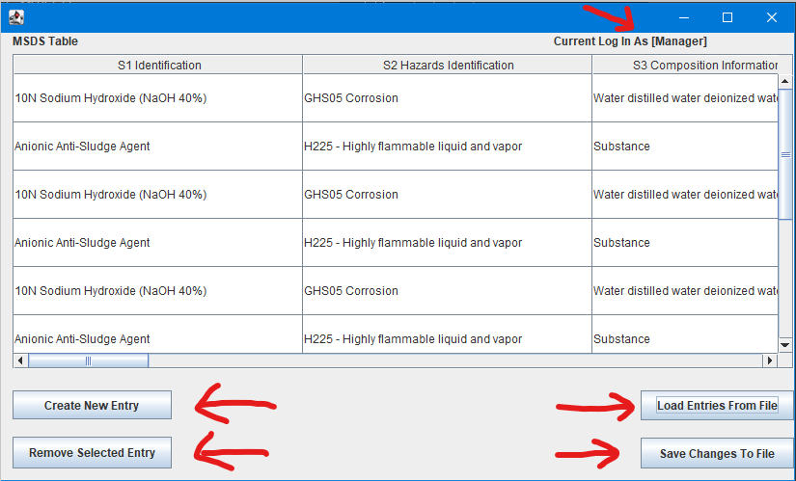

Figure



Figure

*Figure 4* HazMat can be accessed by clicking the HazMat button on the main application form after executing

HazMat Materials Management:

Hazardous Materials Management, commonly shortened to "HazMat" in industry, is the second aspect of our program. HazMat involves tracking elements that are currently in the workplace, how much, where it is located, and the category it falls under ( Toxic, etc).

The purpose of such an application serves as a digital reference for employees to manage inventory and can be used to train employees and reduce ignorance of hazardous materials. Some compounds sound, smell, or look benign but may be very explosive or neurotoxic.

In an industry level application, more specific roles and permissions would be implemented such as employee, cleaners, managers, and such. Deletion permissions of events that happen should be tightly controlled for investigation reasons.

Team 2: Patrick Carroll, James Montis, Aaron Fortner