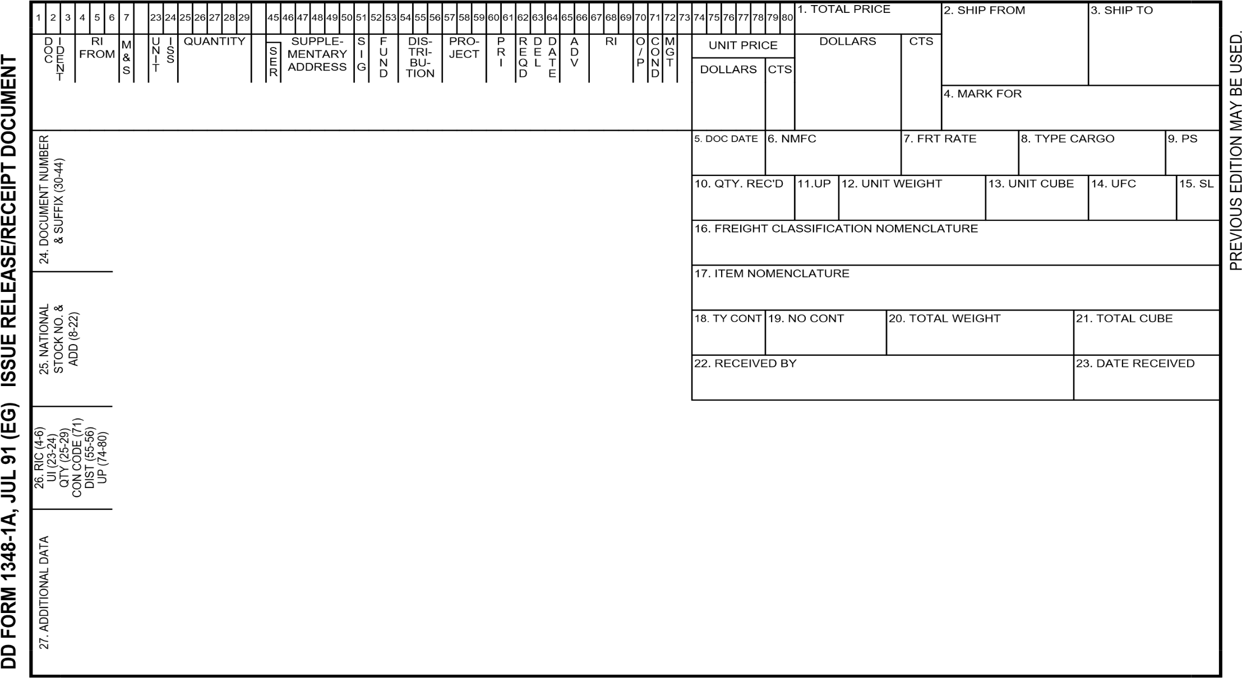

**SG4310**

**W81UBU**

**00**

**12000**

**EA 00001 N A H**

**TRUCK, CARGO**

**POC:**

John Doe

Phone 123-456-7890

Email John.Doe@mail.mil

**12000**

**00**

2320-01-494-5874

W81UBU12341234