*7.1 (Assign grades) Write a program that reads student scores, gets the best score, and then assigns grades based on the following scheme:

Grade is A if score is >best - 10

Grade is B if score is > best - 20;

Grade is C if score is > best - 30;

Grade is D if score is > best - 40;

Grade is F otherwise.

The program prompts the user to enter the total number of students, then prompts the user to enter all of the scores and concludes by displaying the grades. Here is a sample run: 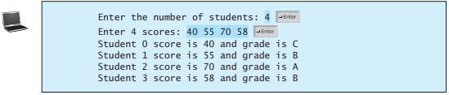

|  |
| --- |
| package assigngrades;  import java.util.*;  public class AssignGrades {  public static void main(String[] args) {  Scanner input = new Scanner(System.in);  int student,best=0;  String[] grade = {"A","B","C","D","F"};  System.out.print("Enter the number of student: ");  student = input.nextInt();  int[] score = new int[student+1];  System.out.print("Enter "+student+" scores: ");  for(int a=0;a<student;a++){  score[a] = input.nextInt();  if(score[a] >= best){  best = score[a];  }  }  for(int a=0;a<student;a++){  System.out.print("Student "+(a)+" score is "+score[a]+" and grade is ");  if(score[a]>=(best-10)){  System.out.print(grade[0]);  }else{  if(score[a]>=(best-20)){  System.out.print(grade[1]);  }else{  if(score[a]>=(best-30)){  System.out.print(grade[2]);  }else{  if(score[a]>=(best-40)){  System.out.print(grade[3]);  }else{  if(score[a]<(best-40)){  System.out.print(grade[4]);  }}}}}  System.out.println();  }  }  } |

**7.3 (Count occurrence of numbers) Write a program that reads the integers between 1 and 100 and counts the occurrences of each. Assume the input ends with 0. Here is a sample run of the program:

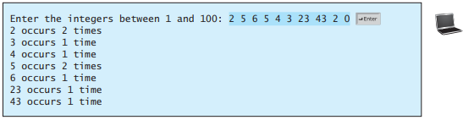

|  |
| --- |
| package countoccurrenceofnumbers;  import java.util.*;  public class CountOccurrenceOfNumbers {  public static void main(String[] args) {  Scanner input = new Scanner(System.in);  int[] integers = new int[100];  int[] times = new int[100];  int exit,a=0;  System.out.print("Enter the integers between 1 anf 100: ");  do{  exit = input.nextInt();  if(exit!=0){  if(integers[exit]==exit){  times[exit]++;    }else{  integers[exit] = exit;    times[exit]++;  }  a++;  }  }while(exit!=0);    for(int b=0;b<a;b++){  if(integers[b]!=0){  System.out.print(integers[b]+" occurs "+times[b]);  if(times[b]>1){  System.out.println(" times");  }else{  System.out.println(" time");  }  }else{  if(a<100){  a++;  }  }  }    }  } |

7.8 (Average an array) Write two overloaded methods that return the average of an array with the following headers:

public static int average(int[] array)

public static double average(double[] array)

Write a test program that prompts the user to enter ten double values, invokes this method, and displays the average value.

|  |
| --- |
| package averageanarray;  import java.util.Scanner;  public class AverageAnArray {  public static void main(String[] args) {  Scanner input = new Scanner(System.in);  double[] array = new double[10];  int averageInt;  double averageDouble = 0;  System.out.println("Enter 10 double value: ");  for(int a=0;a<array.length;a++){  array[a] = input.nextDouble();  }  averageInt = (int)average(array);  averageDouble = average(array);  System.out.println("Average Int = "+averageInt);  System.out.println("Average Double = "+averageDouble);  }    public static int average(int[] array){  int average = 0;  for(int a=0;a<array.length;a++){  average+=array[a];  }  return average/array.length;  }    public static double average(double[] array){  double average = 0;  for(int a=0;a<array.length;a++){  average+=array[a];  }  return average/array.length;  }  } |

7.9 (Find the smallest element) Write a method that finds the smallest element in an array of double values using the following header:

public static double min(double[] array)

Write a test program that prompts the user to enter ten numbers, invokes this method to return the minimum value, and displays the minimum value. Here is a sample run of the program:



|  |
| --- |
| package findthesmallestelement;  import java.util.*;  public class FindTheSmallestElement {  public static void main(String[] args) {  Scanner input = new Scanner(System.in);  double[] num = new double[10];  System.out.print("Enter ten numbers: ");  for(int a=0;a<num.length;a++){  num[a] = input.nextDouble();  }  System.out.print("The minimum numbers is: "+min(num));  }    public static double min(double[] array){  double min = array[1];  for(int a=0;a<array.length;a++){  if(min>=array[a]){  min = array[a];  }  }  return min;  }    } |

***7.35 (Game: hangman) Write a hangman game that randomly generates a word and prompts the user to guess one letter at a time, as shown in the sample run. Each letter in the word is displayed as an asterisk. When the user makes a correct guess, the actual letter is then displayed. When the user finishes a word, display the number of misses and ask the user whether to continue to play with another word. Declare an array to store words, as follows:

// Add any words you wish in this array

String[] words = {"write", "that", ...}; 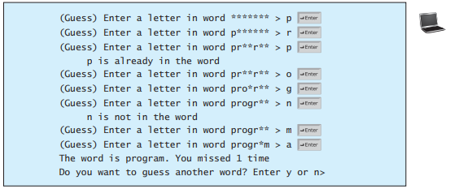

|  |
| --- |
| package gamehangman;  import java.util.*;  public class GameHangman {  public static void main(String[] args) {  Scanner input = new Scanner(System.in);  String play;  do {  char[] word = getWord();    // Display each letter in the word as an asterisk.  char[] asterisks = new char[word.length];  fillAsterisks(asterisks);  int missed = 0;  do {  char guess = getGuess(asterisks);    if (!isCorrectGuess(word, asterisks, guess))  missed++;    } while (!isWordFinish(asterisks));    print(word, missed);    System.out.println("Do you want to guess another word? Enter y or n>");  play = input.next();  } while (play.charAt(0) == 'y');  }  public static char[] getWord() {  String[] words = {"write", "that", "program", "monkey", "rooster", "dog",  "pig", "rat", "ox", "tiger", "rabbit", "dragon", "snake",  "horse", "sheep"};  String pick = words[(int)(Math.random() * words.length)];  char[] word = new char[pick.length()];  for (int i = 0; i < word.length; i++) {  word[i] = pick.charAt(i);  }  return word;  }  public static void fillAsterisks(char[] list) {  for (int i = 0; i < list.length; i++) {  list[i] = '*';  }  }  public static boolean isCorrectGuess(char[] word, char[] blanks, char guess) {  boolean correct = false;  int message = 2;  for (int i = 0; i < word.length; i++) {  if (word[i] == guess) {  correct = true;  if (blanks[i] == guess)  message = 1;  else {  blanks[i] = guess;  message = 0;  }  }  }  if (message > 0)  print(message, guess);  return correct;  }  public static boolean isWordFinish(char[] blanks) {  for (char e: blanks) {  if (e == '*')  return false;  }  return true;  }  public static void print(char[] word, int missed) {  System.out.print("The word is ");  System.out.print(word);  System.out.println(" You missed " + missed + " time");  }  public static void print(int m, char guess) {  System.out.print("\t" + guess);  switch (m) {  case 1 : System.out.println(" is already in the word"); break;  case 2 : System.out.println(" is not in the word");  }  }  public static char getGuess(char[] asterisks){  Scanner input = new Scanner(System.in);  System.out.print("(Guess) Enter a letter in word ");  System.out.print(asterisks);  System.out.print(" > ");  String g = input.next();  return g.charAt(0);  }  } |