**The impact of the Uncanny Valley effect on the perception of animated three-dimensional humanlike characters**

The final publication is available at Springer via https://link.springer.com/article/10.1007/s40869-017-0041-8

**Introduction**

With the recent increase in the release of animation feature films and the increase in realism in these animation films, especially in films such as Polar Express (2004) and Beowulf (2007) the problem of cognitive dissonance as experienced by viewers has led filmmakers and animators to question the origins of this problem and how can it be bridged. The term coined for this problem is the 'uncanny valley hypothesis', which was proposed in 1970 by the robot designer, Mori (McDonnell, Jorg and McHugh, 2008).

Mori proposed a hypothetical graph which predicts that the more human a robot looks, the more familiar it is, until a point is reached at which subtle imperfections make the robot seem eerie. Mori (2012:2) described how someone might look at a prosthetic hand that looks very realistic, causing feelings of affinity in the viewer, until the hand is touched, causing the sense of affinity to be replaced by a feeling of eeriness or repulsion. On the graph this can be represented by a negative measure. This valley or dip in the graph appears just before total human likeness is achieved.

Up to now, most scientific research concerning the uncanny valley hypothesis involved mechanical robots and 2D still images. In previous research the effect of the uncanny valley was tested on either the look of the characters or the emotions (facial animation) or the locomotive expressions (body movements) of characters using mostly still images, but never in combination with animation.

One of the challenges is modelling characters of great visual faithfulness and behavioural authenticity that overcomes the uncanny valley. It is necessary to identify the pitfalls and to make young character designers aware of ways to avoid them.

Against this background, the purpose of this paper is to answer the following research question: How does the uncanny valley affect the perceptions of viewers that observe the combined emotional and expressive locomotion of different stylized animated humanlike characters rendered in different character styles?

The research primarily examined the impact of these different character designs on the uncanny valley effect. The methodology was to change the look of the characters in each short film while keeping the animation the same, hoping it would reveal which style of character was influenced most by the uncanny valley effect.

Four short films were produced. Each film used a different character style, namely Toon; Pixar; Realistic CG, and Real Human Actor. These different character styles were the Independent Variables due to changes applied.

There were two research objectives to this study:

- To assess the response of audiences to the uncanny valley when observing different types of animated 3D characters.

- To assess the response of audiences when watching animation films rendered in different styles.

**Previous research**

According to Hodgins, O’Brien and Tumblin (1998:101) people are experienced at observing subtleties in human movement and that the animation of human figures has long been considered as a significant, but challenging, problem in computer animation.

Chaminade, Hodgins and Kawato (2007:207, 213) investigated how the visual appearance of characters acts upon the perceptual experience of their actions. In the study participants were introduced to various characters animated either with motion data captured from human actors or by altering between key-framed poses configured by an animator, and were required to categorize the characters' movement as biological or artificial. They deliberately applied a simplistic ordinary running motion to ensure all the volunteers taking part in the experiment owned a subjective experience with the natural action.

Chaminade et al. found that movements generated with anthropomorphic characters are perceived as more artificial or more eerie. Participants' reactions prefer ‘biological’ motion, derived from the Signal Detection Theory, and lessen with characters’ anthropomorphism, whilst sensitivity is only affected by the most simplistic rendering style.

According to Chaminade et al. (2007:213) imperfections of both characters and motions could more readily cause the unfavourable emotional reaction demanded by the ‘uncanny valley’ theory for the more anthropomorphic characters.

Unuma, Anjyo and Takeuchi (1995:91) described the processes for modelling kinetic movement of the human figure with emotions, including methods for controlling key-framed or motion capture data. They found that each technique holds its own strengths and weaknesses, attaining the visual comparability of crucial outcomes, particularly for the rating of such subjective qualities as naturalness and emotional expression.

To produce the animation clips for their trials, Unuma et al. (1995:95) changed only the motion and the geometric models utilised; all other features of the rendering were kept unchanged. They stated that it would be interesting to research whether, and how, some other aspects of the rendering would bear upon the observation of movement as well as whether these answers hold true for behaviours other than the running motion used in their study. Unuma et al. (1995:95) postulated that more advanced models that integrate clothing and skin may help to smooth out fast speedups of the limbs and cause the movement to look more lifelike.

Alexander et al. (2009:1) undertook a project known as the 'Digital Emily project'. They set out to achieve an animated, photo real digital face based on the face of a real living person, actress Emily O’Brien. This allowed for absolute comparability between the facial performance of the actress and a synthesized version of it. According to Alexander et al. the cardinal prerequisites for a digital actor to look realistic enough for feature film work is that it should look realistic from any point of view, any illumination, any expression, and animated to bring forth any performance. The intent of their study was to cut across the uncanny valley by producing a computer generated face which appeared to be a real, relatable, animated person.

Based on the outcomes of the Digital Emily project, Alexander et al. (2009:13) formulated five necessary guidelines for achieving a photo real digital actor:

1. Adequate facial scanning resolution, precise to the level of skin pores and fine creases in the skin. For Digital Emily this was accomplished with the Light Stage scanning method of Ma et al. (2007:183).
2. 3D geometry and visual aspect data from an extensive range of expressions. For Digital Emily, this was also accomplished through Ma et al. (2007:183).
3. Naturalistic facial animation, which can be appropriated from an actual actor’s performance, including elaborated movement of the eyes and mouth. For Digital Emily this was attained by the semi-automatic Image Metrics video-based facial animation technique.
4. True-to-life skin reflectivity, including the semi-transparency of the skin, which for Digital Emily leveraged a subsurface scattering method as established by Jensen et al. (2001:511)
5. Exact lighting consolidation with the actor’s surroundings, which for Digital Emily was done using HDRI capture and image-based lighting, as described by Debevec (1998:189).

What Alexander and his colleagues did in the Digital Emily project was to try and fool the audience into thinking they were looking at the real actress. They only replaced the face of the actress in the video footage with the digital Emily’s face. The rest of the recorded video image of the real actress, for instance the hair, ears and neck with her own body motion was preserved. The set’s background remained the real world background.

If this is done well enough as they did with the *Digital Emily* project and also with Benjamin Button where the audience do not become aware of a sudden switch-over to a digital character, then it is possible to cross over the uncanny valley. However, with animation films like *Final Fantasy* (2001), *Beowulf*, *Polar Express*, *A Christmas Carol* (2009) and *Mars needs Moms* (2011) where everything is created digitally, the audience is conscious of the fact that they are looking at virtual characters set in a virtual world and are therefore more critical in the way these are presented to them.

For this study, everything was created digitally. The audience was aware that they were looking at virtual characters and was judging them accordingly. The goal of this study was not to cross or avoid the uncanny valley effect, but rather identify it in the animated motion and emotions of the different styled characters.

**Research design**

The study was conducted in two parts. The first part focused on the creation of artefacts which would be used in the second part of the study. Four different character styles were tested:

(A) Toon style (also used for control purposes)

(B) Pixar style with larger near-toon style eyes.

(C) Photorealistic CG character.

(D) Real human actor.

Four films were produced with these four different character styles:

In the first film (D) a real human actor was used in a real world setting. The film can be viewed at the following link: https://www.youtube.com/edit?o=U&video_id=O77gUPvaGZQ

In the second film (C) a 3D computerised representation of the human actor was created; one that is photorealistic and nearly indistinguishable from the real character, e.g. *Polar Express* (2004) and *Mars needs Moms* (2011). The purpose of the film of the photo-real character was to test the effect of the uncanny valley on the participants, and the hypothesis that this 3D animated human character will cause a feeling of eeriness in the audience. The film can be viewed at the following link:

https://www.youtube.com/edit?o=U&video_id=gs-BhAwoegc

In film B the 3D CG character of film C was changed to a 'Pixar' character e.g. *The Incredibles* (2004) and *Up* (2009). It has been proposed that these types of characters do not suffer from the uncanny valley effect. The purpose of film B was to determine whether the stylized 'Pixar' character can possibly suffer from the uncanny valley effect, and where it sits on Mori’s uncanny valley graph. The film can be viewed at the following link:

https://www.youtube.com/edit?o=U&video_id=SvzxNpNcwzs

Film A used the same character as in film (B), but it was now changed to a toon style character, e.g. *Spirit: Stallion of the Cimarron* (2002) and *Iron Giant* (1999). The cartoon character was for control purposes as research has showed that the uncanny valley has no bearing on cartoon characters (Green et al., 2008:2473). The film can be viewed at the following link:

https://www.youtube.com/edit?o=U&video_id=7YvYIHyZOZY

The second part used quantitative research in which the character in the films were evaluated by volunteers. A questionnaire created by Ho and MacDorman (2010:22) with closed-end, scaled check-box type questions was used with the permission of Dr MacDorman to gather the data.

The graph below is hypothetical where data would confirm the uncanny valley effect. It was postulated that there would be a spread between the Toon character and the human character across the uncanny valley graph, with the photorealistic CG character falling primarily in the uncanny valley, as illustrated by the graph in figure 1:

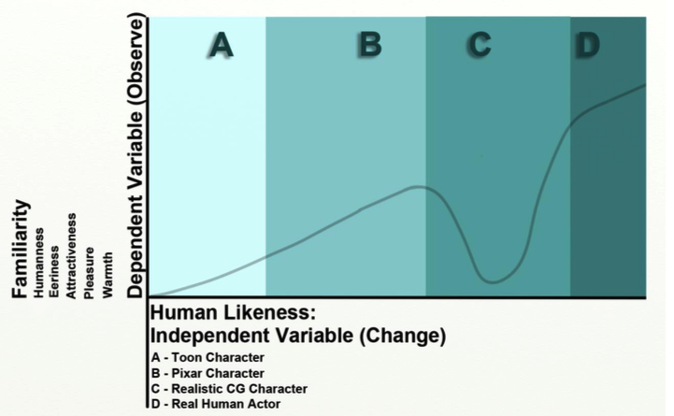

Figure 1. Hypothetical graph of data that according to Mori’s theory will show the uncanny valley.

**Creating the artefacts for the study**

The first step was to shoot and edit a short film with a real human actor. This short film served as reference for the animation versions of the short film. A story was needed that contained motion and facial expressions to transpose onto the animated characters that would be sufficient to test the research question and have sufficient emotional impact on the viewers to engage with the characters on the screen.

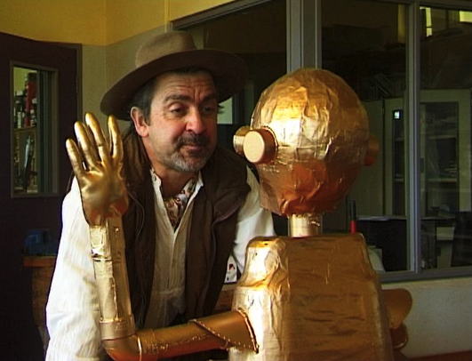

Figure 2. The human actor in the real-life short film ‘Canned Loneliness’.

A short story 'Canned Loneliness' inspired by the children's story 'Pinocchio' by Collodi (1929) was written by the researcher. This short story was set in a post-apocalyptic time, which would add a sense of mystery to the scene and credibility to the existence of robots.

In the story the main character walks towards a building (exterior scene) and also walks inside the building toward the main prop (Pinocchio robot). The expressive locomotion was tested by means of the walking motion, together with the rest of the body language and mannerisms when talking. The emotional locomotion was tested with the talking, combined with the facial expressions showing the emotions of the main character.

**Character design**

To achieve a realistic representation of the human actor and consequently derive realistic animation from it, it was imperative to conserve the crucial proportions of the body and facial features. Photographic image maps were taken of the human actor and used to create diffuse and bump map textures for the CG character.

According to Hamm (1963:39) it is possible to accurately measure the size and positioning of other body parts by using the length of that person's head as a base measurement. This helps to determine the correct proportions of the whole person. Accordingly, the height of the actor was determined to be 6 and a half heads. To check the proportions, according to Hamm a person's height is more or less the same as the width of their outstretched arms, as illustrated in figure 3.

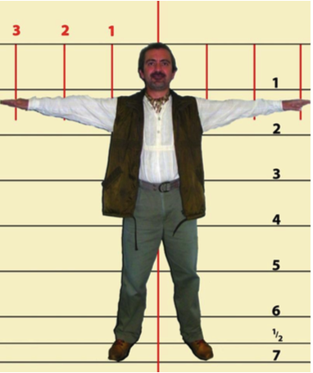

Figure 3. The proportions of the human actor assisting with the modelling of the CG character.

When constructing the CG character one had to bear in mind that the character would be used as a photorealistic version of the human actor. From that 3D model a more stylized version had to be extracted and modified that would resemble a Pixar-type character.

Since the techniques in modelling a CG character are beyond the scope of this study, a brief summary of what was done will be compared to what previous research has proven. MacDorman, Green and Ho (2009:708) suggest the following design principles when creating a CG character in order to avoid the uncanny valley effect:

* To design attractive, human-looking faces that are not eerie, use high polygon counts with smoothing and nearly ideal facial proportions.
* It may be safer to use a less photorealistic texture unless human photorealism is required.
* When using a human photorealistic texture, ensure the proportions of the CG face are within human norms.
* And finally, to prevent eeriness, avoid mismatches in the degree of human likeness of CG elements.

In this study, the first character created (figure 4) was the photorealistic CG character (film C) based on the proportions of the real human actor as in figure 3.

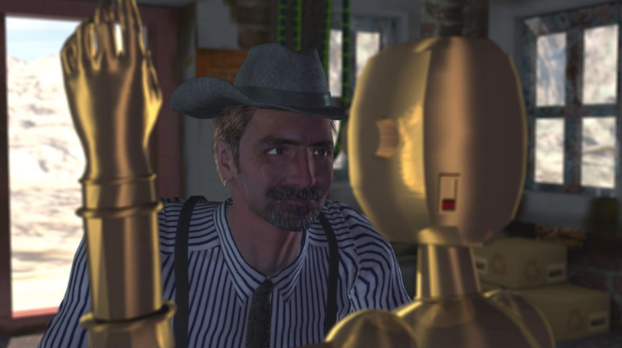

Figure 4. The photorealistic CG character in ‘Canned Loneliness’.

Film (B) contained the Pixar character. For this stylized Pixar character the eyes were enlarged by about 10%. With an increase of more than 10% the researcher experienced that the character started to look overly eerie and did not resemble the human actor anymore (figure 5). This supports the statement by MacDorman et al. (2009:708) that enlarging the eyes by 50% increased the eeriness and decreased the naturalness and attractiveness of a CG face.

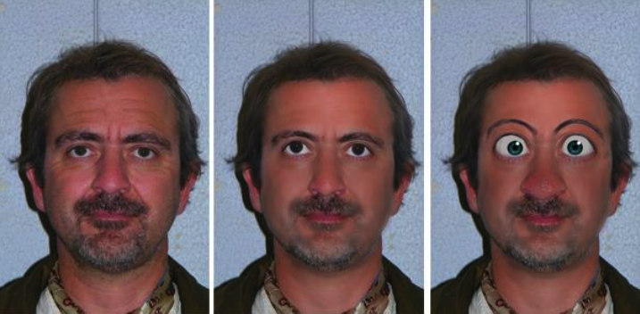

Figure 5. An example of stylistic progression from human physiognomy to ‘Pixar’ caricature.

After the head, the rest of the body and clothing were done following the same method as with the head by extruding edges and adding polygons. There-after the character was UV unwrapped.

Hanson (2006:18) established experimentally that the uncanny valley could be averted, not by avoiding human likeness, but by conscientious design, altering the uncanny faces to accentuate features distinguished as friendly and youthful.

Gould (1980:81) explains that, in the evolution and development of Mickey Mouse, the Disney character designers like Ub Iwerks gave him shorter and pudgier legs by lowering his pants line and covering his spindly legs with a baggy outfit to make him more youthful and likeable by audiences. His head grew relatively larger and his features more youthful. Thomas and Johnston (1981:447) explains that the basic shape used by Disney cartoons for eyes was a circle, because it allowed the animators to give the character's maximum expression. These friendly and youthful features are now typical of the Pixar-stylized characters who are recognizably human but also still unmistakably cartoons. In this study the youthful features were intentionally used with the Pixar-style character in order to plot it on a graph of the uncanny valley.

According to MacDorman et al. (2009:708), the increase in eeriness and decrease in naturalness and attractiveness are much greater for a more photorealistic skin texture than for a less photorealistic skin texture. Therefore, the photo texture and Bump map were toned down to give a more even skin colour. The Subsurface scattering effect was also increased to give it more of a wax toy look in line with the Pixar style.

Proper placement of the iris texture is essential for believable facial expressions. Other criteria include how light interacts with the iris through reflection and refraction through the lens of the eye and also properly showing the wetness of the eyes. In this study the iris needed to be of appropriate size and colour for the photorealistic CG character, but again for the Pixar character the Iris was enlarged to give it a 'cute puppy' youthful look (figure 6).

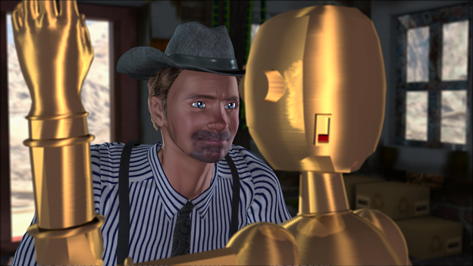

Figure 6. ‘Pixar’ character with a more stylized skin texture and wax toy look.

Film A with the toon character used the same character as in film B. In order to simulate a cartoon style rendering while still maintaining the 3D depth and perspective, it was necessary to apply a Toon host shader to certain objects in the scene that will have ink lines, while other objects would be ignored in the render. Having ink lines on objects further away in the scene made the composition excessively busy and visually distracting.

Therefore, ink lines were applied only to objects like the characters that was closest to the camera. When cartoonists draw human characters, they stylize reality by drawing only the details they consider important. For that reason, differently coloured paint shaders were applied only to the parts of the character and objects necessary to tell the story, ignoring details like the eyelashes and beard. This was applied to the Toon character rendering, resulting in the visual style shown below in figure 7.

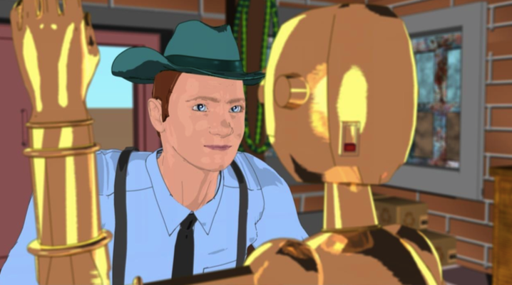

Figure 7. Non-photorealistic render (cartoon style) animated film.

**Motion capture and performance capture**

Chaminade et al. (2007:213) found that people prefer movements generated by means of motion capture as it seems more biological when characters are photorealistic. When anthropomorphism increased, viewers were more sensitive to the type of motion used.

In this study motion capture and performance-driven animation were used to capture the movement of the real actor to drive the body, facial and speech animation of the CG characters. The recorded animation was saved to be used again, since three different animation films had to be made with the same character rig. The motion capture files were used in each animated film to transfer the emotive motions among the virtual characters to ensure that they all used exactly the same movements, which forms the crux of this research.

In line with normal practice in animation, where the voices are recorded before the animation is done, the soundtrack from the real human film was used in the animation films as a reference to time the movement of the CG characters with the human actor in the first video. To ensure that the motion of the CG characters matched up with that of the human actor, the motion of the human actor was captured by means of motion capture.

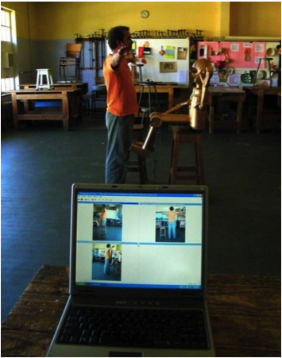

Figure 8. To ensure that the motion of the CG characters matched up with that of the human actor, the motion of the human actor was captured by means of motion capture.

Once the video streams were recorded, the tracking of the motion was done off-line and any problems were rectified on the spot. One limitation was that hand motion was not motion captured which meant that hand translations and rotations had to be done manually using the video streams as reference.

SoftImage allows the import of various motion capture formats of which BioVision (BVH) is the most common. The motion capture data were then loaded into *SoftImage* and constrained to the character rig. The resulting animation from the rig was plotted to function curves so that it could be converted in the animation mixer to animation clips. This allowed the animation to be used on different versions of the CG character which used the same Biped rig.

Post-editing of some of the key frames had to be done to ensure that the motions of the CG characters did fit within the scene and that parts of the CG characters did not penetrate certain geometric structures in the scene, for instance hands on the table and feet on the floor.

One of the greatest challenges in overcoming the uncanny valley effect is to create believable facial expressions for a photorealistic human face. According to Verwey and Blake (2006:163), adding facial animation to characters greatly influences their reality and presence in virtual surroundings. Key framing blend shapes is exhausting and takes up a lot of time which in any event neglects to capture the finer subtleties of human expressions. At the same time, performance capture markers also fail to gather enough detail to create organic expressions like the wrinkling of skin around the eyes of a CG character when squinting.

Sloan, Cook and Robinson (2009:675) formulated reliable rationales to aid animators producing more credible facial animations (figure 9). He studied the movements of the upper and lower regions of the face during the six basic human emotions as described by Ekman (1999:316) which comprise happiness, sadness, anger, fear, disgust and surprise. Sloan discovered that if an emotion such as sadness starts from the upper face, in other words the furrowing of the brow and lowering of the eyes take place before the mouth corners turn downward, the expression will look more authentic. If this expression starts out the other way round, it can look phony.

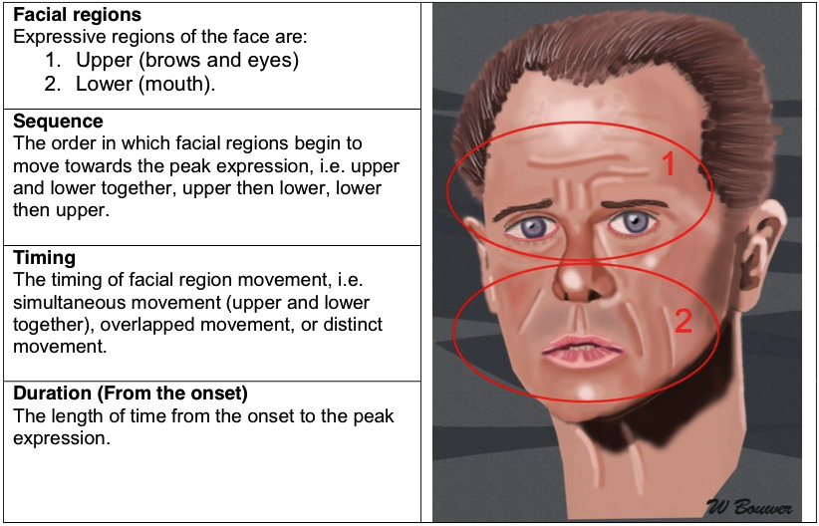

Figure 9. The two choreographed regions of the face and the three conditions of choreography according to Robin Sloan.

Although most of the facial animation in the short films was applied through performance capture, it was still necessary to ensure that it looked natural and flowed with the performance of the recorded voice. For this reason, some clips were opened in the *fCurve editor* and *Dope sheet editor* to move key frames from the upper and lower regions of the face forward (to lead in) or backwards (to follow) to make the facial expressions more natural and realistic following the rationale of Sloan, et al (2009:675).

The performance capture for facial animation was captured in a relatively still environment – this allowed the voice recording from the performance to be used in the final animation videos because the voice obviously matched with the facial performance as captured. The software used for this was *Zign Track* and is based on markers placed on the actor's face which are then tracked and recorded. The recorded C3D files were then imported into *Face Robot* in *SoftImage* and used on the CG characters.

The performance capture was to be done on the same day as the actual filming of the short film for the reason that the actor would by then know his lines and also when to hit certain emotional tones at specific parts of the performance. The set-up involved one normal standard definition video camera linked to a computer via a firewire cable. Before the capture process the green markers were applied to the face of the actor (figure 10). The *Zign Track* performance capture software allows one to specify the colour of the trackers as well as the layout of the markers on the face of the actor that best suits the 3D model to be used.

The entire performance capture was done in one take, similar to a stage play, to allow the actor to attain the proper emotional performance and keep it going. Having the recording as one clip also made the solving of the performance capture data much easier. Tracking the markers on the face of the actor turned out to be quite a challenge because of his beard and moustache. To solve this problem, the function in the performance capture software that allows for the tracking of pixels in the video was used. This permitted the trackers to be locked to the black spots on the green markers which created very accurate tracking.

To use the performance capture data on the character's head in *SoftImage*, the head had to be prepared by firstly identifying and pointing the software to certain facial features and then solving the head. The solving process created controls on the character's head that could be animated by applying the performance capture data to it.

To obtain more natural organic-looking animation it was decided to use *SoftImage*'s *Face Robot* software. Although the facial performances of the digital characters were driven by the performance capture data, the blend shapes created by the software could still be tweaked to get better facial animation to comply with the rules for believable facial expressions as set out by Sloan, et al (2009:675).

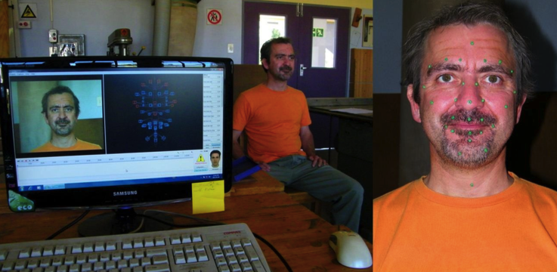

Figure 10. Green markers positioned on the actor's face

**Gathering the data**

Information was gathered about the responsiveness of audiences who observed the film clips. A volunteer sampling procedure was used which is a form of purposive sampling and is a non-probability method.

For this study student volunteers who were considered to be a sector of the normal cinema-going audience were used. These students were assessed on campus. The information was gathered during breaks when they were relaxed and willing to co-operate.

The size of the target group was 50 students. The age of the target population was between 18 and 23, this being the normal age of students on campus and representative of a sector of the normal cinema-going audience. The results from this method would be more accurate as the measuring instruments (questionnaires) were returned in an environment that was not influenced by outside factors such as postage or transport problems. This approach ensured a 100% return of the questionnaires.

Ho and MacDorman (2010:22) created a set of indices to test the realism of anthropomorphic characters. This measuring instrument was used with the permission of Dr MacDorman to test where every animated character in this study was positioned on a graph of the uncanny valley.

Two groups of student volunteers consisting of 25 per group watched the four film clips. To check for reliability in the sampling of the data it was decided to have the first group watch the film clips in a sequence of A, B, C and D and the second group would watch it in the reverse order from D to A. After watching each film, the students were asked to complete the Ho and MacDorman measuring instrument.

The data were analysed and interpreted following the indices in the questionnaire structure, namely: humanness; eeriness; attractiveness; pleasure and warmth.

**Interpretation of results**

In line with the aims of this research, it was primarily the impact of animation on the uncanny valley phenomenon which was more closely examined. The 'humanness index' from the data indices was plotted on the X-axis. The eeriness, attractiveness, pleasure and warmth indices formed the 'familiarity' side of the graph (Y-axis), which were the dependent variables (observation).

The data from the sub-indices was grouped in order to describe the midpoint, variability and confidence levels of the data sets for the indices of all four films. To calculate the margin of error, the following values was used.

The standard deviation for the sample was used and the sample size (n = 50). x is the Average (mean). s is the standard deviation or Sigma. The confidence coefficient of 1.96 for a 95% confidence level was used.

The values which define the range of the confidence interval were calculated with the mean plus the margin of error (upper bound) and the lower bound the mean minus the margin of error. µ (mu) is the average between the upper and lower bounds.

The statistical analysis confirmed the existence of the uncanny valley effect, as well as the hypothesis that the toon character would be least affected and the realistic animated character most affected by the uncanny valley effect.

To facilitate understanding of the statistics in this article, two sets of statistics are provided:

1. Two XY non-linear regression graphs. One indicates the humanness index and one indicates the four other indices, namely: eeriness; attractiveness; pleasure and warmth;
2. A one-way ANOVA that determine whether there is a significant difference between the Eeriness of Film A and Film B and a second one to determine the same for Film A and Film C.

**The XY non-linear regression graphs**

The data gathered was plotted on XY non-linear regression graphs in order to indicate in which films the Uncanny Valley effect appeared from the perception of the audience. The independent variable that was measured is the familiarity index (plotted on the Y axis of a graph). The sum total for each of the four other indices, namely: eeriness; attractiveness; pleasure and warmth, was calculated and converted to a percentage.

The humanness index (plotted on the x axis of a graph) is what was manipulated. This would suffice as a scale for the human likeness of the CG characters and human actor since sub-indices such as Artificial, Human-made, Automatic, Inanimate, Mechanical Movement and Synthetic are what would normally visibly describe the physical properties of a CG actor versus a human actor.

The measuring instrument used Likert scale questions, therefore the higher the value, the more pronounced the uncanny valley effect. This means, according to figure 11 below, the higher the percentage, the more pronounced the uncanny valley effect.

Figure 11: The four films according to Mori’s graph indicating the percentage of uncanny valley effect of each film.

The above graph illustrates that film C has the biggest increase in the uncanny valley effect causing a dip (valley) in the graph. This means the photo-realistic animated character was the most affected by the uncanny valley effect.

Film A (Toon) scored 65% for human likeness and 67.6% for the uncanny valley effect. Film B (Pixar) scored 74% for human likeness and 70% for the uncanny valley effect. Film C scored 75.6% for Human likeness and 72% for the uncanny valley effect. Film D (Real human actor) scored 88% for human likeness and 67% for the uncanny valley effect.

This is in agreement with the findings of Mori and other authors. The humanness index increases as the character becomes more familiar. This is as expected because the character style changes from Toon in film A to a real human in film D. MacDorman et al. (2009:708) found the more human the photo-realistic textured CG character's face looked, the easier it was for people to agree on its degree of human likeness.

To see if and how the uncanny valley effect manifested in each of the familiarity indices, the same calculation was done where the sum total for each of the four main indices for familiarity, namely: eeriness; attractiveness; pleasure and warmth, was calculated and converted to a percentage (figure 12 below).

Figure 12: The four films according to Mori’s graph indicating the percentage of uncanny valley effect of each film according to the indices.

In figure 12 the following observations can be made: Film C with the photorealistic CG human actor has the biggest increase in the uncanny valley effect causing a dip (valley) in the graph. Film A (toon) scored 57% for eeriness, Film B (Pixar) scored 61%, Film C 74% and film D 60%.

**The one-way ANOVA tables**

A one-way ANOVA was used to determine whether there was a significant difference between the Eeriness of the characters in Film A and Film B (table 1) and between the Eeriness of the characters in Film A and Film C (table 2).

|  |  |  |
| --- | --- | --- |
| z-Test: Two Sample for Means |  |  |
| ***Eeriness*** | *Film A* | *Film B* |
| Mean | 22.84 | 24.44 |
| Known Variance | 20.34122 | 17.63918 |
| Observations | 50 | 50 |
| Hypothesized Mean Difference | 0 |  |
| z | -1.835799375 |  |
| P(Z<=z) one-tail | 0.033193667 |  |
| z Critical one-tail | 1.644853627 |  |
| P(Z<=z) two-tail | 0.066387334 |  |
| z Critical two-tail | 1.959963985 |  |

Table 1: z-Test: Two Sample for Means for Eeriness for Film A and Film B

The P(Z<=z) one-tail (0.0331) is less than 0,05 and therefore the null hypothesis is rejected. There is a significant difference in the eeriness between the animated Toon character in film A and the Pixar animated character in film B: The Pixar character in Film B was perceived to be more eerie than the Toon character in film A.

|  |  |  |
| --- | --- | --- |
| z-Test: Two Sample for Means |  |  |
| ***Eeriness*** | *Film A* | *Film C* |
| Mean | 22.84 | 24.52 |
| Known Variance | 20.34122 | 23.64245 |
| Observations | 50 | 50 |
| Hypothesized Mean Difference | 0 |  |
| z | -1.79121844 |  |
| P(Z<=z) one-tail | 0.036629124 |  |
| z Critical one-tail | 1.644853627 |  |
| P(Z<=z) two-tail | 0.073258248 |  |
| z Critical two-tail | 1.959963985 |  |

Table 2: z-Test: Two Sample for Means for Eeriness for Film A and Film C

The P(Z<=z) one-tail (0.0366) is less than 0,05 and therefore the null hypothesis is rejected. There is a significant difference in the eeriness between the animated Toon character in film A and the photorealistic human animated character in film C. The photorealistic human character in Film C was perceived to be significantly more eerie than the Toon character in film A.

Figures 11 and 12 clearly illustrate a progression in eeriness from the Toon character through the Pixar character to the photorealistic CG character, who is positioned in the uncanny valley.

**Conclusion**

A crucial restraint of animation as a whole consists in the objectivity of measuring the outcomes. There is often no appropriate benchmark, as the concluding outcome edges on visual art and it is sometimes hard to estimate how realistic an animation looks to different people. This limitation was largely overcome with the aid of the measuring instrument which allowed for more objective measurement of predetermined indices.

Plotting the results of this research on a chart revealed some close correlations between Mori’s theory and this study’s outcomes. The scoring of the photorealistic CG character means it is placed in the uncanny valley of the graph in correlation with Mori's theory.

All the animation films used exactly the same motion and facial expressions and yet the perceptions of the audience were that the 3D animated characters were more human than the cartoon character, and the human actor was the most human of all the characters. This concurs with the theory of Mori.

The participants also found the realistic CG character more eerie than the other three characters including the human actor. Although all the characters had the same facial animation and body motions applied, the data confirmed that audiences are more sensitive to any imperfections in the applied animation to realistic CG characters than in the stylized characters. This is also in agreement with Mori’s theory.

For the Toon character, the Pixar character and the real human character the warmth index is nearly the same (figure 12). Possible reasons for this are that the volunteer students were considerably younger than the male human actor and for that reason did not identify with him. The actor was older-looking with features like e.g. thick low set eye-brows and deep wrinkles. The animated characters were younger looking because facial features that show age, e.g. wrinkles, were removed and their eyebrows were made thinner and positioned higher.

**Recommendations for future research**

A big issue is that nearly all the studies by the academic community are restrained due to financial constraints. Consequently, there is a solid motivation for testing the academic outcomes on the same high-end equipment that is used in the animation industry.

Further research is necessary to find out why in this study the participants did not rate the warmth of the real human character much higher than that of the Toon and Pixar characters. For some reason the participants did not find the human actor to be a warm humanlike person. It can be speculated that if a younger more attractive human actor had been used, the student audience would have identified more with him and the scores may have turned out differently.

The acting by the human actor was also not optimal. If a more convincing well-known professional actor is used the audience may also feel differently about the warmth of the human character.

The directing of the human actor was not optimal; the emotions should perhaps have been toned down for a 'less is more' effect.

A 3-minute short film is perhaps too short to expect the audience to have an emotional bond with a character on screen. The film must either be longer or an extract from a well-known film can be used.

**Acknowledgments**

We wish to thank Dr Karl MacDorman from the School of Informatics, Indiana University, for his support and permission to use the measuring instrument he has developed.

**Funding**

This research received no grant from any funding agency in the public, commercial, or not-for-profit sectors.

**Conflict of interest**

On behalf of all authors, the corresponding author states that there is no conflict of interest.

**References**

Alexander O, Rogers M, Lambeth W, Chiang M and Debevec P (2009) Creating a photoreal digital actor: The digital Emily project. International Conference on Computer Graphics and Interactive Techniques. 12 (1), pp. 1 - 15.

Chaminade T, Hodgins J and Kawato M (2007) Anthropomorphism influences perception of computer-animated characters' actions. Social Cognitive & Affective Neuroscience. 2 (3), pp. 206 - 216.

Collodi C (1929) The adventures of Pinocchio. 3rd ed. London: The Macmillan Company.

Debevec P (1998) Rendering synthetic objects into real scenes: bridging traditional and image-based graphics with global illumination and high dynamic range photography. In: ACM SIGGRAPH 2008 classes, Los Angeles, 11- 15 August 2008. New York: ACM: pp. 189 - 198.

Ekman P (1999) Facial expressions. In: Dalgleish, T and Power, M. Handbook of Cognition and Emotion. New York: John Wiley & Sons. 316.

Gould SJ (1980) A biological homage to Mickey Mouse. Middlesex: Penguin Books. pp. 81 - 91.

Green RD, MacDorman KF, Ho C and Vasudevan S (2008) Sensitivity to the proportions of faces that vary in human likeness. Computers in Human Behaviour. 24 (1), pp. 2456 – 2474.

Hamm J (1963) Drawing the head and figure. New York: Time Warner International. pp 39.

Hanson D (2006) Exploring the aesthetic range for humanoid robots. In: MacDorman, K(ed.). Proceedings of the ICCS/CogSci-2006 long symposium: Toward social mechanisms of android science, Vancouver, 26 - 29 July 2006. Vancouver: ICCS/CogSci: 39 - 42.

Ho C and MacDorman KF (2010) Indices for plotting characters on the uncanny valley graph: Their development and validation. Computers in Human Behavior. 1 (1), pp. 1 - 28.

Hodgins JK, O’Brien JF and Tumblin J (1998) Perception of human motion with different geometric models. EEE Transactions on Visualization and Computer Graphics, 4(4), pp. 307–316.

Jensen HW, Marschner SR, Levoy M and Hanrahan P (2001) A practical model for subsurface light transport. In: Pocock L (ed.). Proceedings of the 28th annual conference on Computer graphics and interactive techniques, Los Angeles, 12 - 17 August 2001. New York: ACM: pp. 511-518.

Ma WC, Hawkins T, Peers P, Chabert CF, Weiss M and Debevec P (2007) Rapid acquisition of specular and diffuse normal maps from polarized spherical gradient illumination. In: Kautz J(ed.). Proceedings of the 18th Eurographics conference on Rendering Techniques, Prague, 3 - 7 September 2007. Aire-la-Ville, Switzerland: Eurographics Association: pp. 183-194.

McDonnell R, Jorg S and McHugh J (2008) Evaluating Mori, M. 1970. Bukimi no tani [The uncanny valley]. Energy, 7(4), pp. 33–35.

MacDorman KF, Green RD, Ho C and Koch CT (2009) Too real for comfort? Uncanny responses to computer generated faces. Computers in Human Behavior. 25 (1), pp. 695 - 710.

Mori M (Translated by Karl F. MacDorman and Norri Kageki) (2012) The Uncanny Valley. IEEE Robotics & Automation magazine. 1(1): pp. 98 - 100.

Sloan RS, Cook M and Robinson B (2009) Considerations for Believable Emotional Facial Expression Animation. Second International Conference in Visualisation. 1 (1), pp. 61 - 66.

Thomas F and Johnston O (1981) Disney animation: The illusion of life. New York: Walt Disney Productions. pp. 447 - 448.

Unuma M, Anjyo K and Takeuchi R (1995) Fourier principles for emotion-based human figure animation. In: Mair S and Cook R (ed.). Proceedings of the 22nd annual conference on Computer graphics and interactive techniques, Los Angeles, 06 - 11 August 1995. New York: ACM: pp. 91-96.

Verwey JH and Blake EH (2006) The influence of lip animation on the perception of speech in virtual environments. UCT CS Research Document Archive. 1 (1), pp. 163 - 170.