ESI-14 – lipid diffusion constants

The lipid diffusion constants can be ab initia derived from the MD trajectories using embedded software cpptraj in AMBER. By definition, the one dimensional diffusion coefficient can be represented as:

Where the is the concentration in dimensions of , i.e. a function that depends on both location and time. D is the diffusion coefficient in dimensions of . This can be calculated using the Einstein relation:

Where the is the number of dimensions, i.e. in a 2D space we have whereas in single dimension we have . The is the mean square displacement of the selected residues over the trajectory. The trajectories are first unwrapped in order to obtain the continuous path for the selected residues, otherwise the periodic boundary condition may cause severe error. Due to the fact that the diffusion coefficient is calculated from the initial position given by the trajectory, the result for small numbers of atoms will be inherently stochastic for small number of sampled atoms. To deal with this we averaged the result over the 5 MD trajectories and use all the selected residues in the system to calculate its diffusion coefficient. The result can be found below:

|  |  |  |
| --- | --- | --- |
| Diffusion coefficient | In 2D (µm^2/s) | reference (µm^2/s) |
| DOPC | 8.4 | 5 to 14 |
| Texas Red | 4.5 |  |

G. Lindblom and G. Oradd,Biochim. Biophys. Acta BBA -Biomembr., 2009,1788, 234–244

ESI-15

The 50ns long simulation did not show severe displacement of the pigment cofactors in the LHCII monomer. The pigments generally remain their initial position in the crystal structure adopted from pdb 1rwt. The clusters of chlorophylls on the lumen side is less efficient in terms of energy transfer compared to the stromal side, as they are more separated in space.

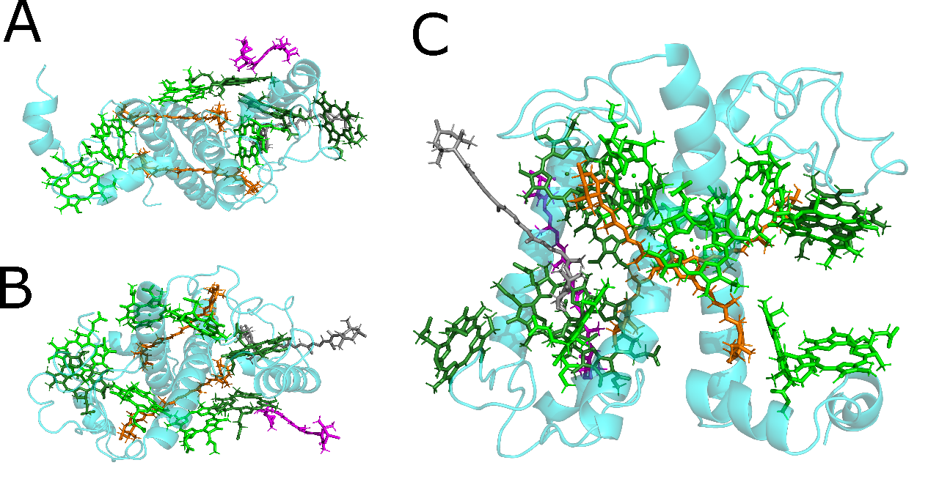

Figure A: The top view(stromal side), B: bottom view(lumenal side) and C: the sideview of the pigment representation. With the chlorophyll a coloured in light green; chlorophyll b coloured in dark green; luteins coloured in orange; neoxanthin and violaxanthin coloured in magenta and grey respectively. The chlorophyll tails are hided for clarity.

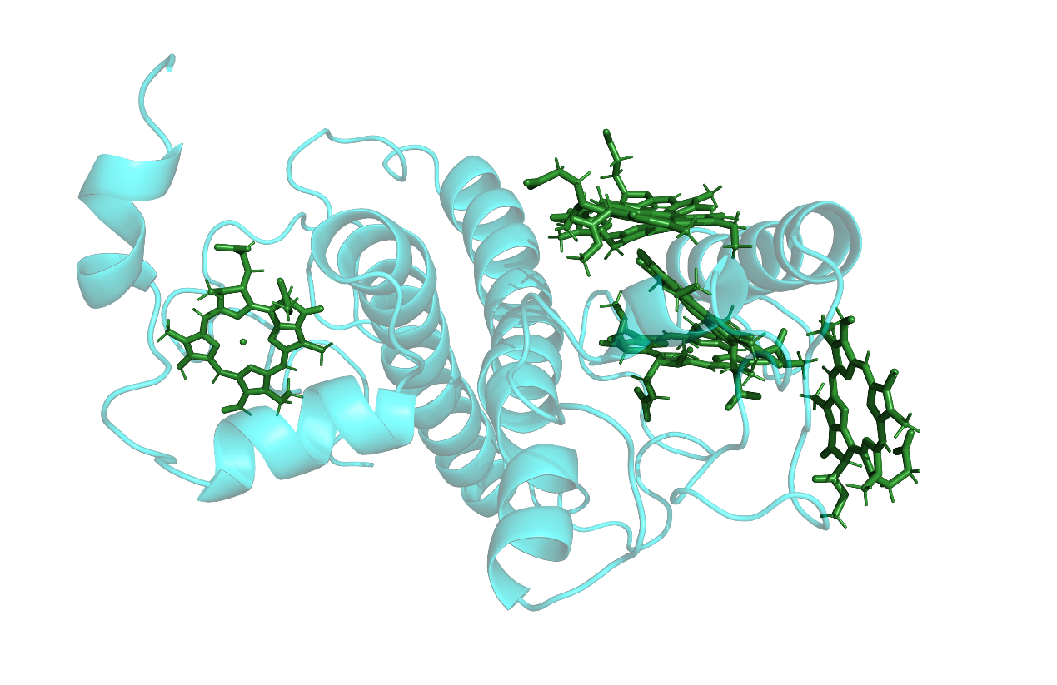

Figure Representation of chlorophyll b in the LHCII monomer (top view).

The 5 out of the 6 Chlorophyll b molecules surrounds the helix C at the interface between the monomers, with the remaining Chlorophyll b 608 left to the lutein pair, shown in figure above. This region was proposed to be critical in terms of energy transfer between the monomer.

Figure: Lumen side view showing the protein structure in cyan ribbon and the 6 chlorophyll b molecules in dark green color.

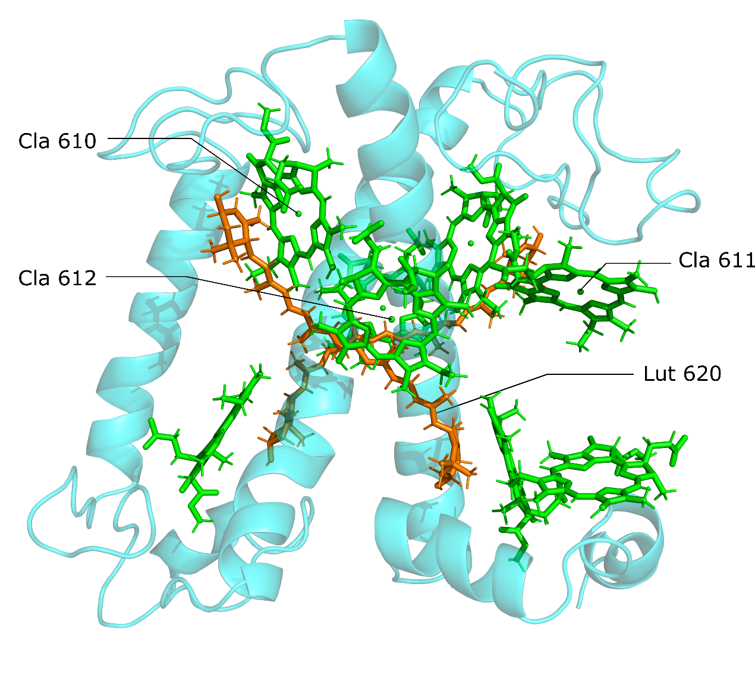

Figure Representation of chlorophyll a molecules and the lutein moleules in the LHCII monomer (side view).

As for the chlorophyll a molecules, the “terminal emitter” generally remains their position, with chlorophyll a 611 slightly displaced towards the chlorophyll b 608. This drifting has been reported in other papers as well and it has little effect on our calculations. Shown in figure below, the luteins are coloured in orange and chlorophyll a molecules coloured in light green. With the terminal emitter cluster labelled with text.

ESI-18 Transition dipole moment for TR and chlorophyll a/b

During the process calculating the coupling interaction between the pigments and the Texas Red, we took the approximation that this can be simplified to a point-dipole problem. Here we define the Qy/Qx transition dipole moments as a vector from its centrally bound Mg atom to the NB/NC atoms respectively (Black arrow and opaque arrow in the figure below). Note that the real dipole moment of Qy transition originates from the Mg atom to the NB atom but slightly deviated towards the NC atom. This is believed to have little effect given the distance between the pair and the fluctuations along the trajectory. We took the convenience that the Qx transition dipole moment is roughly orthogonal to the Qy and thus pointing to the NC atom. Transition dipole strength was set to be 4.5 Debye. Same direction of the dipole moments are applied to Chlorophyll b molecules, with the strength of 3.8 Debye. As for the Texas Red transition dipole moment was approximated from the middle point of C20 and C24 to the middle point of C31 and C25 (shown in black arrow in the figure below). The dipole strength is set to be 10 Debye.

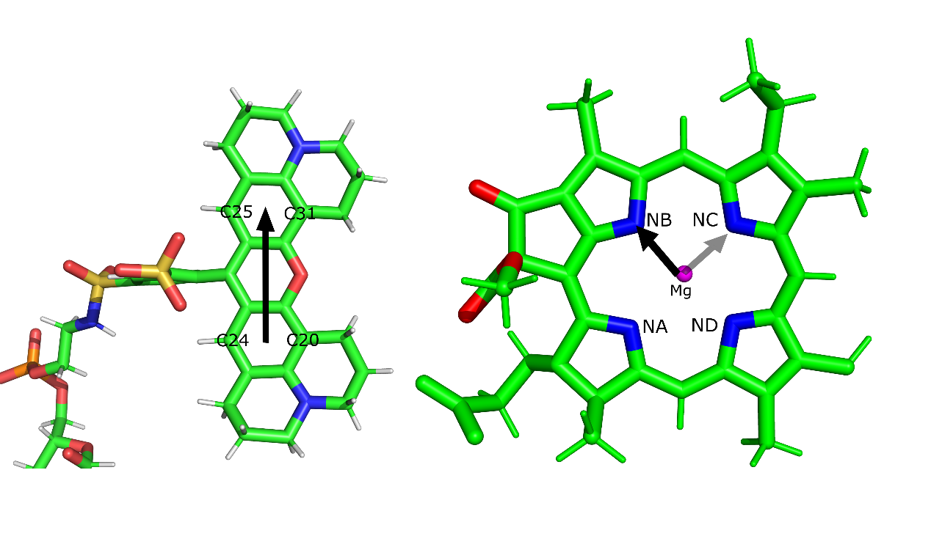

Figure Transition dipole moment of the Texas Red(left) and Chlorophyll a molecule(right). Approximated dipole moments are represented as arrows in figure.

ESI-19

Summary of the calculated couplings

