**TRUSTTRANSIT: TRUSTABLE PUBLIC TRANSIT THROUGH INTEGRATED MULTIMODAL TRANSIT NETWORKS AND TRIP PLANNING**

Michal Weiszer

Queen Mary University of London

Devon Barrett

Podaris Limited

Jun Chen

Queen Mary University of London

**ABSTRACT**

This paper presents a case study of a proposed multi-modal and multi-objective trip planner - TrustTransit. The proposed trip planner will provide safer ways of travelling by proposing alternative trip options with the assessed risk of transport-related COVID-19 exposure (airborne infections in general). The trip options are proposed based on traffic demand, transit modes, passenger load/counts and transmission risk. The case study of TrustTransit presents several trip planning scenarios in Greater London and how these can be evaluated in terms of travelling time and risk. Furthermore, it is shown how the approach can highlight cycling potential for the new cycleways.

**1. INTRODUCTION**

As of this writing (April 2021), over 1.27 million lives have been lost due to the COVID-19 pandemic worldwide. Despite the recently launched vaccination programmes it will take many months until the number of new cases will be sufficiently low in every country in the world. Until then, having some smart form of social distancing in place will be necessary for the foreseeable future. This is very important as some sectors were impossible to maintain the 2m social distancing rule. Furthermore, smart solutions can be helpful in battling any future epidemic such as the seasonal flu.

Public mass transit is one of the sectors where social distancing is hard to achieve and has been affected particularly hard during the pandemic. As restrictions are gradually eased, mass transit is battling issues such as public mistrust, greatly decreased revenue and difficulty to maintain social distancing.

Using public mass transit can contribute to spreading of infectious diseases. As a recent study shows, longer travelling times using London underground and changing trains in busy interchange stations have a correlation with the spread of airborne infections (Goscé & Johansson, 2018). Active transport and/or micro mobility has been encouraged during the pandemic in order to mitigate the risk. However, mass transit plays an irreplaceable role in large urban areas such as London. More sophisticated solutions are needed for megacities due to their size, complexity and long-distance commutes for all trip purposes. Digital technology has the capability to improve trips and ease overcrowding. Using less crowded transport services is not only more pleasant but also reduces the risk of a spike in coronavirus cases (Department for Transport, 2020b).

One of the digital tools for promoting active travel is the Rapid Cycleway Prioritisation Tool (Lovelace & Talbot, 2020). This tool has been developed to identify and rank locations for creating new cycleways. A measure called ‘cycling potential’ is used to rank potential cycleways and is calculated based on route distance and route hilliness. New pop-up cycleways have been created in urban areas as a result. These new cycleways promoted active travel in order to make essential trips safe during lockdown. However, as the traffic levels are now increasing back up to pre-lockdown levels (BBC, 2020), it is not clear which of these temporary cycleways will be converted into permanent ones and where else should be new cycleways created. Occupation of the street space which is used by other business, safety and increased congestions are some of the reason why some cities have already removed these temporary measures (Evening Standard, 2020).

New cycleways also enable the travellers to avoid crowded mass transit. However, in large urban areas, cycling is an attractive mode only for short to medium distances. For longer distances, cycling (active- and micro- mobility in general) needs to be combined with other modes in order to cover the whole trip. The new cycleways should be created in locations which enable the travellers to avoid crowded parts of the mass transit network. This way, the travellers can use cycling for a part of their trip together with mass transit for the less crowded parts. As a result, the ‘cycling potential’ for new cycleway locations should take into account how well the proposed cycleway can be integrated into mass transit network and trip planning.

Multi-modal trip planning tools combine different modes of transport (e.g. public transit, ride-hailing, micro-mobility and car-sharing) for trip recommendations. Examples include commercial trip planning tools (e.g. Google Maps, Swifly, moovit and transit), official city transit apps (e.g. TfL’s journey planner) and open-source platforms (e.g. OpenTripPlanner). Recently, some of them (e.g. Google Maps, CityMapper, and transit) have started to publish crowdedness information which may be used by travellers to estimate the risk of COVID-19 (TechCrunch, 2020; Medium, 2020).

The crowdedness information is important to travellers when deciding the trip options during both pandemic and normal conditions. However, the presence of multiple attributes (e.g. travel time, crowdedness, number of changes, etc.) and multiple trip options is difficult to combine in decision making and can lead to information overload. The problem of finding the best route with multiple objectives is NP hard (i.e. the complexity of solving the problem grows exponentially with the size of the problem) as demonstrated in similar problems (Chen et al., 2016). Also, combining multiple modes of transport (.e.g. adding larger cycle transfers) and integrating real-time transmission feeds while requiring fast response times makes this problem computationally challenging. Therefore, it requires sophisticated solution algorithms, which are currently absent in the existing trip planners. The search for trip options in the current tools does not take into account the extra information (e.g. crowdedness and transmission risk) in order to avoid overcrowding and reduce traffic-related COVID-19 exposure.

In order to address the abovementioned gaps in the current trip planning tools, the following questions need to be answered:

1. How to detect locations with increased congestion and crowding in real-time?
2. How to assess locations with a high risk of transport-related COVID-19 exposure?
3. How to inform travellers to postpone their trips to less crowded periods or redirect them to other modes of transport?
4. How to assist service providers in managing overcrowding and inform them of the available options?
5. How to integrate different forms of travel (active/shared/micro/mass) into a comprehensive transport ecosystem which enable a seamless navigation across different transit modes for travellers, and help transport authorities prioritise new infrastructure?

TrustTransit aims to take the first steps toward modelling and integrating different transit networks, assessing the risk of transport-related COVID-19 exposure, proposing alternative trip options with the assessed risk, identifying new cycle infrastructure locations taking into account crowding information and informing both travellers and service providers. In this study, we demonstrate the feasibility of such an approach, by using the multi-modal routing function within the Podaris platform to provide different routing options. Each option is then assessed in terms of COVID-19 transmission risk linked to crowdedness along the journey.

Travellers can use the recommended trip options to make informed decisions. For example, a trip option with less crowdedness or better ventilation can be chosen, or trips can be postponed (cancelled) until the conditions are improved. Employers/employees can utilise these recommendations to address the risk of commuting to work and implement efficient mitigation strategies (e.g. staggered hours systems). Transportation/city planners can use TrustTransit along with simulation in strategic decision making (e.g. the frequency of services, locations of new cycleways and hire stations) and better crowd management (Department for Transport, 2020a).

The paper is structured as follows. Section 2 details the framework of the trip planning tool. Section 3 presents case studies of trip planning using the proposed planner. Section 4 summarises the work and proposes future directions.

**2. TRIP PLANNING TOOL**

The Podaris platform (https://app.podaris.com/) is an online platform for planning transport infrastructure and services which enables to conduct early-stage transport planning studies a highly collaborative fashion. The platform provides tools for high-level system design, scheduling, civil engineering and demand modelling together with an interface to communicate the results to the non-expert stakeholders. The Podaris platform is shown in Figure 1.

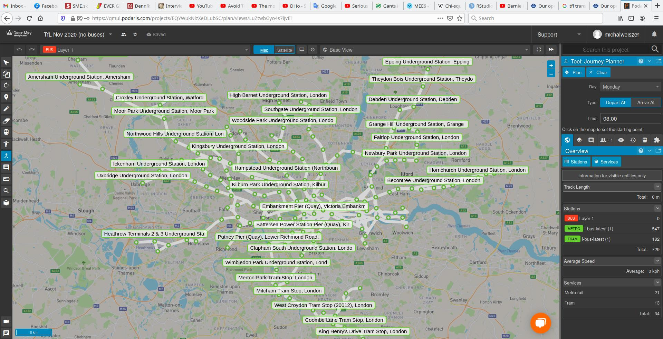

Figure 1. Screenshot of the Podaris platform with Greater London transport network.

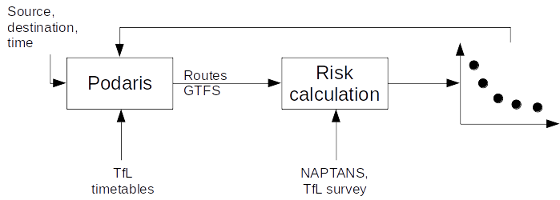

Trade-off routes

Figure 2. Overview of the trip planning tool framework.

Figure 2 shows the overview of the trip planning tool. The trip planning tool uses the Podaris platform routing function to find routes from the user given source to destination at the specified time. The routing function searches the transport network graph incorporating the Transport for London (TfL) timetables. The timetables were obtained from (TfL, 2020) in TransXChange format. The routing function returns the found routes, ordered by trip duration. Each route consists of legs, where a leg is characterised by a single mode of transport. The route is encoded in a JavaScript Object Notation (JSON) format detailing the legs along General Transit Feed Specification (GTFS) information such as intermediate stops, travel time between stops, etc. In this case study, only walking and underground were initially considered in the routing function. Cycling is taken into account only if the cycling time along any walking legs is longer than 10 minutes. Here, an average cycling speed 4.5 m/s is used to calculate the cycling time.

The risk calculation function approximates the risk for a route as number of people encountered during each leg of the trip multiplied by the duration of each leg. The risk *R* for a route is calculated as the sum of the risk of all legs as calculated in (1):

(1)

The risk *R* is expressed in units of passengers multiplied by minutes (abbreviated as pax.min). Walking and cycling legs have *R*=0 as they take place outdoors. For underground legs, the leg starts by walking to the platform from the entrance at the boarding station, where is the walking duration and is number of people using the station at the given time. is the waiting time for the train at the platform. After boarding the train, the train will pass through intermediate stations, where each link between the *k*-th and the previous station takes and has passengers in the carriage. At the alighting station, is the walking duration from the platform to the station exit and is the number of people using the station at the given time. For legs with a transfer between underground lines, walking from the platform is replaced by transfer time (walking time between platforms of transferring underground lines). and are determined from the Annual Station Counts (2019) and from NUMBAT (2018) surveys. The survey dataset represents the travel demand on a typical autumn weekday (Monday-Thursday), Friday, Saturday and Sunday at all stations and lines. In this study, and are constants of 120 seconds. A National Public Transport Access Node (NAPTAN) database is used to match GTFS information from the routing function with the survey data.

After the risk is calculated for each route, *R* is returned to the Podaris platform to display as can be seen in Figure 3.

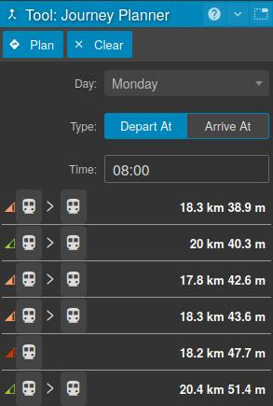Figure 3. Routing options with risk information displayed in the Podaris platform.

**3. USE CASES**

This section presents different use cases of using the proposed trip planning tool.

**3.1 Trip planning examples**

The trip requests are on Monday, 8:00AM, 9th, November 2020. The sources and destinations are chosen such that the trip involves a transfer, to demonstrate the different options in route selection. Each case presents 6 routes which involve walking between stations and additional routes where some walking legs (longer than 10 min.) are replaced by cycling. If no leg is done by cycling, routes marked as ‘walk’ and ‘walk+cycle’ have the same time.

Figure 4a shows a trade-off of different routes from Wimbledon to King’s Cross St. Pancras station. The route with the highest risk (5109 pax.min) is one of the shortest ones (39 min). This route involves taking a District line train to Earl’s Court, changing to another District line train to Victoria and changing to a Victoria line train to King’s Cross St. Pancras. The route with an almost similar time (40 min) and lower risk (4571 pax.min) has a slight waiting time at Wimbledon for the next direct District line train to Victoria and then taking the Victoria line to King’s Cross St. Pancras. Just by taking a direct train instead of changing in between the risk was lowered by 10%. The route with the lowest risk (2652 pax.min) is 9 min. longer than the shortest route. This route takes a District line train to Earl’s Court, changes to a Piccadilly line train at Russell Square and walks the rest for 9 min. As we can see, leaving out transfer in Victoria and King’s Cross by walking one leg of the route could lower the risk by 48%, as those stations belong to some of the busiest ones in the morning peak. The shortest route (38 min.) is by cycling from Wimbledon to Colliers Wood and taking a direct Northern line train to the destination.

In Figure 4b, the best route from Gants Hill to King’s Cross St. Pancras in terms of both time and risk is by taking a Central line train to Chancery Lane and cycling the rest. While this option with cycling is even faster than taking a tube with a transfer, the risk is lowered by 45%.

|  |  |
| --- | --- |
| (a) | (b) |

Figure 4. Trade-off of routes from (a) Wimbledon to King’s Cross St. Pancras station, (b) Gants Hill to King’s Cross St. Pancras.

|  |  |
| --- | --- |
| (a) | (b) |

Figure 5. Trade-off of routes from (a) Walthamstow Central to Bank, (b) King’s Cross St. Pancras to Bank.

In Figure 5a, the shortest route (27 min) from Walthamstow Central to Bank has the most risk (4352 pax.min). Taking a Victoria line train and changing at Oxford Circus to a Bakerloo line train to Embankment, and then cycling the remainder reduces the risk (2609 pax.min) and lasts 35 min. in total. Including cycling not only reduces the risk, but also has a competitive travel time, as we can see on routes around the 30 min mark. Similarly, in Figure 5b, the best route from King’s Cross St. Pancras to Bank in terms of both time and risk is by cycling to Chancery Lane and taking a Central line train to Bank. It has a risk lowered by 34% compared to the similarly long route using only the tube.

As we can see from the previous examples, there is a clear trade-off between the routes linking the source to destination. A choice of line and transfer station has a direct impact on the risk, as some lines and stations are less busy than others. Furthermore, swapping a tube to cycling/walking in a part of the route can lower the risk significantly. Interestingly, cycling is faster than taking a tube to the destination in some cases, as cycling on short distances can be faster than the transfer time and waiting for the train.

**3.2 Cycleway potential identification**

In this section, we show how the routes found by the proposed trip planning tool can be used to highlight cycling potential for new cycleways and complement the previously proposed the Propensity to Cycle Tool (PCT) (Lovelace & Talbot, 2020). PCT identifies priority locations for new cycleways, ranking roads by their estimated ‘cycling potential’. The potential in PCT represents the estimated number of cycling trips along this road travelling to or from work or school assuming the Government’s aim to double cycling by 2025 is met.

The ‘top ranked new cycleways’ represents the roads with the highest cycling potential which also have spare space; that is, are either wide or have two or more road lanes in one direction.

PCT also identifies what a ‘cohesive network’ for cycling might look like if we were to consider a wider range of interventions such as closing roads to motorised traffic and creating one-way systems. Unlike the ‘top ranked new cycleways’ layer, the cohesive network comprises all the major high cycle potential corridors, including sections where the roads are narrower. The cohesive network was generated by joining up roads that have a high cycling potential on some or all their length.

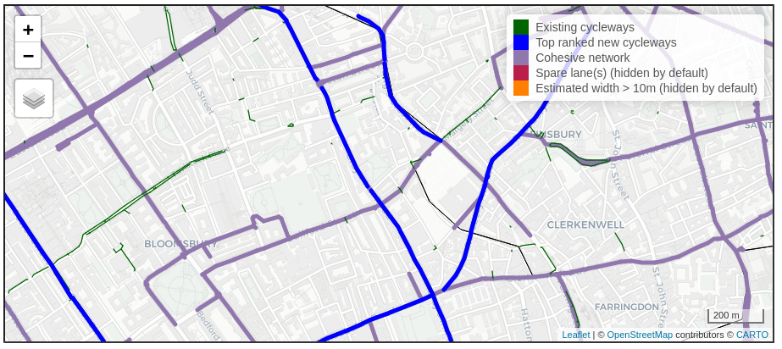Figure 6. Area around King’s Cross in PCT.

Chancery Lane

King’s Cross St. Pancras

Russel Square

Figure 6 shows the area south of King’s Cross in PCT. As presented in the previous section, the route with the lowest risk from Wimbledon to King’s Cross St. Pancras station involves a walking leg from Russell Square to King’s Cross. This leg could also be covered by cycling. Also, the best route from Gants Hill to King’s Cross St. Pancras has a cycling leg from Chancery Lane to King’s Cross. As can be seen in Figure 6, the route from Chancery Lane to King’s Cross lies along the top ranked cycleway. However, there is no top ranked cycleway from Russell Square to King’s Cross. Instead, the route would use the cohesive network, or a new cycleway not considered in PCT.

Figure 7 shows the area to the west of Bank in PCT. Some routes to Bank, presented in the previous section, include a cycling section. The route from Walthamstow Central to Bank (30 min., 3197 pax.min) has a cycling leg from Holborn to Bank. The route from King’s Cross to Bank (13 min., 2004 pax.min) has a cycling leg from Farringdon to Bank. In both routes, the cycling leg could use a part of the cohesive network. However, the immediate area around Bank is not included in either cohesive network or top ranked cycleways.

Figure 7. Area around Bank in PCT. 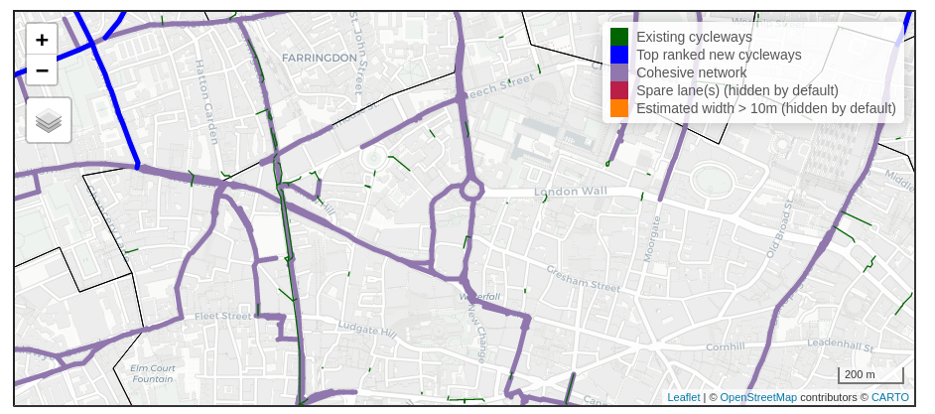

Holborn

Bank

Farringdon

The shortest route (38 min.) from Wimbledon to King’s Cross includes cycling from Wimbledon to Colliers Wood. Figure 8 shows the area around Wimbledon in PCT. As can be seen, apart from existing cycleways, there is no information about top ranked new cycleways or cohesive network.

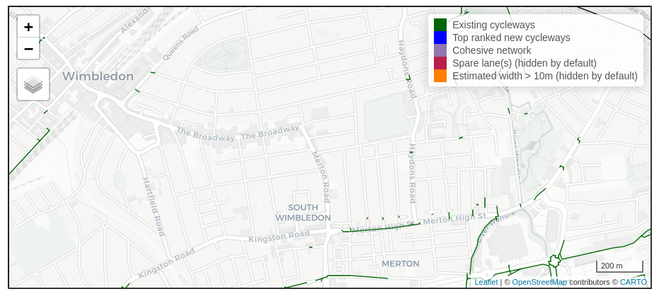

Wimbledon

Colliers Wood

Figure 8. Area around Wimbledon in PCT.

The previous cases illustrate how the routes found by the trip planner could inform the PCT for cycling potential. In many cases, the prosed routes by the trip planner are not part of the top ranked cycleways or cohesive network in PCT. Systematic sampling of sources and destinations for trips and the subsequent analysis of trade-off routes could estimate the use of cycleways if passengers switched to active travel on their journeys. This information could be integrated into PCT to calculate the new ‘cycling potential’.

**4. CONCLUSIONS AND FUTURE DIRECTIONS**

This study proposed a trip planning tool which was integrated into the Podaris platform. The case studies showed several trip planning scenarios in Greater London and how these can be evaluated in terms of travelling time and risk. Furthermore, we showed how the routes generated by the planning tool can be merged with the existing planning tools (e.g. PCT) to highlight cycling potential for the new cycleways.

The cascading consequences of the pandemic will cause chaos in the transport sector for years. Moreover, COVID-19 will not be the last major airborne infection that endangers us. In this study we used static data and simplified route choice algorithms. The aim is to provide evidence for creation of new cycleways that are fully integrated into mass transit networks. While using static data and simplified routing can help to respond to the pandemic as quickly as possible, we need to get “shovel ready” for the similar crisis in future, without it causing similar disruption to our lives. In light of the above and building from this study, the future directions could improve the proposed trip planning tool in several ways:

(1) The station passenger counts, and train crowding information, are estimated in this study from static data. A passenger load/counts unit that captures the dynamics of traveling through various on-board and in-station sensory data could provide accurate data about the crowding in real-time.

(2) The transmission risk proxy (e.g. static passenger load/counts) could be replaced with the estimated transmission risk following detailed transmission studies (Goscé & Johansson, 2018; Goscé et al., 2020) that consider real-time pedestrian dynamics at transit stations and time spent in each transit mode.

(3) The overall risk level of traffic-related COVID-19 exposure could take into account various factors (e.g. traffic demands, transit modes, real-time passenger load/counts, personal health conditions, transmission risk, reproduction number (R) and behaviours).

(4) The simplified routing function could be extended into a multi-objective routing engine which takes into account several objectives (time, risk, mode) at the same time and returns a trade-off of routes.

(5) The resulting routes could be coupled with a decision-making unit that will provide optimal information display to both travellers (e.g. through web and mobile Apps) to avoid information cluttering.

(6) When calculating transfer times and station ingress/egress times generalised assumptions were made about the physical path due to a simplified representation of station layouts. By enhancing the network, through datasets like OpenStreetMap, more accurate pathways can be identified leading to more realistic travel times. This could potentially also present and opportunity for a higher level of resolution in transmission risk scoring by better understanding physical walking paths chosen by passengers.

**REFERENCES**

BBC (2020) *Coronavirus: Will pop-up bike lanes keep new cyclists on the road?* Available from: <https://www.bbc.co.uk/news/uk-53105020> [Accessed 18 May2021]

Chen, J., Weiszer, M., Locatelli, G., Ravizza, S., Atkin, J.A., Stewart, P. and Burke, E.K., (2016). Toward a more realistic, cost-effective, and greener ground movement through active routing: a multiobjective shortest path approach. *IEEE Transactions on Intelligent Transportation Systems*, 17(12), pp.3524-3540.

Department for Transport. (2020a) *Coronavirus (COVID-19): safer transport guidance for operators.* Available from: <https://www.gov.uk/government/publications/coronavirus-covid-19-safer-transport-guidance-for-operators> [Accessed 18 May2021]

Department for Transport. (2020b) *£2 billion package to create new era for cycling and walking*. Available from: <https://www.gov.uk/government/news/2-billion-package-to-create-new-era-for-cycling-and-walking> [Accessed 18 May2021]

Evening Standard (2020) *Westminster drops pop-up cycle lane plan on Oxford Street.* Available from: https://www.standard.co.uk/news/transport/oxford-street-cycle-lane-plan-dropped-westminster-a4471246.html

[Accessed 18 May2021]

Goscé, L. and Johansson, A., (2018). Analysing the link between public transport use and airborne transmission: mobility and contagion in the London underground. *Environmental Health*, 17(1), pp.1-11.

Goscé, L., Phillips, A., Spinola, P., Gupta, R.K. and Abubakar, I., 2020. Modelling SARS-COV2 spread in London: approaches to lift the lockdown. *Journal of Infection*, 81(2), pp.260-265.

Lovelace, R. and Talbot, J. (2020) *Rapid Cycleway Prioritisation Tool.* Available from: <https://www.cyipt.bike/rapid/> [Accessed 18 May2021]

Medium (2020) *You can avoid crowds on public transit with new, real-time crowding info.* Available from: https://medium.com/transit-app/you-can-avoid-crowds-on-public-transit-with-new-real-time-crowding-info-b61e60f5502

[Accessed 18 May2021]

TechCrunch (2020) *Google Maps updated with COVID-19 info and related transit alerts.* Available from: https://techcrunch.com/2020/06/08/google-maps-updated-with-covid-19-info-and-related-transit-alerts/?guccounter=1

[Accessed 18 May2021]

Transport for London (TfL). (2020) *Our open data*. Available from: https://tfl.gov.uk/info-for/open-data-users/our-open-data