CORRECTION Subject 1

华东理工大学2022–2023学年第一学期

East China University of Science and Technology,

2022–2023 school year, first semester

《***************************》Final Exam A / B 2022.12

开课学院/School：国卓学院，专业/Major：化工与制药

考试形式/ Exam format： ，所需时间/ Time required： 90 分钟/ Minutes

考生姓名/Name： 学号/Student ID： 班级/Class：

任课老师/Teacher ：CERNEAUX Sophie

|  |  |  |  |  |  |  |  |
| --- | --- | --- | --- | --- | --- | --- | --- |
| 题序/ Number of sections | 1 | 2 | 3 | 4 | 5 | 6 | 总 分Total point number |
| 得分/Points per section | 50 | 50 |  |  |  |  | 100 |
| 评卷人/Responsible teacher |  | | | | | |  |

Documents are not allowed during the exam.

The duration of the exam is 90 minutes.

**Section 1. Study of the stronalsite Na2SrAl4Si4O16. (50 points)**

The stronalsite is part of the feldspaths family and is a natural compound that crystallizes in the **I b a 2** space group.

1) Mode de réseau I, Z=2 *(2 points)*

2) **Centered lattice I, translations of ½ (a+b+c)** *(4 points)*

3) **Class of symmetry: m m 2 so the crystalline system is orthorombic** *(4 points)*

4) **Stereographic projection** *(20 points)*

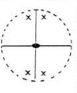

5) Définissez de façon la plus détaillée possible les différents éléments de symétrie du groupe d’espace I b a 2. Indiquez leur nature, expliquez les opérations générées et donnez leur position par rapport aux axes cristallographiques. *(20 points)*

**Symmetry elements:**

* **41: 4-fold screw axis parallel to (Oz). Rotation of 2pi/4 or pi/2 around z plus a translation of ¼ of c.**
* **1: identity**
* **b : glide mirror of type b that is perpendicular to the (Ox) axis, or // to the plane (zOy). We have a mirror reflection through the (zOy) plane and a translation of ½ of b in the direction // to x.**
* **a: glide mirror of type a that is perpendicular to (Oy), or // to the plane (xOz). We have a mirror reflection through the (xOz) plane and a translation of ½ of a in the direction // to y.**
* **2 : 2 fold rotation axis // to (Oz). Rotation of pi around z**

**Section 2. Study of the cristobalite beta or β-SiO2. (50 points)**

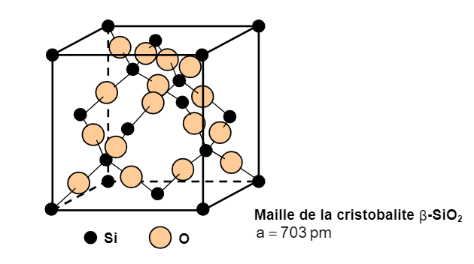

1) *(4 points)* 8 Si et 16 O SiO2 so 2 motifs /unit cell

2) *(4 points)* 2,20g/cm3

3) (6 points) **The W wire is heated by Joule effect, wehnelt, electrons are thus accelerated under vacuum and potential difference between the cathode and anti-cathode, the electrons hit the metallic target so we have interactions with the electrons from the anti-cathode and emission othe XR beam: continuous spectrum plus characteristic radiations**

4) *(8 points)*

**2dhkl sin Ɵ = λ**

**Donc d111=1,5406/2sin10=4,4359 Å**

**D022 = 2,7121 A**

**d222 = 2,2522 A**

5) *(12 points)*

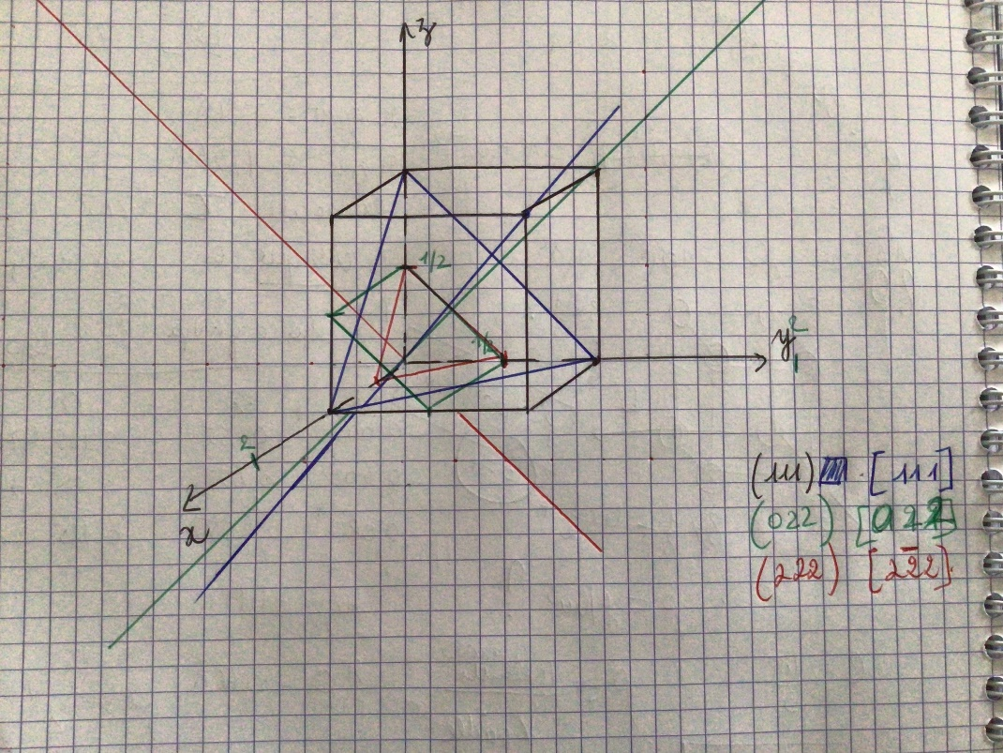

6) *(16 points)*

**Symmetry elements :**

* **21 : 2-fold screw axis // to (Ox), or perpendicular to (yOz). Rotation of pi around the axis (Oz) and a translation of ½ of a in the direction // to x.**
* **3 : 3-fold rotation axis // to (Oz), or perpendicular to (xOy). Rotation of pi/3 around (Oz) three times with the last rotation being the identity.**
* **1 : identity**