Payment Hub
Observability and Performance Testing Guide
Setting up the stack, reading the metrics, and five fault-injection scenarios worked through panel by panel
Author: Jatin Mehta
Version: 1.1
Date: 8 October 2026
Describes: Branch main as of 8 October 2026
Audience: Engineers new to observability
All payment data shown is synthetic. Screenshots are from the local Docker stack on Windows.
Contents
1. Start here 1
1.1 What you will learn 1
1.2 How to read this guide 1
1.3 About this version 1
2. Observability concepts 3
2.1 Metrics, logs and traces 3
2.2 How Prometheus collects metrics 3
2.3 The three metric types 4
2.4 rate(), increase() and why a counter's first value is invisible 4
2.5 Percentiles, and why averages mislead 4
2.6 Kafka in four ideas 4
2.7 Two views of lag 5
2.8 Saturation and the IO wait ratio 5
2.9 RED and USE 5
2.10 Annotations 5
3. Setting up (Windows, macOS, Linux) 6
3.1 What you need 6
3.2 Give Docker enough memory 6
3.3 First start 7
3.4 Check it works 7
3.5 Stopping and cleaning up 8
3.6 Problems we hit, and how to recognise them 9
4. Stack tour 10
4.1 Components 10
4.2 A payment's journey 11
5. Dashboards and what every panel means 13
5.1 The three dashboards 13
5.2 Reading a panel 14
5.3 Simulator 15
5.4 Processing & Lag 16
5.5 Transactions and Commits 21
5.6 Process 25
5.7 gRPC 28
5.8 JDBC 30
5.9 Disk Usage 32
5.10 Memory: Kafka broker (JVM) 33
5.11 Memory: Hub and ESS (Python) 36
6. Running a performance test 39
6.1 Readiness: is the system really ready? 39
6.2 Generating traffic 39
6.3 Injecting a fault 40
6.4 Marking the run on the dashboards 40
6.5 A scenario as a script 40
6.6 Looking at the run 41
6.7 After the run 41
7. The triage method 42
7.1 Finding one payment's journey in Kibana 42
8. Scenario 1: a slow dependency 43
8.1 Timeline 43
8.2 Prediction 43
8.3 The investigation 44
8.4 Prediction versus reality 48
8.5 Root cause 48
8.6 Knock-on effects 48
8.7 Lessons 48
9. Scenario 2: a slow database 49
9.1 Timeline 49
9.2 Prediction 49
9.3 The investigation 50
9.4 Prediction versus reality 53
9.5 Root cause 53
9.6 Lessons 53
10. Scenario 3: a network outage 55
10.1 Timeline 55
10.2 How the retry ladder works 55
10.3 Prediction 55
10.4 The investigation 56
10.5 Prediction versus reality 58
10.6 Finding the root cause 59
10.7 Lessons 59
11. Scenario 4: a slow broker 60
11.1 Timeline 60
11.2 Prediction 60
11.3 The investigation 60
11.4 Prediction versus reality 65
11.5 Root cause 65
11.6 Lessons 65
12. Scenario 5: memory growth (a soak test) 66
12.1 Timeline 66
12.2 Prediction 66
12.3 The investigation 66
12.4 Separating the two leaks 69
12.5 Prediction versus reality 70
12.6 Why so much memory 70
12.7 Extrapolation 70
12.8 Lessons 70
13. Findings, fixes and open issues 71
13.1 Scorecard 71
13.2 Fixed during the scenarios 71
13.3 Open issues 71
13.4 What a real test plan should check 72
14. Glossary 73
Appendix A. Command cheat sheet 74
Stack 74
Traffic and faults 74
Readiness queries (paste into Prometheus, http://localhost:9090) 74
URLs 74
Appendix B. Metric catalogue 75

If the page numbers look wrong after editing, right-click the list and choose Update Field, then Update entire table.

1. Start here
This guide explains how the Payment Hub is observed: how to bring up the local stack, what each component does, what every metric and dashboard panel means, and how those panels were used to find real problems in five fault-injection scenarios.
It is written for someone new to observability. Every concept is introduced through the Hub's own metrics, so by the end you should be able to open the Grafana dashboards during a test and explain what you are looking at.

1.1 What you will learn
- What observability is, and the difference between metrics, logs and traces.
- How to set up and start the stack on Windows, macOS or Linux.
- What each part of the stack does: the Hub, the External Systems Simulator (ESS), Kafka, PostgreSQL, Prometheus, Grafana, the exporters and the ELK log stack.
- What each of the 40 panels on the performance dashboard measures, what normal looks like, and what bad looks like.
- How to run a performance test properly: readiness checks, a warm-up gate, injecting a fault and marking it on the dashboards.
- A repeatable method for reading the dashboards top-down to find a root cause.
- Five worked investigations, each with the screenshots that led to the answer.

1.2 How to read this guide
If you want to… | Read
Understand the ideas first | Chapter 2 (concepts), then chapter 4 (stack tour)
Get the stack running | Chapter 3 (setup), then Appendix A (commands)
Know what a panel means | Chapter 5 (dashboards and panels) and Appendix B (metric catalogue)
Run a test yourself | Chapter 6 (running a test) and chapter 7 (triage method)
Learn by example | Chapters 8 to 12, one per scenario
See what was found and fixed | Chapter 13 (findings)

1.3 About this version
This guide describes branch main as of 8 October 2026. That is later than commit 4e215b2, the most recent commit when it was written: the later fixes from the scenario runs, the compliance rename and the cross-platform scripts/dev.py are described here but were not yet committed. Commands and ports may change after that; the repository's README.md, compose.yaml and CLAUDE.md are the source of truth for exact values. All payment data is synthetic.
Watch out
The screenshots were taken before the compliance screening service was renamed in the code. A few legends and method names in them still show its earlier abbreviation; they refer to the same service. The text of this guide uses the current names throughout.
Key idea
Observability is the ability to answer questions about a running system from the outside, without changing its code to ask them. A good set of metrics, logs and dashboards lets you go from "something is slow" to "this stage is waiting on that dependency" in a few minutes.

2. Observability concepts
This chapter covers the ideas you need to read the dashboards. Each idea is shown with a real metric from the Hub.

2.1 Metrics, logs and traces
Signal | What it is | In this stack | Best at answering
Metrics | Numbers sampled over time, already aggregated (a count, a rate, a percentile). | Prometheus scrapes them; Grafana draws them. | Is something wrong? Where? Since when? How much?
Logs | One line per event, with full detail (which payment, which step, what error). | Every service writes one JSON line per event; Filebeat ships them to Elasticsearch; Kibana searches them. | What exactly happened to this payment?
Traces | The path of one request across services, as timed spans. | The Hub creates OpenTelemetry spans and can export them, but the local stack runs no trace store. | Which hop of one request was slow?
Table 1. The three signals. In this guide, metrics find the problem and logs confirm it.
Metrics are cheap because they are aggregated: the Hub does not record a separate number for each payment, it records running counts and timings for each stage. That is why metrics can run at full load while detailed logging is switched down in performance mode.
Logs are the opposite: rich but expensive. Every payment carries a UETR (its unique end-to-end reference), and every log line about it includes payment.uetr, so you can search one payment's full journey in Kibana.
Key idea
A useful rule: metrics tell you THAT something is wrong and WHERE; the per-payment log trace tells you WHAT happened. Every scenario in this guide follows that path.

2.2 How Prometheus collects metrics
Prometheus uses a pull model. Each service exposes a plain-text page at /metrics, and Prometheus fetches ("scrapes") it every 5 seconds. Each line on that page is one time series: a metric name plus a set of labels.
# One series: records processed by the routing stage that succeeded
hub_records_processed_total{service="hub-routing",outcome="ok"} 2017

# Same metric, different labels = a different series
hub_records_processed_total{service="hub-routing",outcome="retry"} 3
Labels are how you slice a metric: by stage (service), by format (format="MT" or "MX"), by consumer group, and so on. Each distinct combination of labels is stored separately, so labels must have few possible values. That is why the test run ID is added once per scrape as an external label, never as a label on every metric.

2.3 The three metric types
Type | Behaviour | Hub example | How you read it
Counter | Only ever goes up (resets to 0 when the process restarts). | hub_records_processed_total | Never look at the raw value; take its rate: rate(...[1m]) gives records per second.
Gauge | Goes up and down; a reading of the current value. | hub_kafka_consumer_lag, hub_held_payments, process_resident_memory_bytes | Read it directly: "lag is 345 right now".
Histogram | Counts observations into buckets (≤ 5 ms, ≤ 10 ms, … ≤ 30 s). | hub_grpc_server_latency_seconds, ess_e2e_latency_seconds | Use histogram_quantile(0.95, …) to estimate a percentile.

Watch out
A histogram can only report up to its highest bucket. When scenario 1 drove end-to-end latency past 30 seconds, every panel showed exactly 30 s, because 30 s was the top bucket. The real value was higher. The end-to-end histograms were extended to 10 minutes before scenario 3 so the retry tail could be measured.

2.4 rate(), increase() and why a counter's first value is invisible
rate(x[1m]) is the average per-second increase of counter x over the last minute. increase(x[5m]) is the total increase over five minutes. Both need at least two samples: a counter that is born at 1 and never changes shows an increase of 0, because Prometheus never saw it at 0.
This caught out the Rebalance panel: every consumer group rebalanced once at start-up, but increase() showed zero. The panel now shows the cumulative count since start-up instead.

2.5 Percentiles, and why averages mislead
The p95 (95th percentile) latency is the value that 95 % of payments were faster than. p50 is the median, p99 the slowest 1 % boundary. Percentiles show what most users experience and how bad the tail is; an average hides both.
Example from scenario 5: p95 end-to-end latency was 0.97 s, but the slowest payment took 8.3 s. An SLO that only checks p95 passes that run; the max shows that some payments were badly delayed.

2.6 Kafka in four ideas
- Topic: a named, append-only log of records. The Hub uses one topic per step, for example hub.in.mx.raw, hub.pay.canonical, hub.out.mx.
- Partition: a topic is split into partitions so several consumers can share the work. Records with the same key (the UETR) always land on the same partition, so one payment's records stay in order.
- Consumer group: the set of consumers sharing a topic. Each Hub stage is one group, for example cg-screening. Kafka assigns each partition to exactly one member of the group.
- Offset and lag: each record has a position (offset). A group's lag is how many records are waiting: the end of the log minus the group's committed position. Rising lag means work is arriving faster than the stage can finish it.
The Hub processes each batch of records inside a Kafka transaction: it reads, processes, writes its output and commits its position in one atomic step. Downstream stages only read committed data. That makes processing safe after a crash, and it also means a record is invisible downstream until the whole batch it belongs to commits (this matters in scenario 1).

2.7 Two views of lag
Panel | Measured by | Strength | Weakness
Consumer Lag (Consumer) | Each Hub stage, when it reads a record | Cheap, per partition | Only updates when a record arrives, so a stuck stage freezes at its last value
Consumer Lag (Broker) | kafka-exporter, asking the broker for each group's committed offset | Keeps updating even if the consumer is stuck or gone | Can briefly read slightly negative on transactional topics (clamped to 0)

2.8 Saturation and the IO wait ratio
Each Hub stage is one thread that loops: poll Kafka for records, process them, commit. The IO wait ratio is the share of that thread's time spent waiting for records. Near 100 % means the stage is idle and has plenty of spare capacity. Falling towards 0 % means it is saturated: as soon as it finishes one batch, the next is already waiting.
This one number tells you which stage is the bottleneck. In scenario 1, only screening fell to 0.5 %; in scenario 4, every stage fell at once.

2.9 RED and USE
Two checklists help decide what to measure:
- RED, for services: Rate (requests per second), Errors, Duration (latency). The gRPC panels are RED for every call the Hub makes and serves.
- USE, for resources: Utilisation, Saturation, Errors. IO wait, lag, connection usage and memory are USE for stages, Kafka, the database and the processes.

2.10 Annotations
An annotation is a marker on the time axis of every Grafana panel, with a short text. Each scenario posted one when it started, when the fault went in, when it was removed and when it ended. They turn a dashboard into a story: you can see exactly what changed after the fault marker.

3. Setting up (Windows, macOS, Linux)
The stack runs the same on all three: every component is a Linux container. Only a few host settings differ, and one command checks them for you.

3.1 What you need
 | Windows | macOS (Intel or Apple Silicon) | Linux
Containers | Docker Desktop (WSL 2 backend) | Docker Desktop | Docker Engine with the Compose plugin, or Docker Desktop
Memory for Docker | 10 GB, in %UserProfile%\.wslconfig | 10 GB, in Docker Desktop: Settings, Resources | The host's own memory: about 9 GB free
Elasticsearch setting | Set by Docker Desktop | Set by Docker Desktop | sudo sysctl -w vm.max_map_count=262144
Python 3.12 or later | For the helper script and the tests | Same | Same
Git, a browser | Yes | Yes | Yes

The full stack uses about 9 GB. Without the elk profile (logs) it needs about half that, and the Elasticsearch setting does not matter. Every image is published for both Intel/AMD and ARM processors, so Apple Silicon Macs run it natively.
Watch out
Supported container runtimes are Docker Desktop and Docker Engine. Podman, Colima and rootless Docker are not tested: Filebeat reads the Docker socket and the containers' log files, which those expose differently.

3.2 Give Docker enough memory
Windows: Docker Desktop's VM gets half the machine's RAM by default. Create %UserProfile%\.wslconfig with the lines below, run wsl --shutdown, and start Docker Desktop again.
[wsl2]
memory=10GB
swap=4GB

[experimental]
autoMemoryReclaim=gradual
macOS: Docker Desktop, Settings, Resources: set Memory to 10 GB and apply.
Linux: containers use the host's memory directly. Set the Elasticsearch kernel setting once, and keep it across reboots:
echo "vm.max_map_count=262144" | sudo tee /etc/sysctl.d/99-elasticsearch.conf
sudo sysctl --system

3.3 First start
These commands are the same in PowerShell, Terminal on macOS, and any Linux shell. Run them from the repository folder. On macOS and Linux the interpreter may be called python3.
python scripts/dev.py doctor # is this machine ready? says what to fix
python scripts/dev.py up # build the image once, start everything
python scripts/dev.py ready --wait 300 # wait until it is really ready
doctor checks Docker, memory, the Elasticsearch setting and whether the stack's ports are free. up creates .env from .env.example the first time, builds the shared image once and starts the stack. ready waits for the conditions described in chapter 6.
Key idea
python scripts/dev.py with no arguments lists every task: install, check, doctor, up, ready, stop, down, logs, send, trace and more. It uses only Python's standard library, so it works on a fresh clone.
Which services start is set by COMPOSE_PROFILES in .env:
Profile | Starts | Use
solo | The whole Hub in one container | Local development and these tests (the default)
stages | One container per stage (11) | Production shape; do not combine with solo
obs | Prometheus, Grafana, kafka-exporter | Metrics and dashboards
elk | Elasticsearch, Kibana, Filebeat | Logs (about 4 GB of RAM)

If another program already uses one of the stack's ports, change it in .env, for example GRAFANA_HOST_PORT=3001. .env.example lists them all.

3.4 Check it works
- Open http://localhost:9090/targets. The hub, ess, kafka and kafka-exporter targets should show UP. The hub-stages targets show DOWN, which is expected: that is the per-stage topology, and it is not running.
- Open http://localhost:3000 (no login). Go to Dashboards, then the Payment Hub folder.
- Send a few payments: docker compose exec -T ess python -m ess.cli batch -n 30 -r 1. All 30 should report COMPLETED.
- Open 3 · Performance deep-dive and set the time range to the last 15 minutes. The panels should show the traffic.
- Follow one payment everywhere with python scripts/dev.py trace.
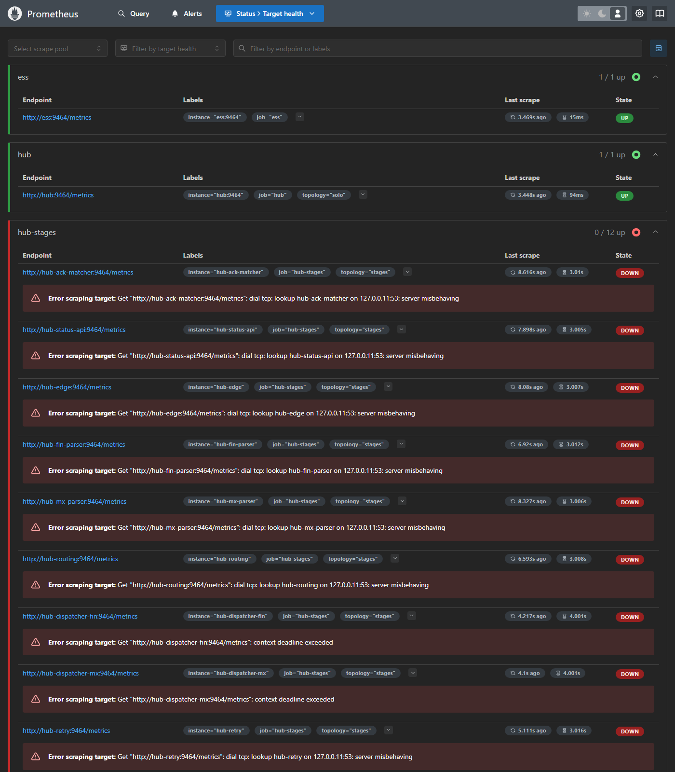
Figure 1. Prometheus's targets page. Every scrape target the stack defines, and whether Prometheus can reach it. hub-stages is DOWN by design when the solo profile runs.

3.5 Stopping and cleaning up
Command | Effect
python scripts/dev.py stop | Stops the containers and keeps all data, metrics and logs
python scripts/dev.py up --no-build | Starts them again
python scripts/dev.py down | Deletes the containers and all their data. Nothing in this stack uses named volumes

3.6 Problems we hit, and how to recognise them
These were found on a Windows laptop. The first applies to any laptop: Docker Desktop on macOS pauses its VM on sleep in the same way.
Symptom | Cause | Fix
Payments accepted but never complete; no errors anywhere | The computer slept. Kafka removed the Hub's consumers from their groups and most never rejoined | Fixed in the Hub: a stage that holds no partitions for a minute rejoins by itself, and the Hub reports unhealthy meanwhile (hub_stage_stalled). python scripts/dev.py ready shows it
Image build hangs on "load metadata" or fails with "Temporary failure in name resolution" | DNS inside Docker Desktop's VM stopped working, usually after sleep (seen on Windows) | Restart Docker Desktop, then python scripts/dev.py up. A fixed DNS server in Docker Desktop's Docker Engine settings should prevent it (suggested, not yet tested)
A container cannot start: "port is already allocated", but nothing is using the port | A stale reservation inside Docker after a stack was torn down (seen on Windows) | Restart Docker Desktop
Very high latency and many DEADLINE_EXCEEDED errors right after starting | Elasticsearch and Kibana are still starting and using most of the CPU | Wait about 5 minutes and pass the warm-up gate before testing
A run at 10 payments/s fails with deadline errors | A 16 GB laptop runs out of CPU above about 3 to 5 payments/s with the full stack | Keep local runs at about 3/s, or drop the elk profile
On Windows, docker exec ... /opt/kafka/... fails with "no such file or directory" | Git Bash rewrites the path into a Windows path | Use PowerShell or WSL, or set MSYS_NO_PATHCONV=1. scripts/dev.py is not affected

Lesson
Turn off sleep while testing, on any laptop. Two runs in this guide were spoiled by the computer sleeping.

4. Stack tour
The figure below shows every component, how payments flow between them, and where each kind of telemetry is collected.
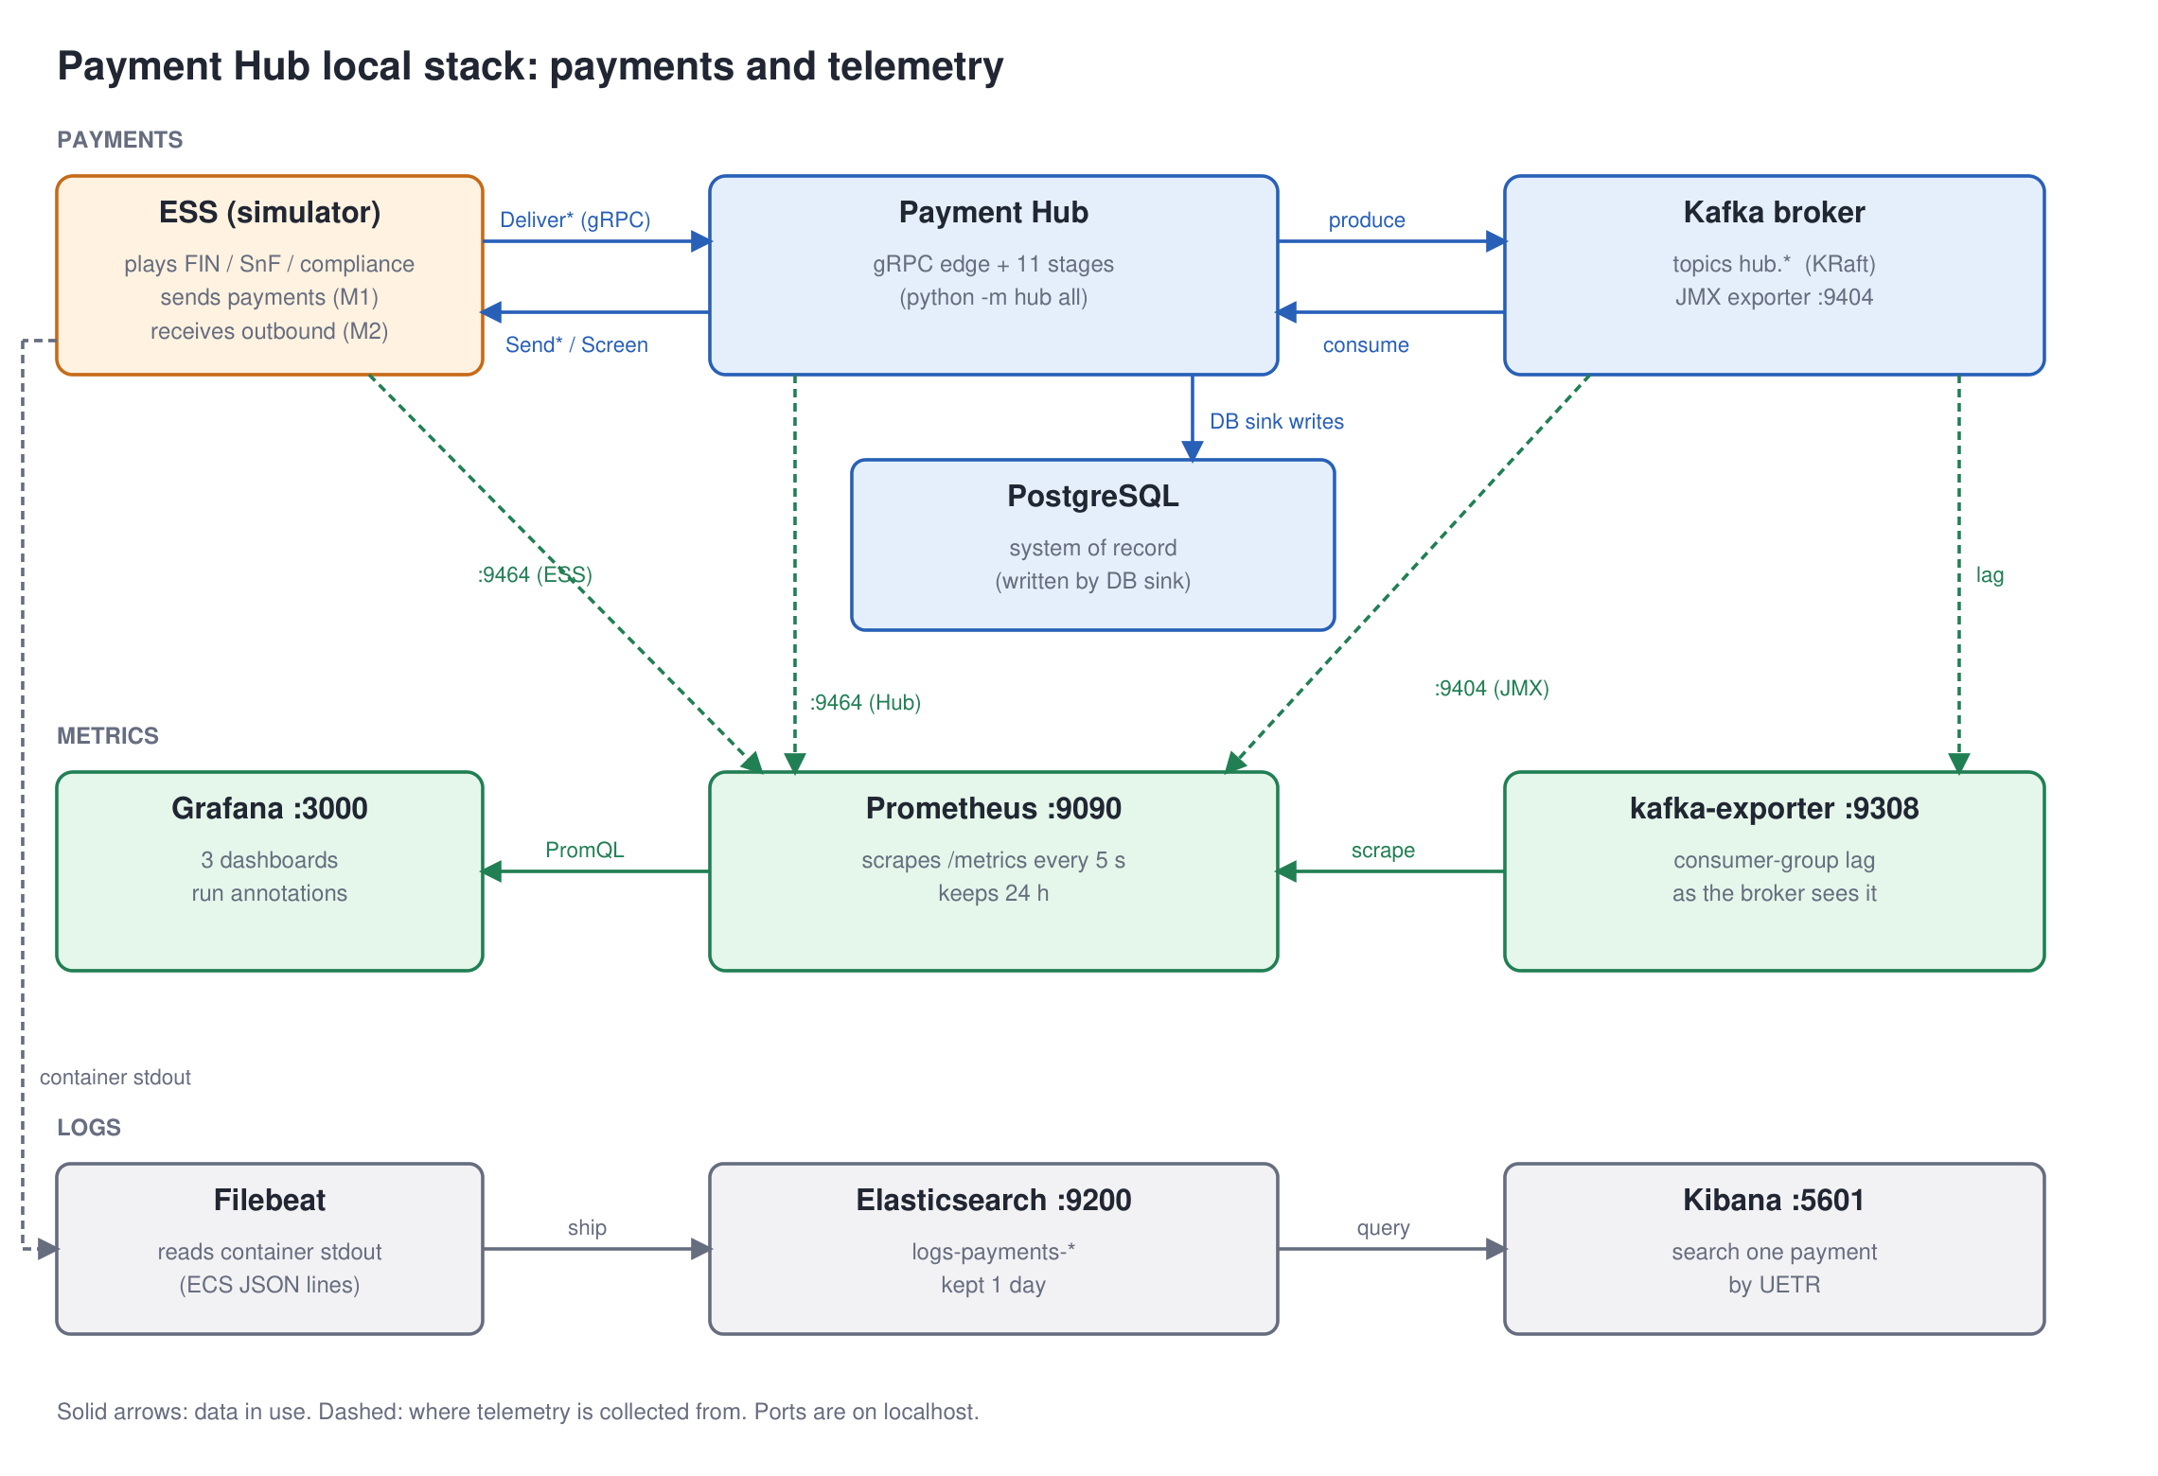
Figure 2. The local stack. Payments flow along the top row. Prometheus scrapes metrics from the ESS, the Hub, the Kafka broker and kafka-exporter; Grafana draws them. Logs go from container output through Filebeat to Elasticsearch, and Kibana searches them.

4.1 Components
Component | Container | Port (localhost) | What it does | What it gives you
Payment Hub | hub | 8443 gRPC edge  8080 status API  9464 metrics | Receives payments, parses, screens, routes, settles, dispatches them and matches the network ACK. All 11 stages in one process (solo) | Hub metrics at /metrics; one JSON log line per event
External Systems Simulator (ESS) | hub-ess | 9101 control | Plays the outside world: delivers payments in (as FIN and SnF), receives payments out, answers compliance screening, sends ACKs. Fault profiles let you make it slow, fail or go down | ESS metrics, including the simulator's own end-to-end latency
Kafka broker | hub-kafka | 29092 clients  9404 JMX metrics | Stores every topic. Single broker, KRaft mode. Includes the Prometheus JMX exporter agent | Broker throughput, request and transaction timings, log sizes, JVM memory and GC
kafka-init | hub-kafka-init | – | Creates all topics, then exits | –
PostgreSQL | hub-postgres | 5432 | The system of record, written by the DB sink stage | Tables payment (latest state) and payment_audit (every state change)
Prometheus | hub-prometheus | 9090 | Scrapes all metrics every 5 s and stores them for 24 hours | PromQL queries, the targets page
Grafana | hub-grafana | 3000 | Dashboards, provisioned from files in the repository | Three dashboards, annotations
kafka-exporter | hub-kafka-exporter | (internal 9308) | Asks the broker for each consumer group's lag | kafka_consumergroup_lag
Elasticsearch | hub-elasticsearch | 9200 | Stores the logs, deleted after a day | Index logs-payments-*
Kibana | hub-kibana | 5601 | Searches the logs | One payment's journey by UETR
Filebeat | hub-filebeat | – | Reads container output and ships the JSON lines to Elasticsearch | –
Table 2. Every component of the local stack.

4.2 A payment's journey
Following one MX (ISO 20022) payment through the Hub shows where each metric comes from. Each step writes to the next Kafka topic, inside a transaction, and publishes a state change to hub.pay.status.
Step | Where | State | Timestamp
The ESS, playing SnF, calls DeliverMx. This is message M1 | Hub edge (gRPC) | – | T0 network delivery
The edge writes the raw message to hub.in.mx.raw and replies ACCEPTED | Edge | RECEIVED | T1 accepted
Parse the XML into the canonical model | mx-parser | PARSED | T2
Call the compliance Screen service (the ESS answers) | screening | SCREENED (or HELD on a hit) | T3
Choose the network and route | routing | ROUTED
Post to the ledger | settlement | SETTLED
Call SendMx on SnF (the ESS receives message M2) | dispatcher-mx | DISPATCHED | T4 handoff
SnF sends the network ACK back through NotifyAck | Edge, then ack-matcher | COMPLETED | T5 ACK, T6 completed
Every state change is written to PostgreSQL | db-sink | –

The ESS times M1 to M2 itself (the simulator's end-to-end latency). The Hub times T0 to T6 (the Hub's end-to-end latency). Comparing the two is useful: the simulator's view includes every gRPC hop and any queueing outside the Hub's own code.
Key idea
MT (SWIFT FIN) payments follow the same steps with DeliverFin, hub.in.fin.raw, fin-parser, dispatcher-fin and SendMt. MT and MX only share the middle of the pipeline.

5. Dashboards and what every panel means
Grafana has three dashboards in the Payment Hub folder. Dashboards 1 and 2 are summaries; dashboard 3, the performance deep-dive, has 40 panels in rows. This chapter goes through every panel.

5.1 The three dashboards
Dashboard | Purpose | Look here first for
1 · Run overview | Is the run healthy? Payments per second in and out, achieved ratio, errors, held payments, end-to-end percentiles, retries, payments waiting for an ACK | The headline numbers of a test
2 · Pipeline stage breakdown | Where time goes and where work accumulates: lag, payments in flight, latency per stage, transaction cost | Which stage is slow
3 · Performance deep-dive | Every detail: simulator, processing, transactions, gRPC, database, disk, memory | Root cause

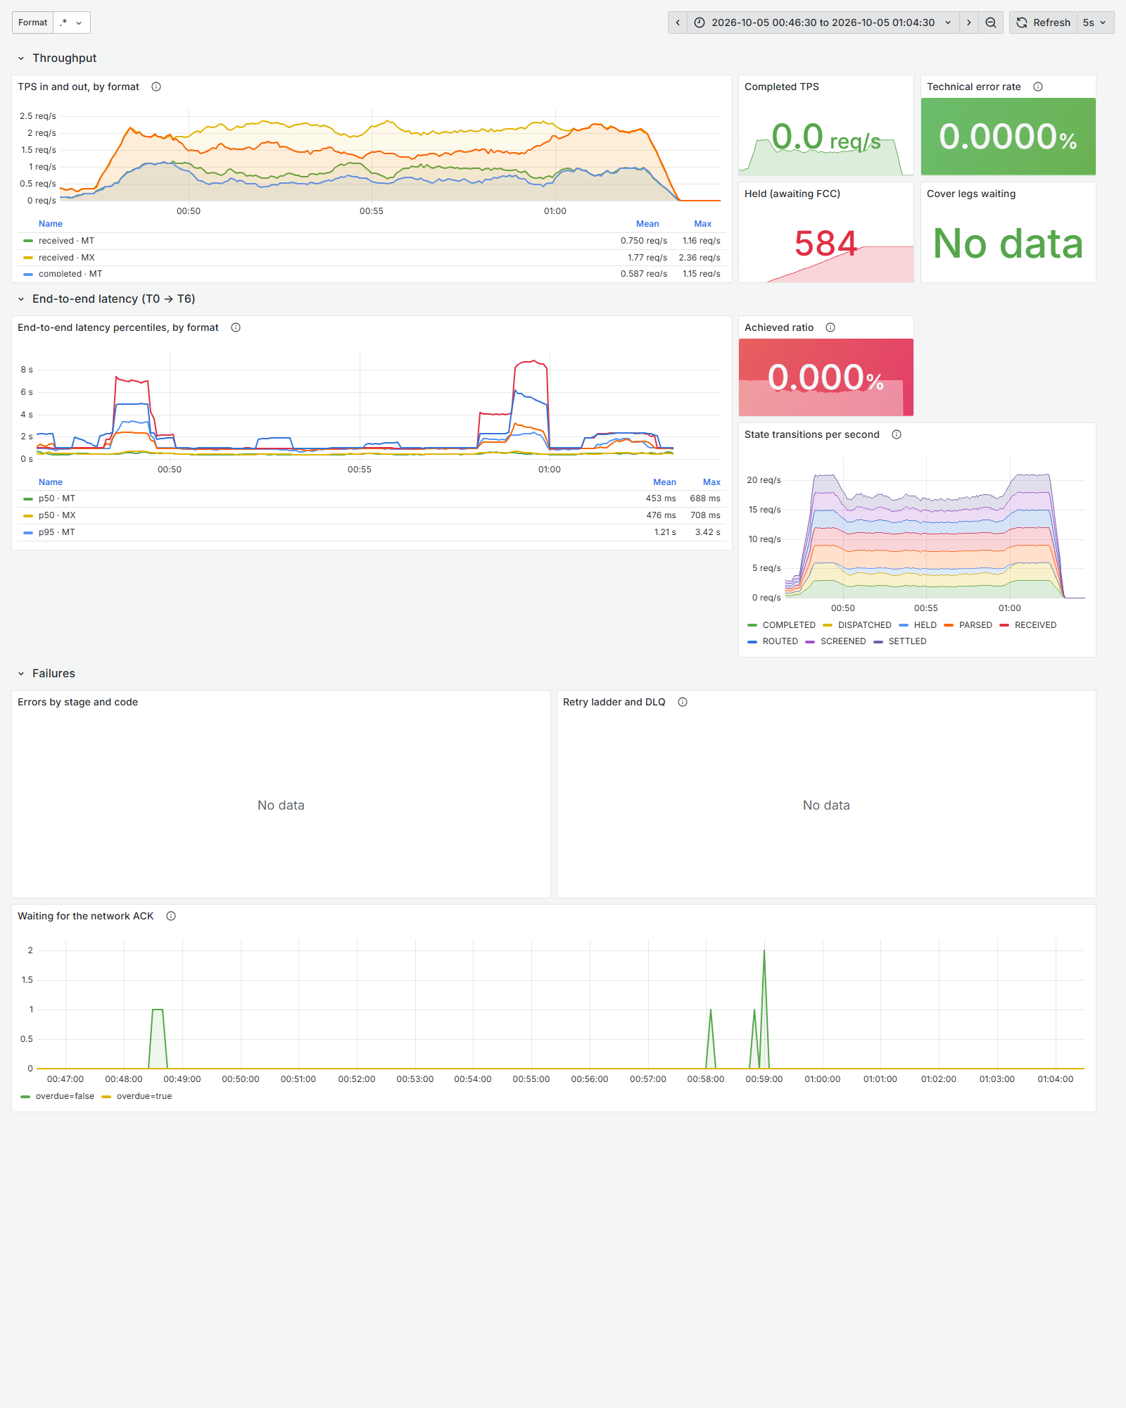
Figure 3. Dashboard 1 · Run overview, over the scenario 5 soak. The bottom panel, "Waiting for the network ACK", was added after scenarios 1, 3 and 4 found payments stuck without one. The coloured number tiles show the value at the END of the time window, after the traffic had stopped, which is why "Achieved ratio" reads 0 % here; the graphs show the run itself.

5.2 Reading a panel
- Hover over the ⓘ next to a panel title for its description.
- The legend table under each graph shows mean, max or last values for each line; click a line's name to show only that line.
- The Stage drop-down at the top filters the stage-level panels to one or more stages.
- Drag across a graph to zoom in on a time range; the whole dashboard follows.
- Vertical markers are annotations posted by the test scripts (start, fault, recovery, end).
Key idea
All screenshots in this chapter come from the scenario 5 soak (5 October, 00:46 to 01:04), so they show steady traffic and, in the Disk Usage and Memory rows, a real leak. Each scenario chapter shows the panels that mattered for that scenario.

5.3 Simulator
What the outside world experiences. Measured by the ESS, so it includes everything the Hub's own timers cannot see.

E2E Latency (Simulator)
p50, p95 and p99 time from the ESS sending a payment in (M1) to receiving the Hub's outbound message for it (M2), by format.
Normal on this stack | What bad looks like | Scenarios
p95 about 0.5–0.8 s at 3/s | Climbs and stays up; flat at 30 s means "30 s or more" in older runs (top bucket) | 1, 3, 4

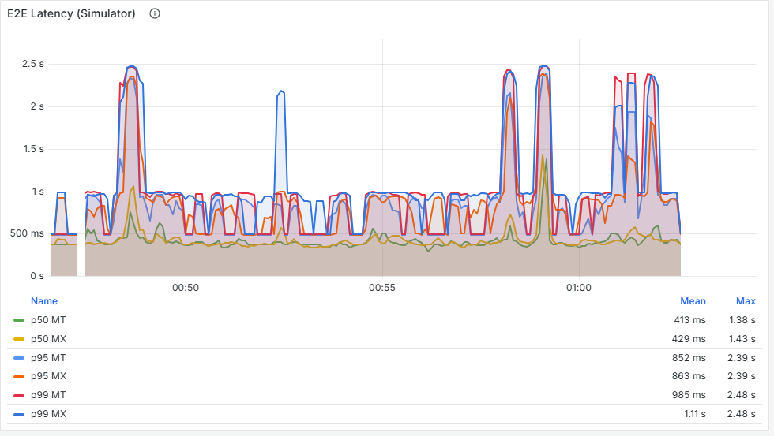
Figure 4. E2E Latency (Simulator).

M1 sent (Simulator), M2 received (Simulator)
Payments delivered in, and outbound messages received out, per second. Also: M2 with no waiting M1 (a repeat), and how many M1 are still waiting.
Normal on this stack | What bad looks like | Scenarios
M1 and M2 lines on top of each other at the input rate; "awaiting" near 0 | A gap between the lines: the Hub is taking in more than it sends out. "Awaiting" rising: work is stuck inside | 1, 3, 5

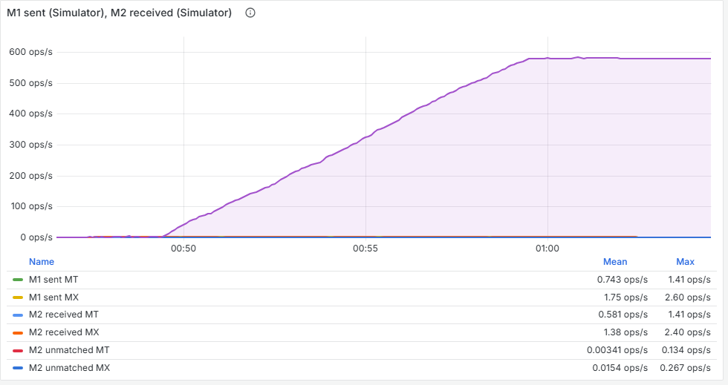
Figure 5. M1 sent (Simulator), M2 received (Simulator).

E2E Latency
The Hub's own T0 to T6 percentiles, observed when the network ACK completes a payment.
Normal on this stack | What bad looks like | Scenarios
Close to the simulator's view, slightly lower | Rises with the simulator's view; a big difference between the two points at queueing outside the Hub's code | 1

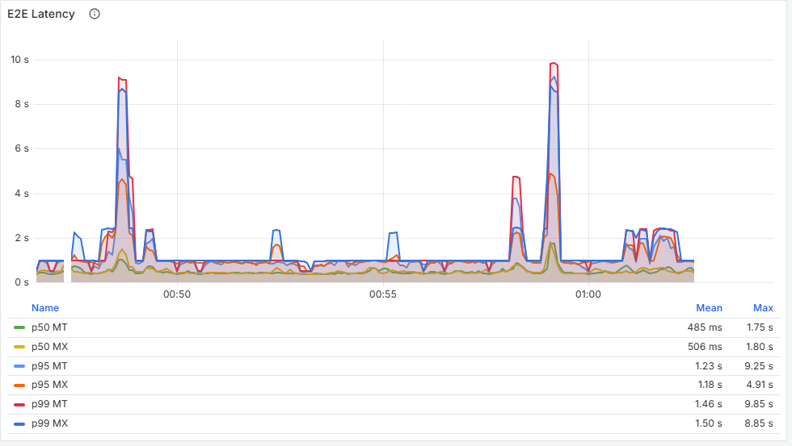
Figure 6. E2E Latency.

5.4 Processing & Lag
Where work is piling up, and how fast each stage and the broker are moving records.

Consumer Lag (Consumer)
Lag reported by each stage when it reads a record, by group and topic.
Normal on this stack | What bad looks like | Scenarios
0–5 | Rising for one group. It freezes if the consumer stops reading, so check the broker view too | 1

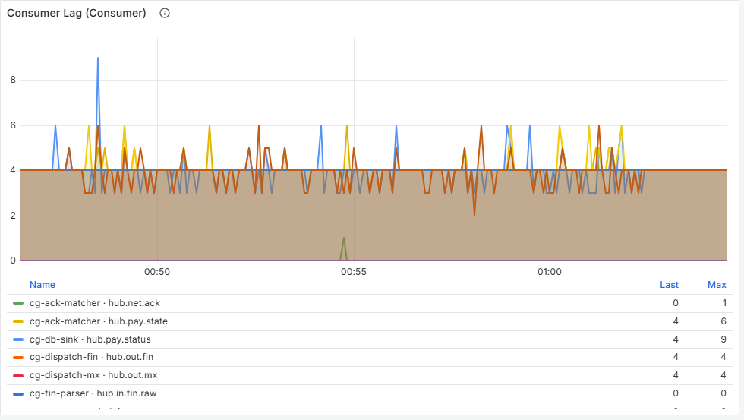
Figure 7. Consumer Lag (Consumer).

Consumer Lag (Broker)
Lag from kafka-exporter: the broker's view of each group's committed position. Clamped at 0.
Normal on this stack | What bad looks like | Scenarios
0–5 for every group | One group climbing while the others stay at 0 points at that stage (scenarios 1 and 2). Rising for every group at once points at Kafka or the whole process | 1, 2, 4

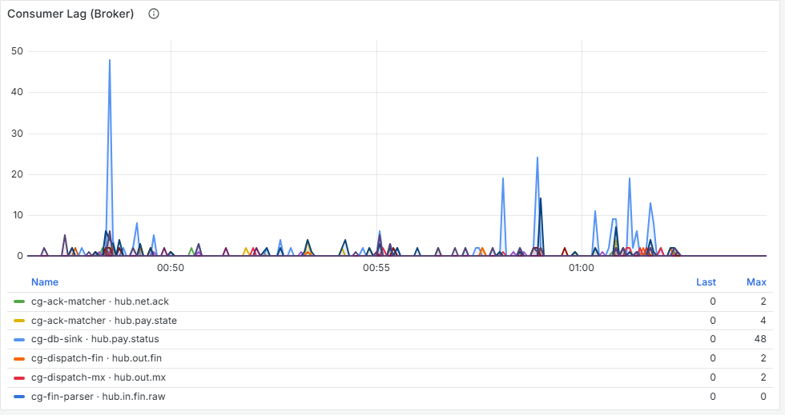
Figure 8. Consumer Lag (Broker).

Streams processed records per second
Records each stage processed, by outcome: ok, retry (sent to a retry topic) or dlq.
Normal on this stack | What bad looks like | Scenarios
Only ok, several per second per stage | retry appearing (a dependency failing); dlq appearing (a human must look) | 3

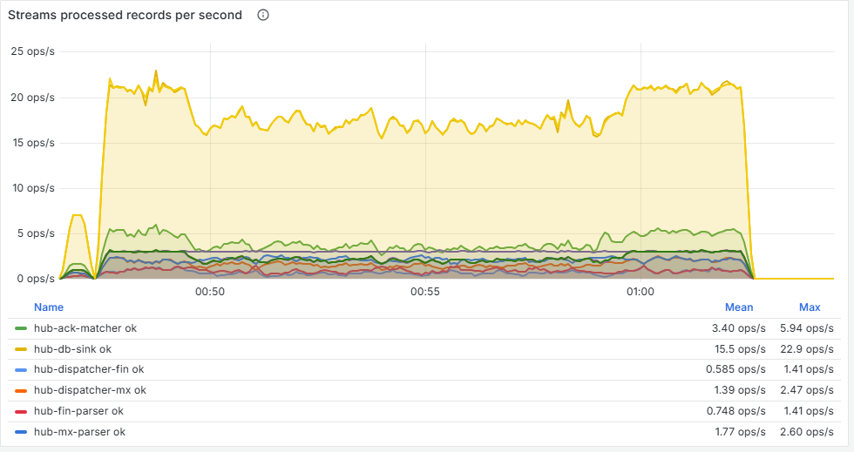
Figure 9. Streams processed records per second.

Listener consumed records per second
Every record each consumer group read, including the internal state topic.
Normal on this stack | What bad looks like | Scenarios
Steady, roughly proportional to the payment rate | Drops to 0 for a group while lag rises: that group has stopped consuming | –

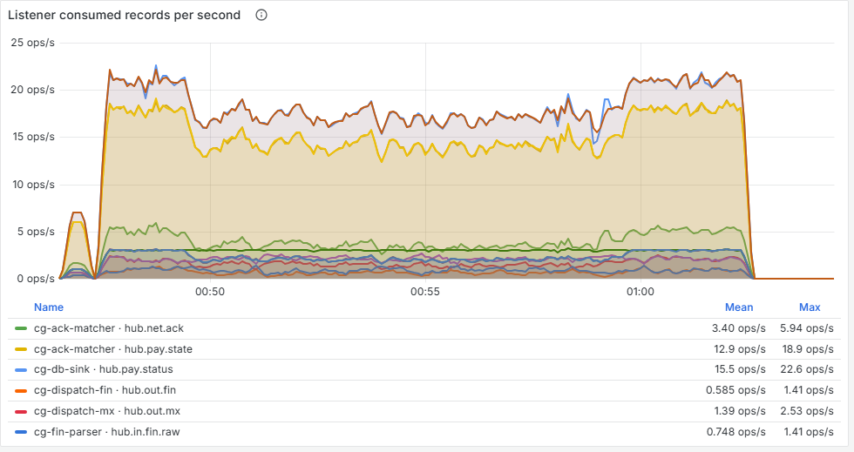
Figure 10. Listener consumed records per second.

Broker records in per sec
Records appended to each topic per second (from the broker). One payment writes several records, so this is not payments per second.
Normal on this stack | What bad looks like | Scenarios
A stable stack of topics | New topics appearing, for example hub.out.mx.retry.30s | 3

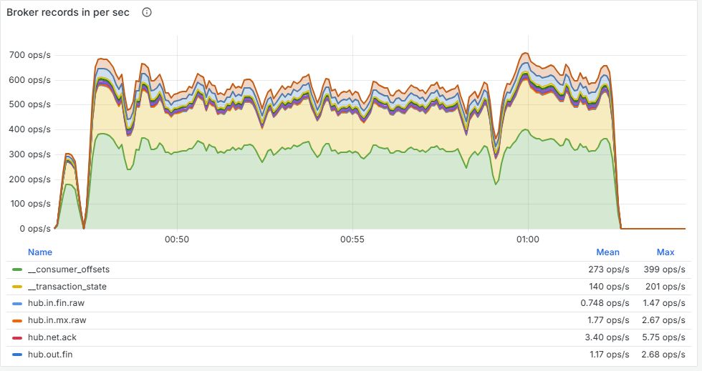
Figure 11. Broker records in per sec.

Broker records in total
Cumulative records per topic since the broker started.
Normal on this stack | What bad looks like | Scenarios
Climbing steadily | Sizing only | –

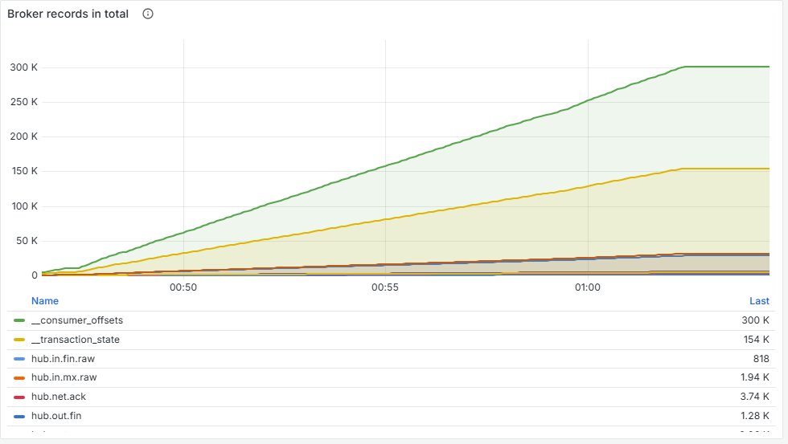
Figure 12. Broker records in total.

Broker bytes in per sec
Bytes written to each topic per second. The raw MT/MX topics dominate because only they carry the full message.
Normal on this stack | What bad looks like | Scenarios
Tens of kB/s locally | Sizing only | –

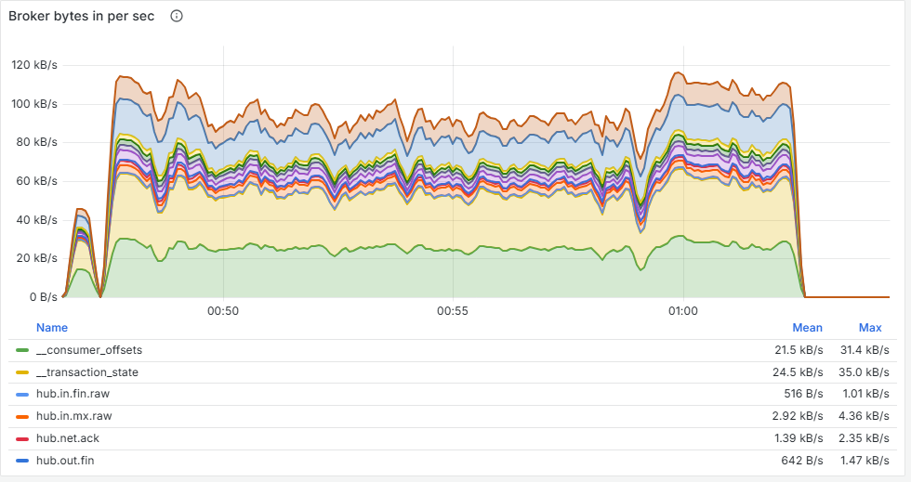
Figure 13. Broker bytes in per sec.

Broker bytes out per sec
Bytes read from each topic per second; multiplied by the number of groups reading it.
Normal on this stack | What bad looks like | Scenarios
Higher than bytes in | Sizing only | –

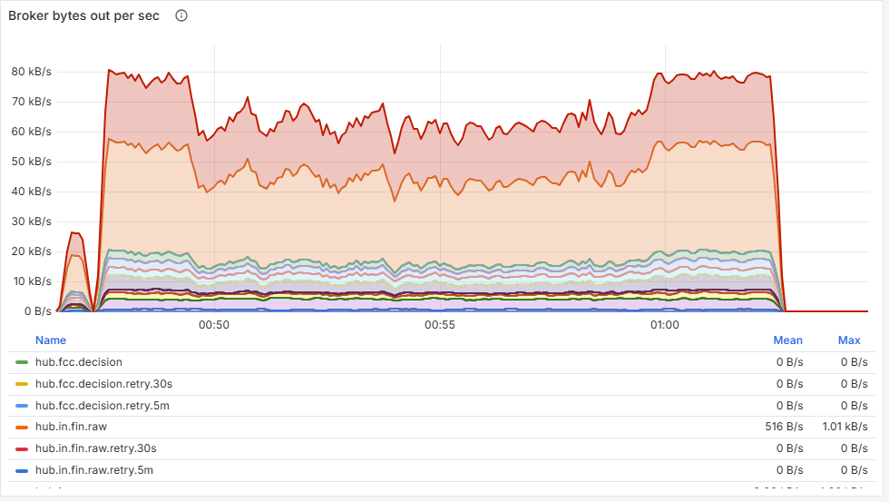
Figure 14. Broker bytes out per sec.

5.5 Transactions and Commits
The cost of Kafka transactions, from the Hub's side and the broker's side.

Streams commit latency average
Average time for a stage to commit one transaction (output records and consumer position together).
Normal on this stack | What bad looks like | Scenarios
7–15 ms | Much higher than process latency: the stages spend their time committing, not working (scenario 4: about 150 ms) | 4

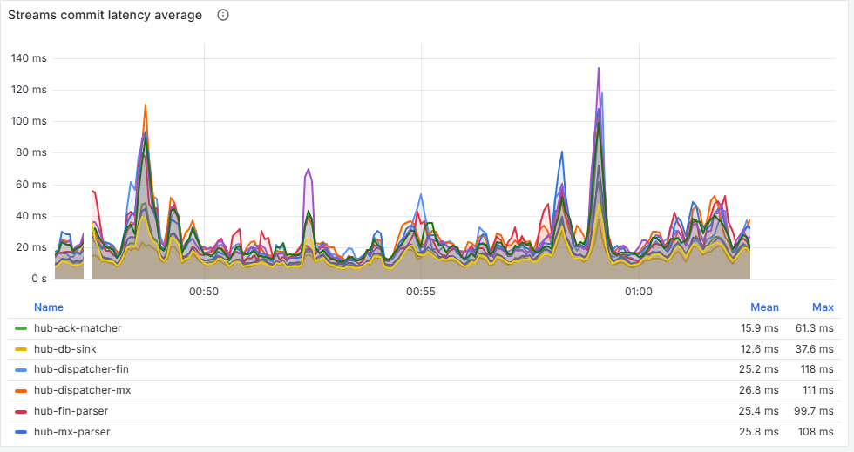
Figure 15. Streams commit latency average.

Broker prepare to complete average
The broker's average time for WriteTxnMarkers (writing commit markers to every partition) and EndTxn (the client's commit request).
Normal on this stack | What bad looks like | Scenarios
1–5 ms | Rising together with commit latency confirms the broker is the slow side. This is a slow-moving average, so it understates spikes | 4

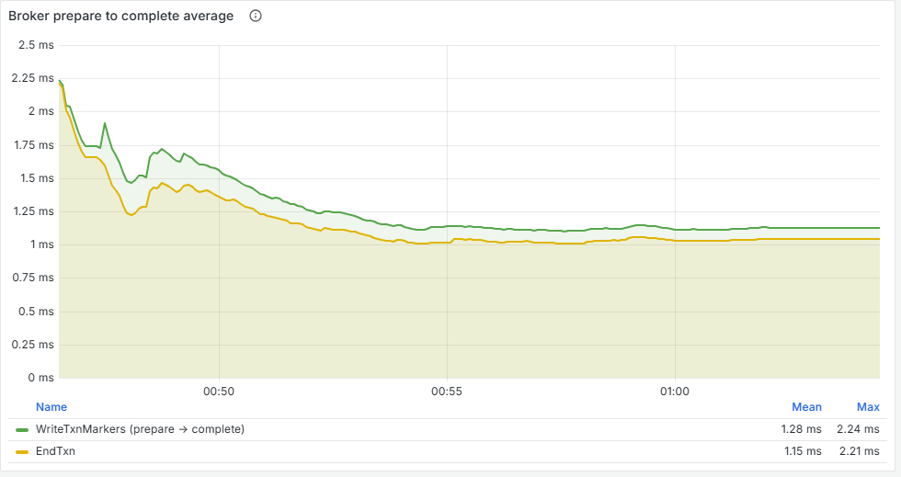
Figure 16. Broker prepare to complete average.

Commit per second
Committed and aborted transactions per stage.
Normal on this stack | What bad looks like | Scenarios
Roughly the record rate at low load (one record per batch) | Commits falling while records stay flat: batches are growing because commits are slow (scenario 4). Any aborted series needs a look | 4

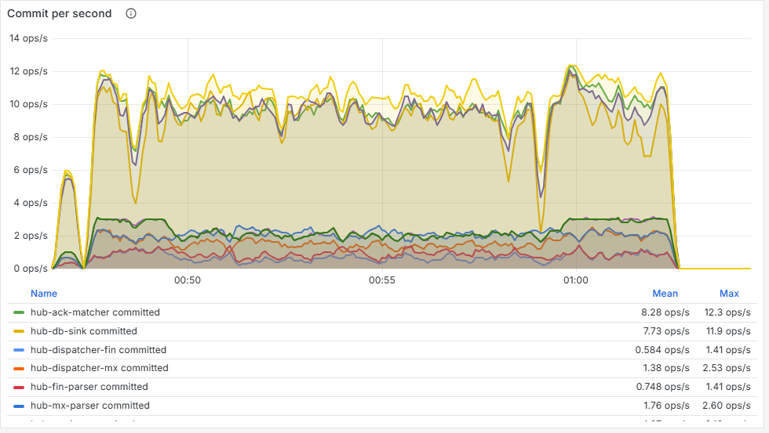
Figure 17. Commit per second.

Streams commit latency max
Longest single commit per stage over the last 30–60 s.
Normal on this stack | What bad looks like | Scenarios
Under 0.3 s | Seconds: one slow commit holds back every record in its batch | 1, 4

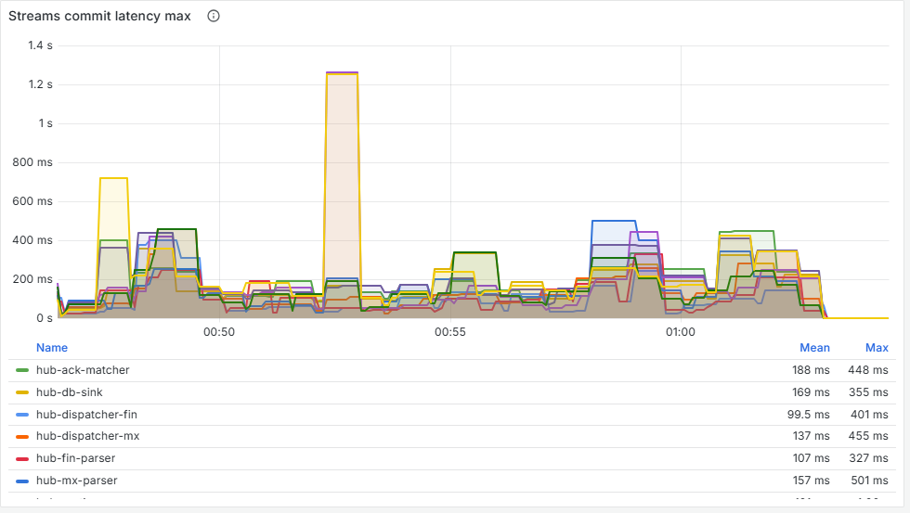
Figure 18. Streams commit latency max.

Broker prepare to complete max
The broker's maximum for the same two requests.
Normal on this stack | What bad looks like | Scenarios
Under 0.4 s | Sustained high values | 4

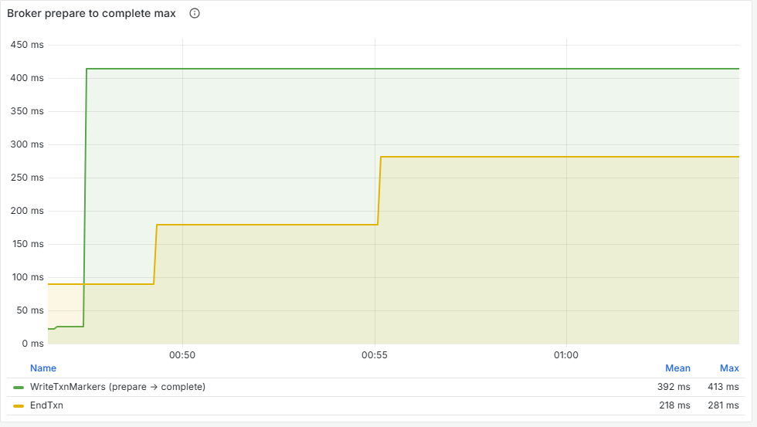
Figure 19. Broker prepare to complete max.

Broker errors
Request errors by API and error code, plus failed produce and fetch requests.
Normal on this stack | What bad looks like | Scenarios
Occasional CONCURRENT_TRANSACTIONS or COORDINATOR_LOAD_IN_PROGRESS blips are normal | Sustained error rates | –

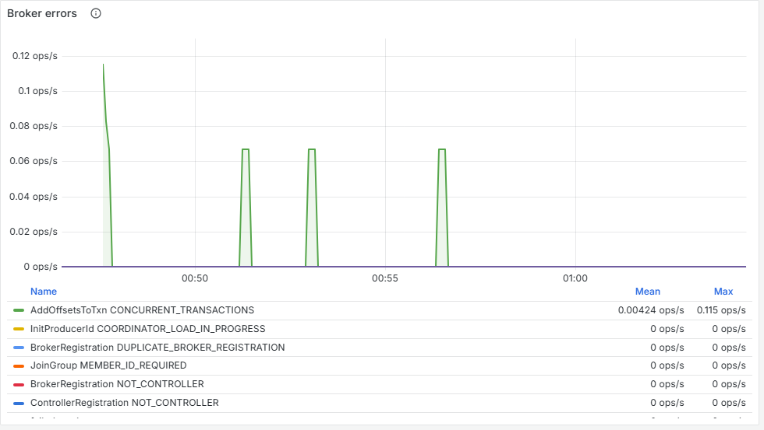
Figure 20. Broker errors.

5.6 Process
How busy each stage is and where its time goes.

Process latency avg
Average time to process one record in each stage, not counting the commit. Includes outbound gRPC calls. A separate post-commit series shows work done after the commit (the DB sink's database write).
Normal on this stack | What bad looks like | Scenarios
1–20 ms; screening about 17 ms | One stage jumping (scenario 1: screening 17 → 390 ms) | 1, 2, 4

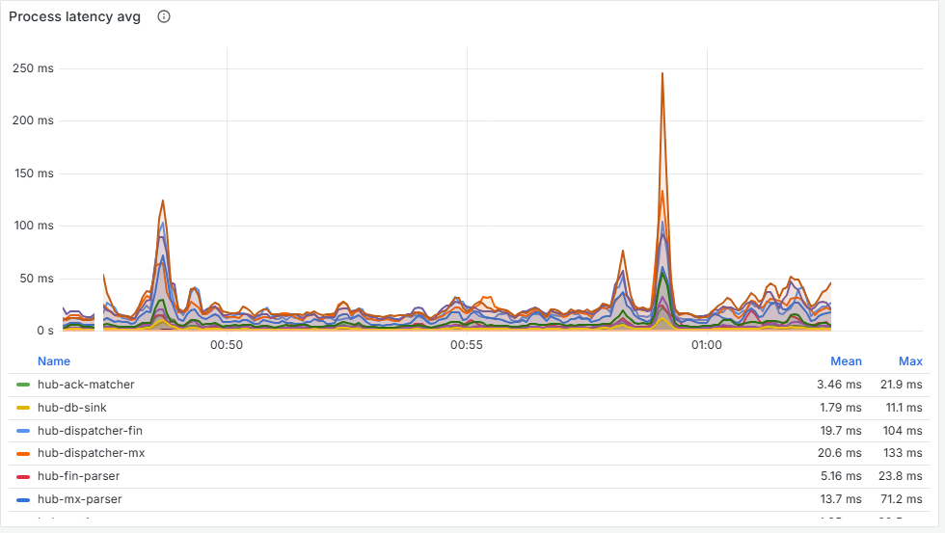
Figure 21. Process latency avg.

Rebalance
Partition assignment changes per consumer group since the process started, and the partitions each group holds now.
Normal on this stack | What bad looks like | Scenarios
One assignment per group at start-up; partitions held never 0 | Steps up mid-run (a consumer left or crashed); partitions held at 0 means a stage is doing nothing | –

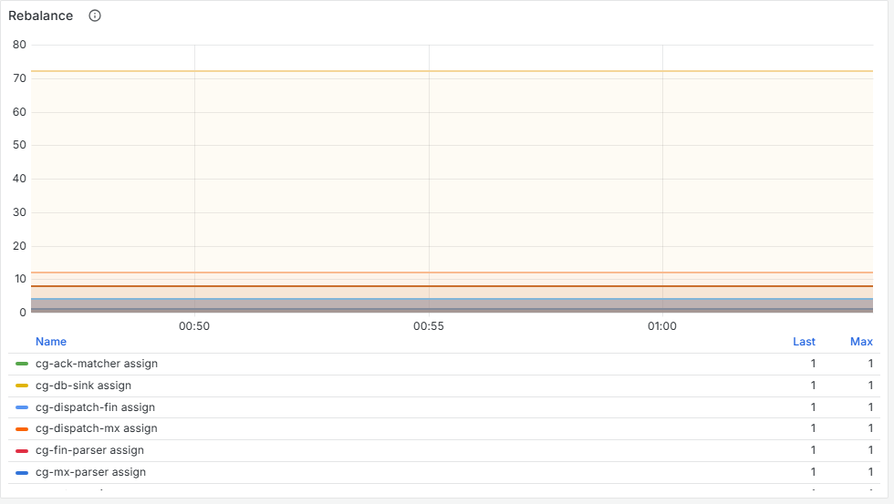
Figure 22. Rebalance.

Process Total
Records processed since the process started, by stage and outcome.
Normal on this stack | What bad looks like | Scenarios
Climbing steadily | A stage that stops climbing | –

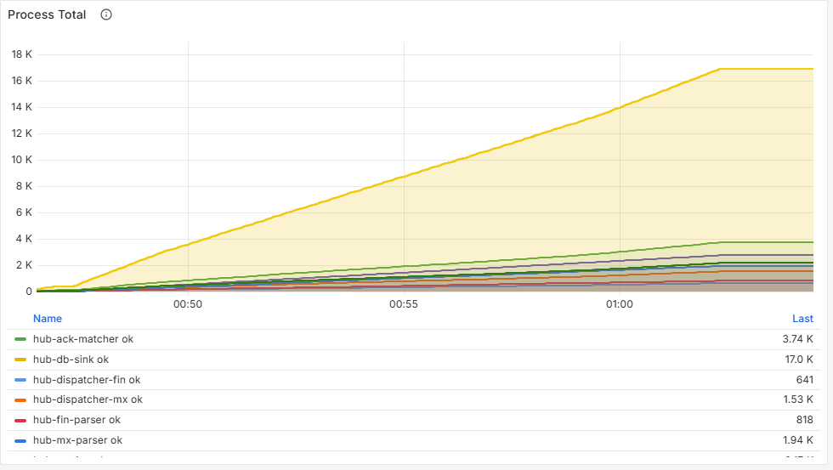
Figure 23. Process Total.

Process latency max
Longest single-record processing time per stage (30–60 s window), plus the longest post-commit step.
Normal on this stack | What bad looks like | Scenarios
Under 0.5 s | Spikes show individual slow records that an average hides | 1

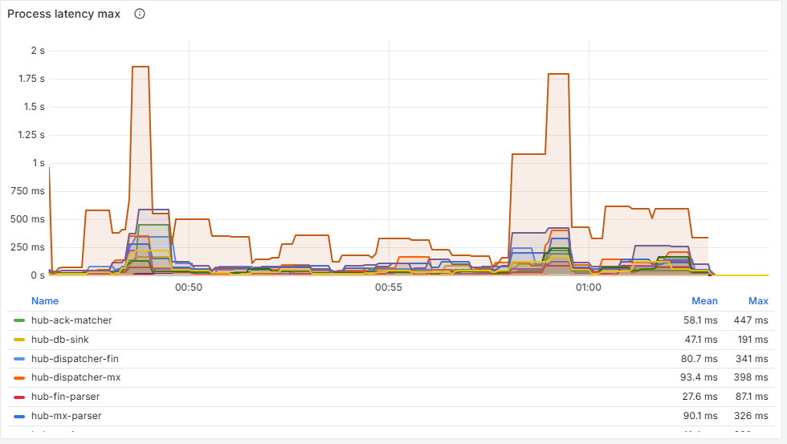
Figure 24. Process latency max.

Poll time
Average and p99 time a stage spends inside one Kafka poll.
Normal on this stack | What bad looks like | Scenarios
Close to the 50 ms poll timeout when idle | Mostly a sanity check; high when idle is normal | –

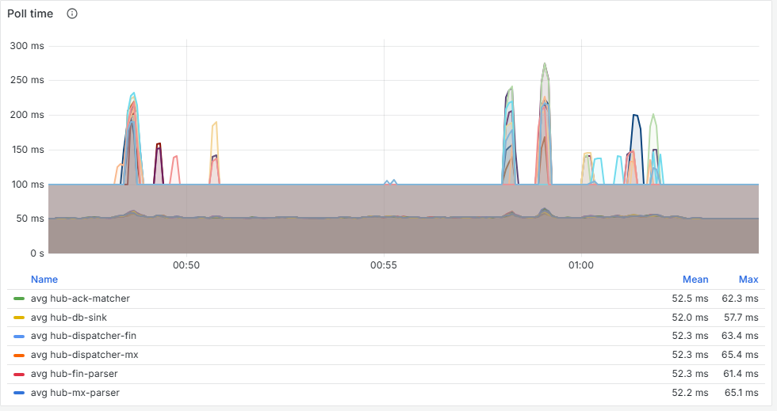
Figure 25. Poll time.

IO Wait Ratio
Share of each stage thread's time spent waiting for records. Near 100 %: idle. Near 0 %: saturated.
Normal on this stack | What bad looks like | Scenarios
60–99 % | One stage near 0 % is the bottleneck (scenarios 1 and 2). All stages falling together points at something shared (scenario 4) | 1, 2, 4

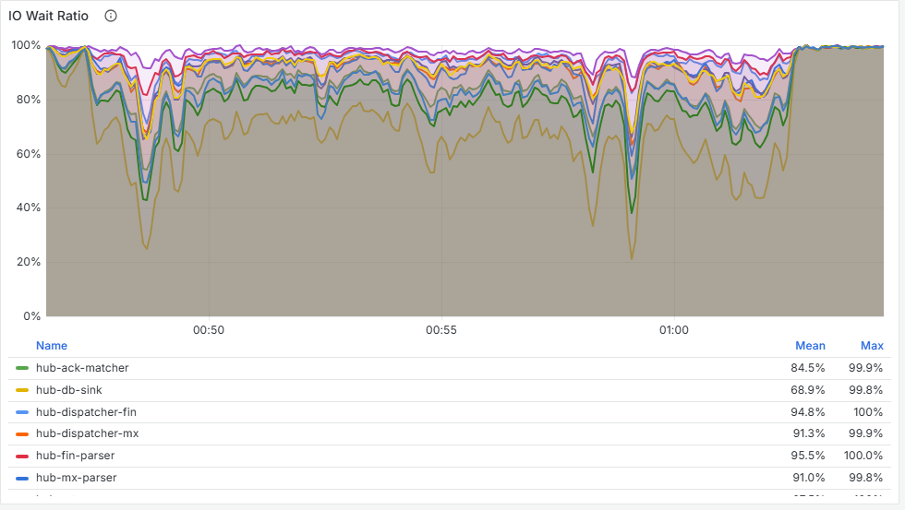
Figure 26. IO Wait Ratio.

5.7 gRPC
Every call the Hub makes and serves, as RED (rate, errors, duration).

gRPC client calls (outbound)
Calls made per second by the Hub and the ESS, by method and status. Each retry counts as a separate attempt; retries are also shown on their own.
Normal on this stack | What bad looks like | Scenarios
All OK | DEADLINE_EXCEEDED or UNAVAILABLE on one method points at that dependency (scenario 1: Screen; scenario 3: SendMx) | 1, 3, 4

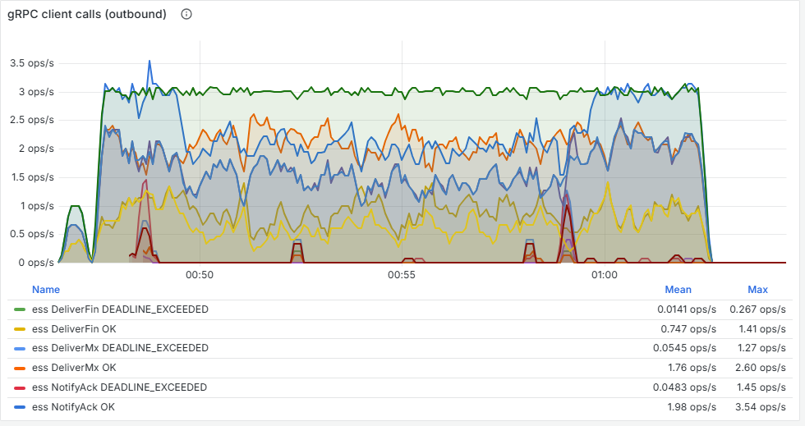
Figure 27. gRPC client calls (outbound).

gRPC client call duration (outbound)
p50 and p99 duration of outbound calls by method. Deadlines: Deliver* 200 ms, Send* 500 ms, Screen 1 s.
Normal on this stack | What bad looks like | Scenarios
Tens of ms | p99 reaching the method's deadline | 1

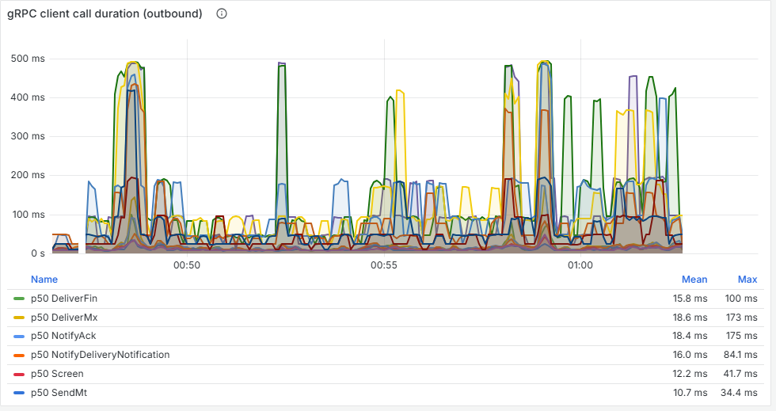
Figure 28. gRPC client call duration (outbound).

gRPC server calls (inbound)
Calls served per second by method and status (the ESS control API is excluded).
Normal on this stack | What bad looks like | Scenarios
All OK | Errors on the edge methods | –

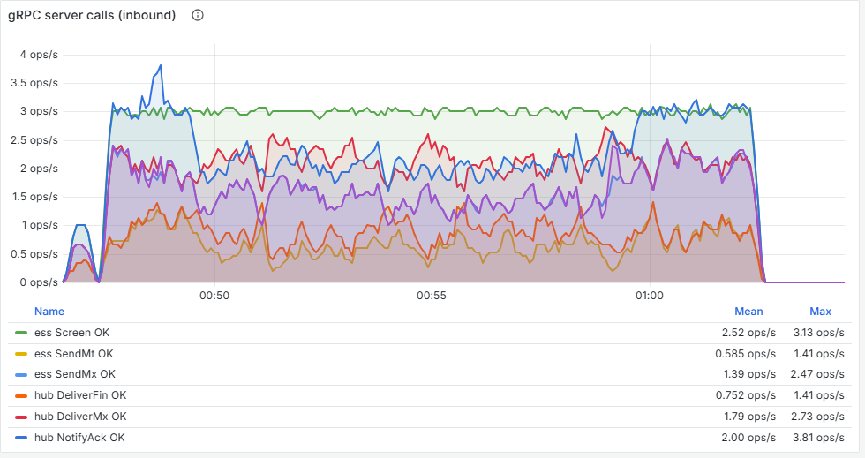
Figure 29. gRPC server calls (inbound).

gRPC server call duration (inbound)
p50 and p99 time inside the server handler.
Normal on this stack | What bad looks like | Scenarios
p99 under about 0.2 s | If clients see deadlines but this stays low, calls are queueing before the handler runs (an overloaded process) | 4

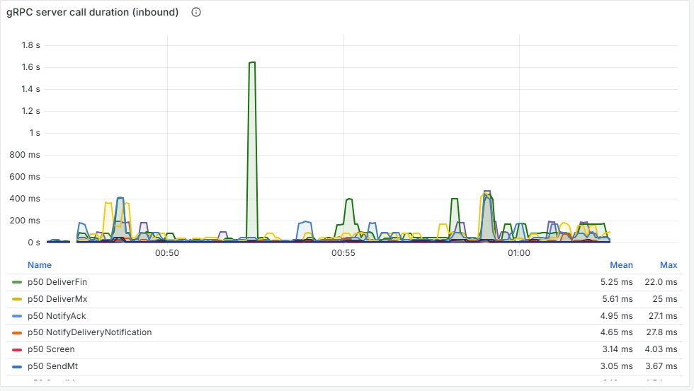
Figure 30. gRPC server call duration (inbound).

5.8 JDBC
The DB sink's connection to PostgreSQL. The Hub is Python, so these are psycopg figures, named after their JDBC equivalents.

JDBC idle connections
The DB sink's one connection: idle between batches, active during a write.
Normal on this stack | What bad looks like | Scenarios
Flicks between idle and active | Pinned active: the database cannot keep up (scenario 2) | 2

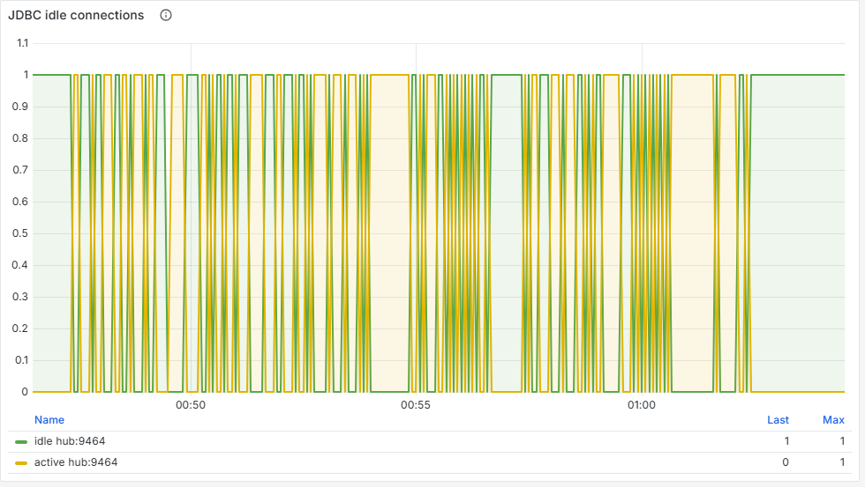
Figure 31. JDBC idle connections.

JDBC Calls
Statements and transaction calls per second, by operation (upsert, audit_insert, commit) and outcome.
Normal on this stack | What bad looks like | Scenarios
About 7 upserts per payment: 21 a second at 3 payments a second | A ceiling below what the load needs, or error outcomes | 2

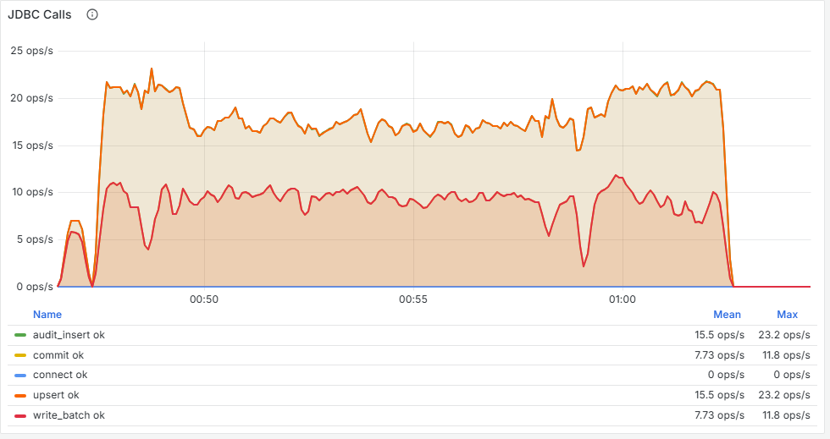
Figure 32. JDBC Calls.

5.9 Disk Usage
What is stored, and whether it keeps growing.

Kafka disk usage
Size of each topic's log on the broker.
Normal on this stack | What bad looks like | Scenarios
Grows with traffic, trimmed by retention | Sizing only | –

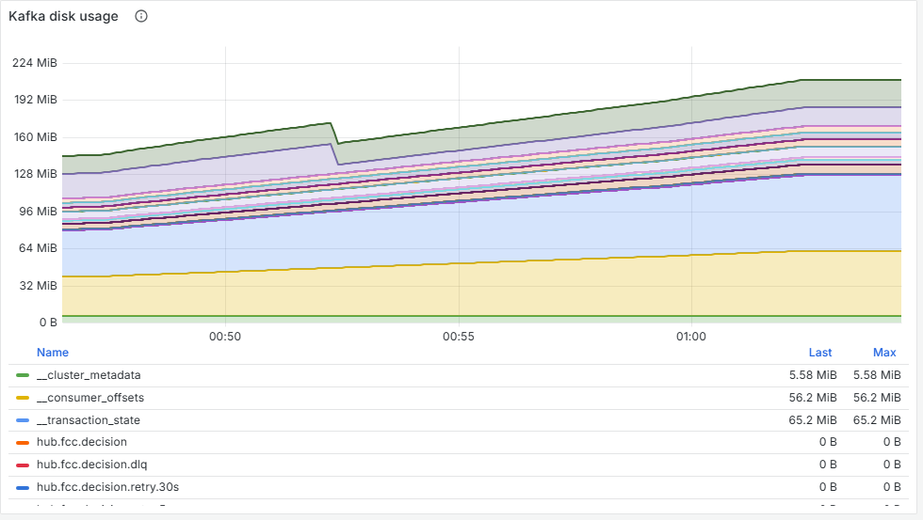
Figure 33. Kafka disk usage.

Kafka streams Disk usage per instance
Estimated bytes held in each stage's in-memory state store (the Kafka Streams equivalent).
Normal on this stack | What bad looks like | Scenarios
Small and bounded | Rising for as long as traffic runs: a leak (scenario 5) | 5

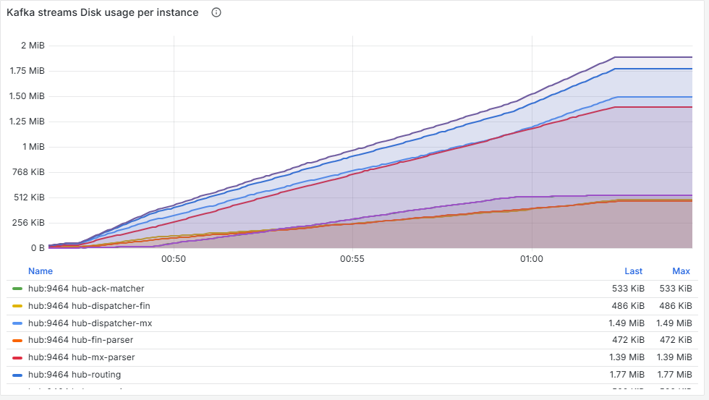
Figure 34. Kafka streams Disk usage per instance.

Kafka stream number of keys per instance
Keys (payments) held in each stage's state store.
Normal on this stack | What bad looks like | Scenarios
Bounded: payments in flight plus a window of finished ones | Rising in a straight line with every payment (scenario 5: routing and settlement) | 5

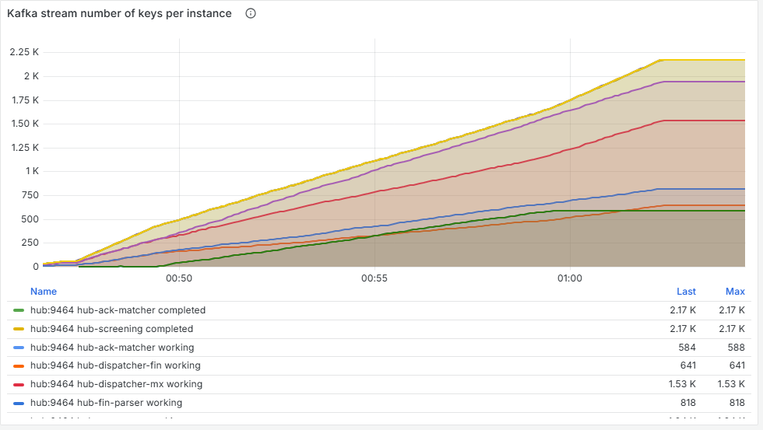
Figure 35. Kafka stream number of keys per instance.

5.10 Memory: Kafka broker (JVM)
The broker is a Java process. Under its 1.5 GB container limit the JVM picks the Serial garbage collector, so the old generation is called "Tenured Gen".

Used Memory - Old Gen
Long-lived objects in the broker's heap.
Normal on this stack | What bad looks like | Scenarios
A sawtooth | A floor that keeps rising | –

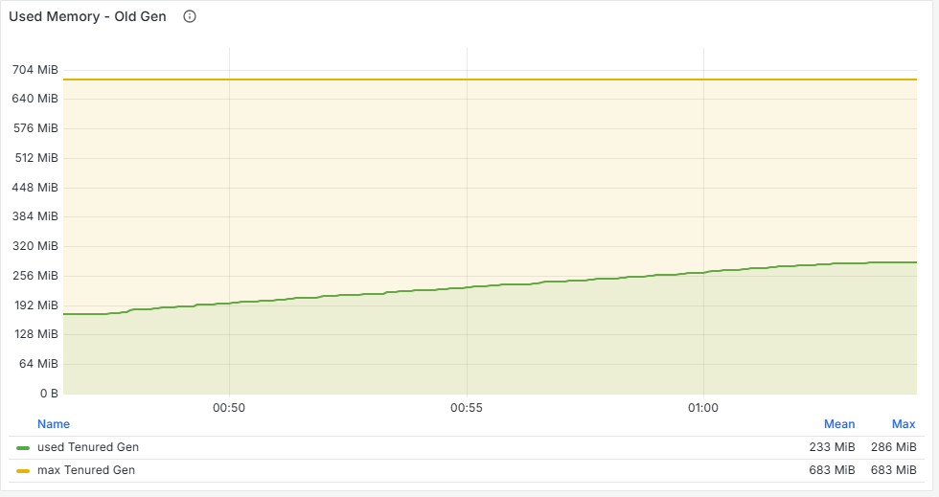
Figure 36. Used Memory - Old Gen.

Used Memory - Heap
Total heap used, committed and maximum (1 GB).
Normal on this stack | What bad looks like | Scenarios
Well under the maximum | Close to the maximum | –

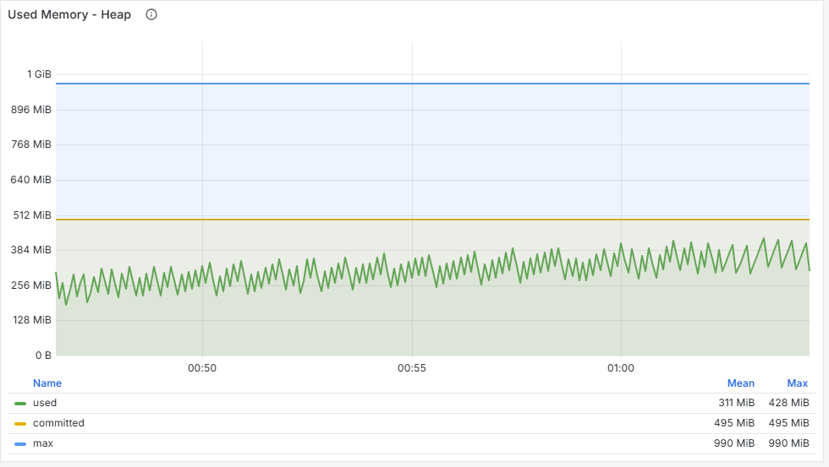
Figure 37. Used Memory - Heap.

Used Memory - Non-Heap
Metaspace, code cache and class space.
Normal on this stack | What bad looks like | Scenarios
Flat after start-up | Growing | –

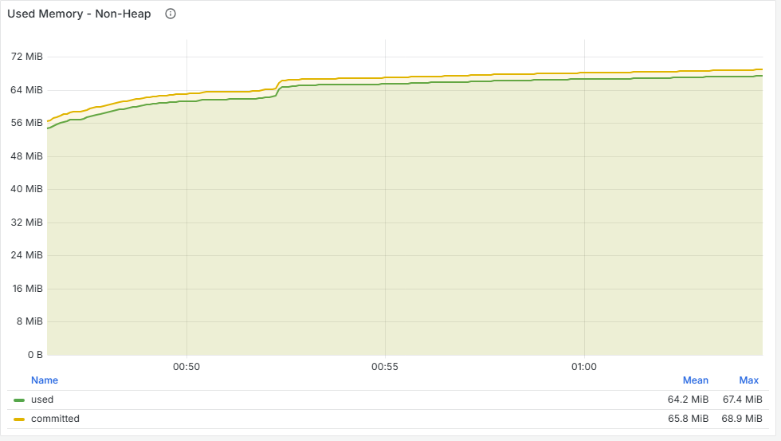
Figure 38. Used Memory - Non-Heap.

Full GC Pauses
Time per second in full collections, and their count.
Normal on this stack | What bad looks like | Scenarios
Rare | Frequent: the broker pauses for every one | –

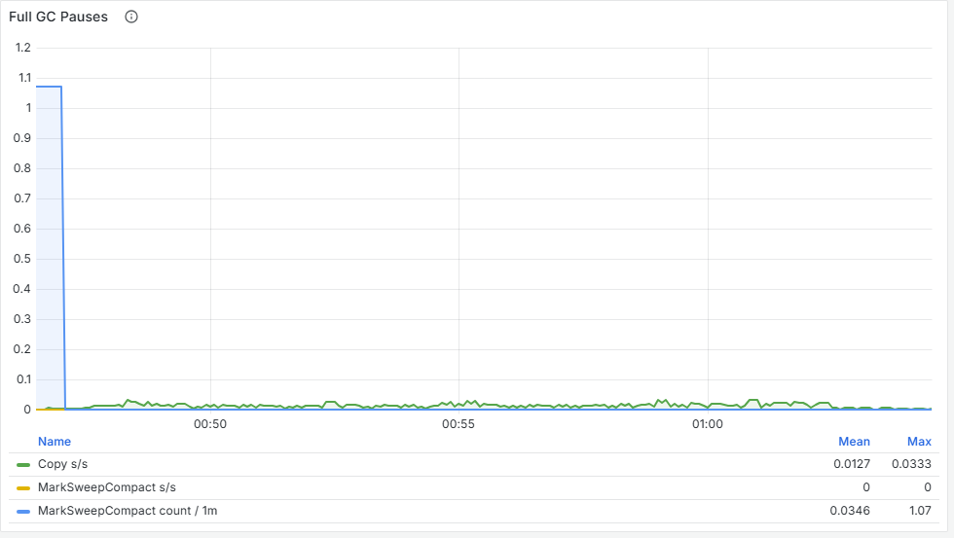
Figure 39. Full GC Pauses.

5.11 Memory: Hub and ESS (Python)
Python has no old/young heap split; the resident memory (RSS) is what the container's memory limit is enforced against.

Used Memory - Resident (RSS)
Physical memory used by the Hub and ESS processes.
Normal on this stack | What bad looks like | Scenarios
Hub 120–200 MB, ESS 60–80 MB | A steady upward slope under steady load: a leak (scenario 5: about 37 KB per payment) | 5

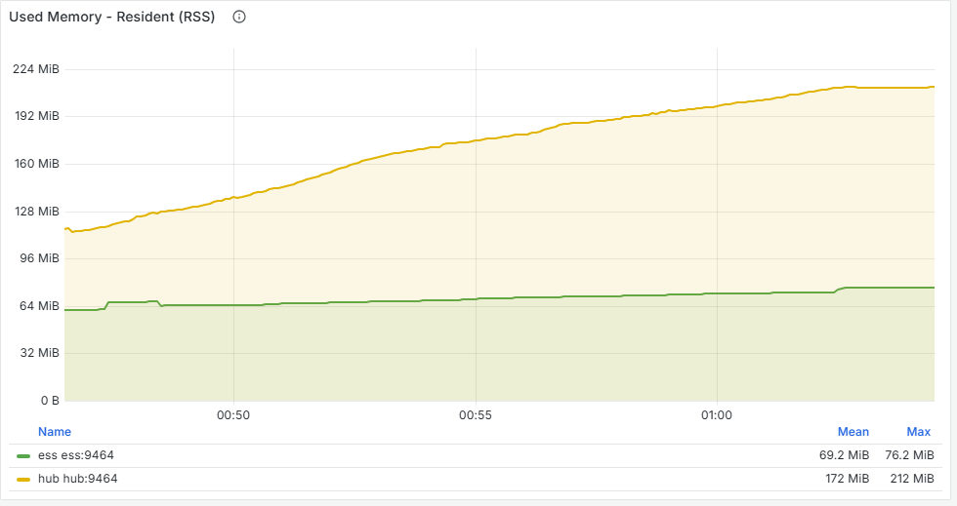
Figure 40. Used Memory - Resident (RSS).

Allocated blocks
Memory blocks the Python interpreter has allocated.
Normal on this stack | What bad looks like | Scenarios
Flat under steady load | Growing with RSS | 5

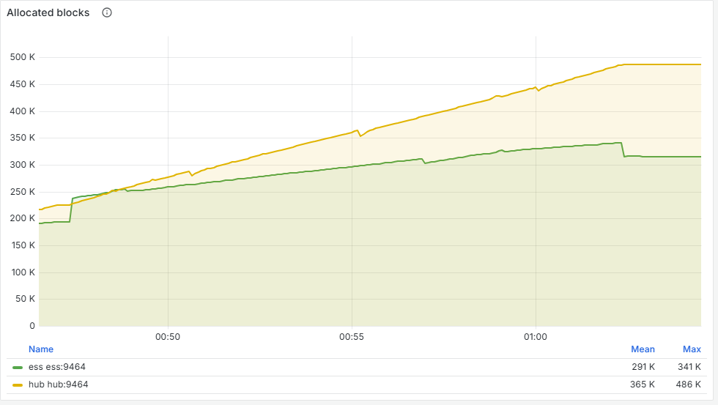
Figure 41. Allocated blocks.

Virtual memory
Address space reserved by each process.
Normal on this stack | What bad looks like | Scenarios
Flat | Rarely useful | –

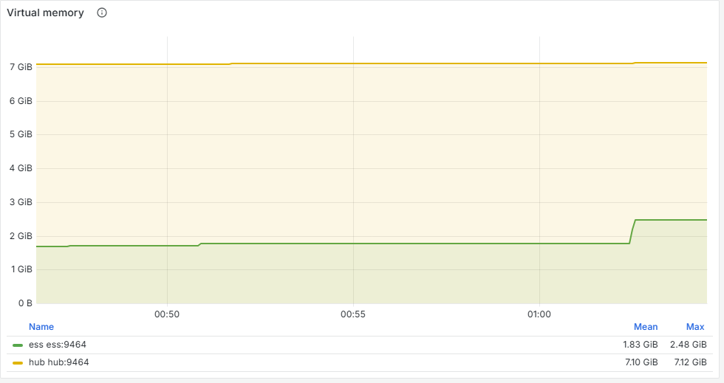
Figure 42. Virtual memory.

Full GC Pauses (generation 2)
Time per second in Python's full garbage collection, and the p99 pause.
Normal on this stack | What bad looks like | Scenarios
Pauses under 100 ms | Pauses longer than the 200 ms edge deadline (scenario 5: 210 ms) | 5

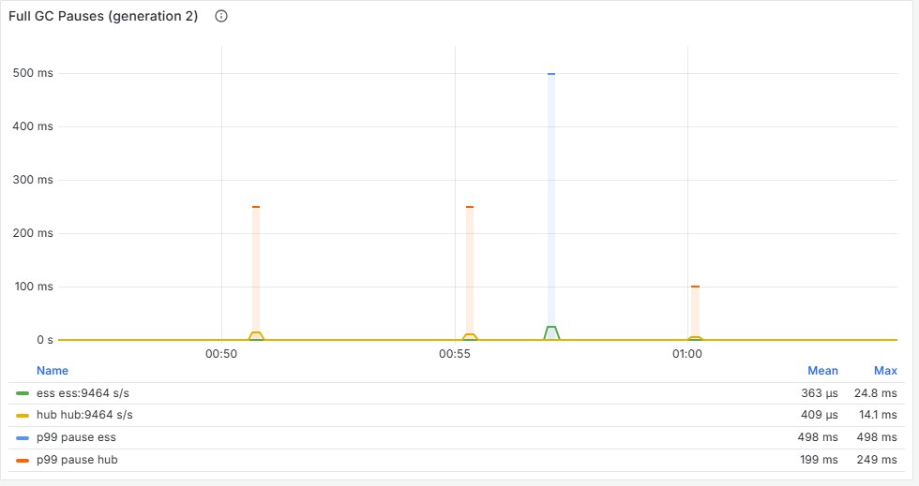
Figure 43. Full GC Pauses (generation 2).

6. Running a performance test
Every scenario in this guide followed the same procedure. Most of the runs that had to be thrown away skipped a step of it.

6.1 Readiness: is the system really ready?
"All containers are running" is not enough. python scripts/dev.py ready checks the first five of these for you; add --wait 300 to keep trying while the stack starts. This table explains what it checks and why:
Check | How | Why
Every container healthy | docker compose ps | Obvious, but not sufficient
Every scrape target up | Prometheus, Status, Targets (or http://localhost:9090/targets) | Missing targets mean missing panels
All 11 consumer groups hold partitions | Prometheus query: count(hub_kafka_assigned_partitions > 0) must return 11 | After the PC slept, most groups held 0 partitions while the Hub still reported healthy (scenario 1's first attempt)
Lag is zero | sum(clamp_min(kafka_consumergroup_lag,0)) returns 0 | Leftover work distorts the baseline
The stack has warmed up | At least 5 minutes since start-up | Elasticsearch and Kibana use most of the CPU while they start (scenario 2's aborted attempt)
Warm-up gate passes | Send 30 payments at 1/s: all must complete with p95 under 1 s | Proves the baseline is healthy, not just running

# Warm-up gate (one line; the same in any shell)
docker compose exec -T ess python -m ess.cli batch -n 30 -r 1 --run-id warmup --wait 60s

# Expect: settled 30 unsettled 0 ... p95 under 1000 ms ... batch ok
To split a long command over several lines, end each line with a backslash in bash or zsh, and with a backtick in PowerShell.

6.2 Generating traffic
ess batch sends a fixed number of payments at a steady rate and reports how they settled. It is the simulator's sender, not a load generator: about 10 payments a second is its local ceiling, and this machine itself copes with about 3.
Option | Meaning | Used in the scenarios
-n | How many payments | 540 to 2,700
-r | Payments per second | 3
-c | Deliveries in flight at once | 4
--mix | Weighted message types | pacs.008=60,MT103=30,pacs.009=10
--hit-rate | Share of payments with a party on the sanctions watchlist | 0.05 in the demo runs
--run-id | A name for the run, stored with every payment | e.g. s2-db-slow-r3
--wait | How long to wait for payments to finish before reporting | 30 s to 8 min

6.3 Injecting a fault
Two kinds of fault were used: changing how the simulated outside world behaves (an ESS profile), and starving a container of CPU. Both can be applied and removed while traffic runs.
Scenario | Inject | Remove
1 Slow compliance service | ess profile set compliance --accept-latency 300ms --p99 1500ms --kind lognormal | ess profile set compliance --accept-latency 2ms --kind fixed
2 Slow database | docker update --cpus 0.02 hub-postgres | docker update --cpus <N> hub-postgres
3 SnF outage | ess profile set snf --outage --for 60s | Ends by itself after 60 s
4 Slow broker | docker update --cpus 0.5 hub-kafka | docker update --cpus <N> hub-kafka
5 Held payments | ess profile set compliance --hit-rate 0.3 --decision-delay 60m | ess profile set compliance --decision-delay 100ms

ess commands run inside the simulator container: prefix them with docker exec hub-ess python -m ess.cli.
Watch out
profile set replaces the NAK, hit, block and duplicate rates with whatever you pass (0 if you leave them out), but keeps the release rate if you pass 0. Check the current profile before changing it, so a fault changes only what you intend.
docker update --cpus 0 does not remove a CPU limit. Set it to the number of CPUs Docker has, shown as <N> above: docker info --format "{{.NCPU}}" prints it (12 on the laptop used here).

6.4 Marking the run on the dashboards
Post an annotation at each phase change, so every panel shows when the fault went in and came out:
curl -s -X POST localhost:3000/api/annotations -H 'Content-Type: application/json' \
-d '{"dashboardUID":"hub-performance","time":'$(date +%s%3N)',
"tags":["my-run"],"text":"FAULT: compliance slow"}'
This is bash or zsh syntax (macOS, Linux, WSL or Git Bash). Repeat it with hub-pipeline and hub-run-overview to mark all three dashboards.

6.5 A scenario as a script
Each scenario was a small script: start the traffic in the background, then sleep, inject, sleep, remove, and annotate each step.
docker exec hub-ess python -m ess.cli batch -n 900 -r 3 --run-id s4 --wait 120s &
ann "S4 start: baseline"; sleep 90
docker update --cpus 0.5 hub-kafka; ann "S4 FAULT"; sleep 120
docker update --cpus $(docker info --format '{{.NCPU}}') hub-kafka; ann "S4 RECOVER"
wait; ann "S4 end"

6.6 Looking at the run
To show exactly one run, put its start and end in the dashboard address as milliseconds since 1970, for example:
http://localhost:3000/d/hub-performance?orgId=1&from=1791154290000&to=1791154770000
Or use the time picker in the top right of Grafana and type the start and end times.

6.7 After the run
- Read the batch report: accepted, duplicates, errors, settled, unsettled, end-to-end percentiles.
- Count final states in the system of record:
docker exec hub-postgres psql -U hub -d payments -c "select state, count(*) from payment where run_id='s4-broker-cpu' group by 1;"
- Check hub_awaiting_ack{overdue="true"} on dashboard 1: anything above the pre-run value is a payment that will never complete on its own.
- Restore every profile and CPU limit you changed.
Lesson
Count outcomes from the Hub's own records, not from client errors. In scenario 4 the client counted 9 delivery errors, but 6 of those payments had been written durably: their reply simply arrived after the client's deadline.

7. The triage method
Every investigation in this guide used the same five questions, in the same order. The figure below summarises them.
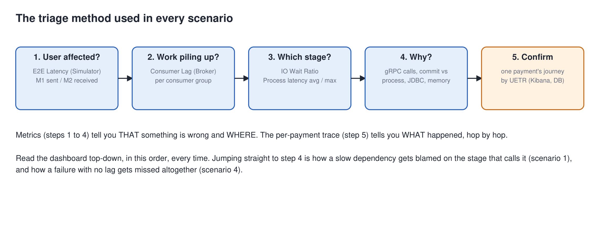
Figure 44. The triage method. Read the dashboard top-down; confirm with one payment's journey.
Question | Panels | What you learn
1. Is the user affected? | E2E Latency (Simulator); M1 sent / M2 received | Whether there is a problem at all, how big, and since when
2. Where is work piling up? | Consumer Lag (Broker), per group | Which stage is behind, or that nothing is (scenario 4)
3. Which stage is slow? | IO Wait Ratio; Process latency avg and max | Which stage is saturated, and whether it is one stage or all of them
4. Why? | gRPC client calls and duration; commit vs process latency; JDBC; memory | Whether the cause is a dependency, Kafka, the database or the process itself
5. Confirm | One payment's journey: Kibana (search payment.uetr), PostgreSQL payment_audit | Exactly what happened, hop by hop, with timestamps

7.1 Finding one payment's journey in Kibana
- Open http://localhost:5601 and go to Discover.
- Choose the logs-payments-* data view (create it once if asked).
- Search for payment.uetr : "<the UETR>" and sort by time, oldest first.
- Read the events in order: grpc.server.recv, kafka.produce, payment.state, grpc.client.send, and so on. Each line names the service.
In scenario 3, this is what showed that a payment marked FAILED had in fact been re-sent, ACKed and completed 59 seconds later.
Watch out
Elasticsearch deletes logs after one day, and Prometheus keeps metrics for 24 hours. Take screenshots and notes within a day of a run.

8. Scenario 1: a slow dependency
Question | What happens when the compliance screening service slows down?
Injected | The ESS's compliance service answers Screen with a lognormal delay: median 300 ms, p99 1.5 s, past the Hub's 1 s deadline
Run | second attempt, 3 October, 3 payments/s, 900 payments
Headline | A 0.3 s slowdown in a dependency became a 40× rise in end-to-end latency, because of how screening batches its work

8.1 Timeline
Time | Phase | What changed
21:22:06 | Baseline | Compliance answers in 2 ms
21:23:40 | Fault | Compliance answers in 300 ms (median), 1.5 s (p99)
21:25:42 | Recovery | Compliance back to 2 ms
21:29:09 | End | Batch finished

8.2 Prediction
Screening calls the compliance service once per payment. At about 380 ms per call on average it can do about 2.6 a second, below the 3 a second arriving. So cg-screening lag and end-to-end latency should rise steadily during the fault, to perhaps 20 s, and about 4 % of calls should exceed the 1 s deadline and be retried.

8.3 The investigation

Step 1: is the user affected?
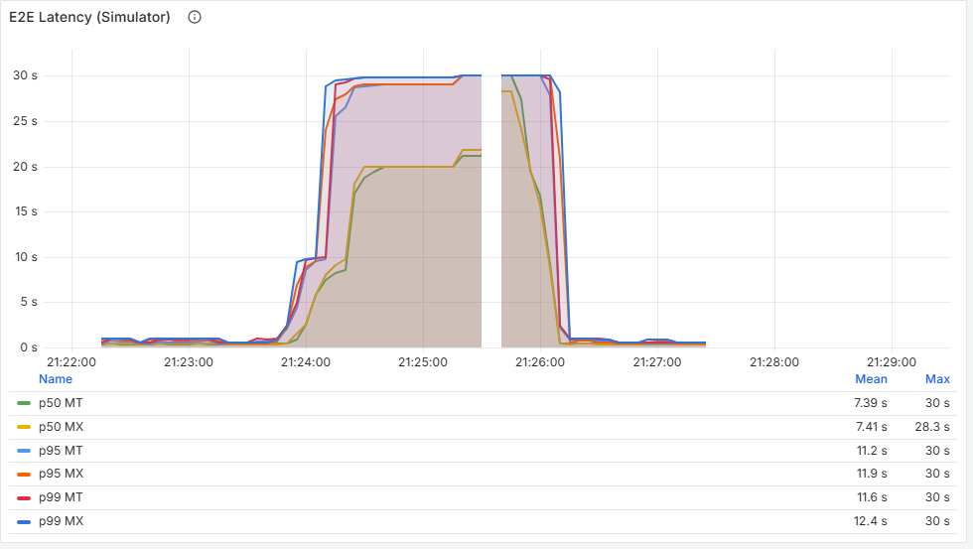
Figure 45. E2E Latency (Simulator). Flat below 1 s until the fault at 21:23:40, then at 30 s within a minute: the top of the histogram, so the real value was higher. Back below 1 s by 21:26:30.
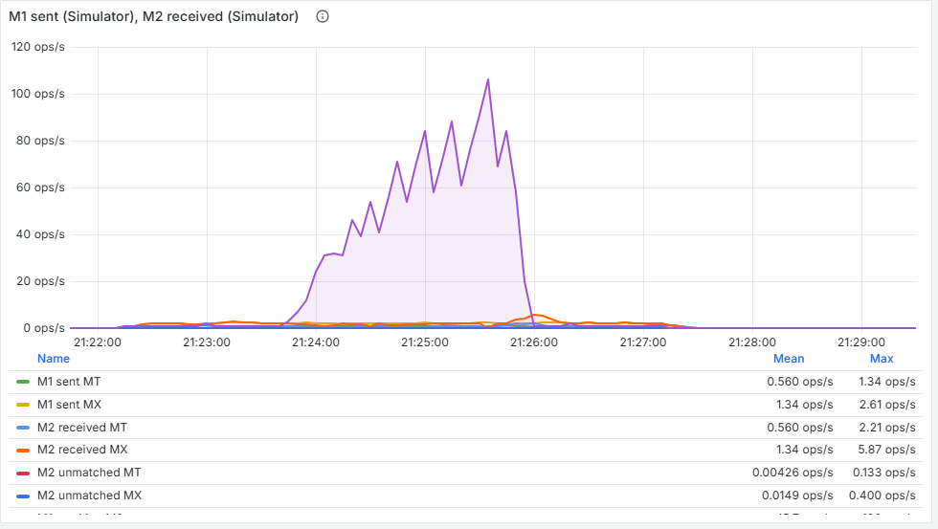
Figure 46. M1 sent / M2 received. The tall purple line is the number of payments still waiting for their M2 (up to about 110), on the same axis as the rates, so the 2 to 3/s lines look flat. Payments keep arriving at 3/s, but outbound messages drop to about 2/s during the fault; after recovery M2 runs above 3/s while the backlog clears.

Step 2: where is work piling up?
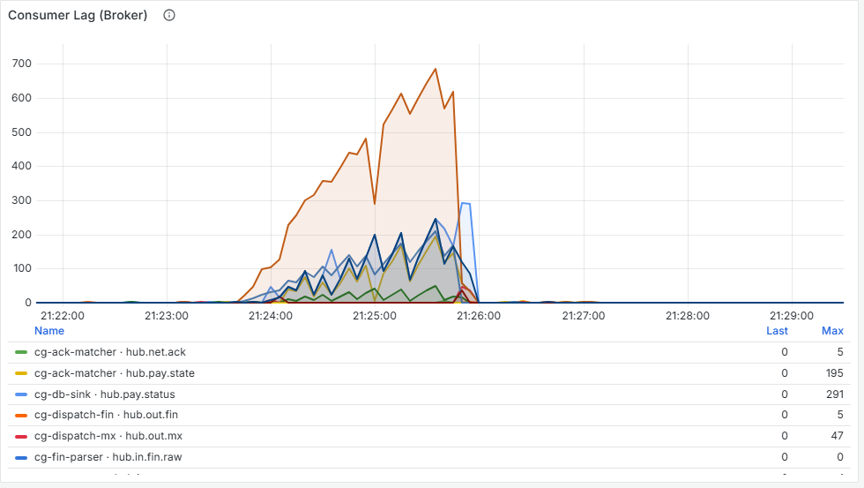
Figure 47. Consumer Lag (Broker). Lag appears only during the fault. The parsers, before screening, stay at 0; screening and the stages after it build lag. Measured during the run, screening's input topic (hub.pay.canonical) peaked at about 180 records; the later stages' lag comes from the bursts screening released. The legend lists only the first six series.

Step 3: which stage is slow?
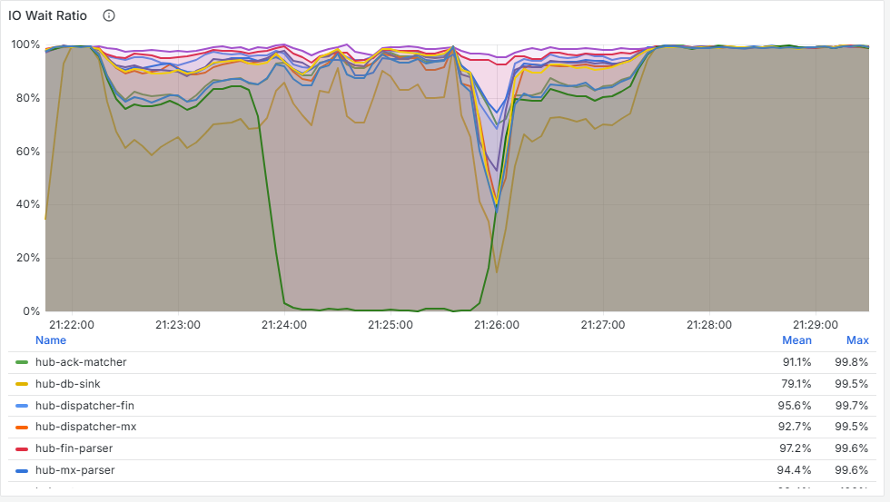
Figure 48. IO Wait Ratio. Screening falls from about 85 % to under 1 %: it never waits for work any more, it is saturated. The other stages stay mostly idle.
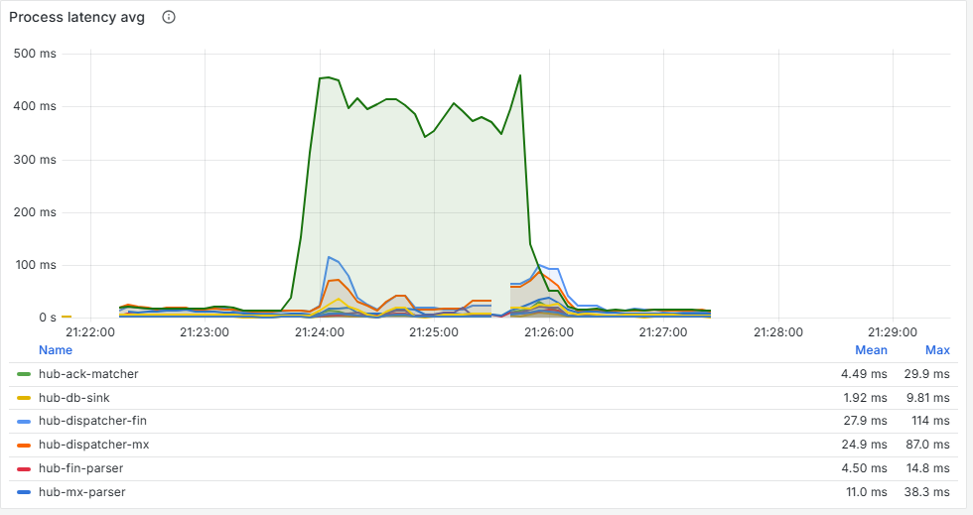
Figure 49. Process latency avg. Screening jumps from 17 ms to about 390 ms per record; routing barely moves. Something inside screening's work became slow.

Step 4: why?
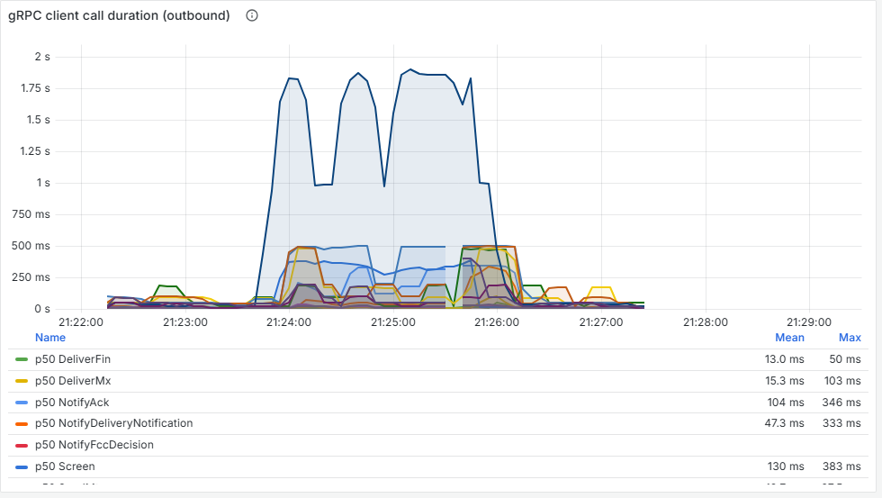
Figure 50. gRPC client call duration (outbound). Screen p99 goes from about 40 ms to over 1 s. The 1.8 s peak is an estimate between the 1 s and 2 s buckets; each call is cut off at the 1 s deadline.
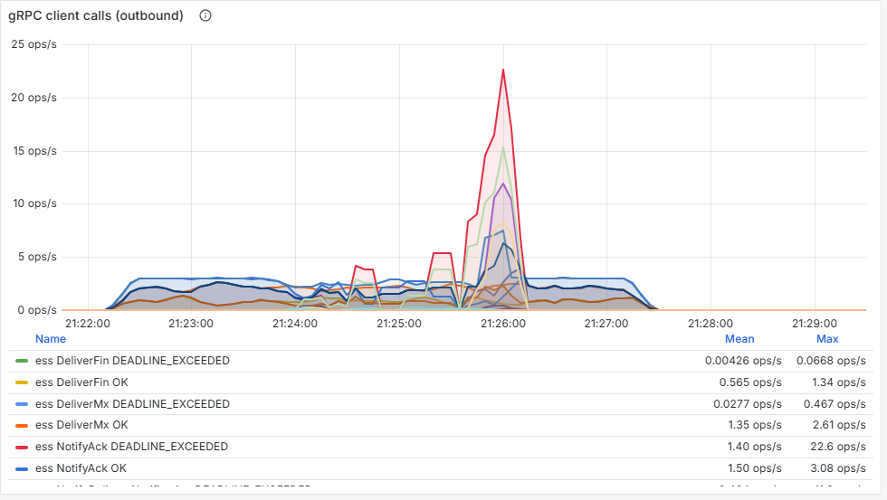
Figure 51. gRPC client calls (outbound). Screen calls show DEADLINE_EXCEEDED for 2–6 % of calls, each followed by a retry. The cause is outside the Hub: the compliance dependency.
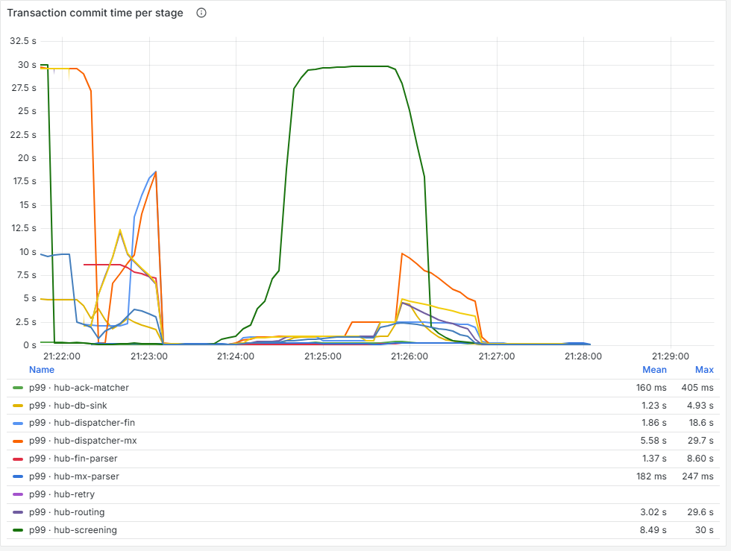
Figure 52. Transaction commit time per stage (dashboard 2): the time to process and commit one whole batch, p99. The amplifier: screening's batches grow from about 20 ms to 30 s (the top bucket) during the fault, because each batch now holds many slow calls (see the root cause). The spikes before 21:23 are the backlog left by the Hub restart draining, before the fault.

8.4 Prediction versus reality
Prediction | Actual | Verdict
Screening capacity about 2.6/s, below the 3/s arriving | 2.0–2.1/s (timeouts and retries cost extra) | Right direction, slightly worse
About 4 % of calls past the deadline | 2–6 % | Correct
Latency rises to about 20 s over two minutes | 30 s or more within one minute | Much worse than predicted

8.5 Root cause
Screening reads a batch of records and calls the compliance service for them one at a time, inside one Kafka transaction. Nothing it writes is visible downstream until the whole transaction commits. As lag builds, each poll returns a bigger batch: 40 records at 0.38 s each is a 15-second transaction, and even the first payment in the batch waits the full 15 seconds. Slowness feeds on itself.

8.6 Knock-on effects
- When large screening batches committed, the next stages received them all at once, so their lag briefly exceeded screening's own.
- During the catch-up burst, many network ACKs from the simulator failed their 200 ms deadline and the simulator gave up on them, leaving 175 payments stuck in DISPATCHED. This was the first sighting of the lost-ACK bug (bug B, fixed later).

8.7 Lessons
Lesson
The stage that looks guilty (screening) was not the cause: the outbound gRPC panels proved the cause was the dependency. Always reach step 4 before blaming a stage.
Batching inside one transaction amplifies a slow dependency. Calling the compliance service concurrently within a batch, or capping each transaction's duration, would contain it (not yet changed).
A histogram can only report up to its top bucket. "30 s" meant "30 s or more"; the end-to-end histograms were extended to 10 minutes afterwards.
What went wrong along the way
The first attempt at this scenario was invalid. The PC had slept earlier, the Hub's Kafka consumers had been removed from their groups, and only one of eleven stages ever rejoined. The Hub still reported healthy and raised no errors; payments were accepted and then went nowhere. None of the 900 payments settled.
The Rebalance panel showed it plainly (partitions held: 0 for almost every group), as did IO wait at 99 % with no work done. This is why the readiness check now requires all 11 groups to hold partitions.

9. Scenario 2: a slow database
Question | What happens when PostgreSQL, the system of record, becomes slow?
Injected | PostgreSQL limited to 0.02 CPU (docker update --cpus 0.02 hub-postgres)
Run | s2-db-slow-r3, 5 October, 3 payments/s, 900 payments
Headline | Customers saw almost nothing, while the database fell more than a minute behind. Completed is not the same as persisted.

9.1 Timeline
Time | Phase | What changed
00:27:31 | Baseline | PostgreSQL unrestricted
00:29:02 | Fault | PostgreSQL limited to 0.02 CPU
00:31:04 | Recovery | Limit lifted
00:32:43 | Sending done | Waiting for the DB sink to drain
00:32:44 | End | DB sink lag back to 0

9.2 Prediction
The DB sink writes every state change to PostgreSQL after the payment has moved on, so payments should still complete normally. Only the DB sink should fall behind: its lag should climb for the whole fault, its database calls should hit a ceiling, and its one connection should stay busy. After recovery, the backlog should drain.

9.3 The investigation

Step 1: is the user affected?
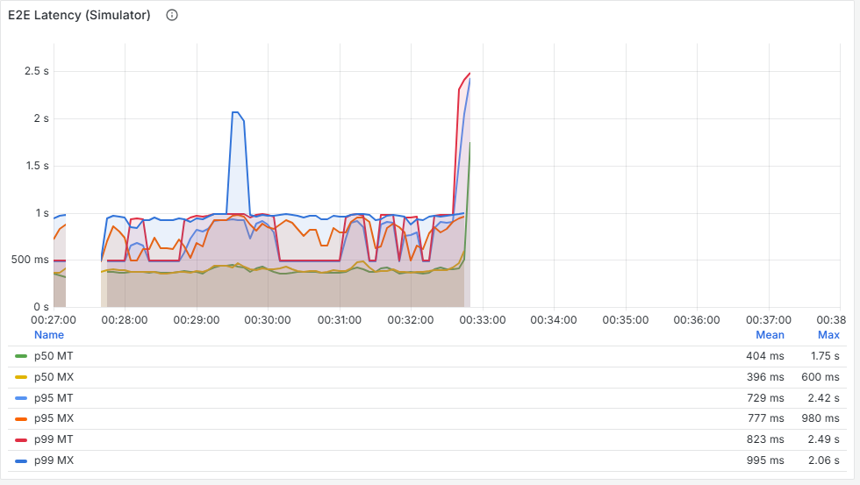
Figure 53. E2E Latency (Simulator). Barely moves: p95 rises from about 0.6 s to 0.9 s. A latency-based SLO passes this run.
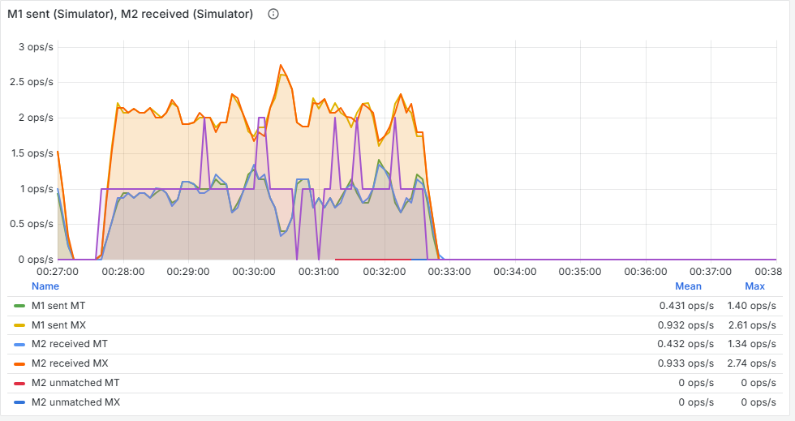
Figure 54. M1 sent / M2 received. Steady at 3/s throughout. From the outside, the Hub looks healthy.

Step 2: where is work piling up?
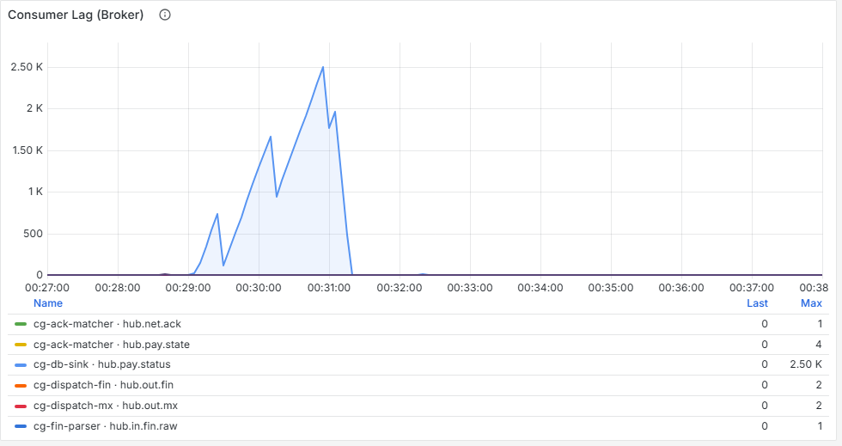
Figure 55. Consumer Lag (Broker). The one panel that catches it: cg-db-sink climbs to about 2,500 records during the fault while every other group stays at about 0. The jagged shape comes from the sink committing in large batches.

Step 3: which stage is slow?
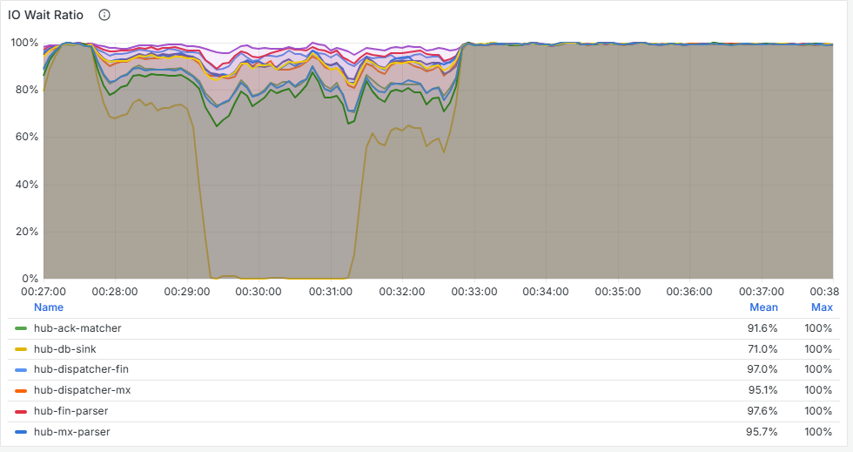
Figure 56. IO Wait Ratio. The DB sink falls to about 0 %: saturated. The other stages carry on as normal.

Step 4: why?
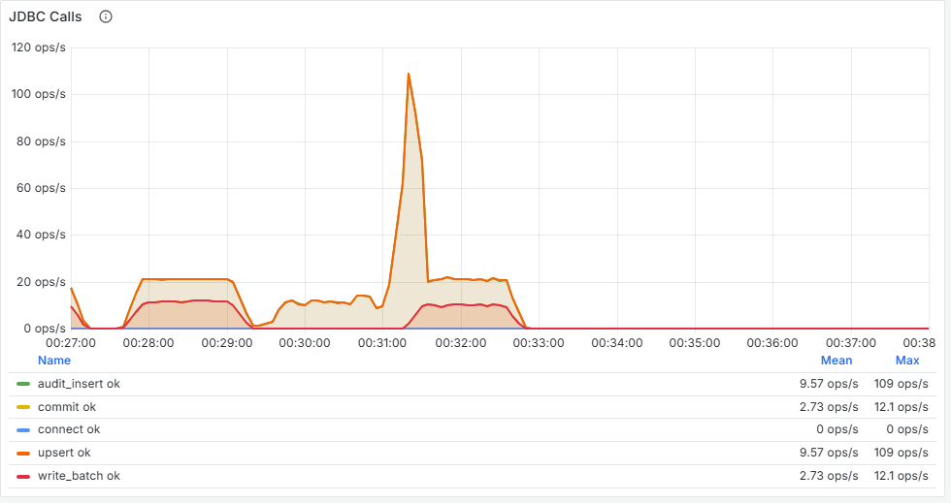
Figure 57. JDBC Calls. Upserts fall from 21/s to 7–12/s, below what the load needs. After recovery they jump to 45/s while the sink catches up.
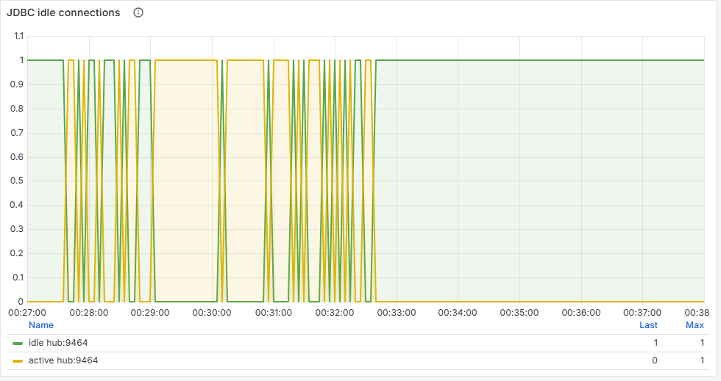
Figure 58. JDBC idle connections. The sink's single connection is pinned active during the fault: it never gets a moment's rest.
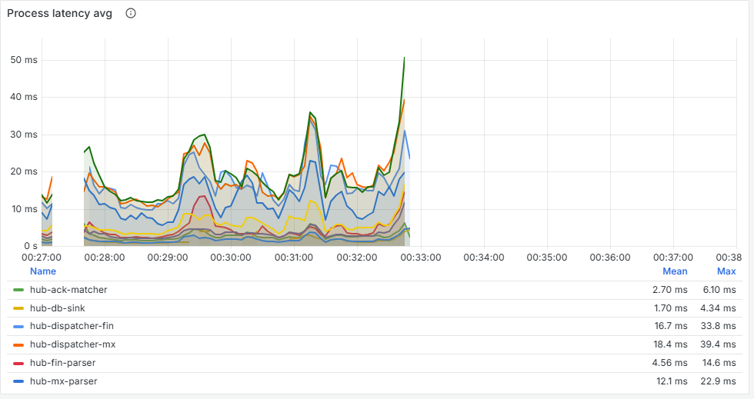
Figure 59. Process latency avg. The DB sink rises only from 1 ms to about 3.6 ms, which would hide the problem. Its database write happens after the commit, outside this measurement (see the lessons).

9.4 Prediction versus reality
Prediction | Actual | Verdict
End-to-end flat; payments still complete | p95 +0.3 s; all 900 completed | Correct
Only cg-db-sink lag climbs | Exactly | Correct
Database calls hit a ceiling; connection pinned | Yes | Correct
DB sink process latency rises sharply | Only 1 → 3.6 ms | Wrong: an instrumentation gap
Backlog drains after recovery | In about 30 s | Correct

9.5 Root cause
Each state change costs two SQL statements on one connection. With the database starved of CPU each statement took up to 1 s instead of 25–40 ms, so the sink could write only about half of what arrived. Kafka held the backlog safely; nothing was lost. In PostgreSQL, the slowest payment's row appeared 64 seconds after the payment completed.

9.6 Lessons
Lesson
Completed is not persisted. For over a minute the status API said COMPLETED while the system of record had no row. The SLO for a real test should include DB sink lag, or the time from completion to persistence.
Lag per consumer group is the panel for this kind of fault. A single total lag figure would show something was wrong, but not where.
Process latency missed the database write because it happens after the commit. A separate post-commit measurement now covers it and appears on both Process latency panels.
Capacity headroom is measurable: at 3/s the database used about 2.5 % of a CPU. Limiting it to 10 % changed nothing; at 2 % it fell behind at once.
What went wrong along the way
First attempt: aborted. The stack had restarted only three minutes earlier and the baseline was already unhealthy (p95 8.8 s, DB sink lag 354). The fault was never injected. The run also exposed a new problem: the fix for lost ACKs made the simulator redeliver failed ACKs so aggressively that it caused a retry storm (38 failed ACK calls a second against 2 real ACKs). Redelivery was then bounded: one call per round, a 2 to 60 s backoff, and at most 5 redeliveries a second.
Second attempt: no effect. Limiting PostgreSQL to 0.1 CPU changed nothing, because it only needed about 0.025. The limit was lowered to 0.02 for the third, valid run.

10. Scenario 3: a network outage
Question | What happens when the SWIFTNet store-and-forward network (SnF) is unavailable for a minute?
Injected | The ESS's SnF returns UNAVAILABLE to every SendMx for 60 s. FIN, and so MT payments, stay up
Run | s3-snf-outage, 3 October, 3 payments/s, 720 payments
Headline | The retry ladder worked, but every payment that went round it was left showing FAILED even after it completed (bug A, now fixed)

10.1 Timeline
Time | Phase | What changed
23:32:32 | Baseline | All networks up
23:33:36 | Fault | SnF returns UNAVAILABLE
23:34:37 | Recovery | Outage window ends
23:36:38 | Sending stops | Retry tiers still draining
23:49:42 | End | Batch finished

10.2 How the retry ladder works
When a stage fails with a temporary error, it does not block its partition. It writes the record to <topic>.retry.30s and moves on. A separate retry service republishes it after 30 seconds. A second failure sends it to .retry.5m, a third to .dlq (the dead-letter queue, for a human).

10.3 Prediction
MT unaffected. MX payments dispatched in the first 30 s of the outage would fail, retry at 30 s while SnF was still down, fail again and wait 5 minutes: about 5.5 minutes end to end. Those in the last 30 s would succeed on their first retry. Nothing should reach the DLQ.

10.4 The investigation
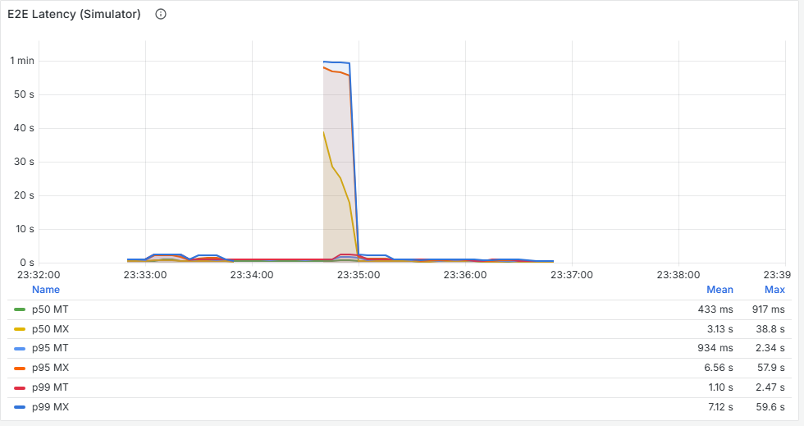
Figure 60. E2E Latency (Simulator). A hump during the outage and the following minute, as payments wait on the retry ladder. These end-to-end histograms reach 10 minutes, so the real tail is visible.
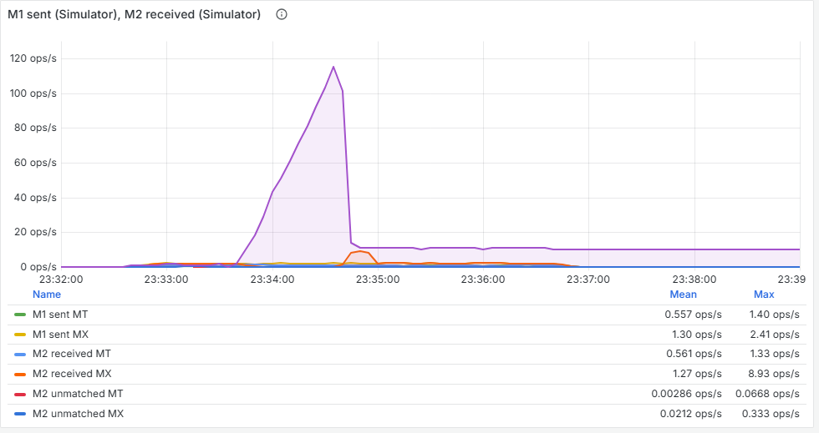
Figure 61. M1 sent / M2 received. MX outbound messages stop during the outage while MT continues; afterwards a burst of retried MX messages arrives at about 5.7/s. The purple line counts payments still waiting for their M2.
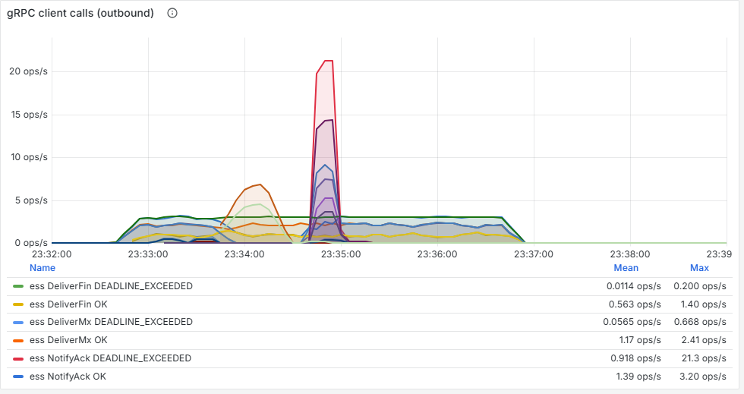
Figure 62. gRPC client calls (outbound). SendMx UNAVAILABLE starts exactly at the fault marker: 211 failed attempts in all, from about 70 payments each tried 3 times.
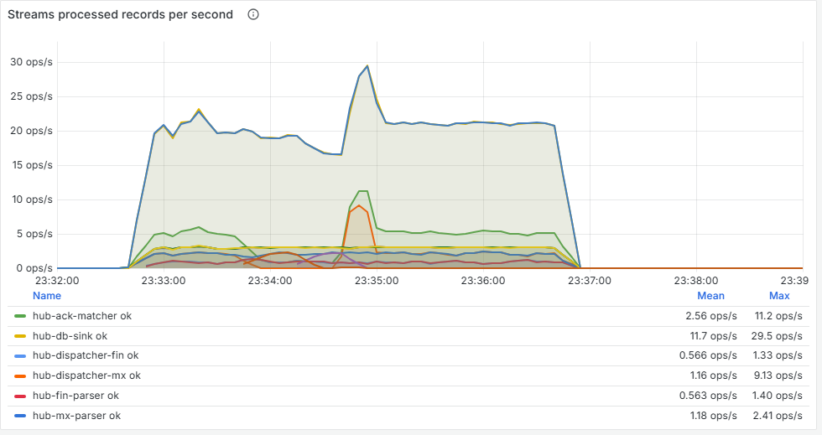
Figure 63. Streams processed records per second. retry outcomes on the MX dispatcher: failed records go to the ladder instead of blocking the partition.
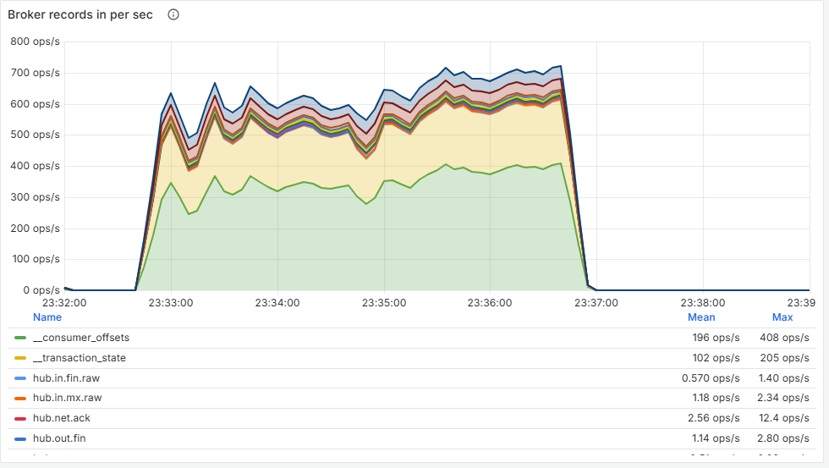
Figure 64. Broker records in per sec. Traffic appears on hub.out.mx.retry.30s during the outage, and on hub.out.mx again 30–60 s later when the retries are republished.
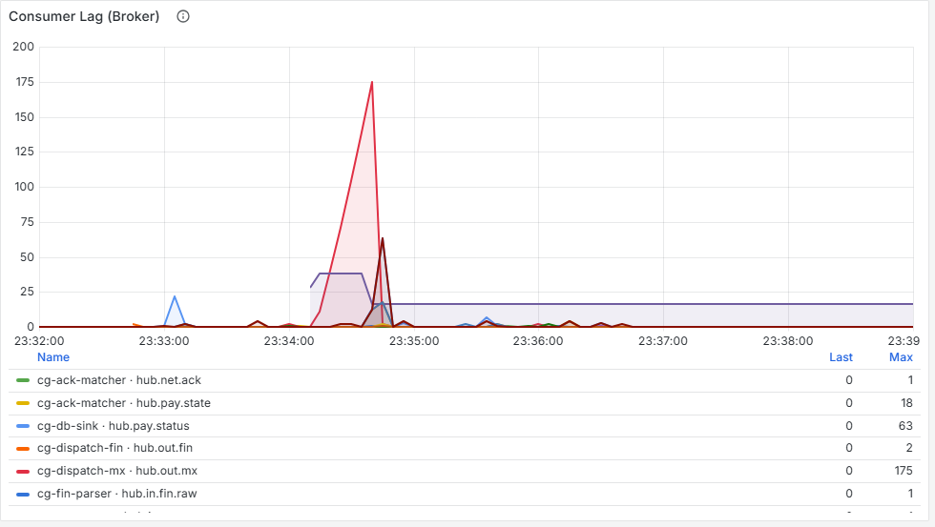
Figure 65. Consumer Lag (Broker). No lasting lag: the ladder keeps every partition moving, which is its purpose.

10.5 Prediction versus reality
Prediction | Actual | Verdict
MT unaffected | Completed normally (apart from 4 lost ACKs) | Correct
MX fails and goes to retry.30s | 211 UNAVAILABLE attempts; 71 records retried | Correct
About 60 payments in the 5-minute tier | Only 2 | Wrong: the 30 s tier really takes 30–60 s, so most retries landed after the outage
Nothing in the DLQ | Nothing | Correct
Every payment completes | 131 reported unsettled | Wrong: two bugs (below)

10.6 Finding the root cause
The dashboards showed the ladder working, but 131 payments never reached COMPLETED. The metrics could not say why, so the investigation moved to step 5: one payment's journey.
Count | Status said | What really happened | Cause
26 | FAILED | Completed: retried, re-sent, ACKed | Bug A
42 | FAILED | Re-sent, but its ACK never reached the Hub | Bugs A and B
63 | DISPATCHED | Sent, but its ACK never reached the Hub | Bug B

Tracing one payment in Elasticsearch showed the full story: SendMx failed three times at 22:33:37 (UTC) and the payment was marked FAILED; at 22:34:35 the retry service republished it; at 22:34:36 it was re-sent, ACKed and completed. PostgreSQL's audit table had every step, but its payment row still said FAILED.
- Bug A: the Hub ranks states so that a payment never moves backwards, and FAILED was ranked like a final state. FAILED here only means "on the retry ladder", so every later DISPATCHED and COMPLETED was refused. Fixed: FAILED is now treated as temporary, ordered by time.
- Bug B: when the simulator's NotifyAck call to the Hub missed its deadline, during the burst of retries, the simulator gave up and the Hub never noticed. Fixed: the simulator now redelivers ACKs (bounded), and the Hub reports any payment waiting more than 60 s for an ACK.

10.7 Lessons
Lesson
Metrics show that something is wrong; the per-payment trace shows what. This root cause was invisible on every dashboard and obvious in one payment's log.
A retry that works can still leave the record of it wrong. Test the whole outcome, not just the mechanism.
"30 s" retry tiers are only as precise as the service that drains them: here, 30–60 s.

11. Scenario 4: a slow broker
Question | What happens when the Kafka broker is short of CPU?
Injected | Kafka limited to 0.5 CPU (docker update --cpus 0.5 hub-kafka)
Run | s4-broker-cpu, 4 October, 3 payments/s, 900 payments
Headline | Throughput held and lag stayed near zero, while latency rose 10×. A failure that lag-based alerting cannot see.

11.1 Timeline
Time | Phase | What changed
23:52:03 | Baseline | Kafka unrestricted
23:53:36 | Fault | Kafka limited to 0.5 CPU
23:55:38 | Recovery | Limit lifted
23:59:06 | End | Batch finished

11.2 Prediction
Every stage commits a Kafka transaction per batch, so a slow broker should slow every stage at once, with no single culprit. Commit time should rise far above processing time. The edge only replies to a delivery after Kafka has stored it, so it may start missing its 200 ms deadline.

11.3 The investigation

Step 1: is the user affected?
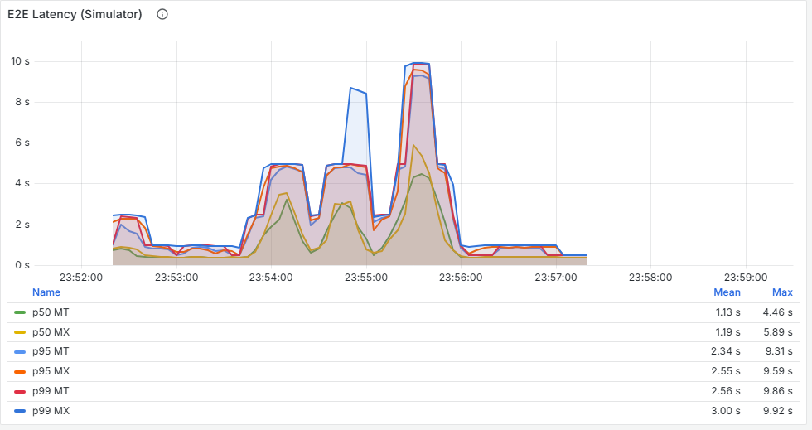
Figure 66. E2E Latency (Simulator). p95 rises from 0.8 s to 4–8 s during the fault and recovers within about a minute.
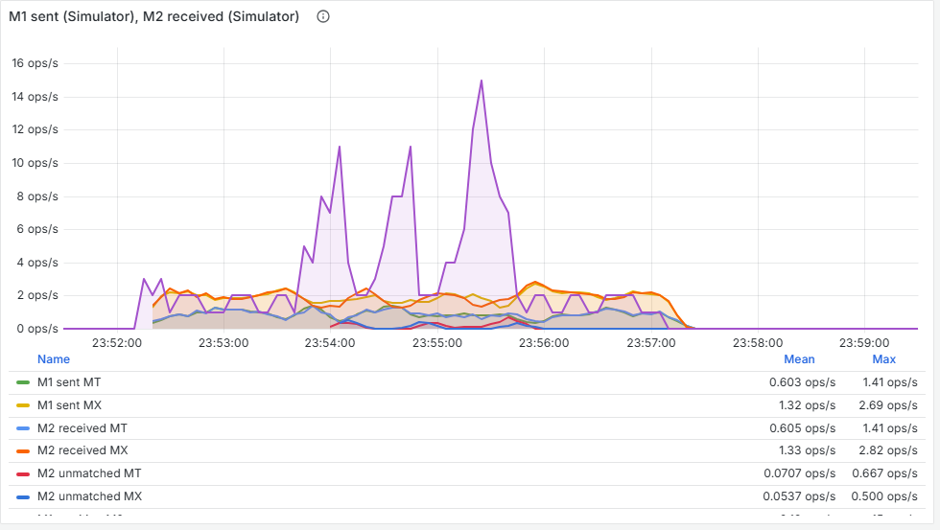
Figure 67. M1 sent / M2 received. Surprisingly, throughput barely changes: 2.6–2.9/s out against about 2.8/s in.

Step 2: where is work piling up?
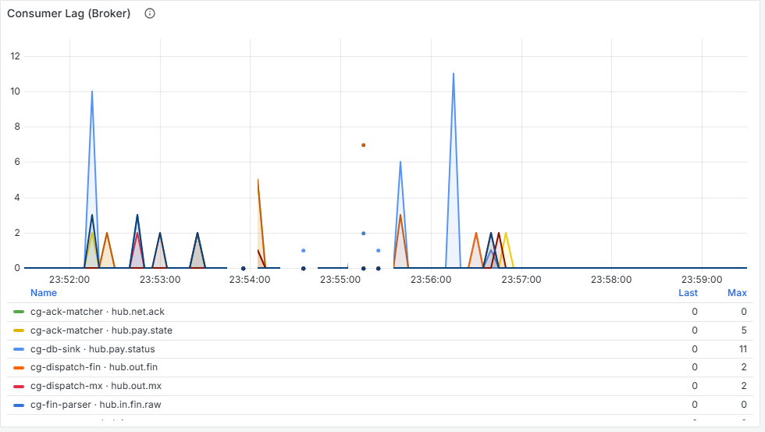
Figure 68. Consumer Lag (Broker). Nowhere: 0–2 records throughout. This is the trap. A lag alert would never fire.

Step 3: which stage is slow?
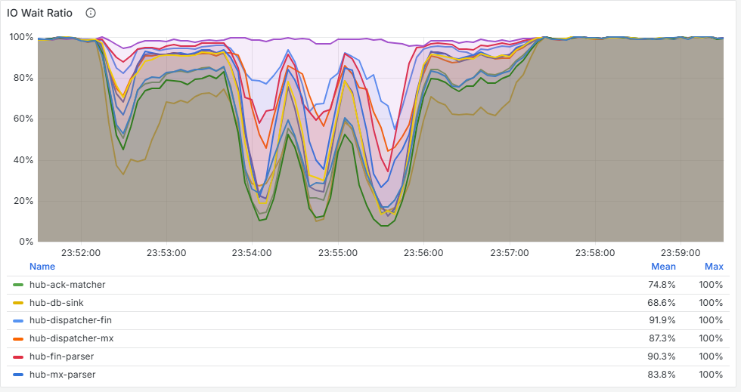
Figure 69. IO Wait Ratio. Every stage falls together (the lowest from 64 % to 24 %), not just one as in scenario 1. Something shared by all stages is slow.

Step 4: why?
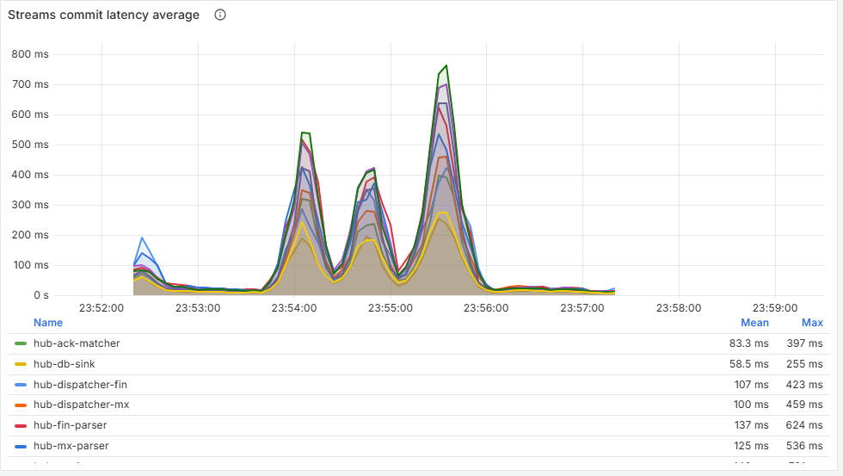
Figure 70. Streams commit latency average. Up from about 14 ms to 120–176 ms in every stage.
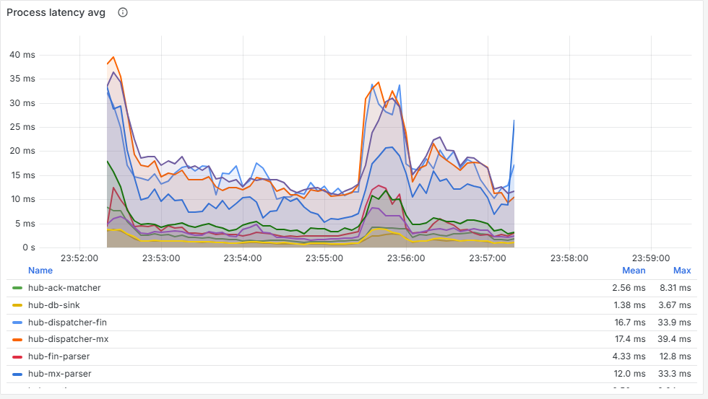
Figure 71. Process latency avg. Unchanged at about 3 ms. Put this next to the previous figure: the stages spend about 98 % of their busy time committing. The cause is the transaction path, not the Hub's code.
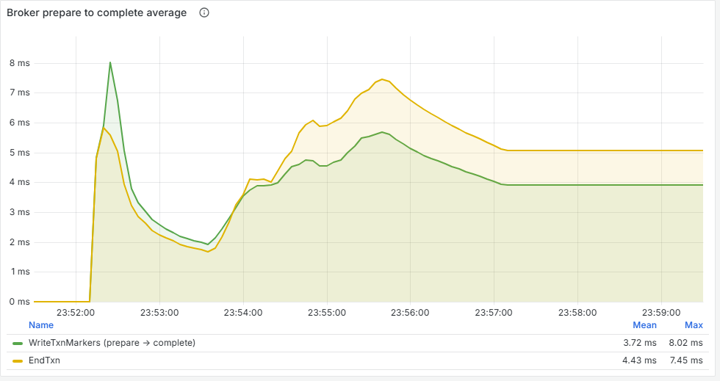
Figure 72. Broker prepare to complete average. The broker's own timings for writing transaction markers rise about 3×. This is a slow-moving average and understates the spike; the client-side commit latency was the better evidence.
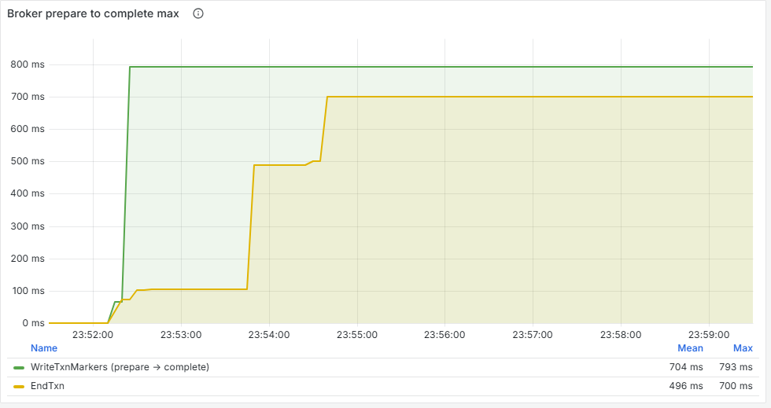
Figure 73. Broker prepare to complete max.
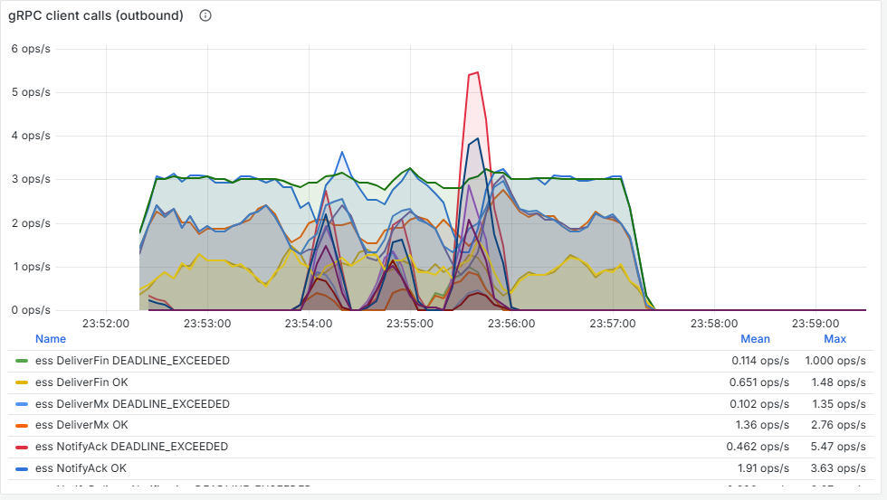
Figure 74. gRPC client calls (outbound). The simulator's Deliver* calls start failing with DEADLINE_EXCEEDED, up to 0.9/s: the edge is waiting on the slow Kafka write before it replies.
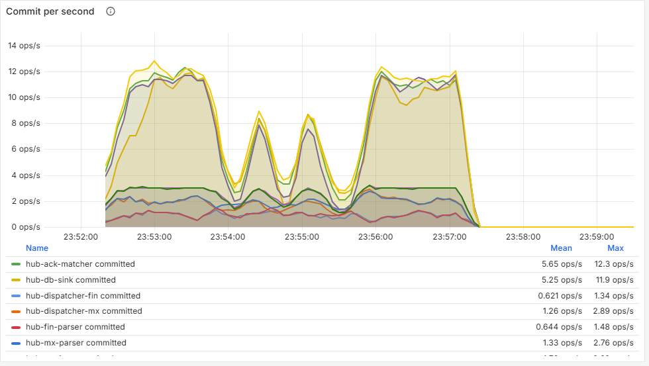
Figure 75. Commit per second. Commits halve (57 → 28–34/s) while records per second stay flat: each commit now carries more records. That self-batching is why throughput held and lag stayed low.

11.4 Prediction versus reality
Prediction | Actual | Verdict
Every stage slows evenly; commit dominates | Commit up about 10×, process unchanged | Correct
Broker transaction timings rise | Up about 3× (average) | Correct
Edge misses its deadline | Up to 0.9/s; 37 duplicates and 9 errors | Correct
Throughput falls | Barely moved | Better than predicted

11.5 Root cause
A starved broker makes every transaction commit slower. While a stage waits for a slow commit, more records pile up for its next poll, so each commit carries more records. Lag stays low because every record now waits for a bigger, slower commit: the whole cost lands on latency.

11.6 Lessons
Lesson
Alert on latency and on the ratio of commit time to process time, not only on lag. This failure was invisible to lag.
Count outcomes from the Hub's records. The client reported 9 errors, but PostgreSQL held 897 payments for 891 acknowledged deliveries: 6 "failed" deliveries had in fact been stored, their reply simply arrived too late.
The broker is part of the system under test. Its CPU headroom needs watching as closely as the Hub's.
Client-side measurements (the Hub's commit latency) showed the problem faster and more accurately than the broker's own averages.

12. Scenario 5: memory growth (a soak test)
Question | Does the Hub's memory stay flat under steady load, and what happens when compliance holds payments and never releases them?
Injected | The compliance service flags 30 % of payments for review and takes 60 minutes to decide, longer than the test
Run | s5-memory-soak, 5 October, 3 payments/s for 15 minutes, 2,700 payments
Headline | Two unbounded memory leaks, one of them present in every run. About 37 KB per payment: out of memory after about 90 minutes at 3/s, or seconds at production volume

12.1 Timeline
Time | Phase | What changed
00:47:15 | Baseline | No holds: only normal growth
00:49:20 | Fault | Compliance holds 30 % of payments
00:59:27 | Fault off | No new holds; held payments stay held
01:02:49 | End | Batch finished

12.2 Prediction
About 0.9 payments a second would be held during the fault, so about 540 in ten minutes, plus slow growth in memory. While preparing the run, the Disk Usage panels showed something more: several stages' state stores were growing with every payment, fault or no fault. The soak was set up to measure both.

12.3 The investigation
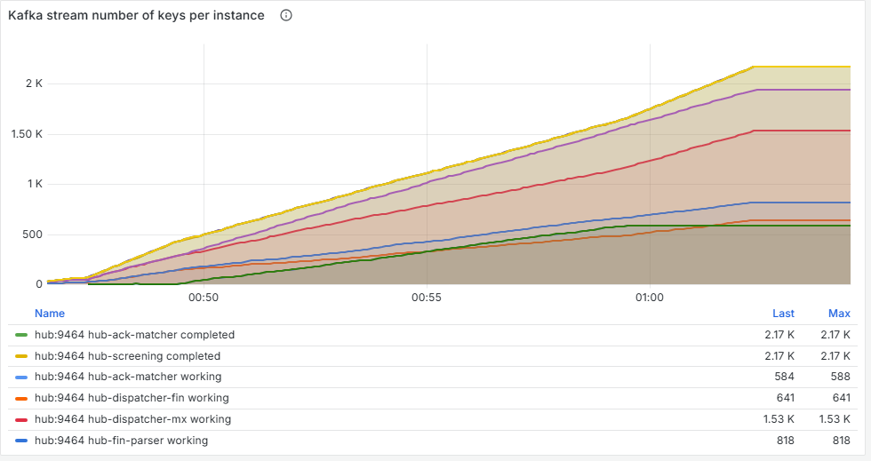
Figure 76. Kafka stream number of keys per instance. The two highest lines (completed) are screening's and the ACK matcher's record of finished payments, kept to recognise duplicates and capped at 100,000 by design: not the leak. The leak is in the working series: the parsers, routing, settlement and dispatchers each gain one key per payment and never shrink, with or without the fault. Screening's working keys (not shown in the clipped legend) climb only during the fault, with the held payments, then go flat.
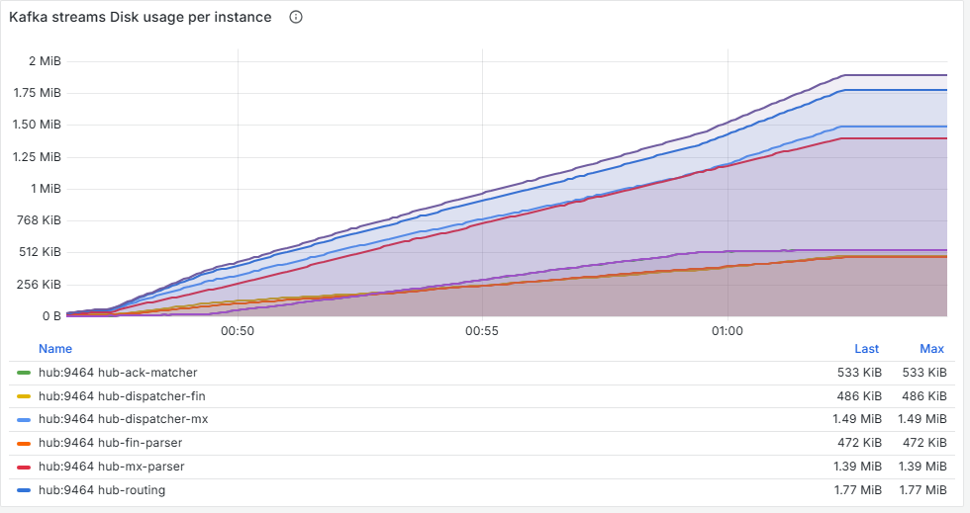
Figure 77. Kafka streams Disk usage per instance. The serialized bytes held by the state stores grow in step with the keys.
Figure 78. Used Memory - Resident (RSS). The Hub grows from 125 MB to 217 MB in 15 minutes, in a straight line, and never comes back down.
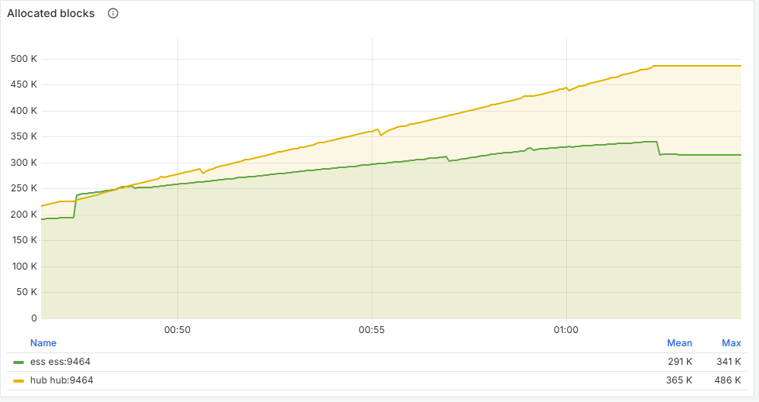
Figure 79. Allocated blocks. The interpreter's allocations grow with RSS, confirming the growth is in Python objects.
Figure 80. Full GC Pauses (generation 2). The Hub (orange) ran four full collections in 15 minutes, pausing about 80 to 250 ms; the worst is longer than the edge's 200 ms deadline. The tall blue spike is the ESS: one full collection estimated at up to 0.5 s (the estimate comes from a histogram bucket, so it is approximate).
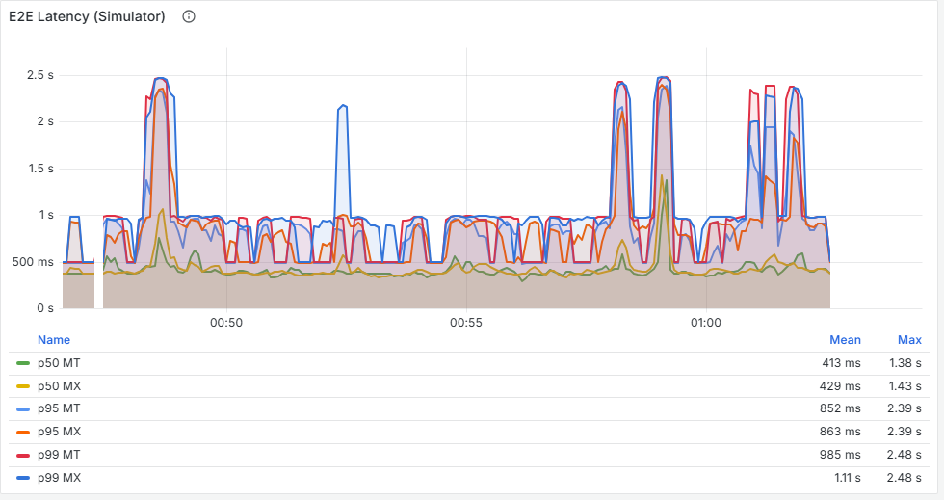
Figure 81. E2E Latency (Simulator). Customers barely notice: p95 stays around 0.6–1 s. A latency SLO passes this run.
Figure 82. M1 sent / M2 received. The "awaiting" line climbs during the fault: held payments, as the simulator sees them.

12.4 Separating the two leaks
 | Start (00:47:30) | End of fault (00:59:30) | End (01:01:30)
Payments in | 85 | 2,221 | 2,579
Held (awaiting compliance) | 0 | 583 | 584: flat
Screening store keys | 1 | 583 | 586: flat
Routing store keys | 85 | 1,659 | 2,017: still climbing
Hub RSS | 125 MB | 207 MB | 217 MB

- The latent leak, in every run: after the fault was switched off, routing still gained exactly one key per payment, and memory still grew about 28 KB per payment. Only screening and the ACK matcher ever drop finished payments; the other stages keep every payment they have processed until the process restarts.
- The injected leak: held payments added about 10 KB per payment during the fault. It stops when holds stop, but nothing frees it unless a decision arrives.

12.5 Prediction versus reality
Prediction | Actual | Verdict
Held payments grow 0.9/s, then stop | 583, then flat | Correct
Routing and settlement: one key per payment | Exactly | Correct
Memory: a few tens of MB at most | +92 MB | Wrong: about 3× more
No out-of-memory restart at 3/s | No restart | Correct
(Interim) GC pauses lengthen as memory grows | 210, 155, 155, 78 ms: no upward trend | Wrong, retracted

12.6 Why so much memory
The stores hold only a few KB of serialized data per payment, yet the process grew about 37 KB per payment. Each stage keeps a full copy of the payment's protobuf envelope as Python objects, plus the dataclasses, lists and dictionaries around it, in several stages at once. Stored bytes understate the real memory cost by about ten times; RSS is the honest number.

12.7 Extrapolation
Load | Time until the Hub reaches its 700 MB limit
3 payments/s (local) | About 85–90 minutes
1,500 payments/s (the design target) | About 10 seconds

Every out-of-memory restart would also force every consumer group to rebalance, with a lag spike across all stages. In a real performance environment, this would be the first failure, long before any latency SLO.

12.8 Lessons
Lesson
Some problems only appear over time. Three-minute runs never showed this leak; a 15-minute soak made it obvious. A real test plan needs a soak of hours.
Watch the shape of a graph, not just its value: a straight line up under steady load is a leak, whatever the current number.
Add an alert on RSS growth per hour at steady load. Latency SLOs will not catch it until the process dies.
Fixes (not yet made): evict finished payments in every stage, store a small marker rather than a full copy, and decide a business rule for payments held too long.

13. Findings, fixes and open issues

13.1 Scorecard
Scenario | Symptom seen first on | Cause found on | Main finding
1 Slow compliance service | E2E Latency (Simulator) | gRPC client call duration; transaction time per stage | Batch transactions amplified a dependency slowdown about 40×
2 Slow database | Consumer Lag (Broker), DB sink only | JDBC Calls; JDBC idle connections | Customers unaffected while the system of record ran 64 s behind
3 SnF outage | gRPC client calls (SendMx UNAVAILABLE) | One payment's journey in Kibana | Retried payments stuck at FAILED (bug A); lost ACKs (bug B)
4 Slow broker | E2E Latency (Simulator); edge deadline errors | Commit latency vs process latency | Latency up 10× with no lag; client errors over-count failures
5 Memory soak | Kafka stream number of keys per instance | Resident memory (RSS); full GC pauses | Two unbounded memory leaks, about 37 KB per payment

13.2 Fixed during the scenarios
Problem | Found in | Fix
A payment retried and then completed stayed FAILED (bug A) | Scenario 3 | FAILED is now temporary: moving into or out of it is decided by time, not rank. Same rule in the status API and in the database
Network ACKs lost when the Hub was briefly slow; payments stuck in DISPATCHED forever (bug B) | Scenarios 1, 3, 4 | The simulator now redelivers ACKs, as a real network does. The Hub reports payments waiting more than 60 s on hub_awaiting_ack{overdue="true"} (dashboard 1)
Redelivery caused a retry storm | Scenario 2 (first attempt) | Bounded: one call per round, 2 to 60 s backoff, at most 5 redeliveries a second per emulator
False "overdue ACK" when the ACK beat the dispatcher's own record | Scenario 2 | A late state record no longer reopens a completed payment
The DB sink's database write was invisible on the process panels | Scenario 2 | Timed separately as hub_post_commit_seconds, shown as "post-commit"
End-to-end histograms stopped at 30 s | Scenario 1 | Extended to 10 minutes
A stage that lost its Kafka partitions (after the computer slept) did no work while the Hub reported healthy | Scenario 1 (first attempt) | A stage with no partitions for 60 s rejoins its group by itself; hub_stage_stalled reports it and the container health check fails meanwhile

13.3 Open issues
None of these is fixed yet. The repository keeps the full list, with the evidence and the code location for each, in docs/known-issues.md; that file is the one to update.
Issue | Impact | Suggested fix
State stores never drop finished payments in most stages | Out of memory after about 90 minutes at 3/s; seconds at production volume | Evict finished payments (bounded LRU or time to live); store a small marker, not a full copy
Screening calls the compliance service one record at a time in one transaction | A slow dependency multiplies latency | Concurrent calls within a batch; a time cap on each transaction
One database connection, two statements per state change | No slack when the database slows | Batch statements; a small connection pool
The "30 s" retry tier takes 30 to 60 s, and some records take several rounds | Recovery from a one-minute outage took several minutes for a few payments (slowest: 329 s in a rerun on 8 October). Nothing is lost | Trace one slow payment in Kibana first; the cause of the repeated rounds is not yet known
The format header (MT / MX) is lost when a record is retried | Panels that split by format under-count retried payments | Copy the original headers when republishing
The simulator drops a payment's end-to-end sample when the Hub answers DUPLICATE to a retried send | The simulator's report under-counts (898 of 900 in the rerun) and misses the slowest payments | Treat DUPLICATE after a retry of the same send as accepted
The full test suite occasionally hangs (roughly one run in three to five on a loaded laptop) | A run may need to be started again; no wrong results are known | Not yet found. Stop the run and start it again
No expiry or escalation for payments held by compliance, or for overdue ACKs | Held payments and missing ACKs accumulate silently | Business rules to decide (re-send, query the network, escalate)
Docker Desktop's network fails after the computer sleeps (seen on Windows) | Builds fail; containers may not start | Disable sleep during tests; restart Docker Desktop; a fixed DNS server in its settings may prevent it
Not yet verified: macOS, ARM processors, and the CI workflow | The stack is written to run there but has not been run there; CI has never run because the repository has not been pushed since | Run it on a Mac; push the repository

13.4 What a real test plan should check
- End-to-end latency percentiles and the maximum.
- Consumer lag per group, including the DB sink.
- The time from completion to persistence in PostgreSQL.
- The ratio of commit time to process time.
- Payments waiting for an ACK beyond the timeout (should be 0).
- Resident memory growth per hour at steady load (should be about 0).
- Full GC pauses against the shortest gRPC deadline (200 ms).
- Outcomes counted from the Hub's records, not from client errors.

14. Glossary
Term | Meaning
ACK / NAK | The network's acknowledgement (accepted) or negative acknowledgement (rejected) of a message the Hub sent
Annotation | A marker with text on the time axis of every Grafana panel
Cardinality | The number of distinct label combinations a metric has; too many slows Prometheus
Compliance screening | Sanctions and financial crime checks on a payment; a hit holds the payment for an analyst's decision
Consumer group | The set of consumers sharing a Kafka topic; each Hub stage is one group (cg-…)
Counter, gauge, histogram | The three metric types (section 2.3)
DLQ | Dead-letter queue: where a record goes after its retries are used up, for a human to look at
ECS | Elastic Common Schema: the field names used in the Hub's JSON log lines
ESS | External Systems Simulator: plays FIN, SnF and compliance screening so the Hub can be tested on its own
FIN, SnF | SWIFT networks: FIN carries MT messages; SWIFTNet store-and-forward (SnF) carries MX (ISO 20022)
Full GC | A garbage collection that examines every object; the process pauses while it runs
HELD | A payment waiting for a compliance decision
Idempotency marker | A note that a stage has already handled a payment, so a redelivered record is not processed twice
IO wait ratio | The share of a stage's time spent waiting for work; near 0 means saturated
Lag | Records waiting to be processed by a consumer group
M1, M2 | The inbound message the simulator sends in, and the outbound message it receives back
MT, MX | SWIFT message formats: MT is the classic FIN format, MX is ISO 20022 XML
p50, p95, p99 | Percentiles: the value 50, 95 or 99 % of observations were below
PromQL | Prometheus's query language
Rebalance | Kafka reassigning partitions among a group's consumers
RSS | Resident set size: physical memory a process is using
Scrape | Prometheus fetching a service's /metrics page
SLO | Service level objective: a target such as "p95 under 1 s"
Soak test | A long run at steady load, to find problems that grow over time
T0 to T6 | Timestamps along a payment's journey, from network delivery (T0) to completion (T6)
Transaction (Kafka) | Reading, processing and writing a batch as one atomic step
UETR | Unique end-to-end transaction reference: the ID that follows one payment everywhere

Appendix A. Command cheat sheet
The same in PowerShell, macOS Terminal and Linux shells, from the repository folder. On macOS and Linux the interpreter may be python3.

Stack
python scripts/dev.py doctor # check this machine
python scripts/dev.py up # build the image once, start everything
python scripts/dev.py ready --wait 300 # wait until it is ready for a test
python scripts/dev.py ps # status and health
python scripts/dev.py logs hub # follow the Hub's logs
python scripts/dev.py trace # send one payment and follow it everywhere
python scripts/dev.py stop # stop, keep data
python scripts/dev.py down # stop and DELETE all data
docker compose restart hub # restart just the Hub

Traffic and faults
docker compose exec -T ess python -m ess.cli batch -n 540 -r 3 --run-id my-run
docker compose exec -T ess python -m ess.cli send -t pacs.008
docker compose exec -T ess python -m ess.cli profile set compliance --accept-latency 300ms --p99 1500ms --kind lognormal
docker compose exec -T ess python -m ess.cli profile set snf --outage --for 60s
docker update --cpus 0.5 hub-kafka # starve a container; restore with your CPU count

Readiness queries (paste into Prometheus, http://localhost:9090)
count(hub_kafka_assigned_partitions > 0) # must be 11
sum(clamp_min(kafka_consumergroup_lag, 0)) # must be 0
hub_awaiting_ack{overdue="true"} # should not grow
sum(hub_stage_stalled) # must be 0
histogram_quantile(0.95, sum by (le) (rate(ess_e2e_latency_seconds_bucket[1m])))

URLs
What | Where
Grafana | http://localhost:3000
Prometheus | http://localhost:9090
Kibana | http://localhost:5601
Hub status API | http://localhost:8080/payments/<UETR>

Appendix B. Metric catalogue
The main metrics behind the dashboards. _total is a counter, _seconds a histogram unless stated.
Metric | Type | Labels | Meaning
ess_e2e_latency_seconds | Histogram | format, flow | Simulator's M1-to-M2 time
ess_m1_sent_total, ess_m2_received_total | Counter | format, flow / matched | Payments in and outbound messages back
ess_notify_redeliveries_total, ess_notify_abandoned_total | Counter | method, error | Simulator ACK redeliveries, and ones given up
hub_payment_end_to_end_seconds | Histogram | format, flow | Hub's T0-to-T6 time
hub_payments_state_total | Counter | service, format, state | State changes (RECEIVED … COMPLETED)
hub_records_processed_total | Counter | service, outcome | Records processed: ok, retry, dlq
hub_process_latency_seconds | Histogram | service | Time to process one record
hub_post_commit_seconds | Histogram | service | Work after the commit (DB sink write)
hub_kafka_commit_seconds | Histogram | service | Time to commit one transaction
hub_kafka_io_wait_seconds_total | Counter | service | Time waiting for records; its rate is the IO wait ratio
hub_kafka_consumer_lag | Gauge | service, topic, group, partition | Lag at read
kafka_consumergroup_lag | Gauge | consumergroup, topic, partition | Lag from the broker (kafka-exporter)
hub_kafka_rebalances_total, hub_kafka_assigned_partitions | Counter, gauge | group, event | Rebalances and partitions held
hub_grpc_client_calls_total, hub_grpc_server_calls_total | Counter | service, method, status | gRPC calls made and served
hub_grpc_client_latency_seconds, hub_grpc_server_latency_seconds | Histogram | service, method | gRPC call duration
hub_db_calls_total, hub_db_call_seconds, hub_db_connections | Counter, histogram, gauge | service, operation, state | Database calls and connections
hub_state_store_keys, hub_state_store_bytes | Gauge | service, kind | State store size per stage
hub_held_payments, hub_awaiting_ack | Gauge | service, overdue | Payments held for compliance; waiting for an ACK
process_resident_memory_bytes | Gauge | job, instance | Process memory (RSS)
hub_python_gc_pause_seconds | Histogram | generation | Garbage collection pauses
kafka_server_brokertopicmetrics_*_total | Counter | topic | Broker records and bytes in and out
kafka_network_request_total_time_ms | Gauge | request, stat | Broker request timings (EndTxn, WriteTxnMarkers, …)
jvm_memory_used_bytes, jvm_gc_collection_seconds | Gauge, summary | area / pool / gc | Broker JVM memory and GC

