Here are the demo screenshots in case there is any problem with installing and running RASA.

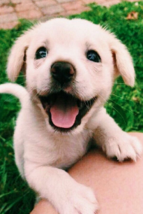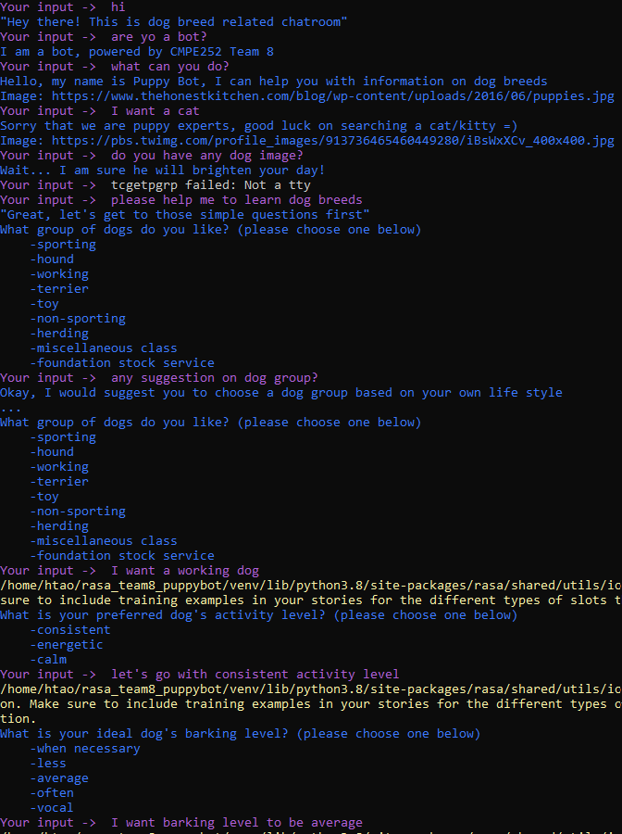

The puppy image is one of the response from out chatbot, our bot opens the image in your local internet browser.

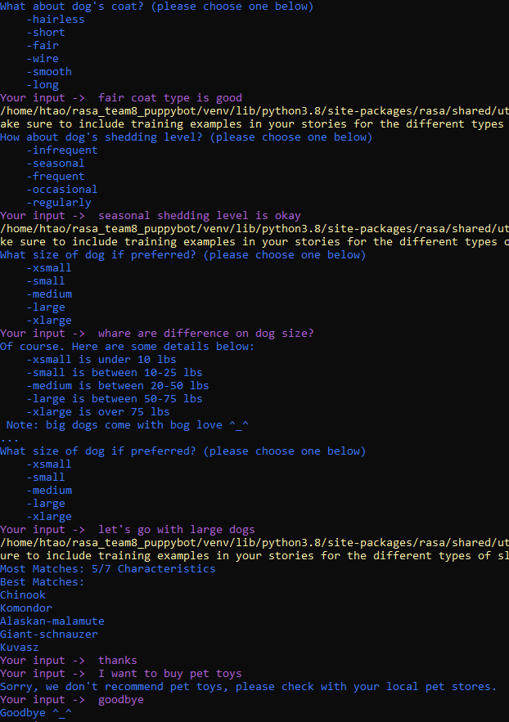

The end result is shown in the red box, there are 5 suggested dogs based on a user choice.