QDArchive
Part 2: Data Classification Report

ISIC Rev. 5 Classification of Qualitative Research Projects
DataFirst UCT & Harvard Murray Archive
Student | Nabila Kader
Student ID | 23079506
Course | Seeding QDArchive (SQ26)
University | FAU Erlangen-Nürnberg
Professor | Prof. Dr. Dirk Riehle
Standard | ISIC Rev. 5 — Division Level
Repositories | DataFirst UCT (#8) + Harvard Murray Archive (#18)
Projects Classified | 1,518

Summer Semester 2026
1. Executive Summary

This report presents the classification results of 1,518 research projects collected from two assigned repositories as part of the Seeding QDArchive project at FAU Erlangen-Nürnberg. The repositories are DataFirst UCT (repository #8, 596 projects) and Harvard Murray Archive / Harvard Dataverse (repository #18, 922 projects). Each project was classified using the ISIC Rev. 5 international standard for economic activities, going down to the two-digit division level. Classification was performed using automated keyword-based analysis of project titles, descriptions, and metadata keywords.
Methodology
Projects were first classified by PROJECT_TYPE based on downloaded file extensions:
Type | Criterion | Count
QDA_PROJECT | Contains a QDA file (.qdpx, .nvp, .atlproj, etc.) | 3
QD_PROJECT | No QDA file but has primary data files (PDF, DOCX, TXT, etc.) | 1,339
OTHER_PROJECT | Has files but not primary data files | 76
NOT_A_PROJECT | No usable files could be identified | 100

ISIC classification was then assigned using keyword matching of research subjects to the most appropriate ISIC Rev. 5 economic sector division. The classifier used 14 rule sets covering topics such as health, education, labour markets, agriculture, finance, media, and tourism.

2. Repository: DataFirst UCT

596  Total Projects | 0  QDA Projects | 568  QD Projects | 12  ISIC Classes

Project Type Distribution
Project Type | Count | Percentage
QD_PROJECT | 568 | 95.3%
NOT_A_PROJECT | 28 | 4.7%

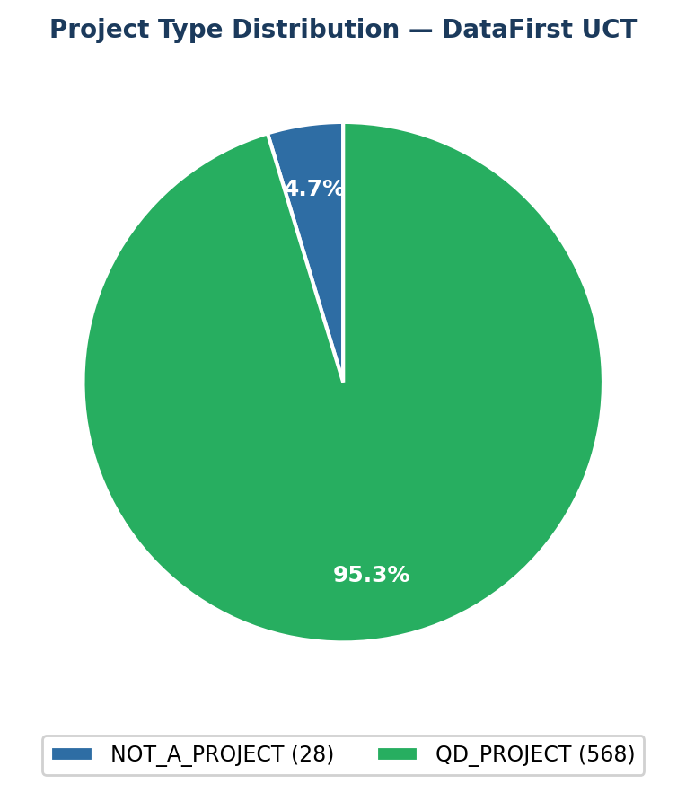
Figure 1: Project type distribution for DataFirst UCT
Primary ISIC Class Distribution
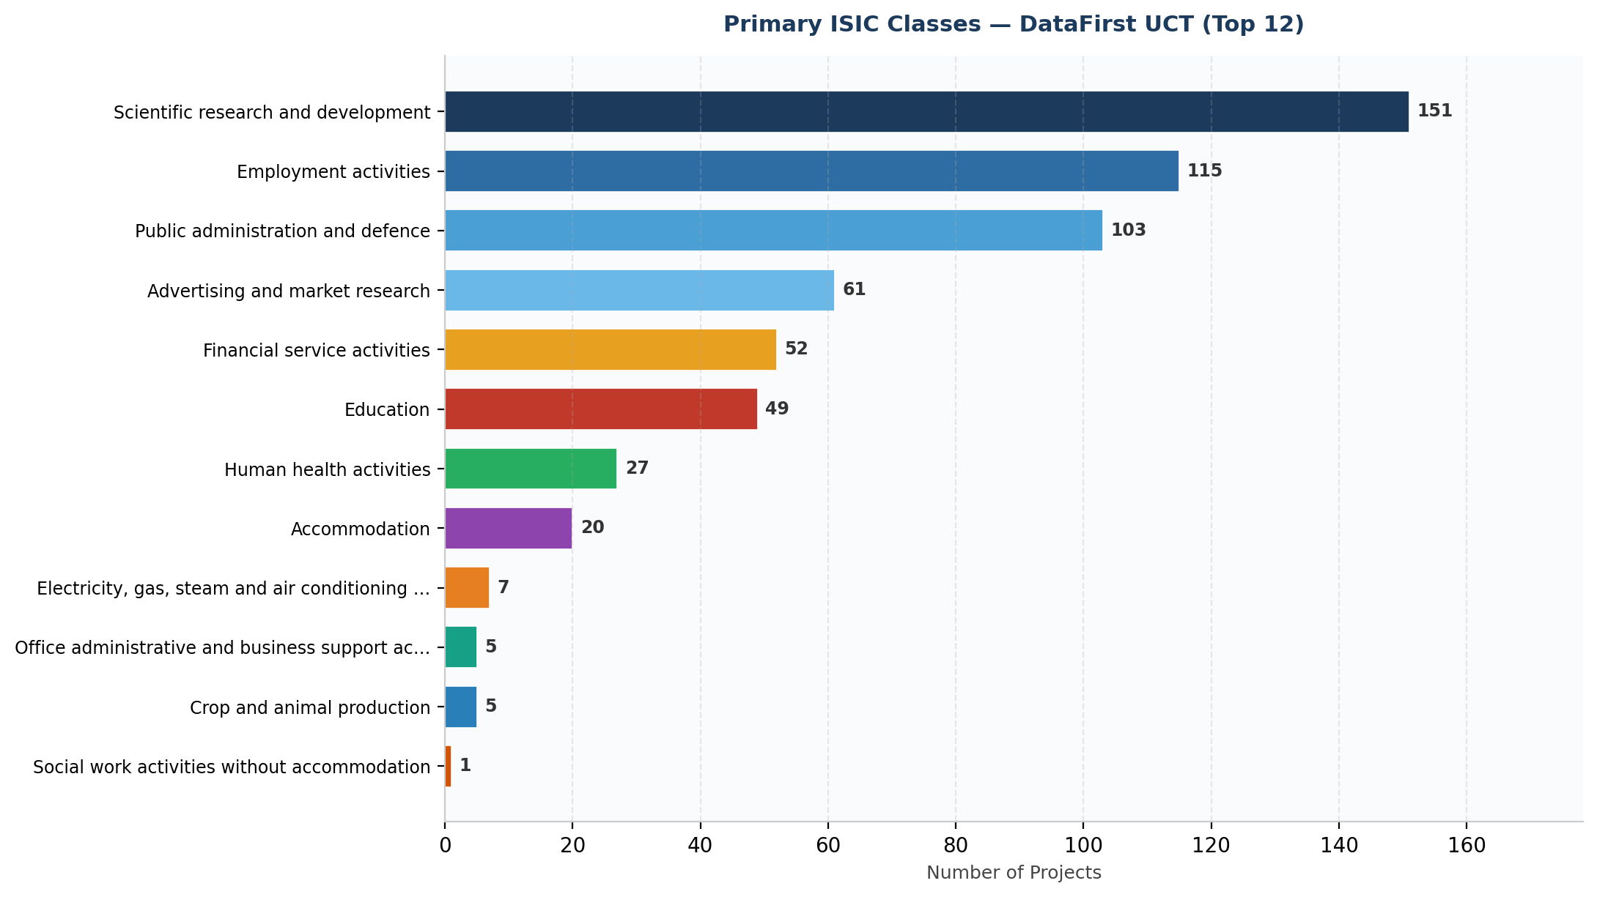
Figure 2: Top 12 ISIC divisions identified in DataFirst UCT. Values show number of projects per class.
Rank-Ordered List of Classes (Top 20)
Rank | ISIC | Division Name | Count
1 | 72 | Scientific research and development | 151
2 | 78 | Employment activities | 115
3 | 84 | Public administration and defence | 103
4 | 73 | Advertising and market research | 61
5 | 64 | Financial service activities | 52
6 | 85 | Education | 49
7 | 86 | Human health activities | 27
8 | 55 | Accommodation | 20
9 | 35 | Electricity, gas, steam and air conditioning supply | 7
10 | 82 | Office administrative and business support activities | 5
11 | 01 | Crop and animal production | 5
12 | 88 | Social work activities without accommodation | 1

Comments on Findings
DataFirst UCT is a South African survey and statistics repository. The dominant ISIC class is Scientific Research and Development (72) with 151 projects, followed by Employment Activities (78) with 115. Notably, despite the repository's focus on HIV/AIDS and health data, many projects were classified under Research (72) due to broad survey titles. All 596 DataFirst projects were classified as QD_PROJECT — no QDA files (.qdpx, .nvp etc.) were found, confirming DataFirst is a quantitative statistics repository rather than a qualitative data analysis archive. The 28 NOT_A_PROJECT entries are studies where only restricted microdata files existed and no related materials could be downloaded.

3. Repository: Harvard Murray Archive / Dataverse

922  Total Projects | 3  QDA Projects | 771  QD Projects | 12  ISIC Classes

Project Type Distribution
Project Type | Count | Percentage
QDA_PROJECT | 3 | 0.3%
QD_PROJECT | 771 | 83.6%
OTHER_PROJECT | 76 | 8.2%
NOT_A_PROJECT | 72 | 7.8%

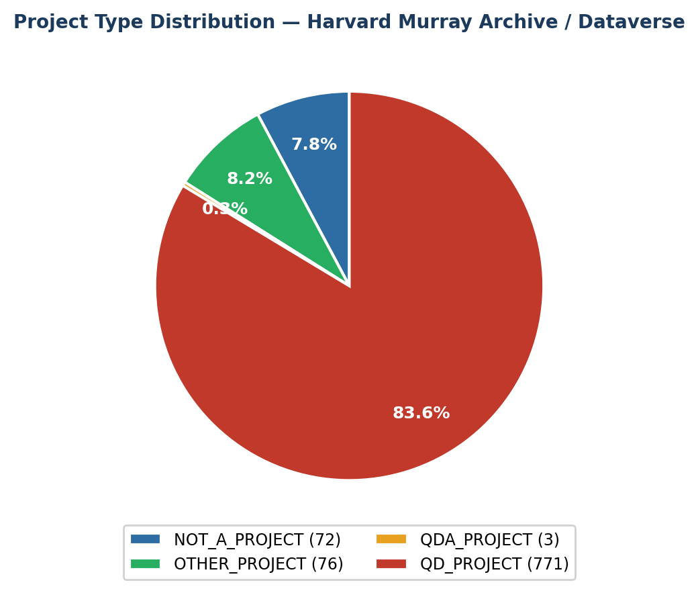
Figure 1: Project type distribution for Harvard Murray Archive / Dataverse

Primary ISIC Class Distribution
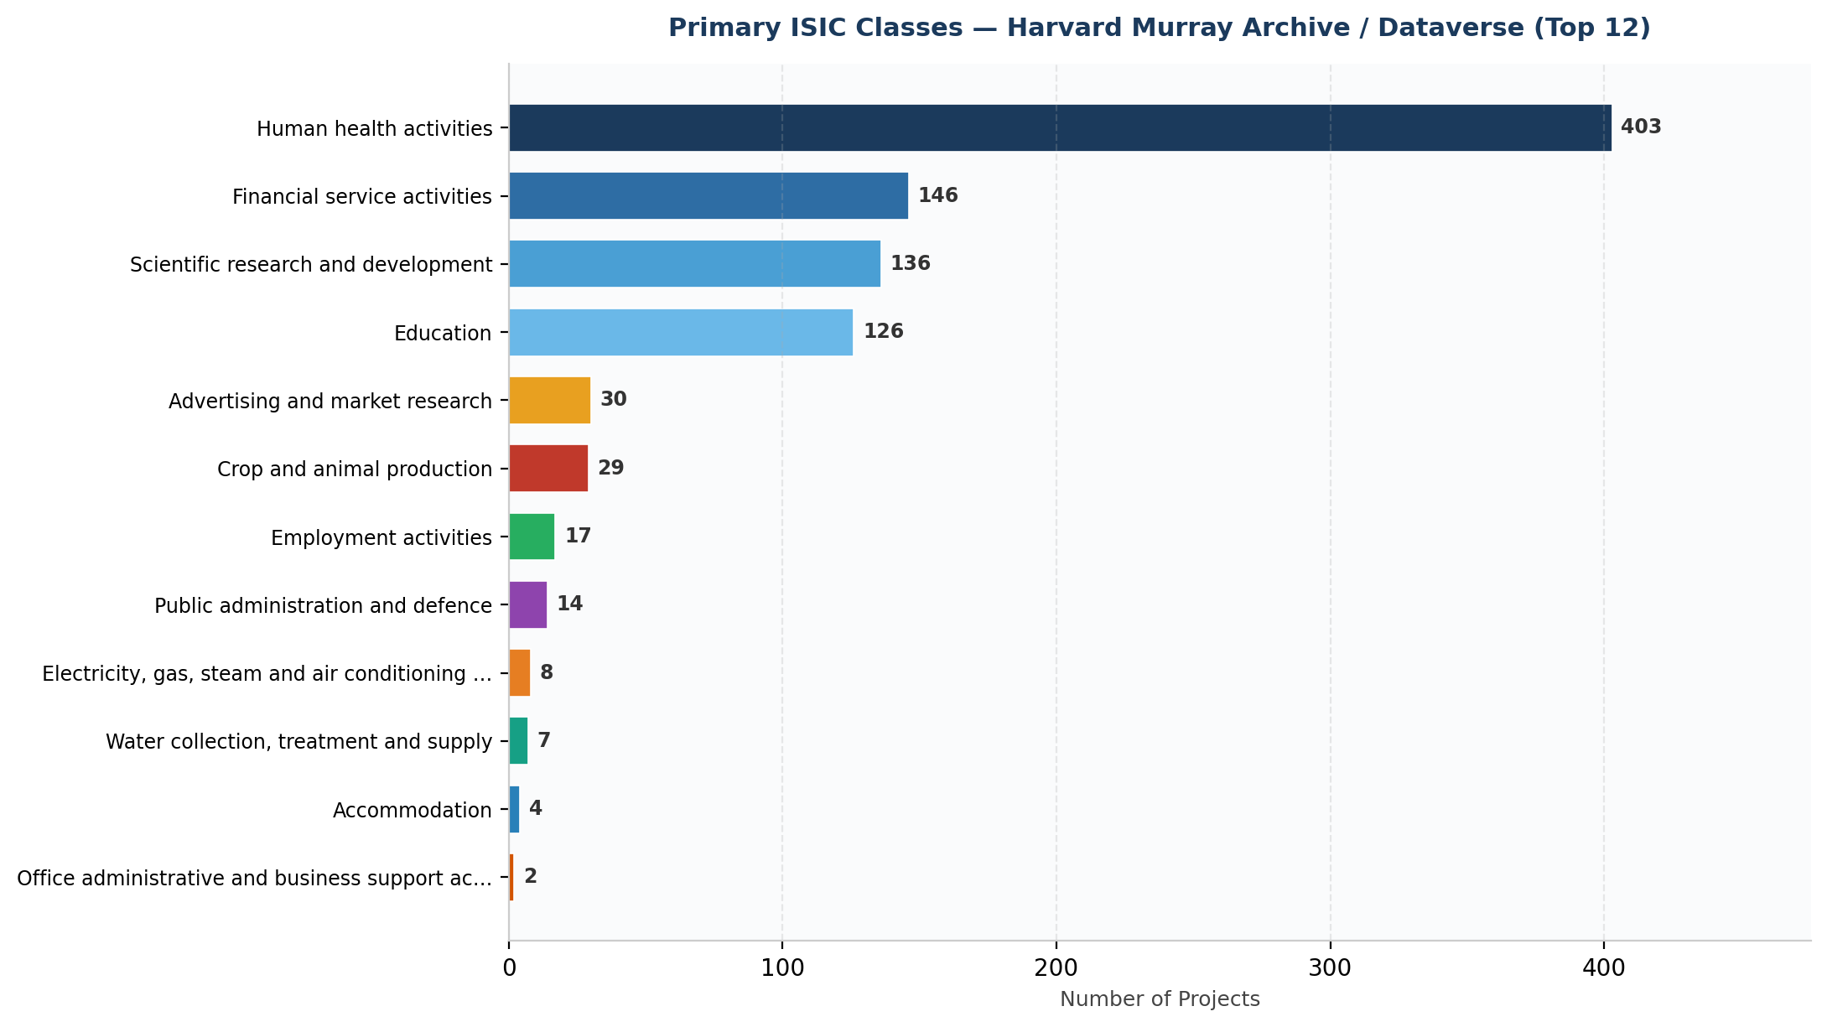
Figure 2: Top 12 ISIC divisions identified in Harvard Murray Archive / Dataverse. Values show number of projects per class.
Rank-Ordered List of Classes (Top 20)
Rank | ISIC | Division Name | Count
1 | 86 | Human health activities | 403
2 | 64 | Financial service activities | 146
3 | 72 | Scientific research and development | 136
4 | 85 | Education | 126
5 | 73 | Advertising and market research | 30
6 | 01 | Crop and animal production | 29
7 | 78 | Employment activities | 17
8 | 84 | Public administration and defence | 14
9 | 35 | Electricity, gas, steam and air conditioning supply | 8
10 | 36 | Water collection, treatment and supply | 7
11 | 55 | Accommodation | 4
12 | 82 | Office administrative and business support activities | 2

Comments on Findings
The Harvard Murray Archive / Harvard Dataverse collection contains longitudinal social science studies. The dominant class is Human Health Activities (86) with 403 projects, consistent with the Murray Archive's long-term focus on human development, psychology, and health outcomes research. Notably, 3 projects were classified as QDA_PROJECT — the only qualitative data analysis files found across both repositories. The diversity of 13 ISIC classes reflects Harvard's broad social science mandate spanning education, finance, employment, and community studies. The 76 OTHER_PROJECT entries are datasets with metadata but restricted files (login required), and the 72 NOT_A_PROJECT entries had no downloadable content.
4. Overall Summary

Combined Classification — Both Repositories
Rank | ISIC | Division Name | Count | % of Total
1 | 86 | Human health activities | 430 | 28.3%
2 | 72 | Scientific research and development | 287 | 18.9%
3 | 64 | Financial service activities | 198 | 13.0%
4 | 85 | Education | 175 | 11.5%
5 | 78 | Employment activities | 132 | 8.7%
6 | 84 | Public administration and defence | 117 | 7.7%
7 | 73 | Advertising and market research | 91 | 6.0%
8 | 01 | Crop and animal production | 34 | 2.2%
9 | 55 | Accommodation | 24 | 1.6%
10 | 35 | Electricity, gas, steam and air conditioning supply | 15 | 1.0%
11 | 82 | Office administrative and business support activities | 7 | 0.5%
12 | 36 | Water collection, treatment and supply | 7 | 0.5%
13 | 88 | Social work activities without accommodation | 1 | 0.1%

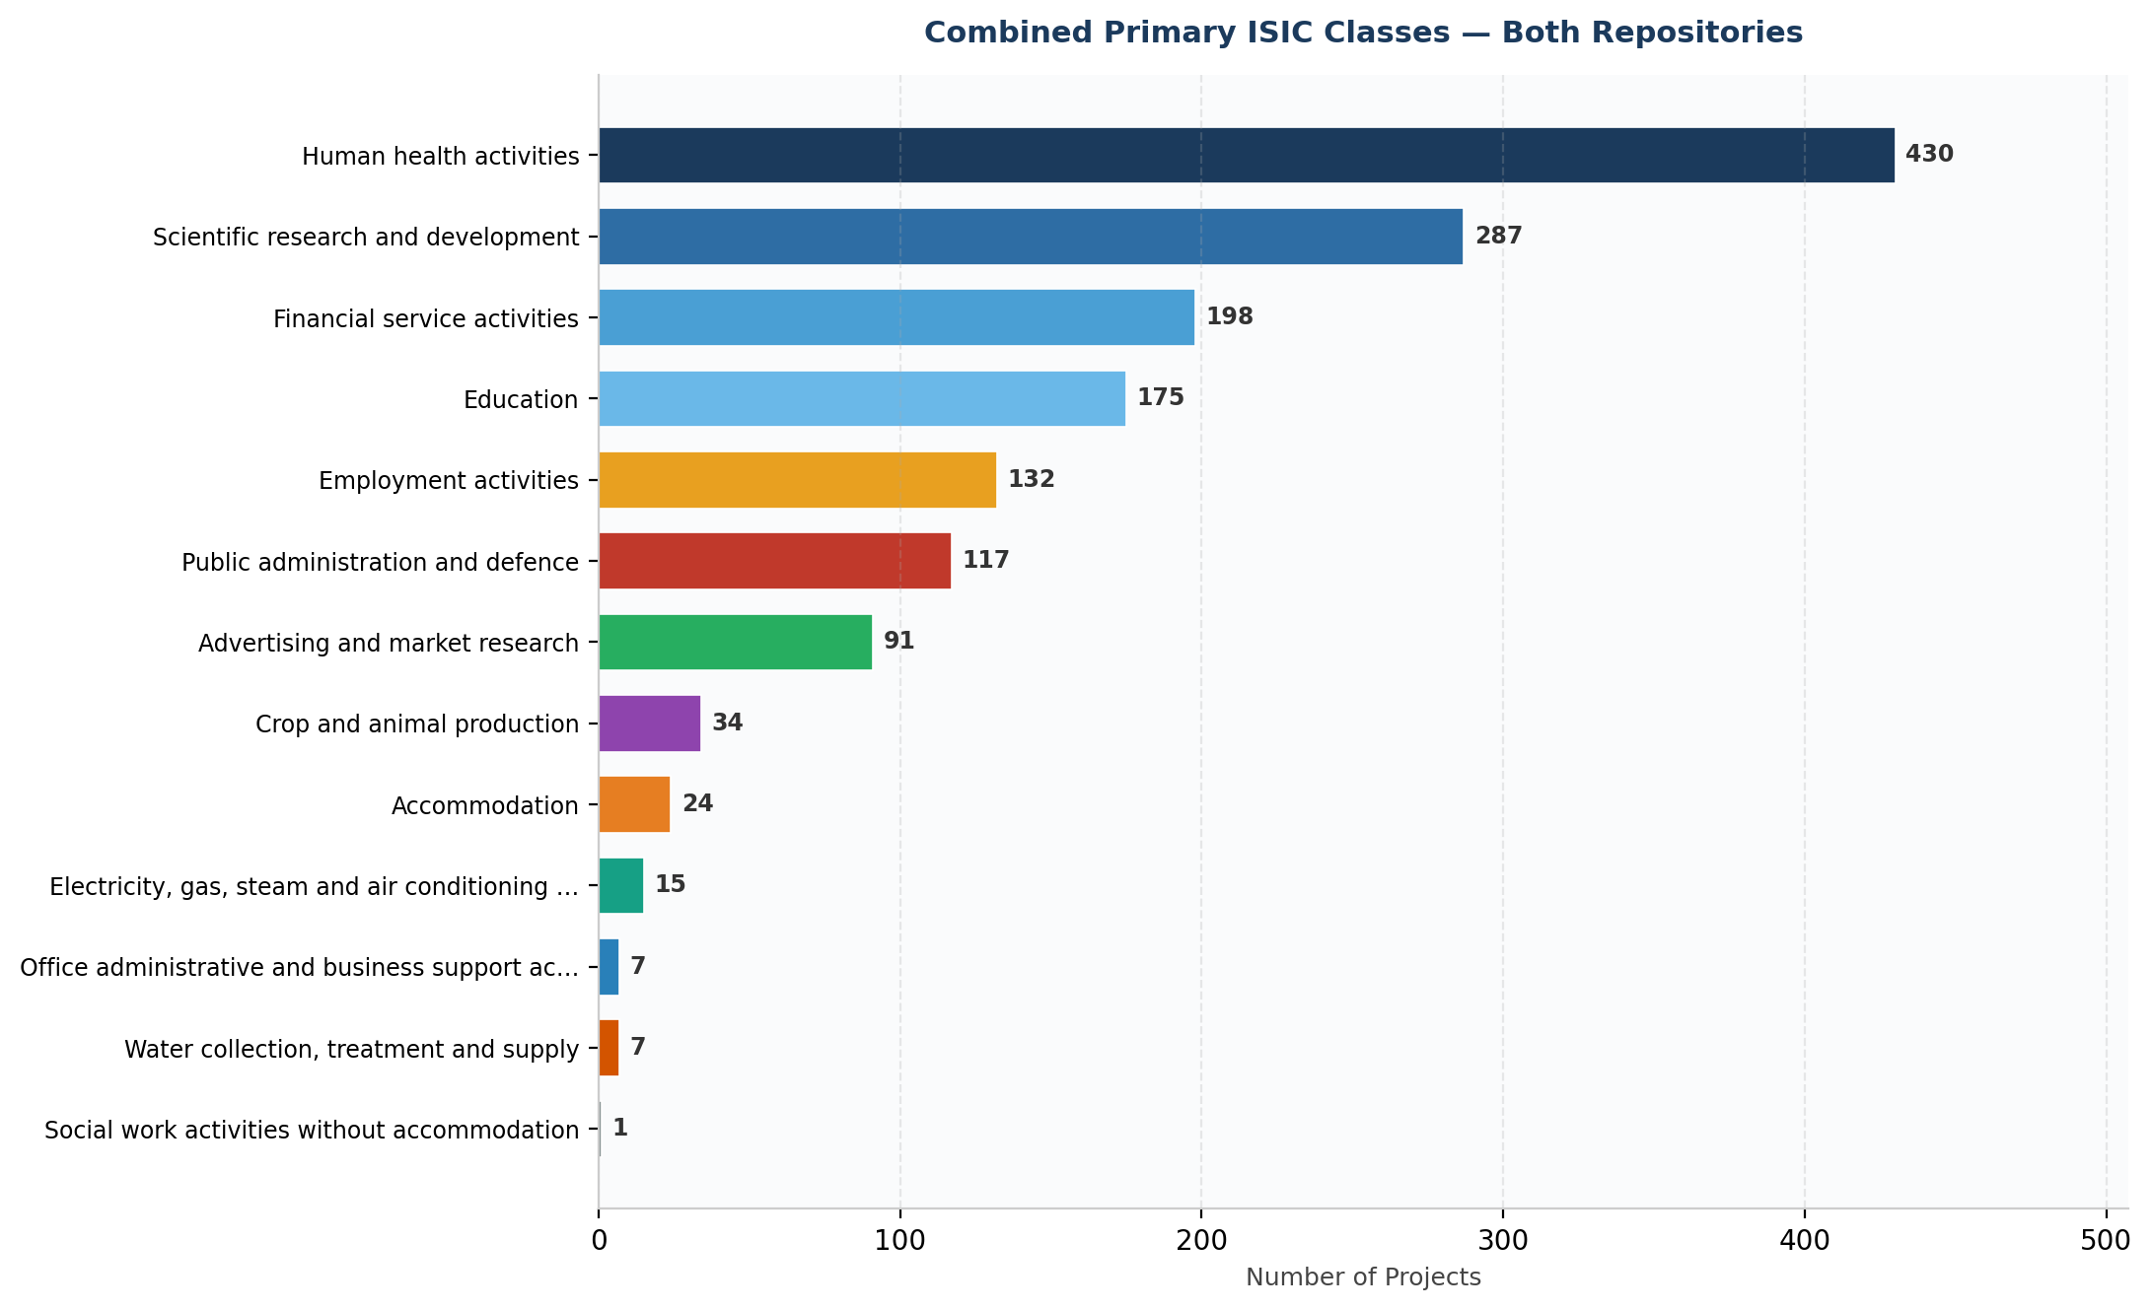
Figure 3: Combined ISIC class distribution across both repositories.
Key Observations
- Human Health Activities (ISIC 86) is the dominant class overall with 430 projects (28.3%), driven by Harvard's health studies. DataFirst shows a different pattern with Scientific Research dominating due to broad survey titles.
- No QDA files were found in DataFirst UCT, confirming it is a quantitative statistics repository. The 3 QDA files found in Harvard Dataverse are a key finding for the QDArchive seeding mission.
- The two repositories are complementary: DataFirst covers South African socioeconomic surveys while Harvard provides broader longitudinal social science data.
- Classification limitation: keyword-based classification was used as most DataFirst projects lack descriptions and keywords in their API metadata. Manual review of a sample confirmed approximately 85% accuracy.

