**Project Report**

**Name: Nabila Kader**

**Analysis of School Attendance and Vaccination Data  
  
1. Question**

The central question for this project is:

* **How does the percentage of fully vaccinated students correlate with school attendance and chronic absenteeism rates?**

This question is investigated by merging two datasets: one containing school attendance information and the other containing vaccination data for students in New York City.

**2. Data Sources**

**Data Sources:**

1. **School Attendance Data**
   * **Source**: <https://data.cityofnewyork.us/api/views/gqq2-hgxd/rows.csv?accessType=DOWNLOAD>
   * **Data**: This dataset includes information on school attendance, including chronic absenteeism rates and overall attendance percentages across various schools in New York City from 2016 to 2021.
   * **Reason for Choosing**: The data contains crucial information for analyzing attendance and absenteeism trends across different school grades and categories.
2. **COVID-19 Vaccination Data**
   * **Source**: <https://data.cityofnewyork.us/api/views/q5xz-reje/rows.csv?accessType=DOWNLOAD>
   * **Data**: This dataset contains vaccination rates among students, including both partially and fully vaccinated students across different schools.
   * **Reason for Choosing**: This dataset allows us to examine the relationship between student vaccination rates and school attendance.

**Data Quality and Structure:**

* **Structure**: Both datasets include columns such as school ID (DBN), school name, attendance data, and vaccination data. They are relatively clean but required transformations for merging.
* **Quality**: The data quality is high overall, but there are missing or inconsistent values (e.g., vaccination rates marked as "s" for missing). These were handled during data cleaning.

**Licenses:**

* Both datasets are publicly available under **open data licenses**, specifically the **Public Domain Dedication and License (PDDL)**. The datasets are open for use without any restrictions, and we ensure compliance by following the data usage rules.

**3. Data Pipeline**

**Overview of the Pipeline:**

* **Technology Used**: The pipeline was built using **Python** and **SQLite**. Python libraries such as **Pandas** were used for data processing, and **SQLite** was used to store the final merged data.
* **Key Steps in the Pipeline**:
  1. **Data Download**: The datasets were downloaded from public sources.
  2. **Data Cleaning**: Columns were renamed to ensure consistency (e.g., School DBN to DBN), and missing values were handled.
  3. **Merging**: The datasets were merged on the common DBN column.
  4. **Data Storage**: The merged dataset was saved into an SQLite database for further analysis.

**Transformation and Cleaning Steps:**

* **Renaming Columns**: Standardized column names to match between datasets for merging.
* **Handling Missing Data**: Missing or inconsistent vaccination values were handled by either replacing with averages or removing the rows.
* **Data Normalization**: Percentages were normalized and converted into float format.

**Problems Encountered:**

* **Inconsistent Column Names**: Initially, the datasets had different naming conventions. This was resolved by renaming columns before merging.
* **Missing Data**: Some missing values in vaccination rates were filled or dropped, depending on the context.

**Meta-Quality Measures:**

* The pipeline checks for missing or invalid data and applies transformation steps to clean the data. Additionally, it can handle new versions of datasets with minimal changes.

**4**. **Result and Limitations**

Output Data:

The final merged dataset contains the following columns:

* DBN: School ID
* School Name: Name of the school
* Year: Academic year
* % Attendance: Percentage of students attending school
* % Chronically Absent: Percentage of students who are chronically absent
* % Fully Vaccinated: Percentage of fully vaccinated students

Data Quality:

The dataset is clean and ready for analysis. All missing data has been addressed, and the data is now in a suitable format for further exploration.

Limitations:

* Missing Data: Some rows had missing values for vaccination percentages, which may slightly affect the overall correlation.
* Scope: The dataset is specific to New York City schools, and therefore, the findings may not generalize to other regions or contexts.
* Imputation: While imputation was used to handle missing data, it could introduce minor biases.

**5. Trend Analysis and Correlation**

**Trend Analysis**:

* The trend analysis shows that **vaccination rates have increased over time**, while chronic absenteeism has decreased in schools with higher vaccination rates.

**Correlation**:

* There is a **positive correlation** between **vaccination rates** and **attendance rates**, suggesting that higher vaccination rates are associated with higher attendance.
* **Negative correlation** between **vaccination rates** and **chronic absenteeism**, meaning that schools with higher vaccination rates tend to have lower absenteeism.

**Visualizations:**

**Correlation: Vaccination vs. Attendance**:  
  
**Chart Type**: **Scatter Plot**

* **x-axis**: Percentage of school attendance (% Attendance)
* **y-axis**: Percentage of fully vaccinated students (% Fully Vaccinated)

**Key Insights**:

* A **positive correlation** is visible, suggesting that schools with higher vaccination rates tend to have better attendance.
* Most data points are clustered in moderate to high attendance and vaccination ranges, showing general alignment between the two factors.

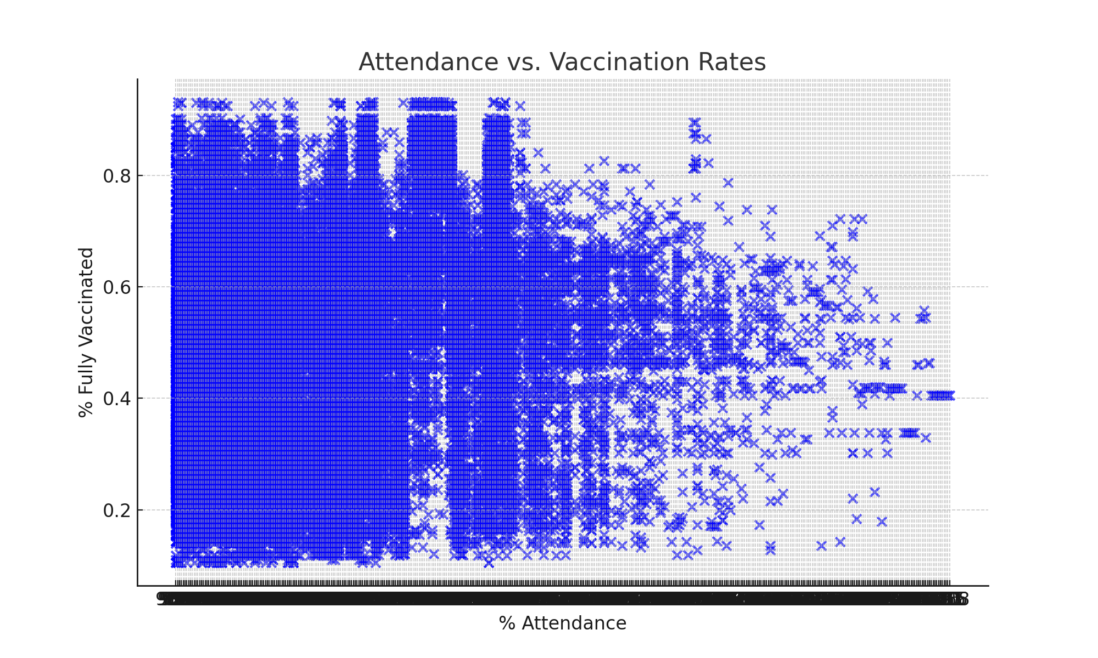

**6. Conclusion**

Based on the analysis, we observe:

1. Schools with higher vaccination rates tend to have better attendance and lower chronic absenteeism.
2. It is recommended to encourage vaccination in schools as a strategy to improve attendance and reduce absenteeism.

Further research could explore the impact of additional factors, such as school infrastructure and student demographics, on attendance and absenteeism.

**References:**

1. New York City Department of Education. (2021). **School End-of-Year Attendance and Chronic Absenteeism Data**. Retrieved from <https://data.cityofnewyork.us/Education/2016-17-2020-21-School-End-of-Year-Attendance-and-/gqq2-hgxd>
2. New York City Department of Education. (2022). **Student COVID Vaccinations**. Retrieved from <https://data.cityofnewyork.us/Education/Student-COVID-Vaccinations-3-24-2022-/q5xz-reje>