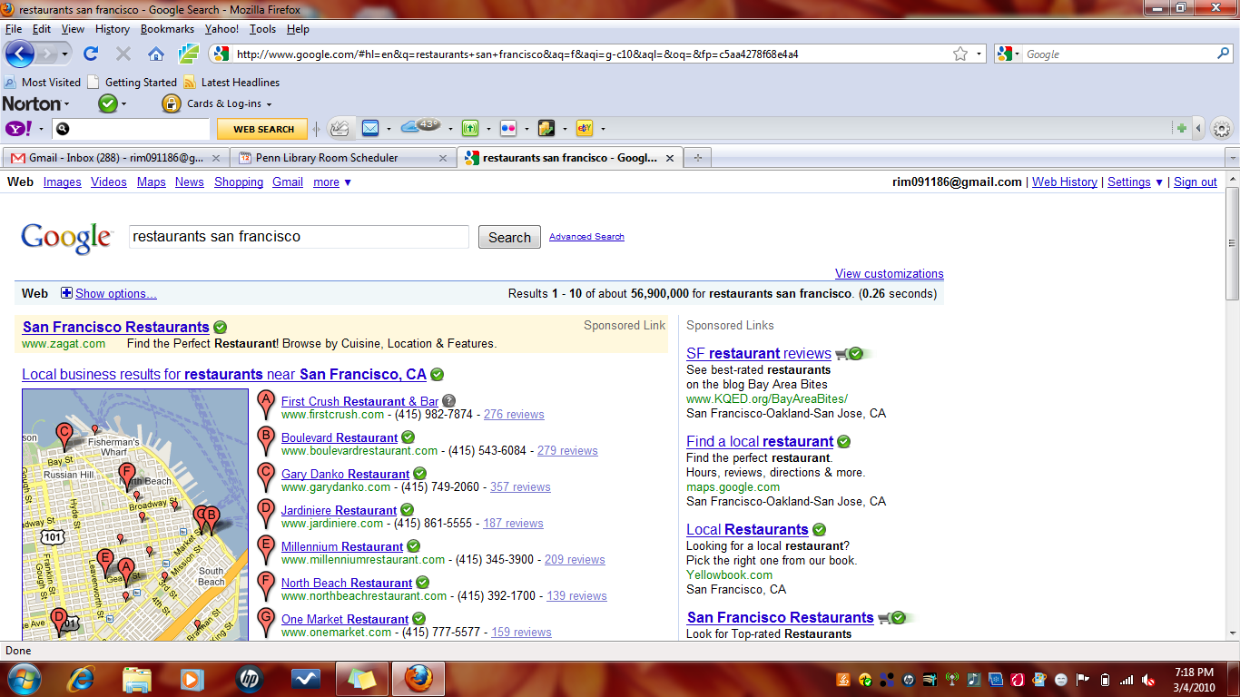

**Script should be able to fulfill the following requirements:**

If we type in a word in the search field of a search engine (Google in our case), then we should be able to fetch the adds that feature in the Sponsored Links section of the first page in a format of a table. For Example, if we type in restaurants San Francisco in the search bar, we want information such as follows:

1) The header information for example SF restaurant reviews, Find a local restaurant (in the example above)

2) The text information in the given adds, such as for example See best-rated restaurants on the blog Bay Area Bites, Find the perfect restaurant (in the example above).

3) The featured URL for example [www.KQED.org/BayAreaBites/](http://www.KQED.org/BayAreaBites/) (in the example above)

4) Location such as San Francisco-Oakland-San Jose, CA (in the example above)

The script should be able to display these 4 fields for every search query in the form of a table. The fields can be called as Header, Text, URL, Location.

Additionally, the script should also be able to do the following:

1) List the keywords, that leads to display of these sponsored links, in a separate column .For example restaurants san Francisco in our case.

2) Total number of Ads in the sponsored link. It was 8 in our example.

3) What is the position of our ad out of the 8 ads. It’s 1 in our example.

So basically, we are going to have a table with 7 fields (as shown in table below). By fields, I mean columns in a table. Below, I have drawn a table which shows our current example, so we will have as many rows as many keywords we give. The script should keep on appending new keyword searches to the existing tables as new rows.

|  |  |  |  |  |  |  |
| --- | --- | --- | --- | --- | --- | --- |
| No. Of Ads | Ranking | KeyWords | Header | Text | URL | Location |
| 8 | 1 | restaurants San Francisco | SF restaurant reviews | See best-rated restaurants on the blog Bay Area Bites | [www.KQED.org/BayAreaBites/](http://www.KQED.org/BayAreaBites/) | San Francisco-Oakland-San Jose, CA |