

Dynamics 365 Media Accelerator

Installation Guide

Contents

Manual Installation Steps 2

Step 1: Acquire Prerequisite Files 2

Step 2: Perform Main Solution Manual Installs 2

Step 3: Create a Blank Portal with the Custom Portal template 6

Step 4: Perform Additional Solution Install with Configuration Migration Tool 6

Package Deployer Installation Steps 8

Step 1: Acquire Prerequisite Files 8

Step 2: Run Package Deployer 8

Reference 9

Manually Importing Solutions 9

Acquiring Configuration Migration tool 9

Importing Solutions with Configuration Migration Tool 9

Acquiring Package Deployer 9

# Manual Installation Steps

## Step 1: Acquire Prerequisite Files

* To import the Main Solutions, acquire the following managed solution files:
  + Media Common Solution (MediaCommon_managed.zip)
  + Media Events and Venues Solution (MediaEventsVenues_managed.zip)
  + Media Sports Solution (MediaSports_managed.zip)
  + Media Event Product Sales Solution (MediaEventProductSales_managed.zip)
  + Media Sports Events Sales Solution (MediaSportsEventsProductSales_managed.zip)
  + Media Apps Solution (MediaApps_managed.zip)
  + Media Registration Portal Solution (MediaRegistrationPortal_managed.zip)
* To import the Additional Solution, you’ll need to setup the Configuration Migration Tool and download the following data files:
  + Configuration Migration Tool
    - For Download Instructions see reference on “Downloading Configuration Migration Tool” below
  + Sample Data (DefaultData.zip)
  + Media Registration Portal Data (MediaRegistration-Portal.zip)

## Step 2: Perform Main Solution Manual Installs

*To import, follow steps in the reference section for “Manually Import Solutions” section below.

**Solutions must be installed in the following order:**

* Media Common Solution (MediaCommon_managed.zip)
  + Expected time to complete – 2 to 5 minutes
  + Expected post installation message: The import of solution: Media Common completed successfully.

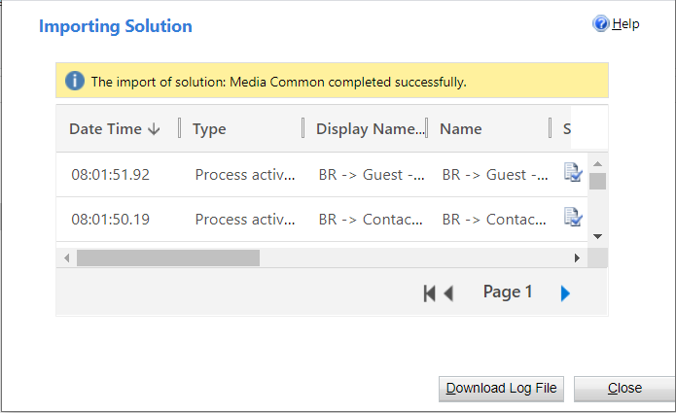

* Media Events and Venues Solution (MediaEventsVenues_managed.zip)
  + Expected time to complete – 2 to 5 minutes
  + Expected post installation message: The import of solution: Media Events and Venues completed successfully.

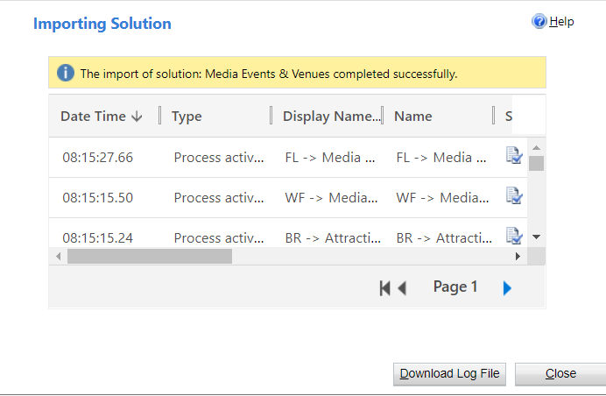

* Media Sports Solution (MediaSports_managed.zip)
  + Expected time to complete – 2 to 5 minutes
  + Expected post installation message: The import of solution: Media Sports completed successfully.

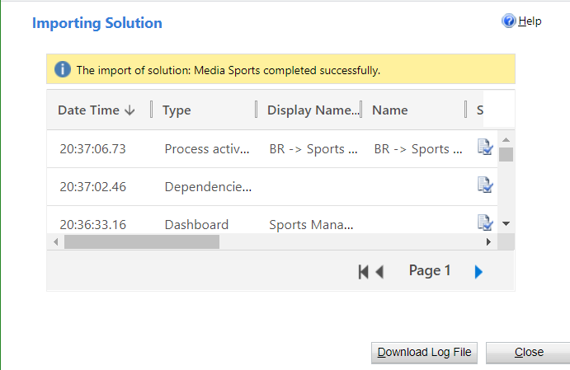

* Media Event Product Sales Solution (MediaEventProductSales_managed.zip)
  + Expected time to complete – 2 to 5 minutes
  + Expected post installation message: The import of solution: Media Event Product Sales completed with warning.

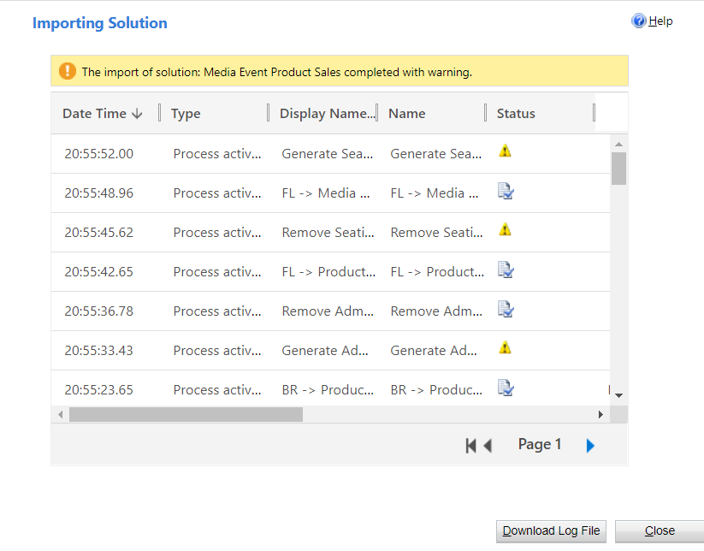

* + **Post installation steps:**
    - 1. Turn on **Generate Admissions** Flow
         1. Under the Media Event Product Sales Solution, click into the Generate Admissions Flow.
         2. Click Edit button.
         3. Add in missing Connections.
         4. Click Save.
         5. Go Back.
         6. Turn On Flow.
      2. Turn on **Remove Admissions** Flow
         1. Under the Media Event Product Sales Solution, click into the Remove Admissions Flow.
         2. Click Edit button.
         3. Add in missing Connections.
         4. Click Save.
         5. Go Back.
         6. Turn On Flow.
      3. Turn on **Generate Seating Products** Flow
         1. Under the Media Event Product Sales Solution, click into the Generate Seating Products Flow.
         2. Click Edit button.
         3. Add in missing Connections.
         4. Click Save.
         5. Go Back.
         6. Turn On Flow.
      4. Turn on **Remove Seating Products** Flow
         1. Under the Media Event Product Sales Solution, click into the Remove Seating Products Flow.
         2. Click Edit button.
         3. Add in missing Connections.
         4. Click Save.
         5. Go Back.
         6. Turn on Flow.
* Media Sports Events Sales Solution (MediaSportsEventsProductSales_managed.zip)
  + Expected time to complete – 30 seconds to 1 minute
  + Expected post installation message: The import of solution: Media Sports Events Sales completed successfully.

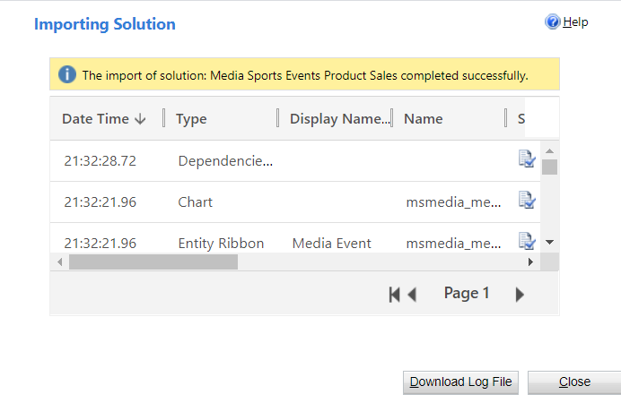

* Media Apps Solution (MediaApps_managed.zip)
  + Expected time to complete – 5 to 10 minutes
  + Expected post installation message: The import of solution: Media Apps completed successfully.

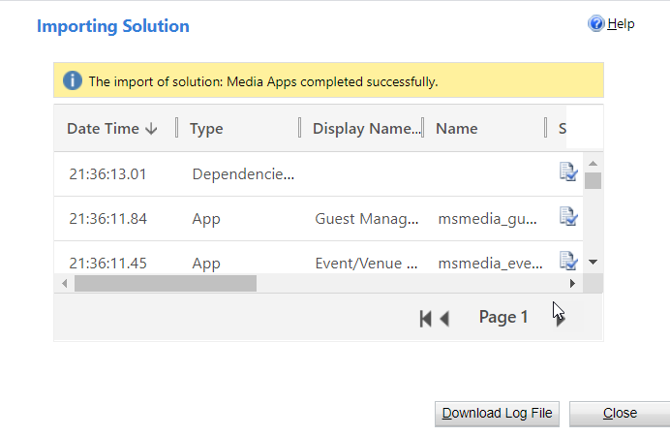

* Media Registration Portal Solution (MediaRegistrationPortal_managed.zip)
  + Expected time to complete – 5 to 10 minutes
  + Expected post installation message: The import of solution: Media Registration Portal completed successfully.
  + **Post installation steps:**
    - **Confirm the 4 included Power Automate Flows have Status = “On”**
      * In make.powerapps.com open the just imported Media Registration Portal solution
      * For each flow included in the solution, open the flow
      * In Power Automate page for the flow identify the “Details” section
      * In the “Details” section confirm that “Status” = On
      * If “Status” = Off
        + Click “Edit” and resolve any connection auth errors, save flow
        + Click “Turn On”  in the top bar
    - After all Flows are confirmed Status = “On” please continue this installation guide

## Step 3: Create a Blank Portal with the Custom Portal template

1. Create a new Blank Portal with the Custom Portal template by following [these](https://docs.microsoft.com/en-us/powerapps/maker/portals/create-portal) directions
   1. Time to complete – 12 – 25 minutes
   2. Post installation message

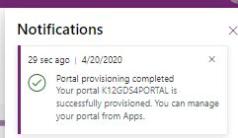

1. Once the Custom Portal is provisioned, the user will need to remove the .js and .css file types in the System Settings
   1. Click on the Settings icon (sprocket) in the upper-righthand corner and click on Advanced Settings
   2. Within Settings, click on Administration within the System area group
   3. Click on System Settings
   4. Within the General tab, proceed to **Set blocked file extension for attachments** section and remove the .js and .css file extension

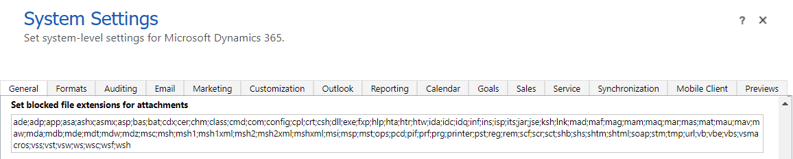

## Step 4: Perform Additional Solution Install with Configuration Migration Tool

To import, follow steps in the reference section on “Import Additional Solutions with Configuration Migration Tool” below.

* Sample Data Package (DefaultData.zip)
  + Time to complete – 8 to 25 minutes
  + Expected post installation message: The import to CDS is complete.

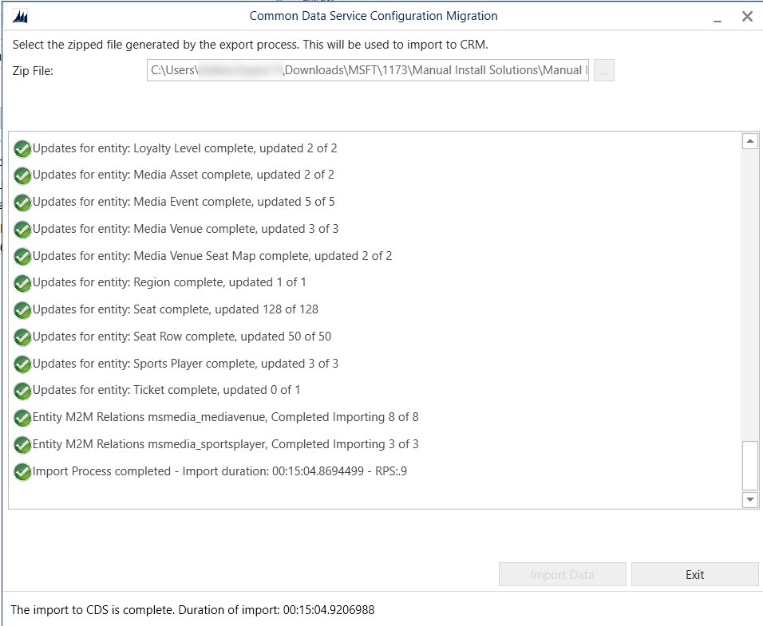

* Media Registration Portal Data (MediaRegistration-Portal.zip)
  + This import is dependent on the completion of “**Step 3: Create a Blank Portal with the custom portal template”**. **Do not** complete this step until portal provisioning is completed.
  + Time to complete – 5-20 minutes
  + Expected post installation message: The import to CDS is complete.
  + **Post Data Import Steps:**
    - **Update the Primary Domain Name on the “Media Registration Portal”**
      * Navigate to the Portal Management model driven app
      * Navigate to the website record
      * Update Primary Domain Name on the "Media Registration Portal" Website record to <your portal url> (e.g. “yourportal.powerappsportals.com”)
    - **Update “Media Registration Portal” site settings**
      * From the website record, navigate to the site settings tab
      * Update the following site settings
      1. MRP_Bing_Key = <your BING API key>
      2. MRP_Image_Api_Domain = <your org base url, e.g. <https://yourorg.crm.dynamics.com>>
      3. MRP_Registration_Edit_Flow = (link from FL -> Guests -> Update Data of Guests Flow, open the Flow, expand the first step, copy the HTTP link)
      4. MRP_Registration_New_Flow = (link from FL -> Guests -> Update Data of Guests Flow, open the Flow, expand the first step, copy the HTTP link)

# Package Deployer Installation Steps

## Step 1: Acquire Prerequisite Files

* To import using the Package Deployer, you’ll need to download Package Deployer and the following package deployer file:
  + Package Deployer
    - For Download Instructions see reference on “Acquiring Package Deployer” below
  + Package Deployer file (MediaAccelerator-PackageDeployer.zip)

## Step 2: Run Package Deployer

* Use the below command script to import the solutions using package deployer:

.\PackageDeployer.exe /Settings:"MediaCommon=true|MediaEventsVenues=true|MediaSports=true|MediaEventProductSales=true|MediaSportsEventsProductSales=true|MediaApps=true|SkipSampleData=false"

* + Expected Result: Import should be successful and have green checkmarks for every step.

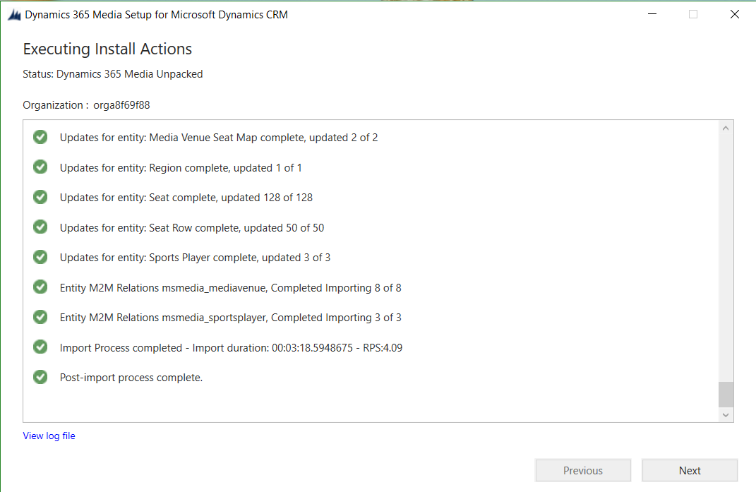

* + Run through same Post Installation steps on the Media Event Product Sales Solution to activate Flows.

# Reference

## Manually Importing Solutions

To manually import a main solution:

1. Navigate to <https://make.powerapps.com/home> > Select your Environment > Click Solutions in left-hand Navigation
2. Click Import button in ribbon
3. Click Choose File button and select managed solution zip file

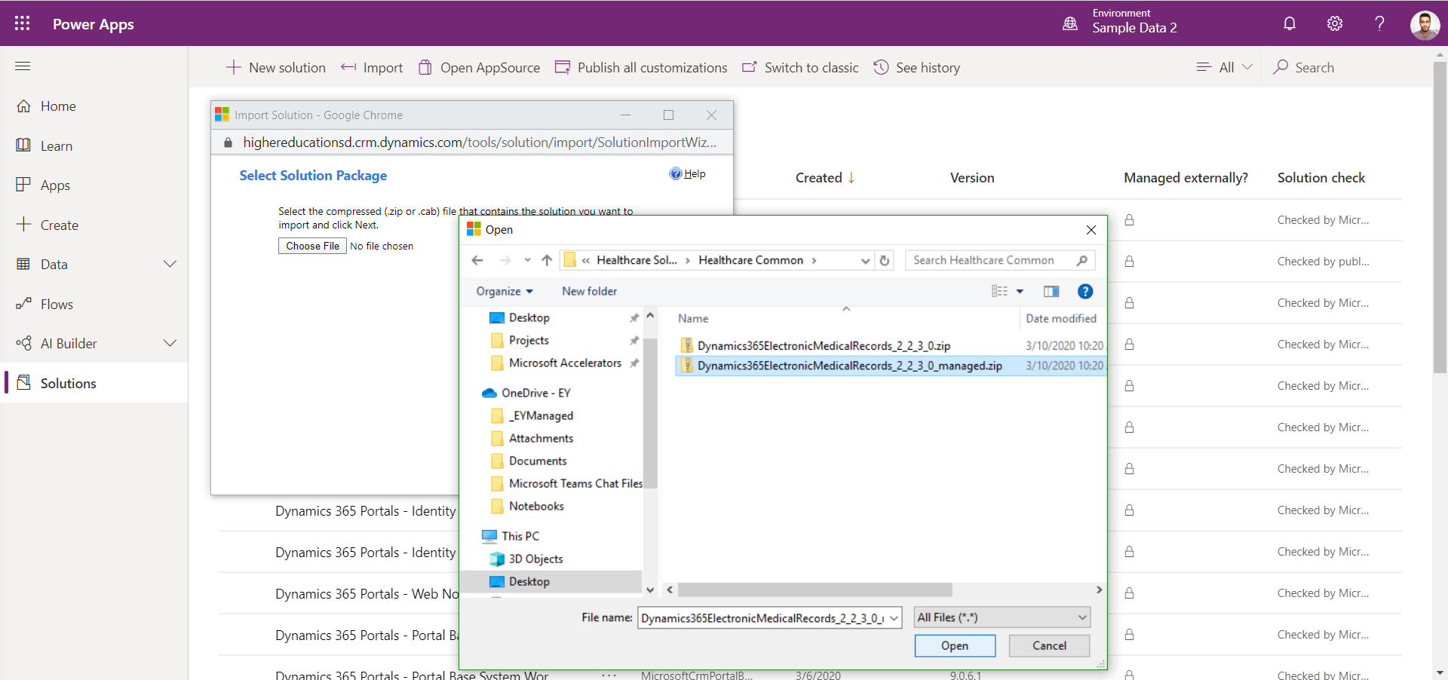

1. Click Open button
2. Click Next through all steps and then Import

## Acquiring Configuration Migration tool

1. Navigate [here](https://docs.microsoft.com/en-us/powerapps/developer/common-data-service/download-tools-nuget) to acquire the Configuration Migration tool
2. Click the NuGet package link for the Configuration Migration Tool
3. Follow directions to download the Configuration Migration tool via Package Manager

## Importing Solutions with Configuration Migration Tool

To Import an additional solution using the Configuration Migration Tool:

1. Open Configuration migration tool
   1. Select “Import Data”
   2. Connect to the org to import the data to the environment of your choice
   3. Select the appropriate data zip file
   4. Perform the import

## Acquiring Package Deployer

1. Navigate [here](https://docs.microsoft.com/en-us/powerapps/developer/common-data-service/download-tools-nuget) to acquire the Package Deployer tool
2. Click the NuGet package link for the Package Deployer tool
3. Follow directions to download the Package Deployer tool via Package Manager