

Dynamics 365 Telco Accelerator

Installation Guide

Contents

Option 1 – Use Package Deployer to Install All Solutions 2

Step 1: Acquire Perquisite Files 2

Step 2: Install Telco Accelerator using Package Deployer 2

Option 2: Import Solutions Manually 2

Step 1: Acquire Prerequisite Files 2

Step 2: Perform the following main solution installs 3

Post Install Configuration 6

Azure Maps Subscription Key 6

Update Environment Variables 6

Share an Embedded Canvas App 6

References 7

Manually Importing Solutions 7

Acquiring Configuration Migration tool 7

Importing Solutions with Configuration Migration Tool 7

Acquiring Package Deployer 7

# Option 1 – Use Package Deployer to Install All Solutions

## Step 1: Acquire Perquisite Files

* To import using the Package Deployer, you’ll need to download Package Deployer Tool and the following package deployer package file:
  + Package Deployer Tool
    - Go to <https://docs.microsoft.com/en-us/powerapps/developer/common-data-service/download-tools-nuget>
    - Click the NuGet package link for the Package Deployer tool
    - Follow directions to download the Package Deployer tool via Package Manager
  + Package Deployer file (TelcoAccelerator-PackageDeployer.zip)

## Step 2: Install Telco Accelerator using Package Deployer

* Use the below command script to import the solutions using package deployer:

.\PackageDeployer.exe /Settings:"TelcoAnchor=true|TelcoCommonCDM=true|TelcoSalesCDM=true|TelcoApps=true|TelcoSalesApps=true|SkipSampleData=false"

* + Expected Result: Import should be successful and have green checkmarks for every step and install following solutions.
    - Telco Anchor Solution (TelcoAnchor_managed.zip)
    - Telco Common CDM Solution (TelcoCommonCDM_managed.zip)
    - Telco Sales CDM Solution (TelcoSalesCDM_managed.zip)
    - Telco Apps Solution (TelcoApps_managed.zip)
    - Telco Sales Apps Solution (TelcoSalesApps_managed.zip)
    - Telco Sample Data (DefaultData.zip)
* **Note**: The [Dynamics 365 Sales Enterprise App](https://docs.microsoft.com/en-us/dynamics365/sales-enterprise/set-up-dynamics-365-sales) is required to be installed / enabled for the import of Telco Sales Solutions, you can mark TelcoSalesCDM=false and TelcoSalesApps=false in the above command to skip Telco Sales solutions

# Option 2: Import Solutions Manually

## Step 1: Acquire Prerequisite Files

* To import the Main Solutions, acquire the following managed solution files:
  + Telco Anchor Solution (TelcoAnchor_managed.zip)
  + Telco Common CDM Solution (TelcoCommonCDM_managed.zip)
  + Telco Sales CDM Solution (TelcoSalesCDM_managed.zip)
  + Telco Apps Solution (TelcoApps_managed.zip)
  + Telco Sales Apps Solution (TelcoSalesApps_managed.zip)
  + Telco Sample Data Package (DefaultData.zip)
* **Note**: The [Dynamics 365 Sales Enterprise App](https://docs.microsoft.com/en-us/dynamics365/sales-enterprise/set-up-dynamics-365-sales) is required to be installed / enabled for the import of Telco Solutions

## Step 2: Perform the following main solution installs

**Solutions must be installed in the following order:**

*To import, follow steps in the reference section for “Manually Import Solutions” section below.

#### Telco Anchor Solution (TelcoAnchor_managed.zip)

* + - Time to complete – 30 seconds to 2 minutes
    - Post installation message

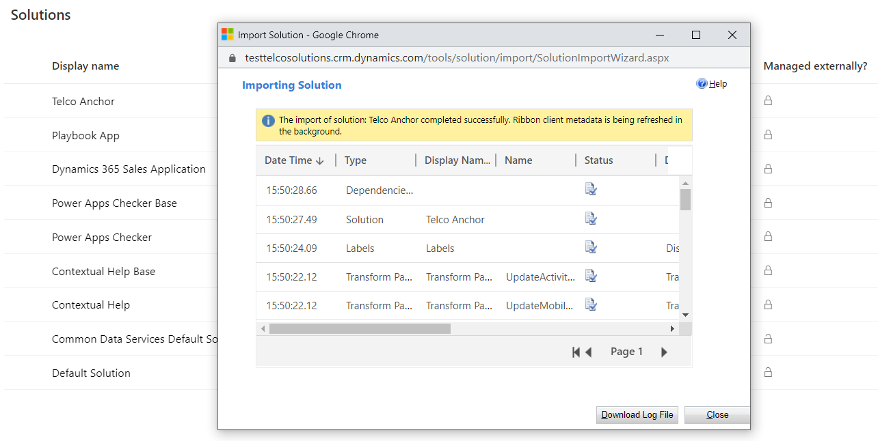

#### Telco Common CDM Solution (TelcoCommonCDM_managed.zip)

* + - Time to complete – 2 to 6 minutes
    - Post installation message

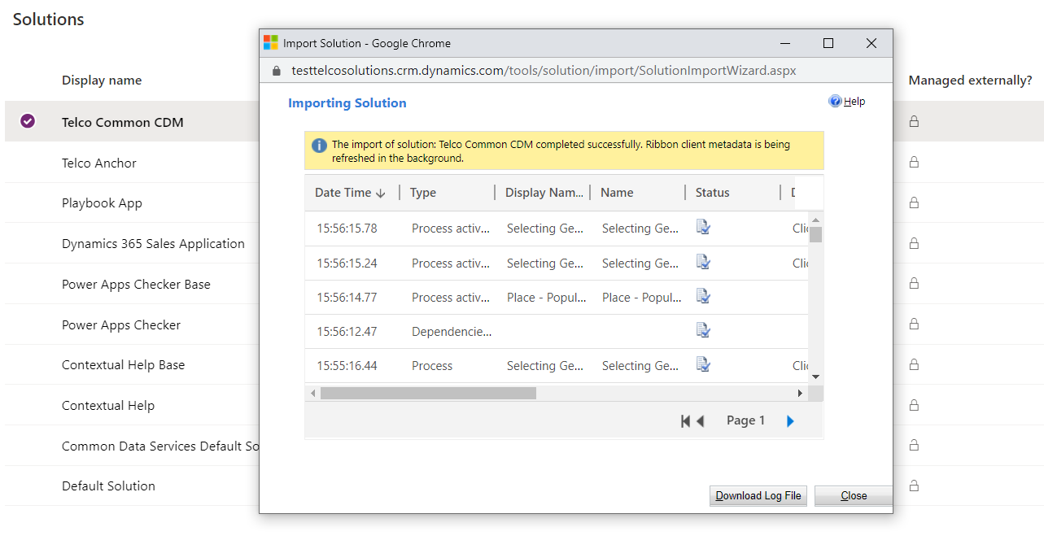

#### Telco Sales CDM Solution (TelcoSalesCDM_managed.zip)

* + - Time to complete – 1 to 3 minutes
    - Post installation message

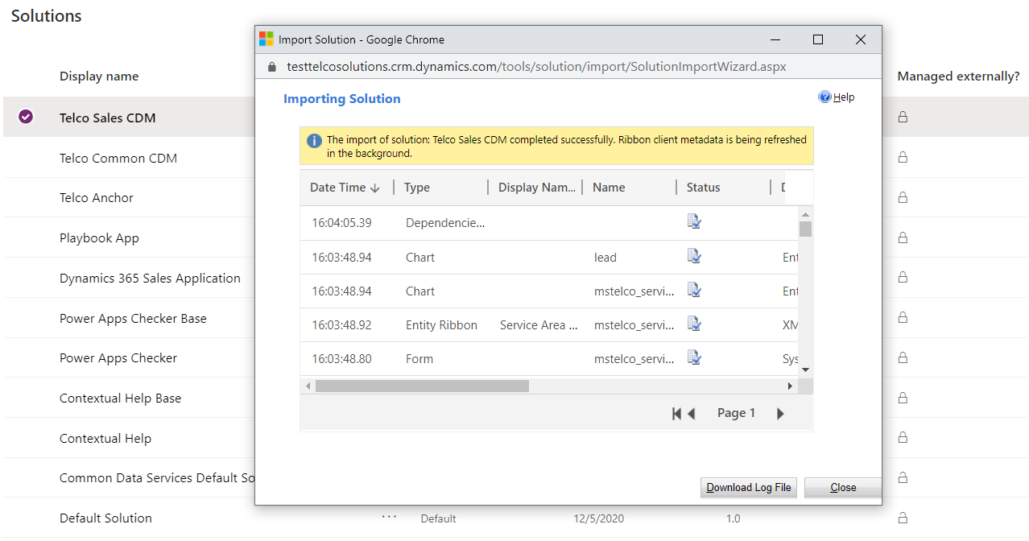

#### Telco Apps Solution (TelcoApps_managed.zip)

* + - Time to complete – 1 to 3 minutes
    - Post installation message

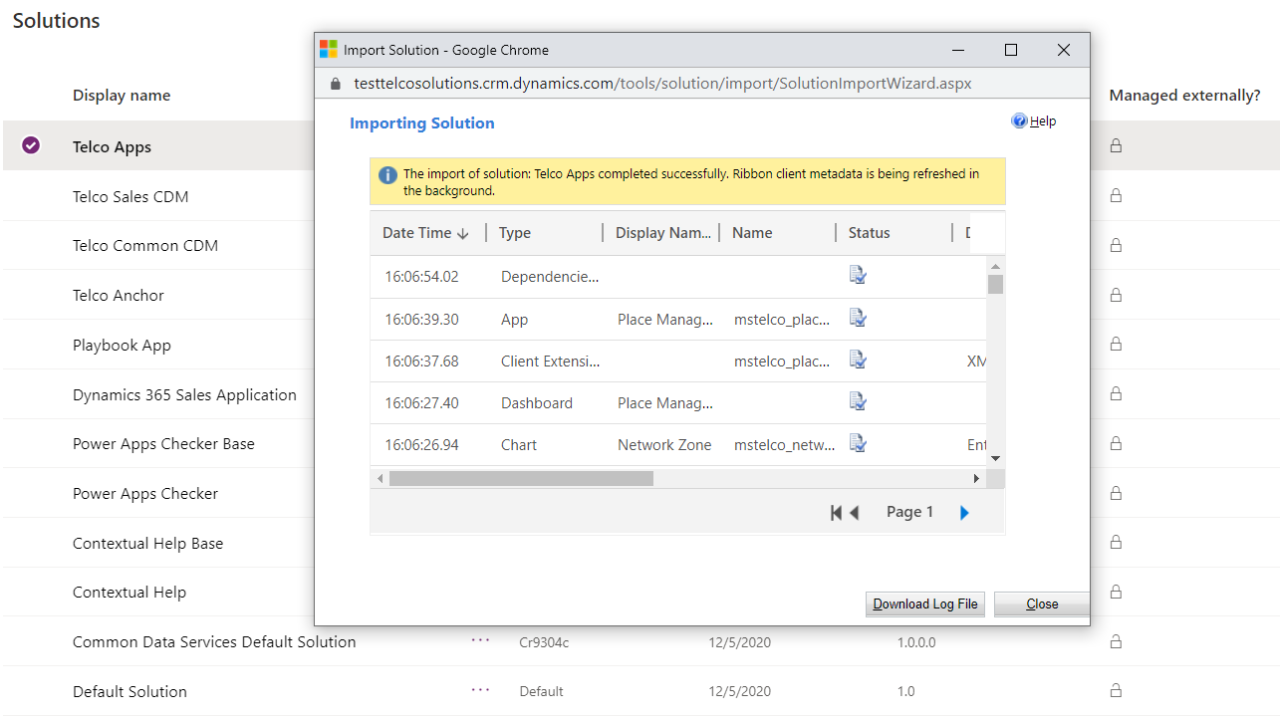

#### Telco Sales Apps Solution (TelcoSalesApps_managed.zip)

* + - Time to complete – 1 to 3 minutes
    - Post installation message

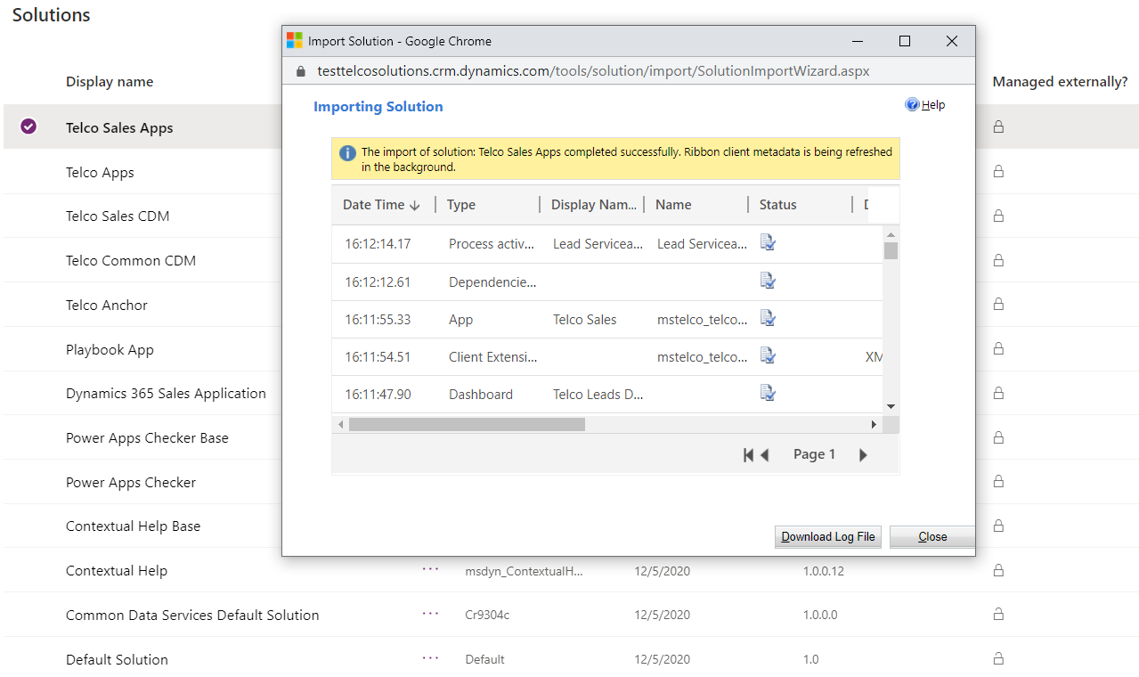

#### Import Sample Data with Configuration Migration Tool

To import sample data for Telco, follow below steps using Configuration Migration Tool

1. Open Configuration migration tool
2. Select “Import Data”
3. Connect to the org to import the data to the environment of your choice
4. Select the sample data zip file (Default_Data.zip)
5. Perform the import

Time to complete – 8 to 25 minutes

# Post Install Configuration

## Setup Azure Maps Subscription Key

* + Use Azure Portal to manage your Azure Maps account by following [these](https://docs.microsoft.com/en-us/azure/azure-maps/how-to-manage-account-keys) directions and acquire a subscription key.
  + Once the Azure Maps account is created, you will need to set the pricing tier to Standard S1 by following [these](https://docs.microsoft.com/en-us/azure/azure-maps/how-to-manage-pricing-tier) directions. (If this step is skipped, polygon visuals will not work in the telco apps)
  + Update environment variable “**mstelco_AzureMapsSubscriptionKey**” with above key
    - Go to make.powerapps.com
    - Ensure you are in the environment where you have install Telco Accelerator Solutions
    - Go to Solutions
    - Select Solution - Telco Apps
    - Select Environment Variable named “**mstelco_AzureMapsSubscriptionKey**”
    - Input the Subscription Key in the Popup and Select Save

## Share Embedded Canvas Apps

Telco Model Driven Apps uses embedded canvas apps to enhance the user experience for certain use cases. You will need to take steps to ensure that all users that have access to the model-driven form also have access to the canvas app. Please refer to the following [guidelines](https://docs.microsoft.com/en-us/powerapps/maker/model-driven-apps/share-embedded-canvas-app) to share the following canvas apps to the users –

* + - Find Geo Address
    - Lead Serviceability Check

# References

## Manually Importing Solutions

To manually import a main solution:

1. Navigate to <https://make.powerapps.com/home> > Select your Environment > Click Solutions in left-hand Navigation
2. Click Import button in ribbon
3. Click Choose File button and select managed solution zip file

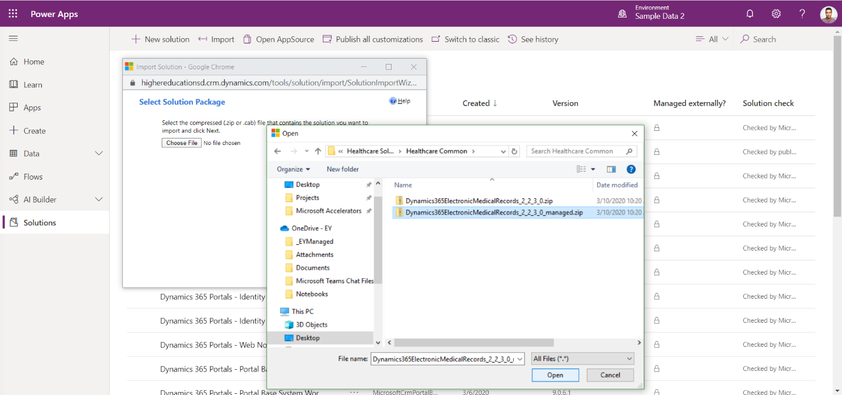

1. Click Open button
2. Click Next through all steps and then Import

**\*Note:** Some imports may take up to an hour to install

## Acquiring Configuration Migration tool

1. Navigate [here](https://docs.microsoft.com/en-us/powerapps/developer/common-data-service/download-tools-nuget) to acquire the Configuration Migration tool
2. Click the NuGet package link for the Configuration Migration Tool
3. Follow directions to download the Configuration Migration tool via Package Manager