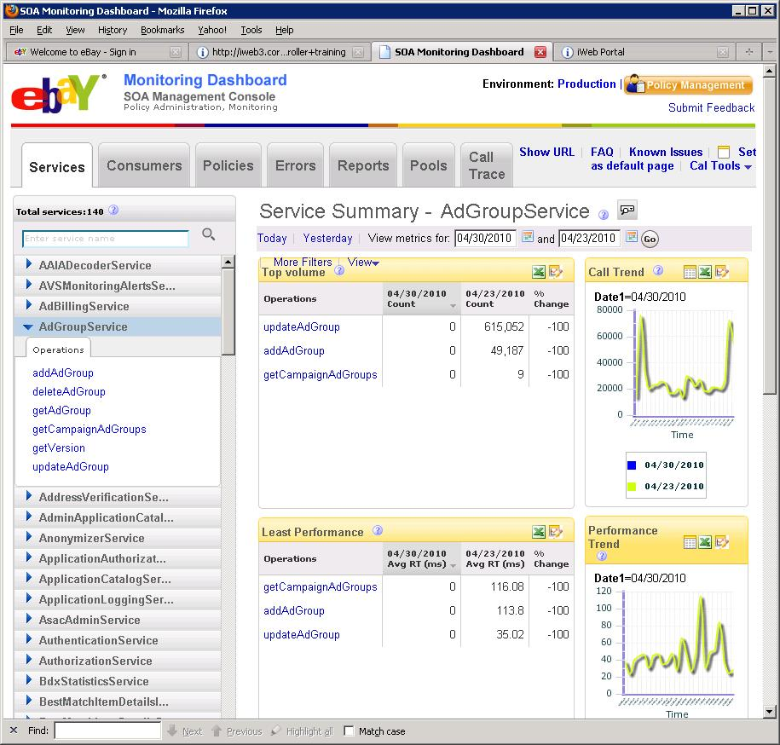

## List of Operations for the above screen shot with sample request structures.

### Top Volume/ Least Performance/Consumer Traffic– These sections display the top call count metric per operation/ Highest Response times per operation and top consumer’s call counts. All these sections can use the same operation.

Operation Name getMetricsData

1. Example request : For the Services page – say the Top Volume

|  |
| --- |
| firstStartTime=12670000 |
| secondStartTime=12456789 |
| duration=3600 |
| aggregationPeriod=1 |
| sortOrder=ascending |
| numRows=10 |
| metricName=CallCount |
| resourceEntityType=Service |
| resourceEntityName=FindingService |
| resourceEntityResponseType=Operation |

* More detailed comments for getMetricsData

|  |  |  |  |
| --- | --- | --- | --- |
| Parm Name | Mandatory(M)/Optional (O) | Data Type | comment |
| firstStartTime | M | long | UTC long in millsecs since 1970. |
| secondStartTime | M | long | UTC long in millsecs since 1970. |
| duration | M | long | The duration value is added to firstStartTime and secondStartTime to provide a range. |
| aggregationPeriod | M | int | The DB interval table to be queried. Value 1= 1H tables, Value 24= 1D tables. |
| sortOrder | O | enum(ascending/descending) | Indicates whether we want the call count data in ascending order or descending order. |
| numRows | O | long | The number of rows to be returned. |
| metricName | M | String – could be CallCount,ResponseTime,ErrorCount and ErrorToCallRatio. | CallCount for “Top Volume”. ResponseTime for “Least Performance” and CallCount again for Consumer Traffic sections. If “All” or missing –indicates all the possible metrics |
| resourceEntityType | M | enum(pool/machine/service/operation/consumer) | For the services page will be “services” |
| resourceEntityName | O | string | Would be the name of the entity for example “FindingService” |
| resourceEntityResponseType | M | enum(pool/machine/service/operation/consumer) | The entities response type, could be operation as in the services page. |
| resourceEntityResponseName | O | string | If this is missing indicates “ALL operations to be listed” |

### Service selection panel on the left

Operation Name getMetricsMetadata

1. Example request : For the Services page – This will be listing ALL the services

|  |
| --- |
| resourceEntityType=Service  resourceEntityTypeName=All |
| resourceEntityResponseType=Service |

We could be listing ALL the pools like such

|  |
| --- |
| resourceEntityType=Pool |
| resourceEntityTypeName=All |
| resourceEntityResponseType=Pool |

or we could be listing operations for a service like this

|  |
| --- |
| resourceEntityType=Service  resourceEntityTypeName=FindingService |
| resourceEntityResponseType=Operation |

### Trend Graphs on the right

Operation Name getMetricValue

1. Example request : For the Services page – say the Call trend

|  |
| --- |
| criteriaInfo.metricName=CallCount  criteriaInfo.serviceName=FindingService |
| criteriaInfo.roleType=Server  startTime= 123456  duration=86400  aggregationPeriod=1 |

# The following details map the various fields across 2 layers

1. SOAFwk Heartbeats to CAL and CAL Data populated to SOAAnalytics Data model
2. DB query mapping to service request.

## SOAFwk Heartbeats to CAL

This is a format of HB being logged to CAL.

H16:00:10.47 SOA_FW_METRIC_client SoaFwk.Time.Total 0 July 30, 2010 4:00:10 PM MST **svc=HalfCheckoutServiceV1&op=null&case=a:Cheggea1e-0 186c-430b-83e2-7dea1eef4fa&role=0&interval=1&clientDC=PHX&serverDC=Unknown&value0=100&value1=5678**

The data fields in the HB example above are all name-value pairs

For example

**svc= HalfCheckoutServiceV1** is the name of the service, the field is called svc.

**Op=null**, here the op is the operation name.

**case=a:Cheggea1e-0 186c-430b-83e2-7dea1eef4fa** , here the case is the consumer name field

**role=0,** this indicates client side logging, role=1 would be server side logging

**interval=1**, not used by CAL

**clientDC=PHX**, not used by CAL

**serverDC=Unknown**, not used by CAL

**value0=100**

**value1=5678 Both values are stats …we do a SUM of value0 and a SUM of value1 when populating into the DB.**

The other dimension like **SoaFwk.Time.Total** is the metric name field.

Here is the Data model for the table- the data is being populated in ….Please note we typically store Ids …but that involves querying other meta data tables and would complicate matters – so for simplicity’s sake I am just using names.

* FACT table (the main metrics table)

|  |  |  |  |
| --- | --- | --- | --- |
| Name |  |  | Comment |
| SOA_1H_POOL_METRIC_ID |  |  |  |
| CAL_CUBE_ID |  |  | UTC long in millsecs used as startTime or endTime – this is when the data is populated into the DB |
| SOA_SERVICE_ID |  |  | Name of the service, HalfCheckoutServiceV1 from the example above. |
| PARTITION_KEY |  |  |  |
| SOA_METRIC_ID |  |  | The metric name like “SoaFwk.Time.Total” which is composite Key with Operation and service from another metadata table. |
| SOA_USE_CASE_ID |  |  | The consumer name like “**a:Cheggea1e-0 186c-430b-83e2-7dea1eef4fa”** |
| POOL_ID |  |  | The pool name we get from the header of the log |
| ROLE_TYPE |  |  | Role=0 is the client, role=1 is the server |
| CREATION_DATE |  |  |  |
| METRIC_COMPONENT_VALUE0 |  |  | SUM of Value0 |
| METRIC_COMPONENT_VALUE1 |  |  | SUM of Value1 |

* Dim tables SOA-SERVICE

|  |  |  |  |  |
| --- | --- | --- | --- | --- |
| Name | Data Type | Default Value | Mandatory | Comment |
| SOA_SERVICE_ID | NUMBER(38) |  | X | Sequence generated Primary Key |
| SERVICE_NAME | VARCHAR2(256) |  | X | Stores Service Name using SOA. |
| CREATION_DATE | DATE |  | X | Date row was created. Standard DB server timezone (PST) |
| LAST_MODIFIED_DATE | DATE |  | X | Date row was last updated. Standard DB server timezone (PST) |

* Dim tables CAL_DIM_POOL

|  |  |  |  |  |
| --- | --- | --- | --- | --- |
| Name | Data Type | Default Value | Mandatory | Comment |
| ID | NUMBER(38,0) |  | X |  |
| NAME | VARCHAR2(256) |  | X |  |
| CREATION_DATE | DATE |  | X | Date row was created. Standard DB server timezone (PST) |
| LAST_MODIFIED_DATE | DATE |  | X | Date row was last updated. Standard DB server timezone (PST) |
| UTF8_STATUS | NUMBER(1) |  |  | A Column to indicate the UTF8 Migration status of the row. Possible value is NULL or 1. Null indicated the record has not been converted to UTF-8 and 1 indicated the record is converted. |
| IS_SECURE | NUMBER(1) |  |  | 1 = Y, 0 = N |

* Dim tables SOA_SVC_POOL

|  |  |  |  |  |
| --- | --- | --- | --- | --- |
| Name | Data Type | Default Value | Mandatory | Comment |
| SVC_POOL_ID | NUMBER (38) |  | X | Primary key. Generated by SOA_SVC_POOL_SEQ |
| SVC_ID | NUMBER (38) |  | X | Foreign service id key , coming from SOA_SERVICE table |
| POOL_ID | NUMBER (38) |  | X | Foreign pool_id key from CAL_DIM_POOL |
| CREATION_DATE | DATE | SYSDATE | X | Date row was created. Standard DB server timezone (PST) |
| LAST_MODIFIED_DATE | DATE | SYSDATE | X | Date row was last updated. Standard DB server timezone (PST) |
| ROLE_TYPE | NUMBER(1) |  |  | possible value will be 0/1, default is 1. Role_type =0 means client side service is deployed on the pool, Role_type =1 means server side service is deployed on the pool, default it should be server side service. |

* Dim tables SOA_USECASE

|  |  |  |  |  |
| --- | --- | --- | --- | --- |
| Name | Data Type | Default Value | Mandatory | Comment |
| SOA_USECASE_ID | NUMBER(38) |  | X | Sequence generated PK for the table. |
| USECASE_NAME | VARCHAR2(128) |  | X | The usecase name. The name is unique. |
| DESCRIPTION | VARCHAR2(512) |  |  | A detail description of the usecase. |
| CREATION_DATE | DATE | SYSDATE | X | Date row was created. Standard DB server timezone (PST) |
| LAST_MODIFIED_DATE | DATE |  | X | Date row was last updated. Standard DB server timezone (PST) |

* Dim tables SOA_METRIC

|  |  |  |  |  |
| --- | --- | --- | --- | --- |
| Name | Data Type | Default Value | Mandatory | Comment |
| SOA_METRIC_ID | NUMBER(38) |  | X | The primary key generated by sequence SOA_METRIC_SEQ |
| METRIC_NAME | VARCHAR2(256) |  | X | String to identify the metric collected like “SoaFwk.Time.Total” and “SoaFwk.Err.Total” |
| SERVICE_NAME | VARCHAR2(256) |  | X | FK to soa_service to identify whiich service the metric is collected |
| OPERATION_NAME | VARCHAR2(256) |  | X | Name of operation within the service that is being measured  getUser, getItem, getFee |
| CREATION_DATE | DATE |  | X | Date row was created. Standard DB server timezone (PST) |
| LAST_MODIFIED_DATE | DATE |  | X | Date row was last updated. Standard DB server timezone (PST) |

* Dim tables SOA_SVC_USECASE

|  |  |  |  |  |
| --- | --- | --- | --- | --- |
| Name | Data Type | Default Value | Mandatory | Comment |
| SVC_USECASE_ID | NUMBER(38,0) |  | X | Generated by SOA_SVC_USECASE_SEQ. |
| SVC_ID | NUMBER(38,0) |  | X | Foreign service id key , coming from SOA_SERVICE table |
| USECASE_ID | NUMBER(38,0) |  | X | Foreign pool_id key from SOA_USE_CASE |
| CREATION_DATE | DATE | SYSDATE | X | Date row was created. Standard DB server timezone (PST) |
| LAST_MODIFIED_DATE | DATE | SYSDATE | X | Date row was last updated. Standard DB server timezone (PST) |

## Service Request – DB – Service Response Mapping

1. **getMetricMetadata**

GetMetricsMetadataRequest contains three input parameters. They are resourceEntityType, resourceEntityName, and resourceEntityResponseType. The resourceEntityType specifies the entity type of the input dimension. It can be service, pool, consumer etc. The resourceEntityName is a list of strings that contain the names of input dimension. The resourceEntityResponseType specifies the entity type of the output dimension. The output dimension can be service, pool, consumer etc. This operation is used to retrieve the names of output dimensions provided the names of input dimension as the input. This operation is also used to retrieve the list of all names of a dimension. Lets see service-pool mapping first and then will see service-consumer (use case) mapping.

Service-Pool Mapping:

The service information is available in the table SOA-SERVICE table. The pool information is available in CAL_DIM_POOL table. SOA_SVC_POOL is the mapping table for service-pool mapping. For service-pool mapping, request will be

resourceEntityType – ResourceEntity.SERVICE

resourceEntityName – list of service names like FindingService, AdGroupService etc. These service names should have an entry in SOA_SERVICE table.

resourceEntityResponseType – ResourceEntity.POOL

For the input service names, the corresponding service ids will be fetched from SOA_SERVICE table. For those service ids, the mapping pool ids will be fetched from SOA_SVC_POOL table. For those pool ids, the corresponding pool names will be fetched from CAL_DIM_POOL table. The list of all pool names will be sent as the response. The response GetMetricMetadataResponse has the following structure.

resourceEntityResponseNames – list of pool names.

Service-Consumer Mapping:

The service information is available in the table SOA-SERVICE table. The consumer (use case) information is available in SOA_USECASE table. SOA_SVC_USECASE is the mapping table for service-consumer mapping. For service-consumer mapping, request will be

resourceEntityType – ResourceEntity.SERVICE

resourceEntityName – list of service names like FindingService, AdGroupService etc. These service names should have an entry in SOA_SERVICE table.

resourceEntityResponseType – ResourceEntity.CONSUMER

For the input service names, the corresponding service ids will be fetched from SOA_SERVICE table. For those service ids, the mapping consumer ids will be fetched from SOA_SVC_USECASE table. For those consumer ids, the corresponding consumer names will be fetched from SOA_USECASE table. The list of all consumer names will be sent as the response. The response GetMetricMetadataResponse has the following structure.

resourceEntityResponseNames – list of consumer names.

Other than mapping, the same operation getMetricsMetadata operation can be used for retrieving the list of all names of a particular dimension. For example, to retrieve the list of service names, the request structure will be

resourceEntityType – ResourceEntity.SERVICE

resourceEntityName – to be null or empty.

resourceEntityResponseType – to be null or empty.

The list of all service names will be fetched from SOA_SERVICE table. The response structure will be

resourceEntityResponseNames – list of service names.

Similarly, the pool names are to be fetched from CAL_DIM_POOL table and the consumer names are to be fetched from SOA_USECASE table.

1. **getMetricData**
2. **getMetricValue**