卷 号 | 4
卷内编号 | 4.1
密 级 | 机密

项目编号: Error: Reference source not found
eboy电子商务系统
分 类:  文档 | Error: Reference source not found  Version:  项 目 承 担 部 门：eboy项目组  撰 写 人（签名）： 蔡通达  完 成 日 期：7月11日  本文档 使 用部门：□主管领导 ■项目组  □客户（市场） ■维护人员 □用户  评审负责人（签名）：王家雷  评 审 日 期：7月12日

目 录
1. 引言 1
1.1 编写目的 1
1.2 背景 1
1.3 定义 1
1.4 参考资料 1
2. 外部设计 1
2.1 类型划分 1
2.2 标识符和约定 1
2.3 数据库表设计格式说明 1
2.3.1 eboy_address 2
2.3.2 eboy_admin 2
2.3.3 eboy_car 3
2.3.4 eboy_comment 3
2.3.5 eboy_delivery 4
2.3.6 eboy_Item 4
2.3.7 eboy_order 5
2.3.8 eboy_picture 7
2.3.9 eboy_user 7
2.3.10 eboy_wish 8
2.4 支持软件 16
3. 结构设计 16
4. 运用设计 17
4.1 数据字典设计 17
4.2 安全保密设计 17

引言

编写目的
本文档旨在详细描述eboy电子商务系统中的数据库结构与设计。本文的读者可为系统的开发者以及系统的维护人员。

背景
待开发的数据库的名称：eboy
使用此数据库的软件系统的名称：eboy电子商务系统
该软件系统开发项目的任务提出者：ebay立项人
该软件系统的用户：在ebay网站上购买商品不方便的中国顾客。

定义
请见术语表

参考资料
Google api
Ebay api
Youdao api
Global Items for Local Market.doc
详细设计说明书

外部设计

类型划分
- 主表
  - eboy_admin
  - eboy_cart
  - eboy_comment
  - eboy_item
  - eboy_user
  - eboy_wish
- 辅助表
  - eboy_address
  - eboy_delivery
  - eboy_order
  - eboy_picture

标识符和约定
数据库表名：eboy_实体类名称
数据库中表内属性名：表名_属性名称
数据库中表内外键属性名：维持原来的名字

数据库表设计格式说明
V0.5

eboy_address
<hibernate-mapping>
<class name="com.eboy.entity.Address" table="eboy_address"
catalog="eboy">

<id name="address_id" type="java.lang.Integer">
<column name="address_id" />
<generator class="identity" />
</id>

<property name="user_id" type="java.lang.Integer">
<column name="user_id" />
</property>

<property name="address_detail" type="java.lang.String">
<column name="address_detail" length="45" />
</property>

<property name="address_zipcode" type="java.lang.String">
<column name="address_zipcode" length="45" />
</property>

</class>
</hibernate-mapping>

eboy_admin
<hibernate-mapping>
<class name="com.eboy.entity.Admin" table="eboy_admin"
catalog="eboy">

<id name="admin_id" type="java.lang.Integer">
<column name="admin_id" />
<generator class="identity" />
</id>

<property name="admin_name" type="java.lang.String">
<column name="admin_name" length="45" />
</property>

<property name="admin_password" type="java.lang.String">
<column name="admin_password" length="45" />
</property>

</class>
</hibernate-mapping>

eboy_car
<hibernate-mapping>
<class name="com.eboy.entity.Cart" table="eboy_cart"
catalog="eboy">

<id name="cart_id" type="java.lang.Integer">
<column name="cart_id" />
<generator class="identity" />
</id>

<property name="user_id" type="java.lang.Integer">
<column name="user_id" />
</property>

<property name="item_id" type="java.lang.Integer">
<column name="item_id" />
</property>

<property name="cart_quantity" type="java.lang.Integer">
<column name="cart_quantity" />
</property>
</class>
</hibernate-mapping>

eboy_comment
<hibernate-mapping>
<class name="com.eboy.entity.Comment" table="eboy_comment"
catalog="eboy">

<id name="comment_id" type="java.lang.Integer">
<column name="comment_id" />
<generator class="identity" />
</id>

<property name="user_id" type="java.lang.Integer">
<column name="user_id" />
</property>

<property name="item_id" type="java.lang.Integer">
<column name="item_id" />
</property>

<property name="comment_rank" type="java.lang.Integer">
<column name="comment_rank" />
</property>

<property name="comment_content" type="java.lang.String">
<column name="comment_content" length="1024" />
</property>

</class>
</hibernate-mapping>

eboy_delivery
<hibernate-mapping>
<class name="com.eboy.entity.Delivery" table="eboy_delivery"
catalog="eboy">

<id name="delivery_id" type="java.lang.Integer">
<column name="delivery_id" />
<generator class="identity" />
</id>

<property name="order_id" type="java.lang.Integer">
<column name="order_id" />
</property>

<property name="delivery_current_position" type="java.lang.String">
<column name="delivery_current_position" length="256" />
</property>

</class>
</hibernate-mapping>

eboy_Item
<hibernate-mapping>
<class name="com.eboy.entity.Item" table="eboy_item"
catalog="eboy">

<id name="item_id" type="java.lang.Integer">
<column name="item_id"/>
<generator class="identity" />
</id>

<property name="item_ebay_id" type="java.lang.String">
<column name="item_ebay_id" length="45" />
</property>

<property name="item_product_id" type="java.lang.String">
<column name="item_product_id" length="45" />
</property>

<property name="item_current_price" type="java.lang.Double">
<column name="item_current_price" />
</property>

<property name="item_title" type="java.lang.String">
<column name="item_title" length="128" />
</property>

<property name="item_gallery_url" type="java.lang.String">
<column name="item_gallery_url" length="256" />
</property>

<property name="item_score" type="java.lang.Double">
<column name="item_score" />
</property>

<property name="item_description" type="java.lang.String">
<column name="item_description" length="16384" />
</property>

<property name="item_count" type="java.lang.Integer">
<column name="item_count" />
</property>

<property name="item_catagory" type="java.lang.String">
<column name="item_catagory" length="45" />
</property>

<property name="item_start_time" type="java.sql.Timestamp">
<column name="item_start_time"/>
</property>

<property name="item_end_time" type="java.sql.Timestamp">
<column name="item_end_time"/>
</property>

</class>
</hibernate-mapping>

eboy_order
<hibernate-mapping>
<class name="com.eboy.entity.Order" table="eboy_order"
catalog="eboy">

<id name="order_id" type="java.lang.Integer">
<column name="order_id" />
<generator class="identity" />
</id>

<property name="item_id" type="java.lang.Integer">
<column name="item_id" />
</property>

<property name="user_id" type="java.lang.Integer">
<column name="user_id" />
</property>

<property name="order_state" type="java.lang.String">
<column name="order_state" length="45" />
</property>

<property name="order_datetime" type="java.sql.Timestamp">
<column name="order_datetime" />
</property>

<property name="order_address" type="java.lang.String">
<column name="order_address" length="90"/>
</property>

<property name="order_item_quantity" type="java.lang.Integer">
<column name="order_item_quantity" />
</property>

<property name="order_phone" type="java.lang.String">
<column name="order_phone" />
</property>

<property name="order_price" type="java.lang.Double">
<column name="order_price" />
</property>

<property name="order_receiver" type="java.lang.String">
<column name="order_receiver" />
</property>

</class>
</hibernate-mapping>

eboy_picture
<hibernate-mapping>
<class name="com.eboy.entity.Picture" table="eboy_picture"
catalog="eboy">

<id name="picture_id" type="java.lang.Integer">
<column name="picture_id" />
<generator class="identity" />
</id>

<property name="item_id" type="java.lang.Integer">
<column name="item_id" />
</property>

<property name="picture_url" type="java.lang.String">
<column name="picture_url" length="256" />
</property>

</class>
</hibernate-mapping>

eboy_user
<hibernate-mapping>
<class name="com.eboy.entity.User" table="eboy_user"
catalog="eboy">

<id name="user_id" type="java.lang.Integer">
<column name="user_id" />
<generator class="identity" />
</id>

<property name="user_referrer_id" type="java.lang.Integer">
<column name="user_referrer_id" />
</property>

<property name="user_password" type="java.lang.String">
<column name="user_password" length="45" />
</property>

<property name="user_name" type="java.lang.String">
<column name="user_name" length="45" />
</property>

<property name="user_email" type="java.lang.String">
<column name="user_email" length="90" />
</property>

<property name="user_phone" type="java.lang.String">
<column name="user_phone" length="45" />
</property>

<property name="user_gender" type="java.lang.String">
<column name="user_gender" length="45" />
</property>

<property name="user_birthday" type="java.sql.Date">
<column name="user_birthday" />
</property>

<property name="user_coupon" type="java.lang.Integer">
<column name="user_coupon" />
</property>

</class>
</hibernate-mapping>

eboy_wish
<hibernate-mapping>
<class name="com.eboy.entity.Wish" table="eboy_wish"
catalog="eboy">

<id name="wish_id" type="java.lang.Integer">
<column name="wish_id" />
<generator class="identity" />
</id>

<property name="user_id" type="java.lang.Integer">
<column name="user_id" />
</property>

<property name="item_id" type="java.lang.Integer">
<column name="item_id" />
</property>

<property name="wish_quantity" type="java.lang.Integer">
<column name="wish_quantity" />
</property>

</class>
</hibernate-mapping>

V1.0
Category
<?xml version="1.0"?>
<!DOCTYPE hibernate-mapping PUBLIC "-//Hibernate/Hibernate Mapping DTD 3.0//EN"
"http://hibernate.sourceforge.net/hibernate-mapping-3.0.dtd">
<!-- Generated 2013-9-9 16:00:41 by Hibernate Tools 3.2.1.GA -->
<hibernate-mapping>
<class name="com.eboy.po.Category" table="Category" catalog="Eboy">
<id name="categoryId" type="java.lang.Integer">
<column name="categoryID" />
<generator class="identity" />
</id>
<property name="categoryName" type="string">
<column name="categoryName" not-null="true" />
</property>
<set name="items" inverse="true" lazy="false">
<key>
<column name="categoryID" not-null="true"/>
</key>
<one-to-many class="com.eboy.po.Item" />
</set>
</class>
</hibernate-mapping>

Comment
<?xml version="1.0"?>
<!DOCTYPE hibernate-mapping PUBLIC "-//Hibernate/Hibernate Mapping DTD 3.0//EN"
"http://hibernate.sourceforge.net/hibernate-mapping-3.0.dtd">
<!-- Generated 2013-9-9 16:00:41 by Hibernate Tools 3.2.1.GA -->
<hibernate-mapping>
<class name="com.eboy.po.Comment" table="Comment" catalog="Eboy">
<id name="commentId" type="java.lang.Integer">
<column name="commentID" />
<generator class="identity" />
</id>
<many-to-one name="item" class="com.eboy.po.Item" fetch="select" lazy="false">
<column name="itemID" not-null="true" />
</many-to-one>
<property name="commentUserName" type="string">
<column name="commentUserName" />
</property>
<property name="commentContent" type="string">
<column name="commentContent" not-null="true" />
</property>
<property name="commentRate" type="double">
<column name="commentRate" precision="22" scale="0" not-null="true" />
</property>
<property name="commentTime" type="timestamp">
<column name="commentTime" length="19" not-null="true" />
</property>
</class>
</hibernate-mapping>

Delivery
<?xml version="1.0"?>
<!DOCTYPE hibernate-mapping PUBLIC "-//Hibernate/Hibernate Mapping DTD 3.0//EN"
"http://hibernate.sourceforge.net/hibernate-mapping-3.0.dtd">
<!-- Generated 2013-9-9 16:00:41 by Hibernate Tools 3.2.1.GA -->
<hibernate-mapping>
<class name="com.eboy.po.Delivery" table="Delivery" catalog="Eboy">
<id name="deliveryId" type="java.lang.Integer">
<column name="deliveryID" />
<generator class="identity" />
</id>
<many-to-one name="order" class="com.eboy.po.Order" fetch="select">
<column name="orderID" not-null="true" />
</many-to-one>
<property name="deliveryLocation" type="string">
<column name="deliveryLocation" not-null="true" />
</property>
<property name="deliveryRemark" type="string">
<column name="deliveryRemark" />
</property>
<property name="deliveryTime" type="timestamp">
<column name="deliveryTime" length="19" not-null="true" />
</property>
</class>
</hibernate-mapping>

Gallery
<?xml version="1.0"?>
<!DOCTYPE hibernate-mapping PUBLIC "-//Hibernate/Hibernate Mapping DTD 3.0//EN"
"http://hibernate.sourceforge.net/hibernate-mapping-3.0.dtd">
<!-- Generated 2013-9-9 16:00:41 by Hibernate Tools 3.2.1.GA -->
<hibernate-mapping>
<class name="com.eboy.po.Gallery" table="Gallery" catalog="Eboy">
<id name="galleryId" type="java.lang.Integer">
<column name="galleryID" />
<generator class="identity" />
</id>
<many-to-one name="item" class="com.eboy.po.Item" fetch="select">
<column name="itemID" not-null="true" />
</many-to-one>
<property name="galleryUrl" type="string">
<column name="galleryURL" not-null="true" />
</property>
</class>
</hibernate-mapping>

Item
<?xml version="1.0"?>
<!DOCTYPE hibernate-mapping PUBLIC "-//Hibernate/Hibernate Mapping DTD 3.0//EN"
"http://hibernate.sourceforge.net/hibernate-mapping-3.0.dtd">
<!-- Generated 2013-9-9 16:00:41 by Hibernate Tools 3.2.1.GA -->
<hibernate-mapping>
<class name="com.eboy.po.Item" table="Item" catalog="Eboy">
<id name="itemId" type="java.lang.Integer">
<column name="itemID" />
<generator class="identity" />
</id>
<many-to-one name="category" class="com.eboy.po.Category" fetch="select">
<column name="categoryID" not-null="true" />
</many-to-one>
<property name="itemEbayId" type="string">
<column name="itemEbayID" length="30" not-null="true" />
</property>
<property name="itemTitle" type="string">
<column name="itemTitle" not-null="true" />
</property>
<property name="itemDescription" type="binary">
<column name="itemDescription" not-null="true" />
</property>
<property name="itemQuantity" type="int">
<column name="itemQuantity" not-null="true" />
</property>
<property name="itemSortScore" type="double">
<column name="itemSortScore" precision="22" scale="0" not-null="true" />
</property>
<property name="itemDiscount" type="double">
<column name="itemDiscount" precision="22" scale="0" not-null="true" />
</property>
<property name="itemThumbnailImageUrl" type="string">
<column name="itemThumbnailImageURL" not-null="true" />
</property>
<property name="itemSandboxId" type="string">
<column name="itemSandboxID" length="30" not-null="true" />
</property>
<property name="itemPrice" type="double">
<column name="itemPrice" precision="22" scale="0" not-null="true" />
</property>
<property name="itemPriceCurrency" type="string">
<column name="itemPriceCurrency" length="10" not-null="true" />
</property>
<property name="itemPackageCost" type="java.lang.Double">
<column name="itemPackageCost" precision="22" scale="0" />
</property>
<property name="itemPackageCostCurrency" type="string">
<column name="itemPackageCostCurrency" length="10" />
</property>
<property name="itemImportCost" type="java.lang.Double">
<column name="itemImportCost" precision="22" scale="0" />
</property>
<property name="itemImportCostCurrency" type="string">
<column name="itemImportCostCurrency" length="10" />
</property>
<property name="itemShippingCost" type="java.lang.Double">
<column name="itemShippingCost" precision="22" scale="0" />
</property>
<property name="itemShippingCostCurrency" type="string">
<column name="itemShippingCostCurrency" length="10" />
</property>
<property name="itemInsuranceCost" type="java.lang.Double">
<column name="itemInsuranceCost" precision="22" scale="0" />
</property>
<property name="itemInsuranceCostCurrency" type="string">
<column name="itemInsuranceCostCurrency" length="10" />
</property>
<property name="itemTaxCost" type="java.lang.Double">
<column name="itemTaxCost" precision="22" scale="0" />
</property>
<property name="itemTaxCostCurrency" type="string">
<column name="itemTaxCostCurrency" length="10" />
</property>
<property name="itemSoldQuantity" type="int">
<column name="itemSoldQuantity" not-null="true" />
</property>
<set name="comments" inverse="true" lazy="false">
<key>
<column name="itemID" not-null="true" />
</key>
<one-to-many class="com.eboy.po.Comment" />
</set>
<set name="orders" inverse="true" lazy="false">
<key>
<column name="itemID" not-null="true" />
</key>
<one-to-many class="com.eboy.po.Order" />
</set>
<set name="itemTags" inverse="true" lazy="false">
<key>
<column name="itemID" not-null="true" />
</key>
<one-to-many class="com.eboy.po.ItemTag" />
</set>
<set name="galleries" inverse="true">
<key>
<column name="itemID" not-null="true" />
</key>
<one-to-many class="com.eboy.po.Gallery" />
</set>
</class>
</hibernate-mapping>

ItemTag
<?xml version="1.0"?>
<!DOCTYPE hibernate-mapping PUBLIC "-//Hibernate/Hibernate Mapping DTD 3.0//EN"
"http://hibernate.sourceforge.net/hibernate-mapping-3.0.dtd">
<!-- Generated 2013-9-9 16:00:41 by Hibernate Tools 3.2.1.GA -->
<hibernate-mapping>
<class name="com.eboy.po.ItemTag" table="ItemTag" catalog="Eboy">
<id name="itemTagId" type="java.lang.Integer">
<column name="itemTagID" />
<generator class="identity" />
</id>
<many-to-one name="tag" class="com.eboy.po.Tag" fetch="select" lazy="false">
<column name="tagID" not-null="true" />
</many-to-one>
<many-to-one name="item" class="com.eboy.po.Item" fetch="select" lazy="false">
<column name="itemID" not-null="true" />
</many-to-one>
</class>
</hibernate-mapping>

Order
<?xml version="1.0"?>
<!DOCTYPE hibernate-mapping PUBLIC "-//Hibernate/Hibernate Mapping DTD 3.0//EN"
"http://hibernate.sourceforge.net/hibernate-mapping-3.0.dtd">
<!-- Generated 2013-9-9 16:00:41 by Hibernate Tools 3.2.1.GA -->
<hibernate-mapping>
<class name="com.eboy.po.Order" table="Order" catalog="Eboy">
<id name="orderId" type="java.lang.Integer">
<column name="orderID" />
<generator class="identity" />
</id>
<many-to-one name="item" class="com.eboy.po.Item" fetch="select" lazy="false">
<column name="itemID" not-null="true" />
</many-to-one>
<property name="orderQuantity" type="int">
<column name="orderQuantity" not-null="true" />
</property>
<property name="orderValidate" type="string">
<column name="orderValidate" length="10" not-null="true" />
</property>
<property name="orderPrice" type="double">
<column name="orderPrice" precision="22" scale="0" not-null="true" />
</property>
<property name="orderAddress" type="string">
<column name="orderAddress" not-null="true" />
</property>
<property name="orderStatus" type="string">
<column name="orderStatus" length="64" not-null="true" />
</property>
<property name="orderPhone" type="string">
<column name="orderPhone" length="32" not-null="true" />
</property>
<property name="orderReceiver" type="string">
<column name="orderReceiver" not-null="true" />
</property>
<property name="orderEmail" type="string">
<column name="orderEmail" not-null="true" />
</property>
<set name="deliveries" inverse="true">
<key>
<column name="orderID" not-null="true" />
</key>
<one-to-many class="com.eboy.po.Delivery" />
</set>
</class>
</hibernate-mapping>

Statisics
<?xml version="1.0"?>
<!DOCTYPE hibernate-mapping PUBLIC "-//Hibernate/Hibernate Mapping DTD 3.0//EN"
"http://hibernate.sourceforge.net/hibernate-mapping-3.0.dtd">
<!-- Generated 2013-9-9 16:00:41 by Hibernate Tools 3.2.1.GA -->
<hibernate-mapping>
<class name="com.eboy.po.Statistics" table="Statistics" catalog="Eboy">
<id name="statisticsId" type="java.lang.Integer">
<column name="statisticsID" />
<generator class="identity" />
</id>
<property name="statisticsMoney" type="double">
<column name="statisticsMoney" precision="22" scale="0" not-null="true" />
</property>
<property name="statisticsTime" type="date">
<column name="statisticsTime" length="10" not-null="true" />
</property>
</class>
</hibernate-mapping>

Tag
<?xml version="1.0"?>
<!DOCTYPE hibernate-mapping PUBLIC "-//Hibernate/Hibernate Mapping DTD 3.0//EN"
"http://hibernate.sourceforge.net/hibernate-mapping-3.0.dtd">
<!-- Generated 2013-9-9 16:00:41 by Hibernate Tools 3.2.1.GA -->
<hibernate-mapping>
<class name="com.eboy.po.Tag" table="Tag" catalog="Eboy">
<id name="tagId" type="java.lang.Integer">
<column name="tagID" />
<generator class="identity" />
</id>
<property name="tagWord" type="string">
<column name="tagWord" not-null="true" />
</property>
<set name="itemTags" inverse="true" lazy="false">
<key>
<column name="tagID" not-null="true" />
</key>
<one-to-many class="com.eboy.po.ItemTag" />
</set>
</class>
</hibernate-mapping>

支持软件
MySQL Server 5.5
- 结构设计
eboy概念数据模型cdm
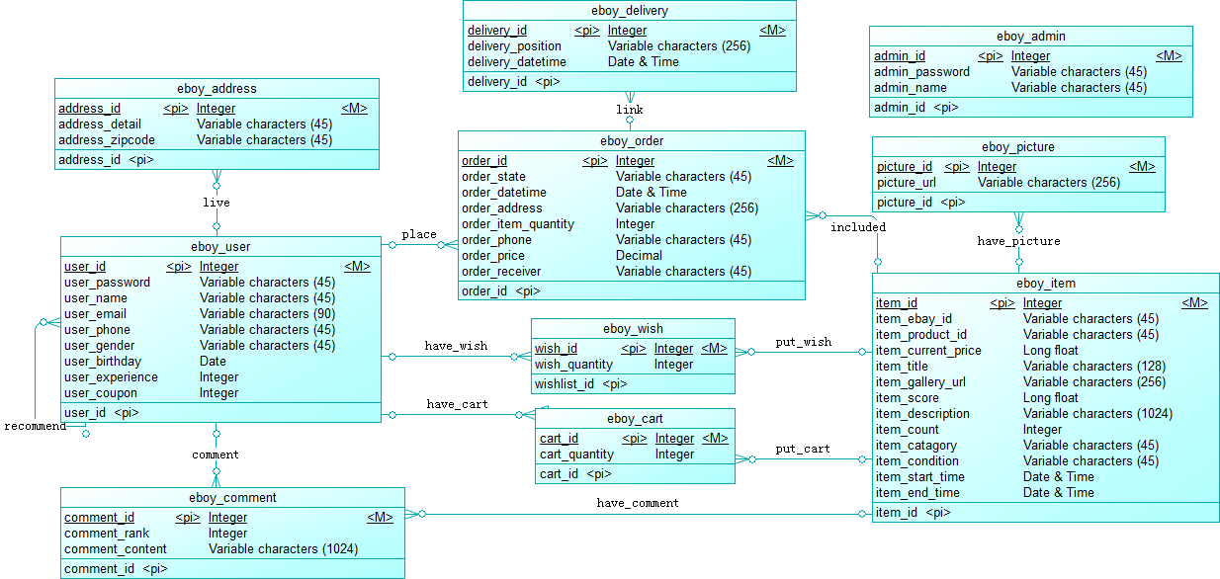
eboy物理数据模型pdm
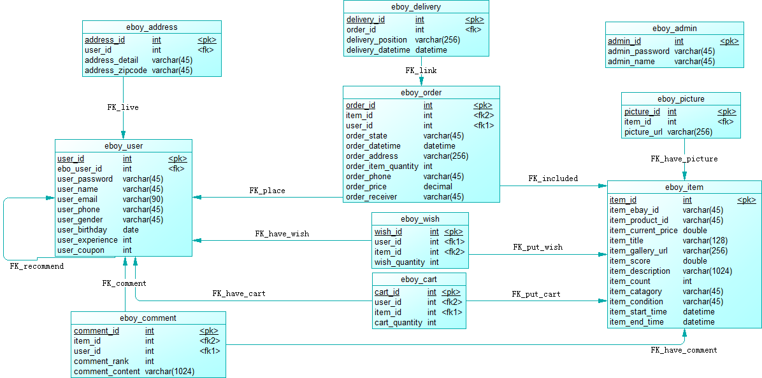

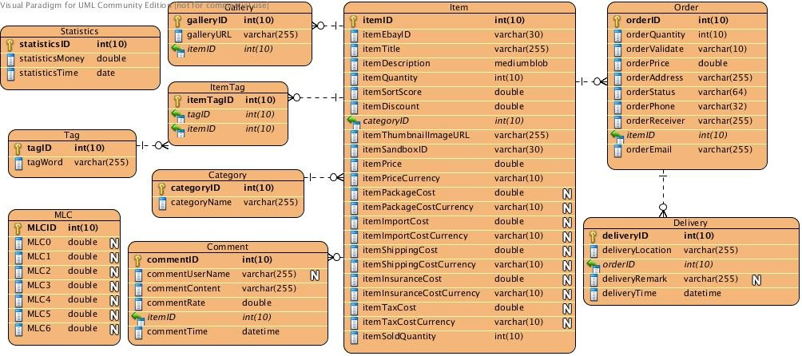
- 运用设计

数据字典设计
详见2.3

安全保密设计
管理员对数据库中的所有内容拥有增删改查的权限
普通用户对
表名 | 增 | 删 | 改 | 查
eboy_address | * | * | * | *
eboy_admin
eboy_cart | * | * | * | *
eboy_comment | * | * |  | *
eboy_delivery |  |  |  | *
eboy_item |  |  |  | *
eboy_order |  |  |  | *
eboy_picture |  |  |  | *
eboy_user | * |  | * | *
eboy_wish | * | * | * | *

