Lr=0.001, batch size=4, epoch=100, subset=inview
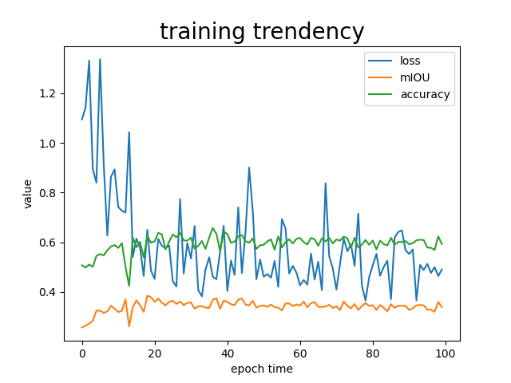
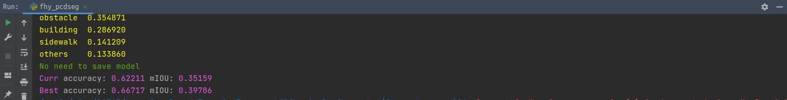

Lr=0.001, batch size=8, epoch=100, subset=inview
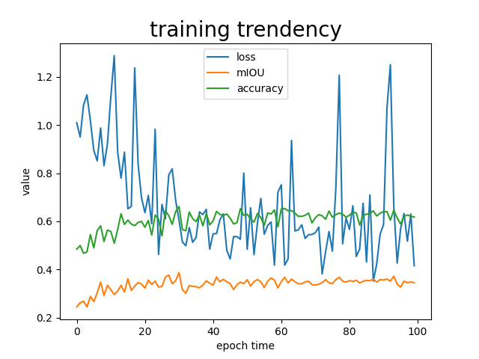
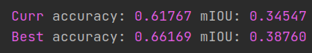

Lr=0.001, batch size=16, epoch=100, subset=inview
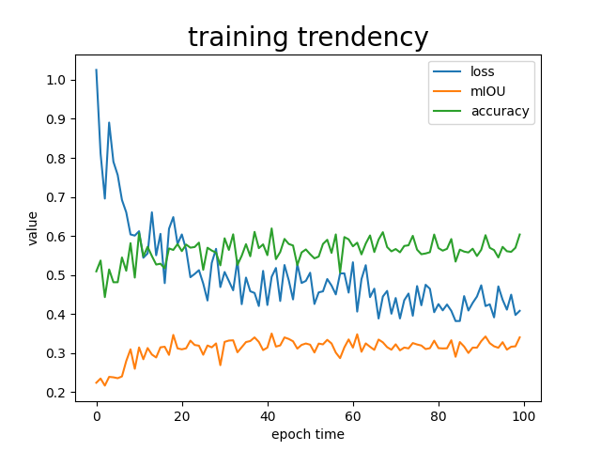
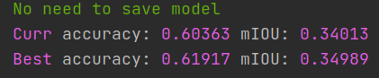

Lr=0.001, batch size=32, epoch=100, subset=inview
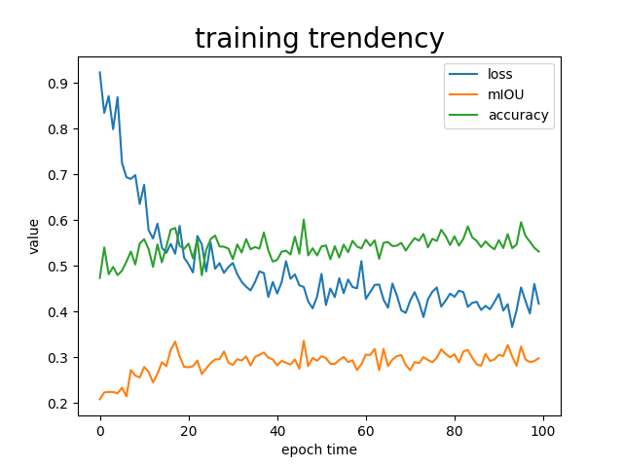
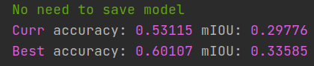

Lr=0.001, batch size=64, epoch=100, subset=inview
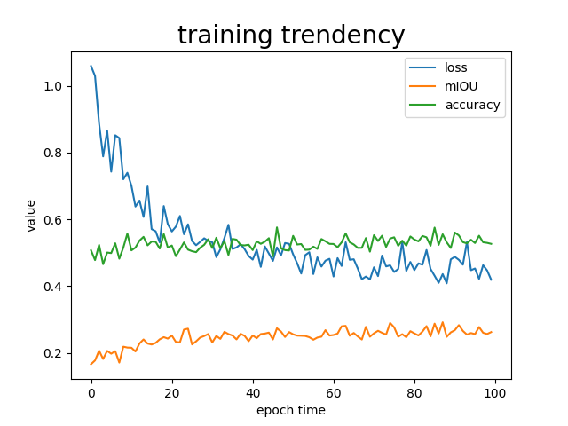
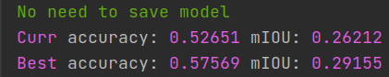

Lr=0.01, batch size=8, epoch=100, subset=inview
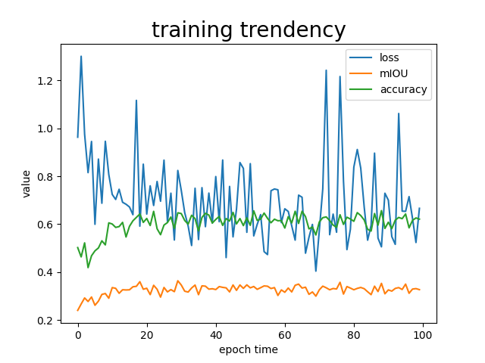
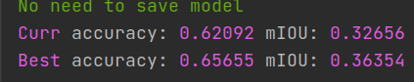

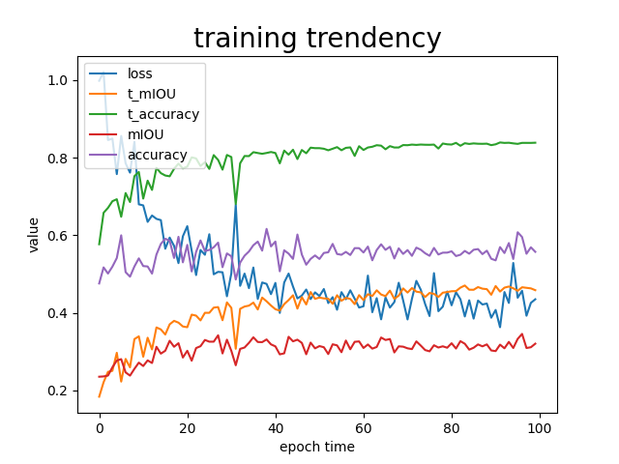

全部数据

