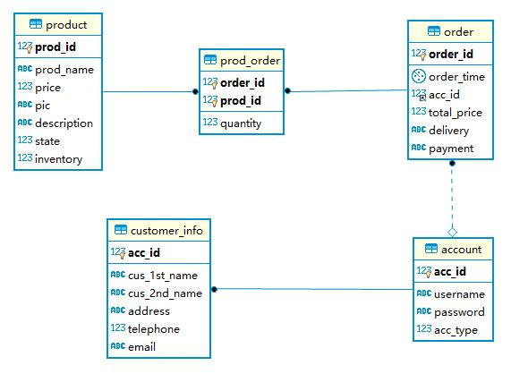**Schema:**

**ER**

**Account:**

|  |  |  |  |  |  |
| --- | --- | --- | --- | --- | --- |
| **Column** | **Type** | **Not null** | **Key** | **Auto increment** | **Column explanation** |
| acc_id | varchar | True | PRI | True | **Account ID** |
| acc_type | varchar | True | \ | \ | **Account Type** |
| password | tinyint | True | \ | \ | **Password** |
| username | int | True | \ | \ | **Username** |

**customer_info**

|  |  |  |  |  |  |
| --- | --- | --- | --- | --- | --- |
| **Column** | **Type** | **Not null** | **Key** | **Auto increment** | **Column explanation** |
| acc_id | int | True | PRI | True | **Account ID** |
| cus_1st_name | varchar | True | \ | \ | **Customer’s 1st name** |
| cus_2nd_name | varchar | True | \ | \ | **Customer’s 2nd name** |
| address | varchar | True | \ | \ | **Address** |
| telephone | Int | True | \ | \ | **Telephone** |
| email | varchar | True | \ | \ | **Email** |

**order**

|  |  |  |  |  |  |
| --- | --- | --- | --- | --- | --- |
| **Column** | **Type** | **Not null** | **Key** | **Auto increment** | **Column explanation** |
| acc_id | int | True | MUL | \ | **Account ID** |
| delivery | varchar | True | \ | \ | **Delivery Method** |
| order_id | int | True | PRI | True | **Order ID** |
| order_time | date | True | \ | \ | **Order time** |
| payment | varchar | True | \ | \ | **Payment Method** |
| total_price | int | True | \ | \ | **Total price** |

**prod_order**

|  |  |  |  |  |  |
| --- | --- | --- | --- | --- | --- |
| **Column** | **Type** | **Not null** | **Key** | **Auto increment** | **Column explanation** |
| order_id | int | True | PRI | \ | **Order ID** |
| prod_id | int | True | PRI | \ | **Product ID** |
| quantity | int | True | \ | \ | **Quantity of single product** |

**product**

|  |  |  |  |  |  |
| --- | --- | --- | --- | --- | --- |
| **Column** | **Type** | **Not null** | **Key** | **Auto increment** | **Column explanation** |
| prod_id | int | True | PRI | \ | **Product ID** |
| prod_name | varchar | True | \ | \ | **Product Name** |
| price | float | True | \ | \ | **Single price** |
| pic | varchar | True | \ | \ | **Picture of Product** |
| description | text | True | \ | \ | **Description about Product** |
| state | tinyint | True | \ | \ | **Availability flag** |
| inventory | int | True | \ | \ | **Inventory Situation** |