**Ecommerce Site – 55089_qing_liu**

Tools: Python, Django, splite, CSS, bootstrap, js, jQuery, PyCharm, Code Whisperer

## Architect

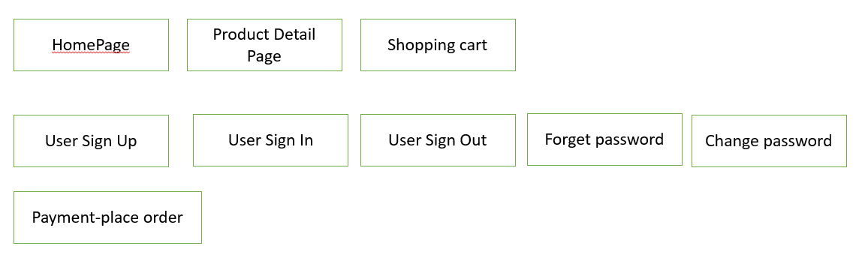

## Site Data (Django provide admin site to check data):

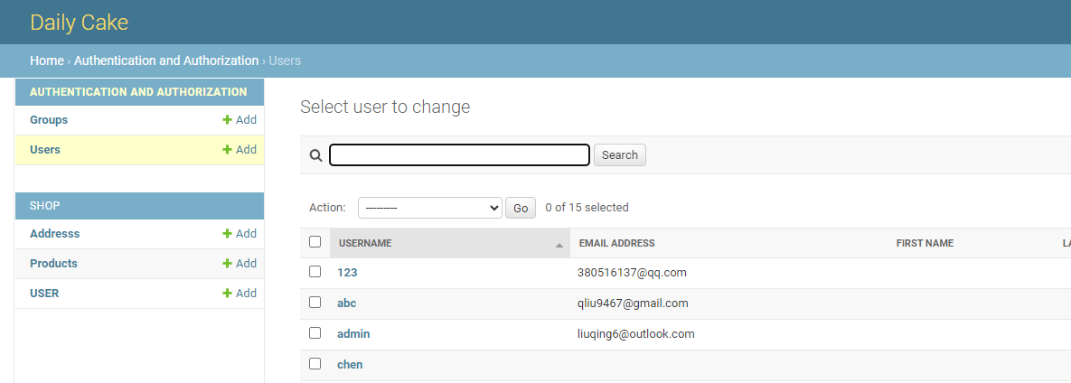

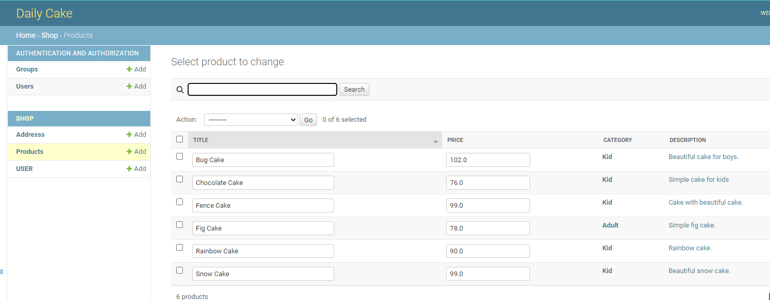

Or to check the code for the DB models:

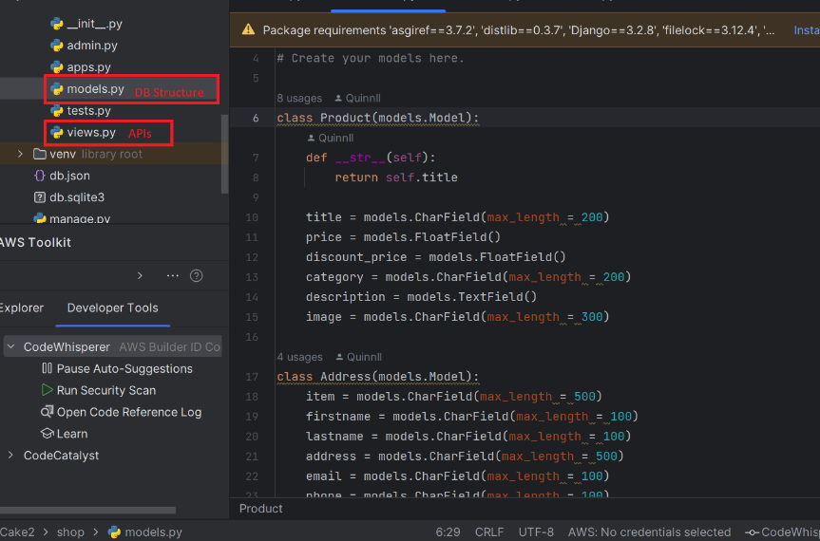

## Web site looks like:

1. Home page:

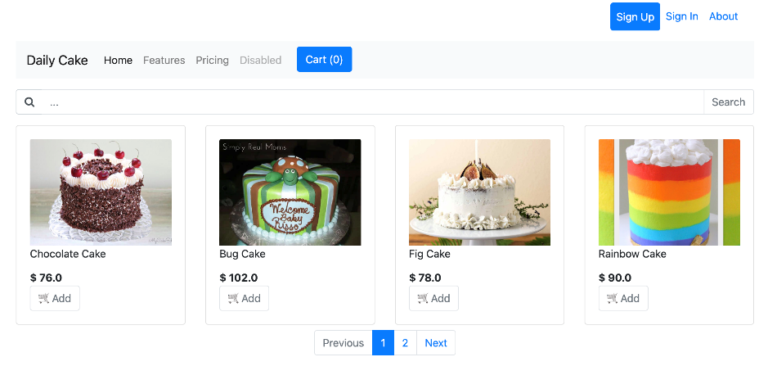

1. Product Detail:

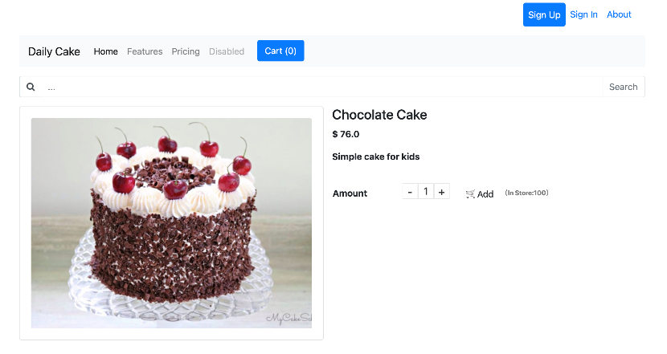

1. Cart:

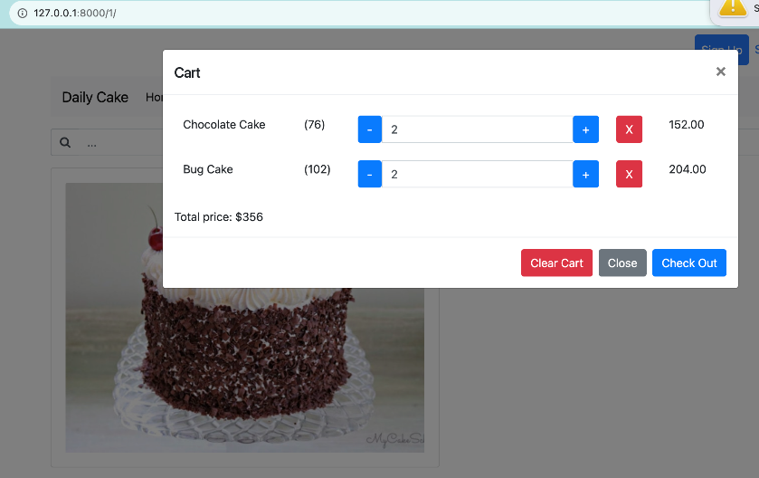

1. Sign up:

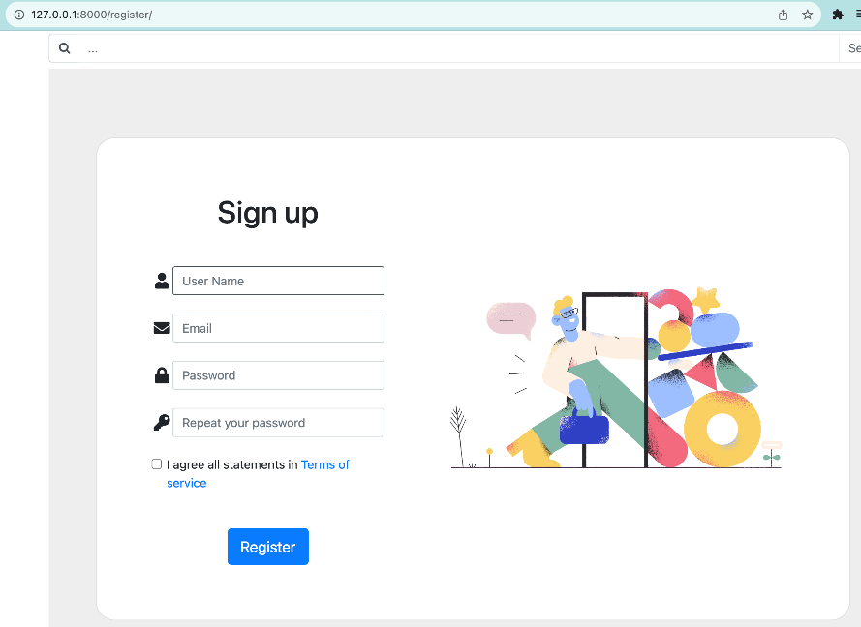

1. Sign In:

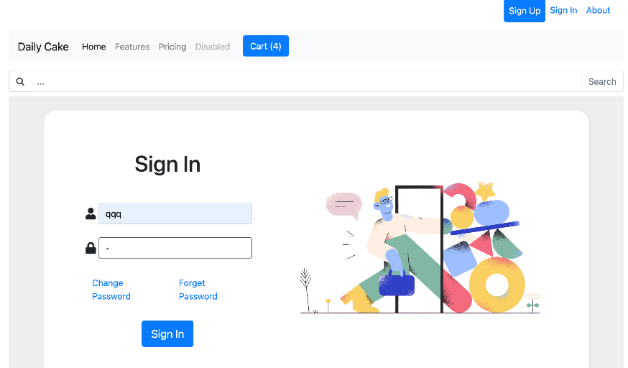

1. Sign Out:

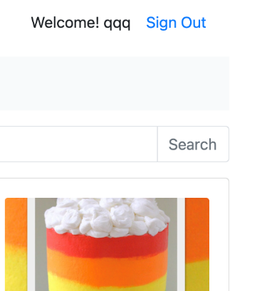

1. Change password & Reset password:

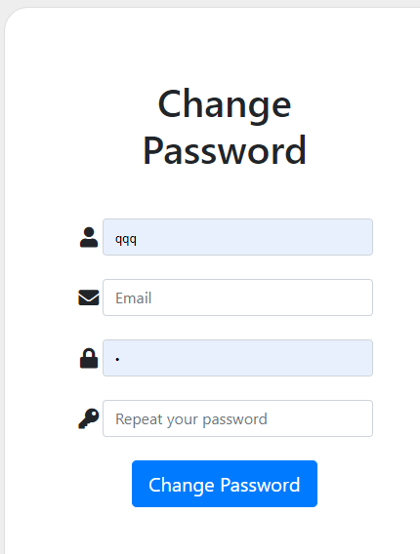

1. Payment:

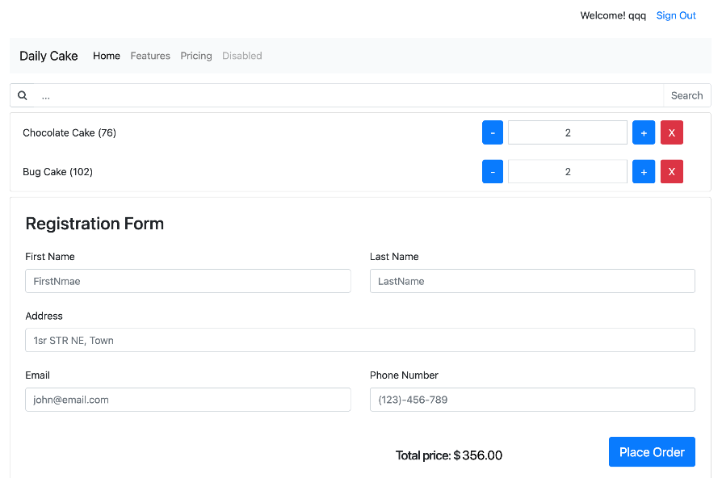

Web site running successfully:

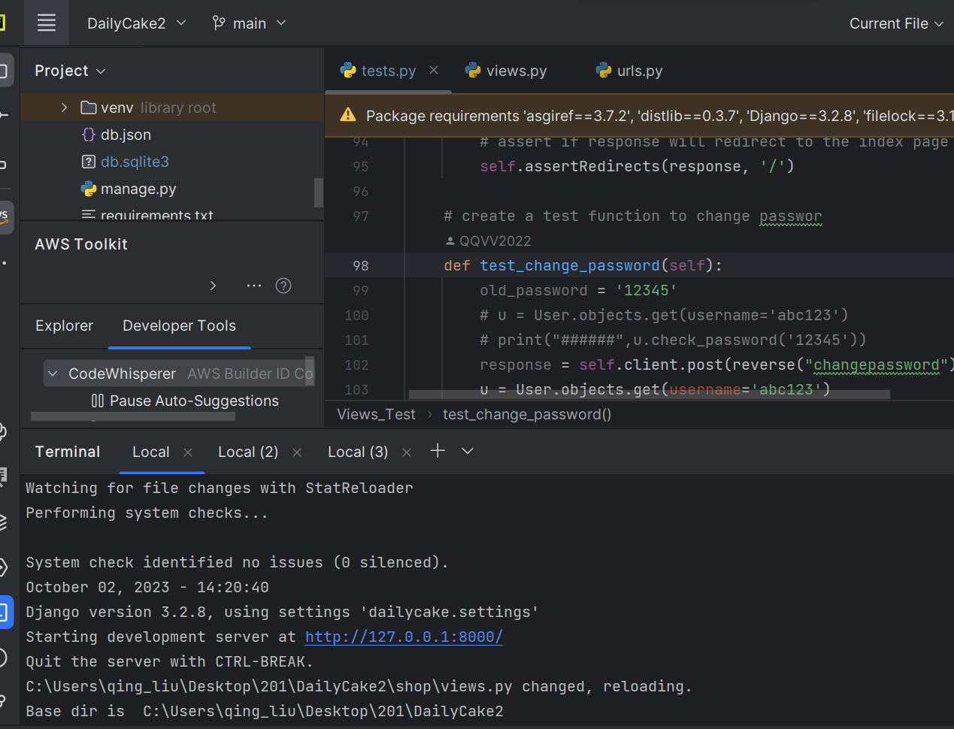

## UnitTest

Unit Test with Code Whisperer (VDI keep failing in installing Python so I have no choice but to develop project in my own laptops. Please note that both Quinnll and QQVV2022 are my code whisperer account names, the Persistent laptop kept failed in python installing, so I use mac for development. After the Persistent python issue fixed, I use another email for development, so it shows 2 names.):

1. Test user model:

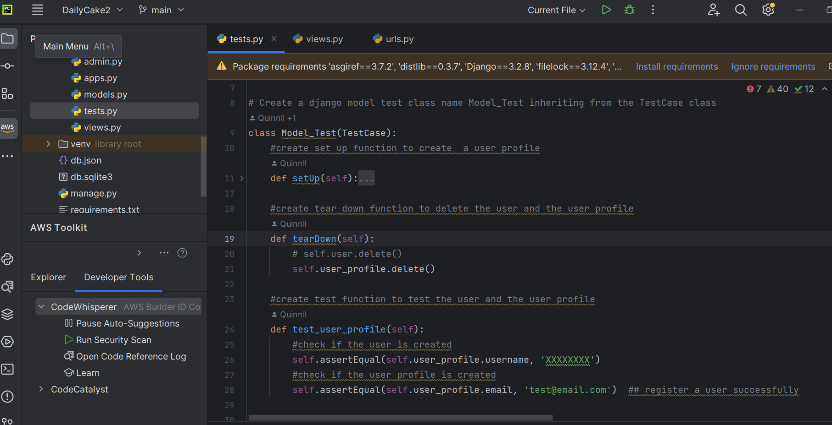

1. Test Views:

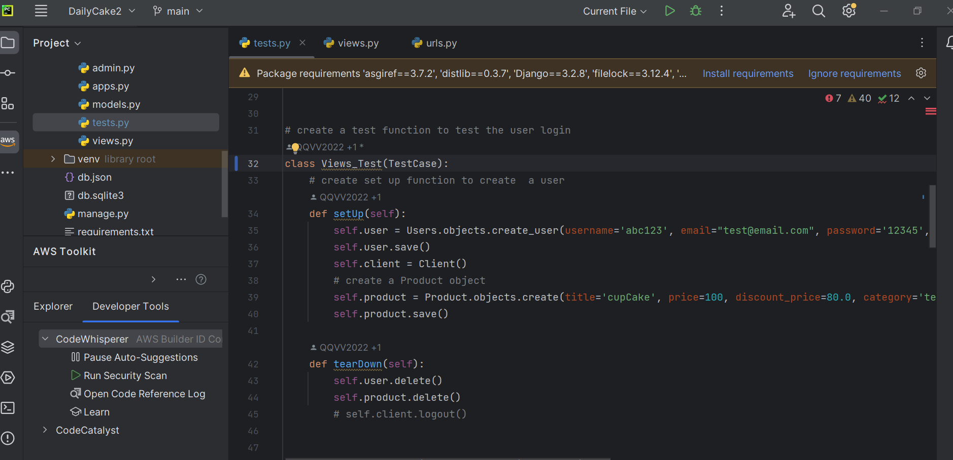

1. Home page and Product detail page tests:

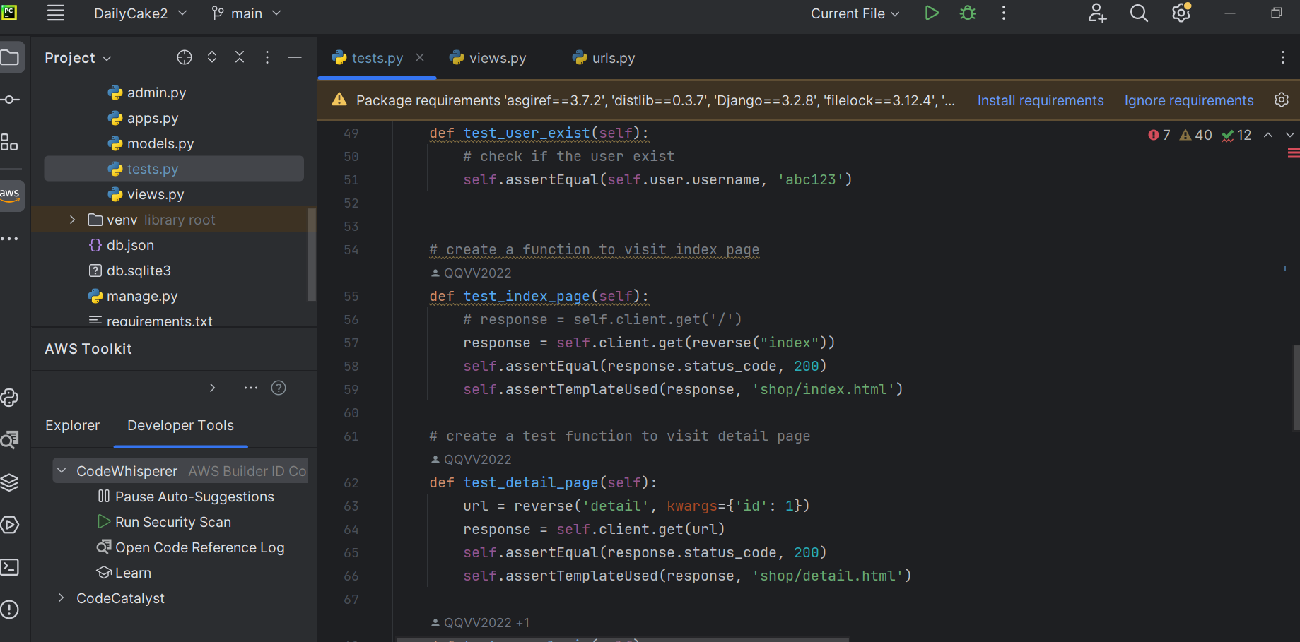

1. User Sign Up, Sign In, Sign Out tests:

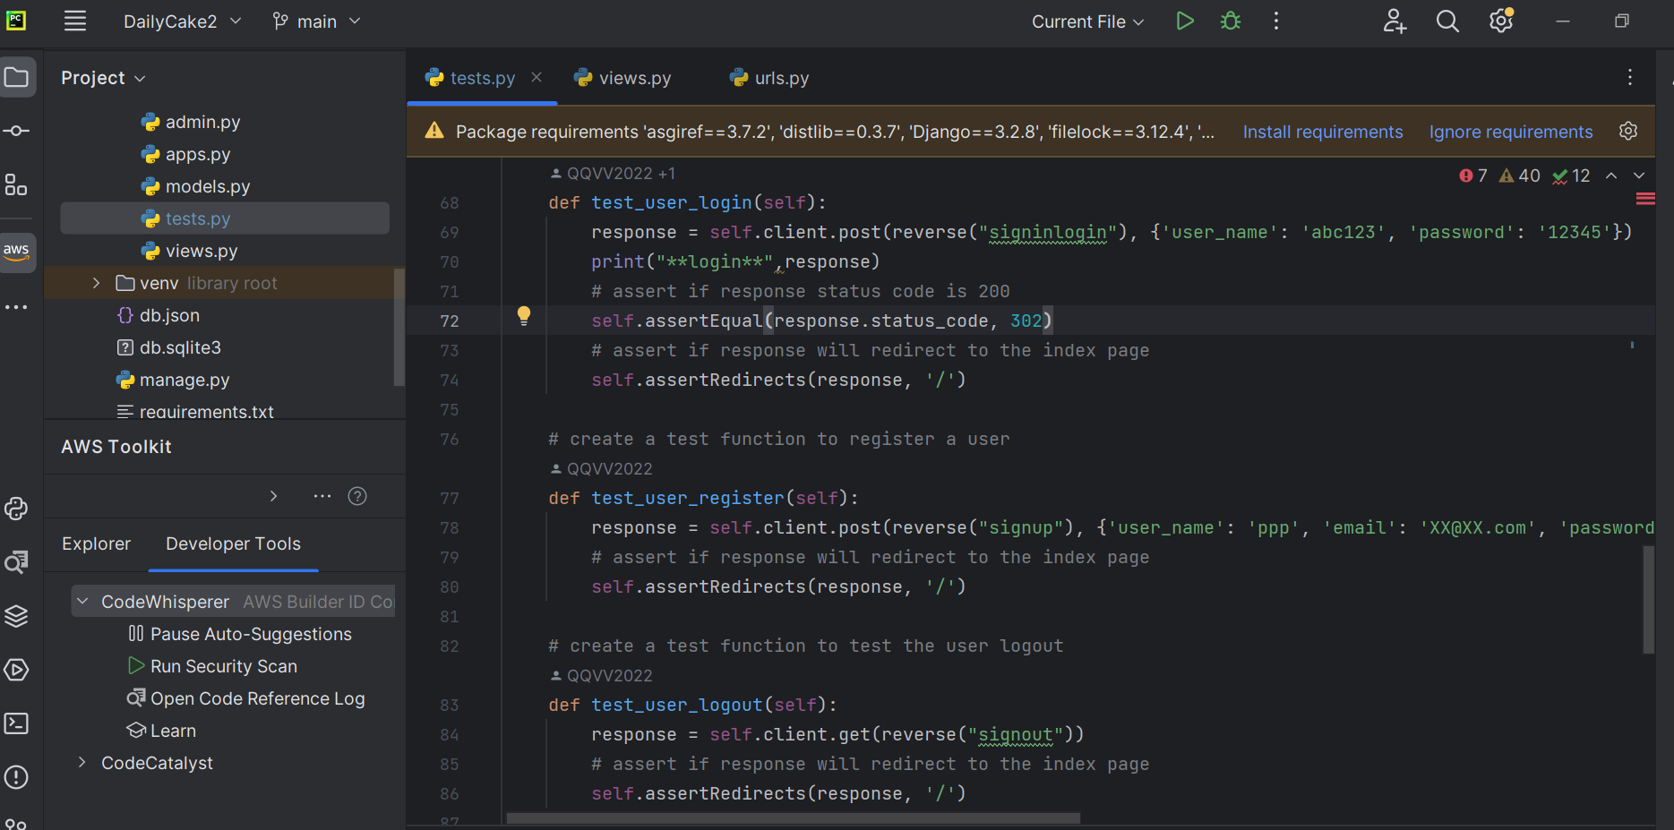

1. Change Password, place Order tests:

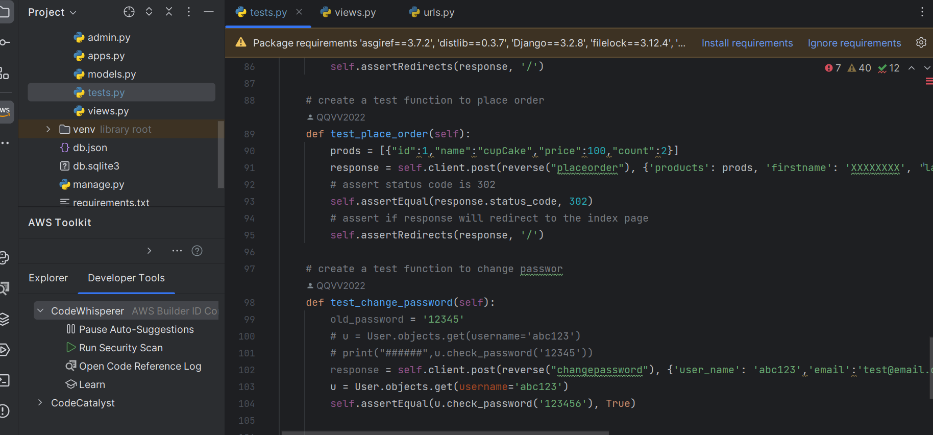

1. Test result is pass:

