**基頻傳輸**

Ex:802.3就用基頻傳輸

<https://oilcut123.pixnet.net/blog/post/354493418-%5b%e6%95%b4%e7%90%86%5d-manchaster%e8%88%87differential-manchester-%e7%b7%a8%e7%a2%bc-%28%e9%99%84%e7%b0%a1>

**曼側斯特(Manchester)** 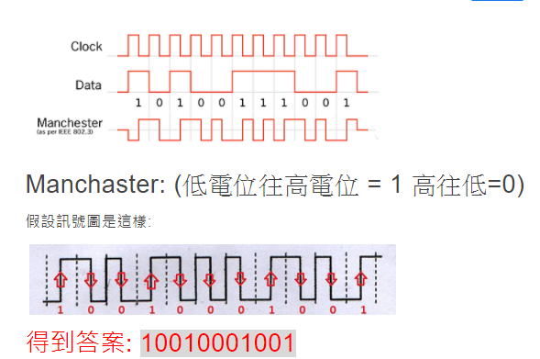

**差動曼側斯特(Differetial Manchester)**

