http://upload.wikimedia.org/wikipedia/commons/d/d4/Button_hide.png

**Orbital state vectors**

From Wikipedia, the free encyclopedia

Jump to: [navigation](http://en.wikipedia.org/wiki/Orbital_state_vectors#mw-head), [search](http://en.wikipedia.org/wiki/Orbital_state_vectors#p-search)

In [astrodynamics](http://en.wikipedia.org/wiki/Astrodynamics) or [celestial dynamics](http://en.wikipedia.org/wiki/Celestial_dynamics) **orbital state vectors** (sometimes **state vectors**) are vectors of [position](http://en.wikipedia.org/wiki/Position_(vector)) (\mathbf{r}) and [velocity](http://en.wikipedia.org/wiki/Velocity) (\mathbf{v}) that together with their time ([epoch](http://en.wikipedia.org/wiki/Epoch_(astronomy))) (t\,) uniquely determine the state of an orbiting body.

State vectors are excellent for pre-launch orbital predictions when combined with time (epoch) expressed as an offset to the launch time. This makes the state vectors time-independent and good general prediction for [orbit](http://en.wikipedia.org/wiki/Orbit).

[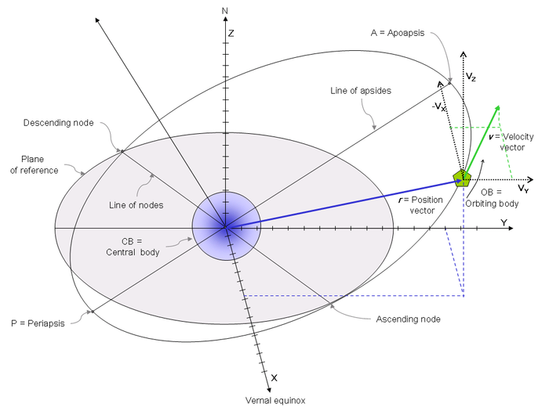](http://en.wikipedia.org/wiki/File:Orbital_state_vectors.png)

[http://bits.wikimedia.org/skins-1.5/common/images/magnify-clip.png](http://en.wikipedia.org/wiki/File:Orbital_state_vectors.png)

[Orbital position vector](http://en.wikipedia.org/wiki/Orbital_position_vector) and [orbital velocity vector](http://en.wikipedia.org/wiki/Orbital_velocity_vector) and other orbit's elements

|  |
| --- |
| **Contents**  [[hide](http://en.wikipedia.org/wiki/Orbital_state_vectors)]   * [1 Frame of reference](http://en.wikipedia.org/wiki/Orbital_state_vectors#Frame_of_reference) * [2 Position vector](http://en.wikipedia.org/wiki/Orbital_state_vectors#Position_vector) * [3 Velocity vector](http://en.wikipedia.org/wiki/Orbital_state_vectors#Velocity_vector)   + [3.1 Derivation](http://en.wikipedia.org/wiki/Orbital_state_vectors#Derivation) |

**[**[**edit**](http://en.wikipedia.org/w/index.php?title=Orbital_state_vectors&action=edit&section=1)**] Frame of reference**

The state vectors must be considered in a particular [inertial frame of reference](http://en.wikipedia.org/wiki/Inertial_frame_of_reference) setting. For most practical applications in astrodynamics this is usually assumed to have the following properties:

* [cartesian right-handed coordinate system](http://en.wikipedia.org/wiki/Cartesian_coordinate_system#Three_dimensional_coordinate_system):
  + with x-axis pointing to [vernal equinox](http://en.wikipedia.org/wiki/Vernal_equinox),
  + with z-axis pointing upwards, meaning the x-y plane is the reference plane.

**[**[**edit**](http://en.wikipedia.org/w/index.php?title=Orbital_state_vectors&action=edit&section=2)**] Position vector**

The **orbital position vector** \mathbf{r}is a [cartesian](http://en.wikipedia.org/wiki/Cartesian_coordinate_system) vector describing the position of the orbiting body in [Frame of reference](http://en.wikipedia.org/wiki/Orbital_state_vectors#Frame_of_reference). Together, the orbital position vector and [orbital velocity vector](http://en.wikipedia.org/wiki/Orbital_velocity_vector) describe uniquely the state of an orbiting body and thus are called Orbital state vectors.

**[**[**edit**](http://en.wikipedia.org/w/index.php?title=Orbital_state_vectors&action=edit&section=3)**] Velocity vector**

**Orbital velocity vector** \mathbf{v}is a [cartesian](http://en.wikipedia.org/wiki/Cartesian_coordinate_system) vector describing velocity of the orbiting body in [Frame of reference](http://en.wikipedia.org/wiki/Orbital_state_vectors#Frame_of_reference). Orbital velocity vector together with [orbital position vector](http://en.wikipedia.org/wiki/Orbital_position_vector) describe uniquely state of the orbiting body and thus are called Orbital state vectors.

For any object moving through space, the velocity vector is [tangent](http://en.wikipedia.org/wiki/Tangent) to the trajectory. If  \hat\mathbf{u}_tis the [unit vector](http://en.wikipedia.org/wiki/Unit_vector) tangent to the trajectory, then

\mathbf{v} = v\hat\mathbf{u}_t

**[**[**edit**](http://en.wikipedia.org/w/index.php?title=Orbital_state_vectors&action=edit&section=4)**] Derivation**

**Orbital velocity vector** \mathbf{v}\,can be derived from **orbital position vector** \mathbf{r}\,by differentiation with respect to time:

\mathbf{v} = {d\mathbf{r}\over{dt}}

Orbital position is when a planet rotates another planet.

Both state vectors and orbital elements have unique advantages over the other. Computed in advance state vectors are more useful for orbital prediction. A time-independent state vector can be combined with the launch time using xxx method in order to arrive at a valid set of orbital elements whereas computed in advance orbital elements are valid only when launch occurs without the slip.

In [astrodynamics](http://en.wikipedia.org/wiki/Astrodynamics) orbital state vectors (\mathbf{r} and \mathbf{v}) are used with the help of following auxiliary vector:

* [specific relative angular momentum](http://en.wikipedia.org/wiki/Specific_relative_angular_momentum) vector \mathbf{h}=\mathbf{r}\times\mathbf{v}

Orbital state vectors can then be used to calculate following [orbital elements](http://en.wikipedia.org/wiki/Orbital_elements) ([Keplerian elements](http://en.wikipedia.org/wiki/Keplerian_elements)) (see their definitions for directions):

* [Inclination](http://en.wikipedia.org/wiki/Inclination) (i\,)
* [Eccentricity](http://en.wikipedia.org/wiki/Eccentricity_(orbit)) (e\,)
* [Longitude of ascending node](http://en.wikipedia.org/wiki/Longitude_of_ascending_node) (\Omega\,)
* [Argument of periapsis](http://en.wikipedia.org/wiki/Argument_of_periapsis) (\omega\,)
* [Mean anomaly](http://en.wikipedia.org/wiki/Mean_anomaly) (M\,)
* [Orbital period](http://en.wikipedia.org/wiki/Orbital_period) (T\,)

together with time (t\,) ([epoch](http://en.wikipedia.org/wiki/Epoch_(astronomy))) those can be used to compute other orbit's parameters:

* [True anomaly](http://en.wikipedia.org/wiki/True_anomaly) (\nu\,)
* [Semi-major axis](http://en.wikipedia.org/wiki/Semi-major_axis) (a\,)
* [Semi-minor axis](http://en.wikipedia.org/wiki/Semi-minor_axis) (b\,)
* [Beta Angle](http://en.wikipedia.org/wiki/Beta_Angle) (\boldsymbol{\beta})
* [Linear eccentricity](http://en.wikipedia.org/wiki/Eccentricity_(mathematics)) (\epsilon\,)
* [Periapsis distance](http://en.wikipedia.org/wiki/Periapsis_distance) (d_p\,)
* [Apoapsis distance](http://en.wikipedia.org/wiki/Apoapsis_distance) (d_a\,)
* [Eccentric anomaly](http://en.wikipedia.org/wiki/Eccentric_anomaly) (E\,)
* [Mean longitude](http://en.wikipedia.org/wiki/Mean_longitude) (L\,)
* [True longitude](http://en.wikipedia.org/wiki/True_longitude) (l\,)

Keplerian elements typically define an [osculating orbit](http://en.wikipedia.org/wiki/Osculating_orbit) because of perturbations in the orbital path. The osculating orbit is valid only at the epoch of the original Cartesian elements.