Anti-Trans Bills in the U.S., 2021-23

Kenan Ince

2023-04-27

# Introduction

**Note. *All data (including merged and filtered data) used in the analysis below is open-access and can be found*** [***on GitHub***](https://github.com/kaince/anti-trans-bills)***.***

Americans who identify as lesbian, gay, bisexual, transgender, queer, or many other identities under the queer and trans umbrella (LGBTQ+ folks for short) have long been targeted by conservative groups in the U.S. Nonetheless, the mid-2010s seemed to many to be a time of increasing acceptance of LGBTQ+ identities; the *Time* magazine article “The Transgender Tipping Point,” for example, quoted actress and advocate Laverne Cox as saying, “We are in a place now where more and more trans people want to come forward and say, ‘This is who I am.’ […] More of us are living visibly and pursuing our dreams visibly, so people can say, ‘Oh yeah, I know someone who is trans.’ When people have points of reference that are humanizing, that demystifies difference (Katy Steinmetz 2014).”

However, after the 2015 Supreme Court ruling in *Obergefell v. Hodges* legalizing “same-sex marriage” (though some of those who were married after *Obergefell* identify as trans or nonbinary), conservative groups have sought to target LGBTQ+ people through “religious freedom” laws allowing for discrimination against “same-sex couples”, and more recently, transgender people, especially transgender youth. Despite the increasing prevalence of trans and nonbinary people in American society, as well as the recent legislative and political attacks on these groups, relatively few academic studies have been conducted on the impact of the surge of anti-trans legislation since 2019. In this article, we attempt to collate data from various sources to analyze the growth, types, progress, and impacts of various anti-trans and -nonbinary bills from 2018 to 2023.

We emphasize these years because, in 2019, the conservative Heritage Foundation and conservative Christian Family Policy Alliance distributed a model strategy for banning gender-affirming care to state legislators at a conference (Harvard Law Review 2021). In 2020, a conference attendee and South Dakota legislator published a version of the bill seeking to criminalize doctors’ provision of puberty blockers and hormones to transgender patients under the age of 16. Similar bills followed the same year: in Colorado, Florida, Illinois, Iowa, Kentucky, Missouri, Oklahoma, and South Carolina (Bauer 2020). Though the 2020 bills failed, the language in bills in South Carolina, South Dakota, and Arkansas in 2021 attempting to allow physicians to refuse to treat transgender children shared similar language, which originated in a “Model Conscience Protection Act” published by Kevin Theriot and Ken Connelly of the conservative Alliance Defending Freedom (Theriot and Connelly, n.d.). As we will see below, more and more bills are being proposed, and more are passing, every year since.

These bills go against studies showing that transgender children between the age of 5 and 12 viewed their gender identities similarly to cisgender children (Olson, Key, and Eaton 2015), among other academic studies. The leading association of pediatricians in the United States recommends “that youth who identify as [transgender] have access to comprehensive, gender-affirming, and developmentally appropriate health care that is provided in a safe and inclusive clinical space…[and] that pediatricians have a role in advocating for policies and laws that protect youth who identify as [transgender] from discrimination and violence (Rafferty et al. 2018).”

*Gender-affirming healthcare* is defined by the World Health Organization as multiple social, psychological, behavioral, and medical treatments “designed to support and affirm an individual’s gender identity” when it differs from their assigned gender at birth (González 2023). Usually, gender-affirming care begins with *social transition*, in which a person begins to present as their correct, felt gender identity in public. Next, *puberty blockers* may be used to delay pubescent changes that do not align with the individual’s gender identity, and *hormone therapy* may be used to align with their gender identity, some of whose effects are reversible. According to guidelines from major medical organizations, hormone therapy should be started once pubescent changes begin. Finally, usually for people over 18, gender-affirming surgeries (including top or bottom surgery) may be considered. If surgeries are offered to teens, multiple health professionals must first evaluate the teen.

Recent bills target all aspects of gender-affirming healthcare, mostly for people under 18 but increasingly for those under 21 or even all adults, as with the 2023 ruling by Missouri’s Attorney General Andrew Bailey that the state’s consumer protection law prevents all Missourians from receiving puberty blockers, hormone therapy, or surgery unless they meet very narrow guidelines (ACLU of Missouri 2023).

We briefly describe how each aspect of gender-affirming healthcare is targeted by the categories of bills used in the data analysis below. Social transition is targeted through youth athletics bills preventing young people from competing on sports teams under their identified gender. ID requirements prevent the changing of the “sex” listed on birth certificates, driver’s licenses, and other government IDs.Public facilities laws prevent all trans people from using restrooms and other gendered public facilities that match their gender identity. Schools/education laws vary but include laws banning teachers from using students’ correct pronouns at all or without parental permission, discussing queer and trans/nonbinary identities in the classroom, and displaying items such as pride flags supporting queer and trans identities, among others.

Drag performance laws (perhaps better categorized as “gender expression laws”), a recent development as of 2023, ban drag shows or “male or female impersonators” in certain circumstances, such as “in the presence of minors” (Tennessee’s Senate Bill 3) or on Sundays from 1 a.m. to 12 p.m. (Arizona’s SB 1030). Laws barring municipalities from passing nondiscrimination protections, as well as religious freedom laws, legalize discrimination in certain circumstances against LGBTQ+ people, particularly by those with a “strongly felt religious conviction” that being LGBTQ+ is wrong. Finally, healthcare laws prevent gender-affirming care for various groups in various ways, often including bans on hormone therapy and surgery for those under 18.

# Methods

## Importing and Merging the Data

We download .csv files from the website [tracktranslegislation.com](https://tracktranslegislation.com) (Trans Legislation Tracker, n.d.), which in turn obtains the data from [LegiScan](https://legiscan.com). This data is up-to-date from 2021 through April 21, 2023. In order to track bills prior to 2021, we use data from the ACLU’s [“Past Legislation Affecting LGBT Rights Across the Country” pages for 2018, 2019, and 2020](https://www.aclu.org/past-legislation-affecting-lgbt-rights-across-country-2018) (American Civil Liberties Union 2018, 2019, 2020). Note that the 2020 page was last updated on March 20, 2020, since many state legislatures were suspended or closed during the first year of the COVID-19 pandemic; the ACLU page promised to “update the tracker as major new developments occur[red] .” This data has distinct variable names and organization, so we also modify the ACLU data to match the Track Trans Legislation data as closely as possible.

For example, bills that were withdrawn, not passed by the end of a given legislative session, explicitly listed as “Dead”, or were recommended against by a committee and did not proceed in the legislature were relabeled “Dead” (at least for that year). The exception was when the bill description is specifically listed as “hearing scheduled”, “referred to committee”, carried over from another year, or otherwise makes clear that the bill is still under consideration, in which case “Introduced” or “Crossed Over” (depending on whether the bill had been passed by at least one chamber) were used.

We only include bills in categories tracked by both data sources; this leaves out, for example, bills preventing localities from passing anti-discrimination ordinances within a state. We use a broad reading of the “religious freedom” category to include bills that allow for people with “sincerely-held religious beliefs” in that state to challenge nondiscrimination laws, discriminate against LGBTQ+ people, refuse to provide healthcare to LGBTQ+ people, refuse to provide adoption services to LGBTQ+ people; discriminate against married LGBTQ+ people, and receive funding for discriminatory student groups at public universities, among others.

## Cleaning the Data

First, the $2018$- $2020$ ACLU datasets code state names by their two-letter abbreviations (e.g., “AZ” instead of “Arizona”), while Track Trans Legislation uses full names. So we use an R function to convert full names to abbreviations in the whole dataset. We verify that the only “State” values that were not successfully converted to abbreviations are for bills that were proposed at the federal level.

We note that, for example, the $2021$ dataset includes some bills passed in January $2022$, so we eliminate duplicate bills.

This decreases the number of bills in our dataset from $927$ to $893$. Next, note that the bills whose status is labeled Introduced* are those that failed to meet their state’s “crossover deadline”, the date by which a bill must pass out of the chamber in which it was introduced and to the other chamber (e.g. State House vs. Senate). According to the site [Track Trans Legislation](https://www.tracktranslegislation.com/), a bill that is not passed in its initial chamber by the crossover deadline “faces high procedural hurdles in order to move forward.” Thus, we wish to classify these bills (at least for the current session) as “dead/failed”.

Moreover, one bill’s status is listed as “Posted”, Kentucky’s HB132 in . [LegiScan research](https://legiscan.com/KY/bill/HB132/2020) reveals that this bill died in committee, so we update its status to Dead/Failed.

There is one last formatting issue to address: the Status variable could take on any of the values Dead/Failed, Dead/Failed, and Dead/Failed (note the additional spaces). We combine them all into one value.

# Results

## Bill Type vs. Status

We now summarize the relationships of the type of bill to its status to determine whether specific types of bills were more likely to succeed.

Note that **crossing over** refers to a bill being passed out of one state legislative chamber (either the State House or State Senate) and moving forward for consideration in the other chamber. Thus, a bill that has crossed over suggests majority support for the bill in at least one chamber.

Table 1: Bill Status by Bill Type

| Bill Type | Crossed Over | Dead/Failed | Introduced | Passed | Signed/Enacted | Vetoed | Total |
| --- | --- | --- | --- | --- | --- | --- | --- |
| Drag Performance | 6 | 11 | 19 | 0 | 2 | 0 | 38 |
| Healthcare | 10 | 85 | 112 | 5 | 17 | 0 | 229 |
| ID Updates | 4 | 9 | 15 | 0 | 5 | 0 | 33 |
| Nondiscrimination Protections | 0 | 6 | 6 | 1 | 0 | 0 | 13 |
| Other | 8 | 26 | 38 | 1 | 4 | 1 | 78 |
| Public Facilities | 6 | 29 | 22 | 2 | 7 | 0 | 66 |
| Religious Freedom | 1 | 13 | 22 | 1 | 4 | 0 | 41 |
| Schools / Education | 8 | 42 | 47 | 1 | 4 | 0 | 102 |
| Youth Athletics | 23 | 70 | 158 | 3 | 35 | 4 | 293 |
| Total | 66 | 291 | 439 | 14 | 78 | 5 | 893 |

We see what percentage of each bill status was made up of each bill type:

Table 1: Percentage of Bills with Each Status, by Type

| Bill Type | Crossed Over | Dead/Failed | Introduced | Passed | Signed/Enacted | Vetoed | Total |
| --- | --- | --- | --- | --- | --- | --- | --- |
| Drag Performance | 15.8% | 28.9% | 50.0% | 0.0% | 5.3% | 0.0% | 100.0% |
| Healthcare | 4.4% | 37.1% | 48.9% | 2.2% | 7.4% | 0.0% | 100.0% |
| ID Updates | 12.1% | 27.3% | 45.5% | 0.0% | 15.2% | 0.0% | 100.0% |
| Nondiscrimination Protections | 0.0% | 46.2% | 46.2% | 7.7% | 0.0% | 0.0% | 100.0% |
| Other | 10.3% | 33.3% | 48.7% | 1.3% | 5.1% | 1.3% | 100.0% |
| Public Facilities | 9.1% | 43.9% | 33.3% | 3.0% | 10.6% | 0.0% | 100.0% |
| Religious Freedom | 2.4% | 31.7% | 53.7% | 2.4% | 9.8% | 0.0% | 100.0% |
| Schools / Education | 7.8% | 41.2% | 46.1% | 1.0% | 3.9% | 0.0% | 100.0% |
| Youth Athletics | 7.8% | 23.9% | 53.9% | 1.0% | 11.9% | 1.4% | 100.0% |
| Total | 7.4% | 32.6% | 49.2% | 1.6% | 8.7% | 0.6% | 100.0% |

And what percentage of each bill type had each status:

Table 1: Percentage of Bills of Each Type, by Status

| Status | Drag Performance | Healthcare | ID Updates | Nondiscrimination Protections | Other | Public Facilities | Religious Freedom | Schools / Education | Youth Athletics | Total |
| --- | --- | --- | --- | --- | --- | --- | --- | --- | --- | --- |
| Crossed Over | 9.1% | 15.2% | 6.1% | 0.0% | 12.1% | 9.1% | 1.5% | 12.1% | 34.8% | 100.0% |
| Dead/Failed | 3.8% | 29.2% | 3.1% | 2.1% | 8.9% | 10.0% | 4.5% | 14.4% | 24.1% | 100.0% |
| Introduced | 4.3% | 25.5% | 3.4% | 1.4% | 8.7% | 5.0% | 5.0% | 10.7% | 36.0% | 100.0% |
| Passed | 0.0% | 35.7% | 0.0% | 7.1% | 7.1% | 14.3% | 7.1% | 7.1% | 21.4% | 100.0% |
| Signed/Enacted | 2.6% | 21.8% | 6.4% | 0.0% | 5.1% | 9.0% | 5.1% | 5.1% | 44.9% | 100.0% |
| Vetoed | 0.0% | 0.0% | 0.0% | 0.0% | 20.0% | 0.0% | 0.0% | 0.0% | 80.0% | 100.0% |
| Total | 4.3% | 25.6% | 3.7% | 1.5% | 8.7% | 7.4% | 4.6% | 11.4% | 32.8% | 100.0% |

It seems like bills related to “ID updates” (i.e., preventing trans and nonbinary people from having their IDs show their correct gender identity), “public facilities” (often preventing trans people from using the bathroom that fits their gender identity), and “youth athletics” (i.e., preventing trans girls from competing on girls’ sports teams) are most likely to be signed by their state’s governor and enacted into law (after passing both legislative chambers).

However, of all the bills that were signed and enacted, most of them by far were related to youth athletics (over double the number of bills from any other category), followed by healthcare, suggesting that more bills were proposed in those categories.

We seek to represent this data in a side-by-side bar chart. In order to provide a more digestible, big-picture viewpoint, we classify the bills by the type of gender-affirming care that is targeted: social transition (excluding artistic performance, which Track Trans Legislation categorizes under Drag Performance), healthcare/medical transition, drag performances (noting that performing in drag and being transgender are distinct, though sometimes overlapping, categories), and Other.

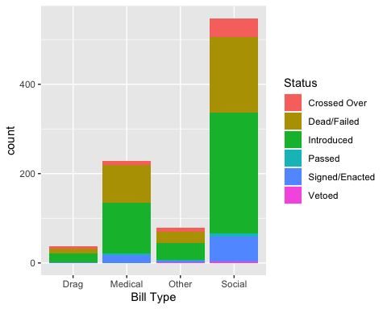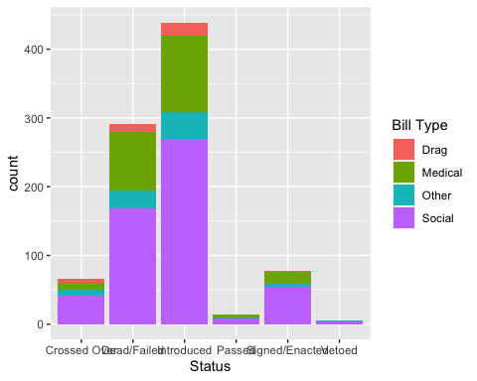

In order to better see proportions, we also show a stacked bar chart that scales every $x$-axis group to $100\%$:

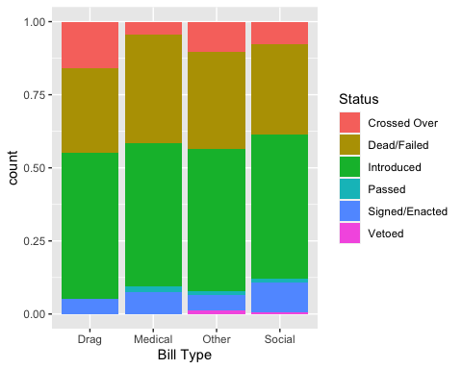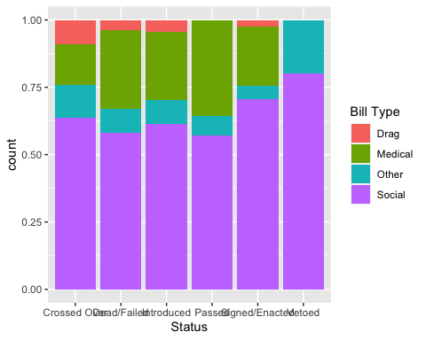

### Did the type of bill impact its likelihood of being passed and/or signed?

However, the observed trends could simply relate to the fact that the largest *numbers* of bills nationwide were proposed in those categories.

In order to simplify the following charts and analysis, we combine certain bill statuses into categories: bills that have crossed over, passed, or were signed and enacted have a significant chance of impacting the lives of trans and nonbinary people in that state, while bills that were vetoed, died, or failed have no chance of impacting lives. Bills listed simply as “introduced” may or may not have the support to eventually pass, but since they are not currently impacting the ability of trans/nonbinary people to access healthcare, play sports, etc., we count them as “Not Passed”.

Now, we want to see a breakdown of the number and percentages of each type of bill that did and didn’t pass.

Table 1: Number of Bills Passed by Bill Type

| Bill Type | Not Passed | Passed | Total |
| --- | --- | --- | --- |
| Drag | 30 | 8 | 38 |
| Medical | 197 | 32 | 229 |
| Other | 65 | 13 | 78 |
| Social | 443 | 105 | 548 |
| Total | 735 | 158 | 893 |

Table 1: Percentage of Bills Passed by Bill Type

| Bill Type | Not Passed | Passed |
| --- | --- | --- |
| Drag | 78.9% | 21.1% |
| Medical | 86.0% | 14.0% |
| Other | 83.3% | 16.7% |
| Social | 80.8% | 19.2% |
| Total | 82.3% | 17.7% |

We wish to plot the number and proportion of each type of bill that was passed.

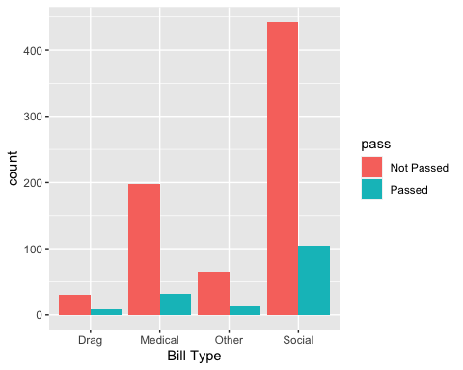

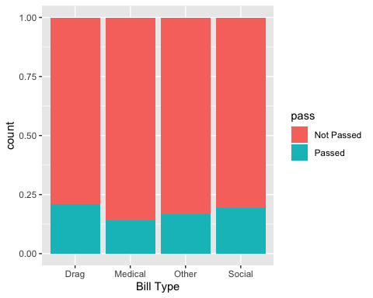

From this chart, it appears that bills restricting hormone therapy, puberty blockers, and other medical interventions are actually somewhat less likely to pass than other types of bills, and that while the number of anti-drag bills is substantially smaller than the number of other types of bills, they are somewhat more likely to pass.

Importantly, fewer than $25\%$ of any type of bill since $2018$ has passed. What happens when we break down the bills by year?

## Is 2023 the Year of Transphobia?

A common claim in the news media, and a common feeling among trans and nonbinary folks, is that $2023$ is by far the worst recent year for anti-trans legislation. Let’s investigate the following questions:

1. What total number of anti-trans bills were proposed each year from $2018$ to $2023$?
2. What total number of anti-trans bills were *passed* each of these years? In $2023$, since the session is not over in many states, we run the analysis in two ways: including both bills that crossed over and bills that were signed/enacted, and only considering bills which were signed/enacted.
3. What types of anti-trans bills were proposed more often in $2023$ than in previous years?
4. What types of anti-trans bills were *passed* more often in $2023$?
5. What states introduced/passed the majority of anti-trans bills in $2023$, and are these the same states as in previous years?

We start by creating a data frame that shows only the bills passed, crossed over (hence passed by at least one chamber of the legislature and not yet dead), and/or signed and enacted between 2021 and 2023, as well as in each year and in the years preceding $2023$.

Table 1: Passed Bills by Year and Type

| Bill Type | 2017 | 2018 | 2019 | 2020 | 2021 | 2022 | 2023 | Total |
| --- | --- | --- | --- | --- | --- | --- | --- | --- |
| Drag Performance | 0 | 0 | 0 | 0 | 0 | 0 | 8 | 8 |
| Healthcare | 0 | 0 | 0 | 1 | 4 | 4 | 23 | 32 |
| ID Updates | 0 | 0 | 0 | 1 | 1 | 1 | 6 | 9 |
| Nondiscrimination Protections | 0 | 0 | 0 | 0 | 0 | 0 | 1 | 1 |
| Other | 0 | 1 | 1 | 0 | 0 | 2 | 9 | 13 |
| Public Facilities | 0 | 0 | 2 | 0 | 0 | 3 | 10 | 15 |
| Religious Freedom | 1 | 1 | 0 | 3 | 1 | 0 | 0 | 6 |
| Schools / Education | 0 | 0 | 0 | 0 | 0 | 4 | 9 | 13 |
| Youth Athletics | 0 | 0 | 0 | 3 | 27 | 21 | 10 | 61 |
| Total | 1 | 2 | 3 | 8 | 33 | 35 | 76 | 158 |

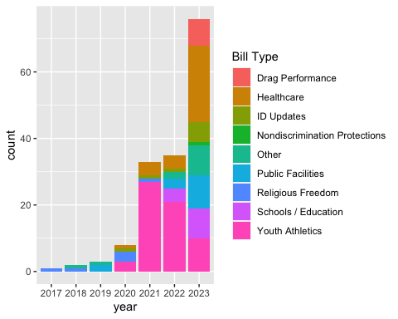

Note that these bills **only go through April 21, 2022**. To emphasize the change in the number of bills that have a chance of passing or have already been passed over time, we combine all the years 2017-2022 and compare them to 2023.

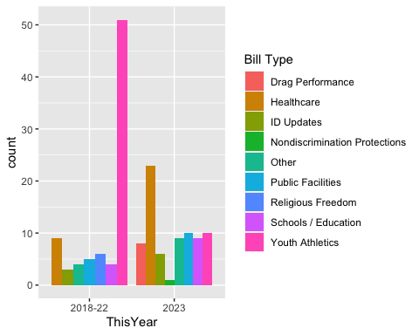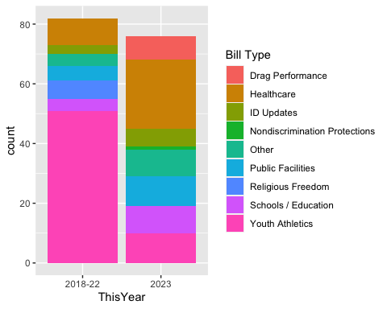

It appears that 2023 will, indeed, have many anti-trans bills pass than all previous years since 2018 combined (again, recall that the 2023 data in this analysis only goes through April 21, 2023). What about the *likelihood* of any particular anti-trans bill to pass in 2023 compared to previous years?

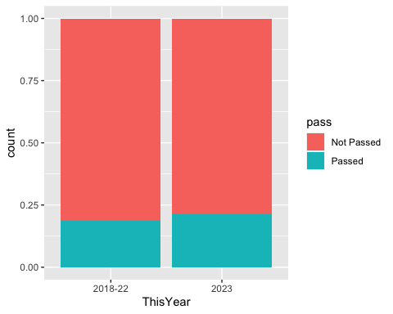

There appears to be a slight increase in the proportion of bills of all types that passed in 2023 compared to 2018-22. This difference becomes even more pronounced when we separate 2022:

Table 1: Bills Passed Before and After 2022

| after_21 | Not Passed | Passed |
| --- | --- | --- |
| 2022-23 | 78.2% | 21.8% |
| 2018-21 | 84.7% | 15.3% |
| Total | 80.1% | 19.9% |

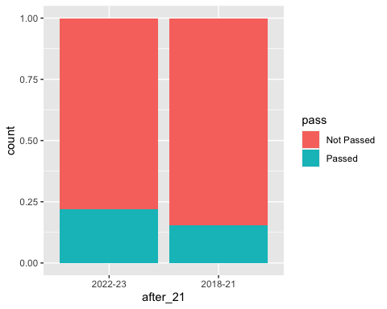

# Directions for Future Work

## Bayesian Analysis

What do Bayesian analyses tell us about the trends seen in the exploratory data analysis above?

## Textual Analysis of Template Bills & Proposed State Bills

There is substantial evidence (Pauly 2023; Schipper 2022; Contreras 2023) that “template bills” containing text for banning aspects of gender-affirming care and social transition were distributed at workshops hosted by far-right organizations such as the Heritage Foundation and Christian Family Policy Alliance over the past several years. For example, throughout 2019, the Heritage Foundation hosted a series of workshops on the “medical risks” of gender-affirming care for trans youth (Harvard Law Review 2021).

Given the text of template bills such as that found in Appendix II of (Theriot and Connelly, n.d.), how many of the bills proposed across the U.S. since 2019 have significant textual similarity to template bills authored by conservative organizations? Which template bills, and which organizations, have had the most influence in the text of bills that were proposed? Passed? In which states?

## Do Anti-Trans Bills Reflect the Will of Voters?

In states where anti-trans bills are passed, is the percentage of voters (eligible/likely voters, residents, etc.) in a state that support such bills a plurality? A majority? Greater or less than the number of legislature members who voted for the anti-trans bill?

How does the number of anti-trans bills passed in a state correlate to how gerrymandered the state is (using a measure such as Markov chain Monte Carlo (Metric Geometry & Gerrymandering Group, n.d.))?

## State Prioritization of Anti-Trans Bills

Are most anti-trans bills passed during the beginning of legislative sessions, indicating that such bills are a high priority for the state legislature?

In order to extract information on state legislature convening and adjourning dates, we download the schedule of state legislature meeting dates from the [National Conference of State Legislatures](https://documents.ncsl.org/wwwncsl/About-State-Legislatures/2023_session_calendar_1.pdf) website, then use the [Tabula tool](https://tabula.technology/) to extract the data into a .csv file, making some manual edits. Finally, we load the .csv file into RStudio.

## Rows: 56 Columns: 3  
## ── Column specification ────────────────────────────────────────────────────────  
## Delimiter: ","  
## chr (3): State, Convene, Adjourn  
##   
## ℹ Use `spec()` to retrieve the full column specification for this data.  
## ℹ Specify the column types or set `show_col_types = FALSE` to quiet this message.

## Impact of Anti-Trans Bills on Trans and Nonbinary Mental Health

The 2022 Trevor Project National Survey on LGBTQ Youth Mental Health (The Trevor Project 2022) found that 59% of young trans men and 48% of young trans women had considered suicide in the past year, while 22% of trans boys and 12% of trans girls had attempted suicide. The same survey found that 93% of trans and nonbinary youth said they had worried about legislation denying trans people access to gender-affirming healthcare.

Is the number of Google searches or Twitter posts related to anxiety, depression, and/or suicidality (“#distress”) among trans and nonbinary folks higher in 2023 than in previous years?

Is the amount of #distress correlated to whether a bill has just passed? To whether the bill impacts social or medical transition, drag performance, or “Other”?

How does the amount of #distress in states that have not passed anti-trans bills compare to states in which an anti-trans bill has been passed in the past year? The past two years?

## Queer and Trans Resistance

How does the number of posts related to organizing protests, whether online or in-person, on Twitter after the passage of an anti-trans bill in a particular state compare to the number immediately before the passage of that bill?

How does the number of out transgender and nonbinary people elected to public office, featured in the most widely consumed media outlets, generally being visible…related to the number of bills proposed/passed? Possible source: [LGBTQ+ Victory Fund](https://victoryfund.org/) for officeholders

ACLU of Missouri. 2023. “Advocates Sue to Block Missouri Attorney General’s Anti-Transgender Rule Restricting Gender-Affirming Care.” <https://www.aclu-mo.org/en/news/advocates-sue-block-missouri-attorney-generals-anti-transgender-rule-restricting-gender>.

American Civil Liberties Union. 2018. “Past Legislation Affecting LGBT Rights Across the Country (2018).” <https://www.aclu.org/past-legislation-affecting-lgbt-rights-across-country-2018>.

———. 2019. “Past Legislation Affecting LGBT Rights Across Country 2019.” <https://www.aclu.org/past-legislation-affecting-lgbt-rights-across-country-2019>.

———. 2020. “Past Legislation Affecting LGBT Rights Across the Country 2020.” <https://www.aclu.org/past-legislation-affecting-lgbt-rights-across-country-2020>.

Bauer, Sydney. 2020. “The New Anti-Trans Culture War Hiding in Plain Sight.” *The New Republic*, February. <https://newrepublic.com/article/156539/new-anti-trans-culture-war-hiding-plain-sight>.

Contreras, Russell. 2023. “The Forces Behind Anti-Trans Bills Across the U.S.” <https://www.axios.com/2023/03/31/anti-trans-bills-2023-america>.

González, Oriana. 2023. “What Is the State of Gender-Affirming Care in America.” <https://www.axios.com/2023/03/03/gender-affirming-care-trans-youth-us>.

Harvard Law Review. 2021. “Outlawing Trans Youth: State Legislatures and the Battle over Gender-Affirming Healthcare for Minors.” *Harvard Law Review* 134 (6). <https://harvardlawreview.org/print/vol-134/outlawing-trans-youth-state-legislatures-and-the-battle-over-gender-affirming-healthcare-for-minors/>.

Katy Steinmetz. 2014. “The Transgender Tipping Point.” <https://time.com/135480/transgender-tipping-point/>.

Metric Geometry & Gerrymandering Group. n.d. “GerryChain.” <https://mggg.github.io/GerryChain/>.

Olson, Kristina R., Aidan C. Key, and Nicholas R. Eaton. 2015. “Gender cognition in transgender children.” *Psychological Science* 26 (4): 467–74. <https://doi.org/10.1177/0956797614568156>.

Pauly, Madison. 2023. “Inside the Secret Working Group That Helped Push Anti-Trans Laws Across the Country.” <https://www.motherjones.com/politics/2023/03/anti-trans-transgender-health-care-ban-legislation-bill-minors-children-lgbtq/>.

Rafferty, Jason, COMMITTEE ON PSYCHOSOCIAL ASPECTS OF CHILD AND FAMILY HEALTH, COMMITTEE ON ADOLESCENCE, GAY, BISEXUAL, AND TRANSGENDER HEALTH AND WELLNESS SECTION ON LESBIAN, Michael Yogman, Rebecca Baum, Thresia B. Gambon, et al. 2018. “Ensuring Comprehensive Care and Support for Transgender and Gender-Diverse Children and Adolescents.” *Pediatrics* 142 (4): e20182162. <https://doi.org/10.1542/peds.2018-2162>.

Schipper, Kellie. 2022. “Conservative Political Tactics to Obstruct Gender-Affirming Healthcare for Transgender Youth in the USA.” PhD thesis.

The Trevor Project. 2022. “2022 National Survey on LGBTQ Youth Mental Health.” <https://www.thetrevorproject.org/survey-2022/assets/static/trevor01_2022survey_final.pdf>.

Theriot, Kevin H, and Ken Connelly. n.d. “Free to Do No Harm: Conscience Protections for Healthcare Professionals.” *Arizona State Law Journal* 49 (0549): 549–605.

Trans Legislation Tracker. n.d. “Trans Legislation Tracker: 2022 Anti-Transgender Bills.” <https://translegislation.com/bills/2022>.