COLLEGE OF COMPUTING AND INFORMATICS
PUTRAJAYA CAMPUS
Software Construction and Methods
CSEB5223

Online Local Mart System
  - Labs 5 and 6 Implementation and Integration
Semester 1 2026/2027 | Section 01B | Group 5
Prepared 28 October 2026
Full name | Student ID
Mohamed Ali Abdelbagi Eltahir | BSW01086109
Babikir Elfadil Mohamed Elfadil | BSW01085748
Ahmed Yaseen Mohamed Ali Suleiman | BSW01085736
Omer Hassan Ahmed Masoud Hibah | BSW01085805
Ahmad Talhah bin Ashaari | BSW01085934

1.0 System overview and scope
The Online Local Mart System helps customers browse local products, place orders and track them. Sellers manage their products and fulfil orders. Administrators manage accounts, approve sellers and organise product categories.
This report continues the Product and Customer work from Labs 3 and 4. Labs 5 and 6 add the remaining applicable modules and integrate them into a working local shopping flow. The implementation uses JavaScript ES6 syntax, Express and EJS. Payments are simulated locally; no real money or external payment API is involved.
The supplied Word report provides the team details and report style. The Lab 2 design provides the class relationships, naming conventions and main use cases.

1.1 Design alignment and integration
Class or module | Implementation
User | Base class for Customer, Seller and Admin; userId, name, email and salted password hash. Login and profile methods are shared.
Customer and Seller | Customer retains phone/address from Labs 3 and 4. Seller has Pending, Approved or Rejected status.
Admin | Manages users, approves sellers, manages categories and views catalogue/orders.
Category and Product | Product references categoryId and sellerId. Only approved sellers can receive products.
Cart and Order | A cart holds product quantities. Checkout creates an order with one seller, price/address snapshots and reserved stock.
Payment and PaymentGateway | Payment stores attempts linked to orders. PaymentGateway returns simulated success or failure.

Customer now uses inherited userId instead of customerId. Product uses categoryId instead of a free-text category. The naming follows the Lab 2 dictionary. Password storage is refined to a salted hash; passwords and hashes are not shown in record tables.
The class diagram assigns one seller to an order, so the cart accepts products from one seller at a time. Different sellers require separate orders. This is an explicit implementation choice for the diagram relationship.
The original ZIP contained an unused JSON file with empty arrays. DataStore now reads and writes it. Existing non-empty legacy data is not overwritten automatically. Once initialised, records survive server restarts; login sessions do not.

1.2 Applicable CRUD and file structure
Module | Create and read | Update and delete
Customer, Seller, Admin | Register/add, search and list. | Edit profiles or authorised account fields. Delete unlinked accounts; retain at least one admin.
Category, Product | Add, search and list. | Edit attributes. Delete only when no cart/order/product references remain.
Cart | Add items and display totals. | Change quantities, remove with zero quantity or confirm clearing the cart.
Order | Create through checkout; search, list and view details. | Advance valid statuses or cancel Pending. Delete Cancelled orders without payment records.
Payment | Create simulated attempts; search and display. | Retry a failed payment as a new attempt. Delete failed attempts only. Successful records remain unchanged.

User and PaymentGateway are supporting classes, so they do not need independent CRUD pages. Order and Payment use workflow-specific changes rather than unrestricted editing of transaction history.
Location | Purpose
models/ | Domain classes and attribute checks.
managers/ | CRUD and rules that connect records.
services/ | DataStore, manager wiring, form definitions and simulated payment.
views/ and public/ | Shared EJS pages, tables, forms and light-theme CSS.
app.js | Express routes, login sessions and role/ownership checks.
tests/integration.js | Eleven repeatable integration test groups using temporary data.

2.0 Product creation and search
Bread is created with price RM 4.50, stock 20, category Drinks and seller Kajang Local Mart. It is renamed Fresh Bread and its price changes to RM 5.00.
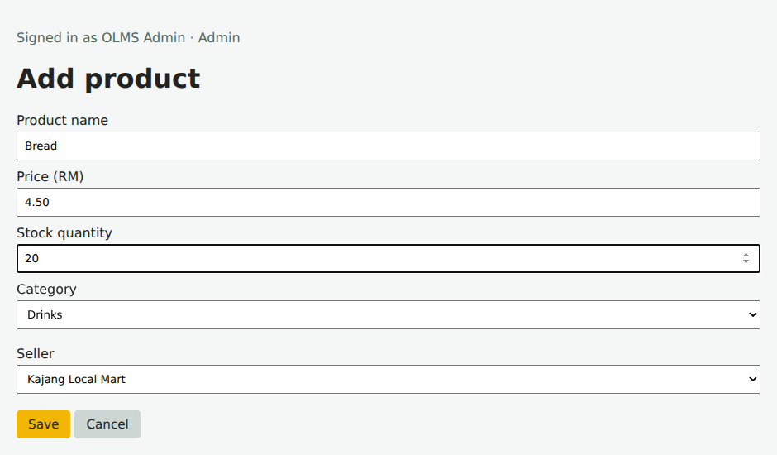
Figure 1: Product input before saving.
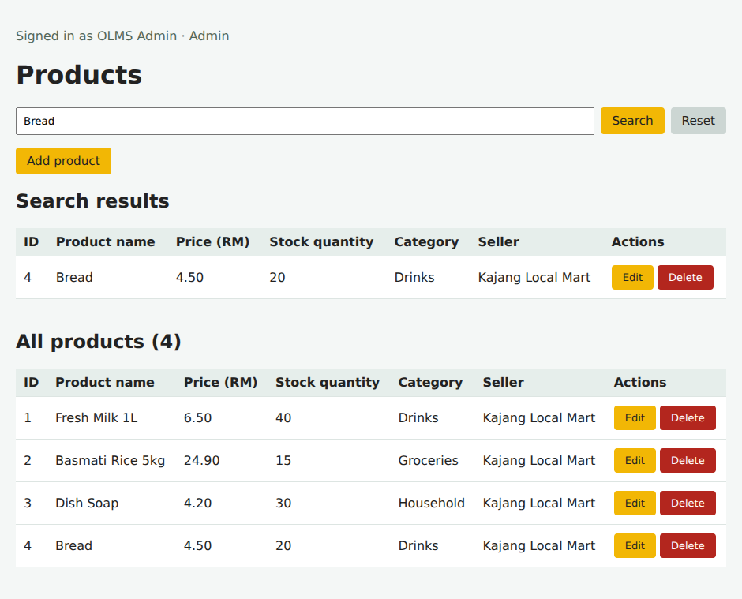
Figure 2: Successful search and the full products list.

2.1 Product editing and unsuccessful search
An administrator can manage all products. Approved sellers can manage their own. Products used in carts or orders cannot be deleted.
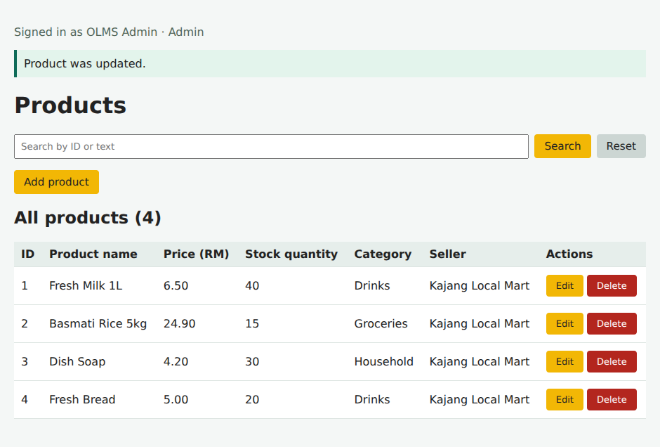
Figure 3: Updated record in the complete list.
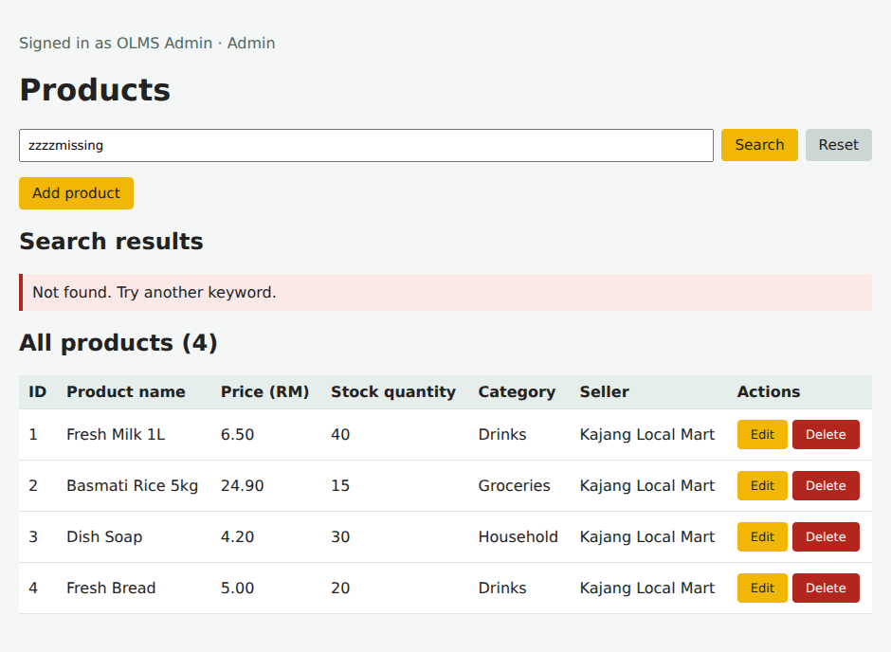
Figure 4: Search with no matching record.

2.2 Product deletion
The delete page shows the selected record before confirmation. Cancel was checked and kept the record. Confirm removed the temporary record and refreshed the full list. Credential fields are deliberately omitted from account deletion pages.
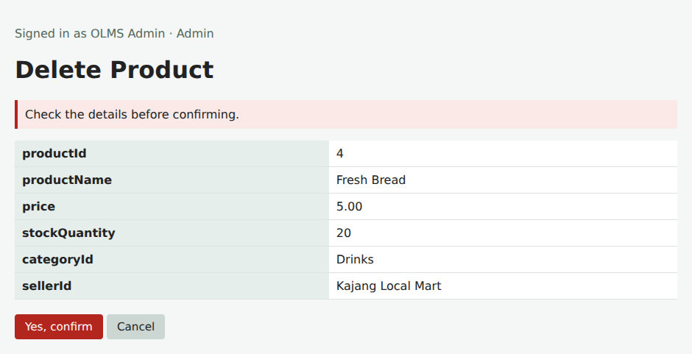
Figure 5: Details shown before deletion.
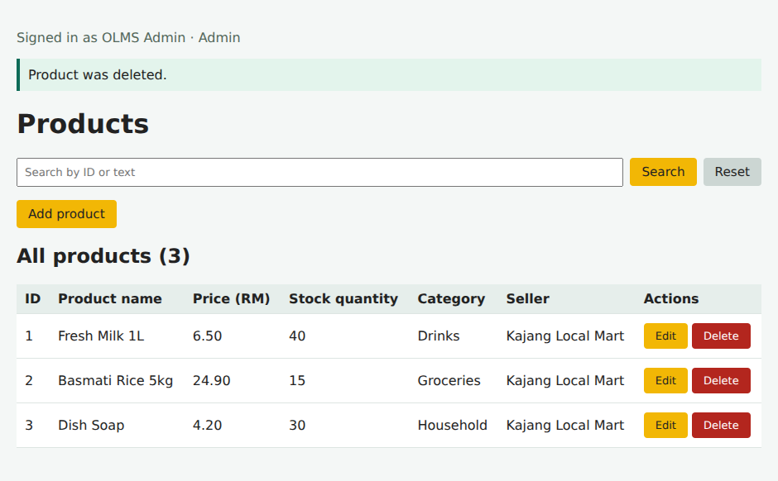
Figure 6: Remaining records after deletion.

3.0 Category creation and search
Bakery is created and then renamed Fresh Bakery. Product forms select an existing category by ID.
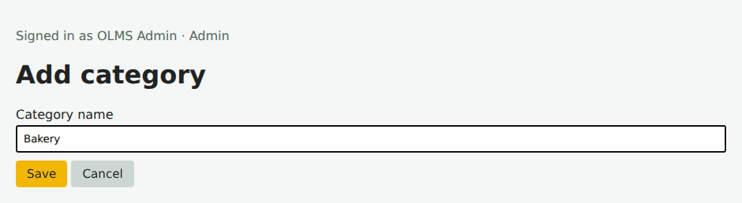
Figure 7: Category input before saving.
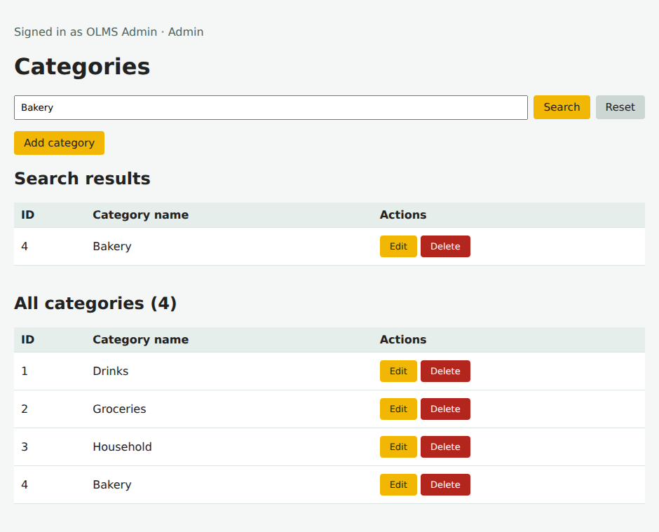
Figure 8: Successful search and the full categories list.

3.1 Category editing and unsuccessful search
Renaming a category keeps product relationships intact. Deleting a category that is used by a product is blocked.
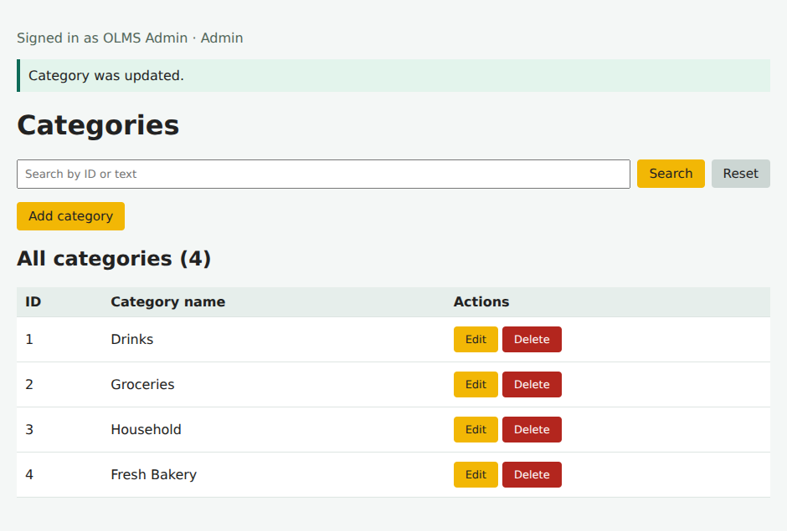
Figure 9: Updated record in the complete list.
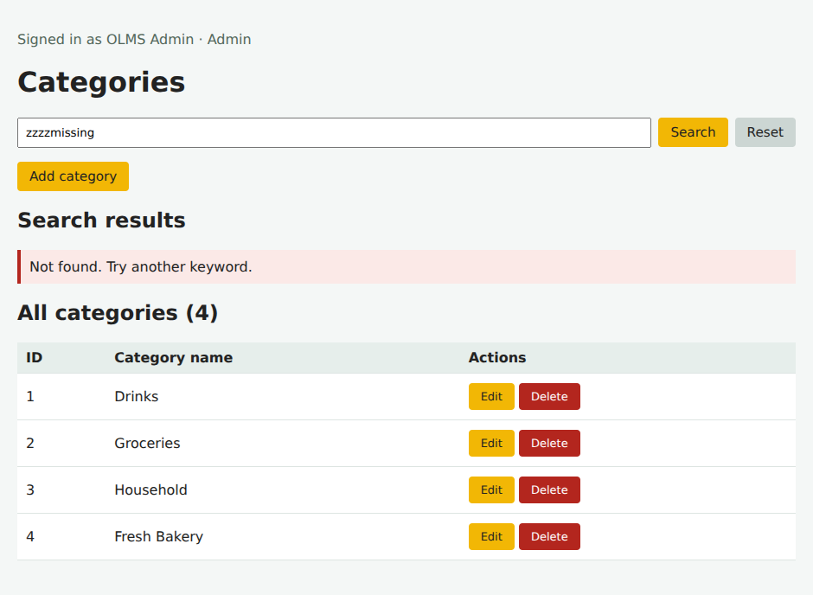
Figure 10: Search with no matching record.

3.2 Category deletion
The delete page shows the selected record before confirmation. Cancel was checked and kept the record. Confirm removed the temporary record and refreshed the full list. Credential fields are deliberately omitted from account deletion pages.
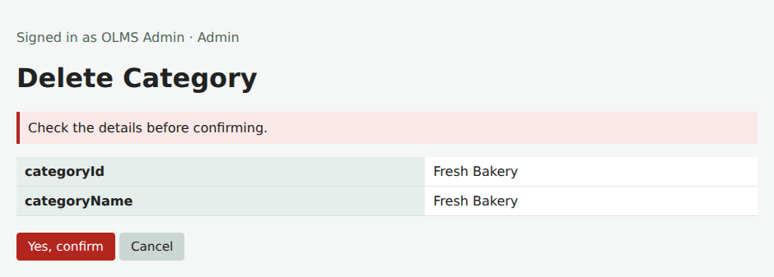
Figure 11: Details shown before deletion.
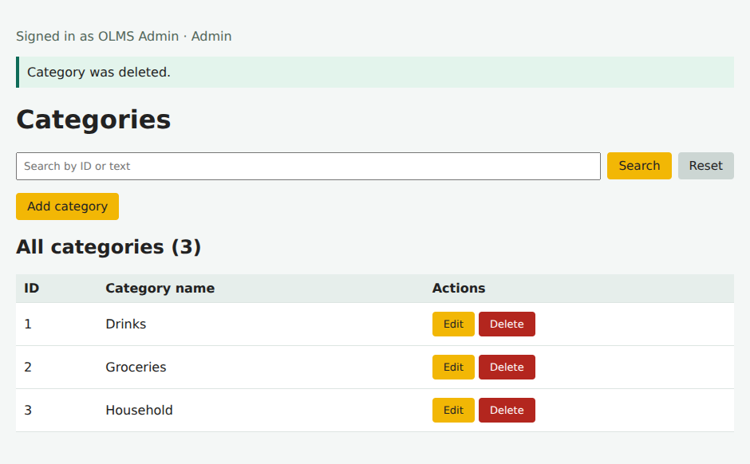
Figure 12: Remaining records after deletion.

4.0 Customer creation and search
Lab Customer is created with an email, password, phone and address. Its name is changed to Updated Lab Customer.
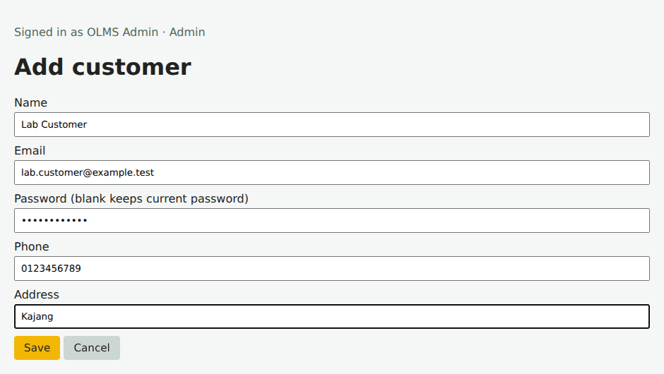
Figure 13: Customer input before saving.
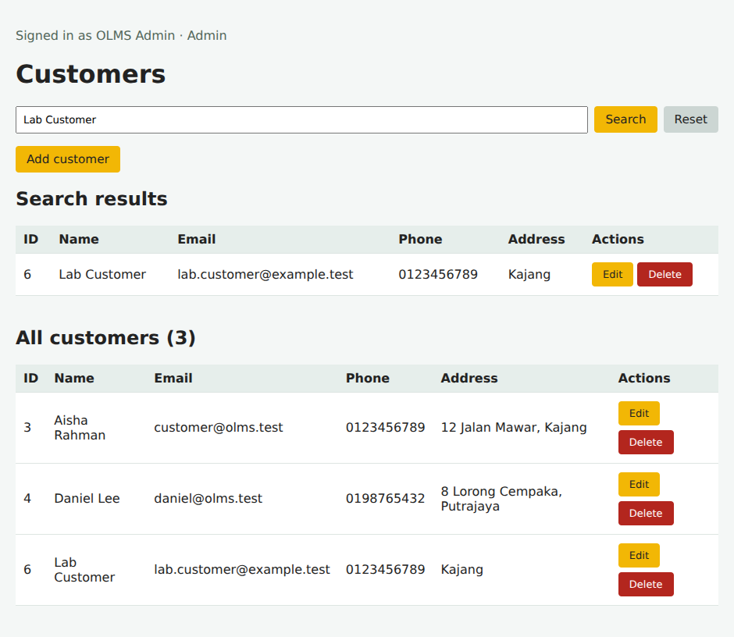
Figure 14: Successful search and the full customers list.

4.1 Customer editing and unsuccessful search
The userId stays fixed. Blank passwords on edit preserve the existing hash. Customers with order history cannot be deleted.
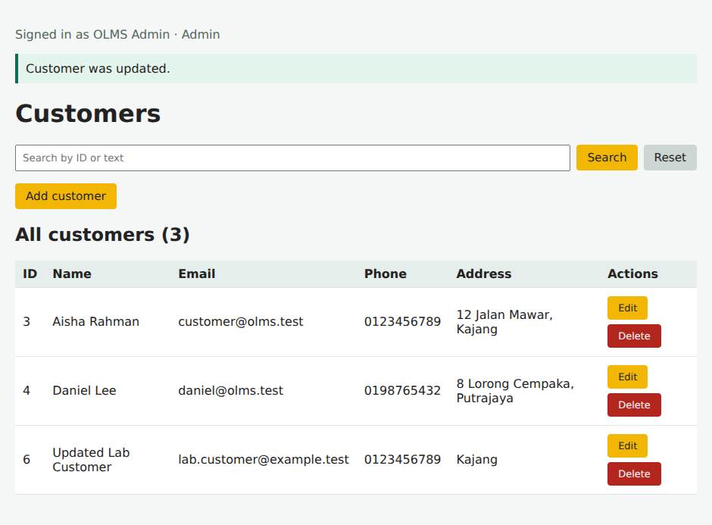
Figure 15: Updated record in the complete list.
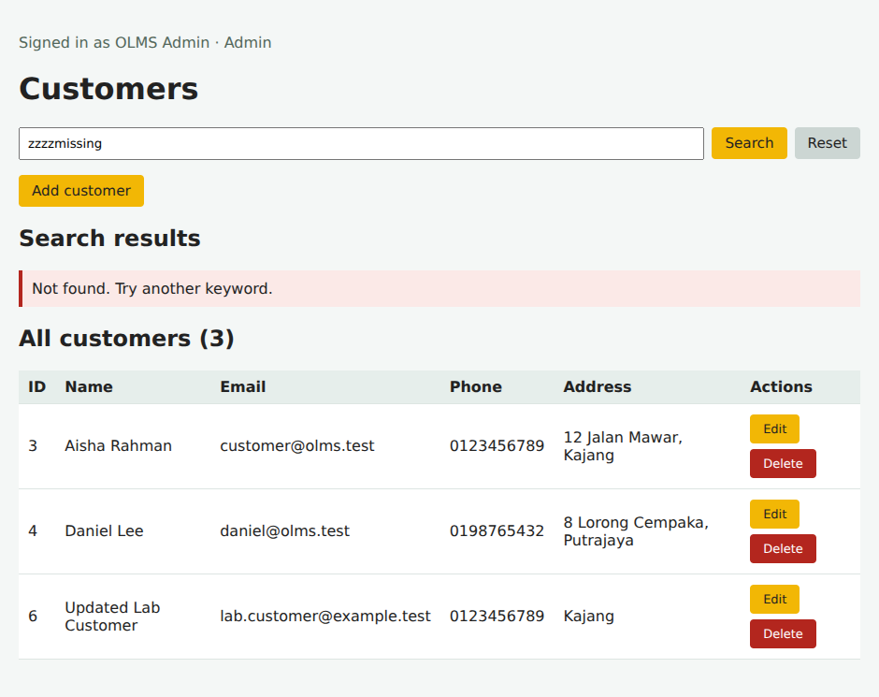
Figure 16: Search with no matching record.

4.2 Customer deletion
The delete page shows the selected record before confirmation. Cancel was checked and kept the record. Confirm removed the temporary record and refreshed the full list. Credential fields are deliberately omitted from account deletion pages.
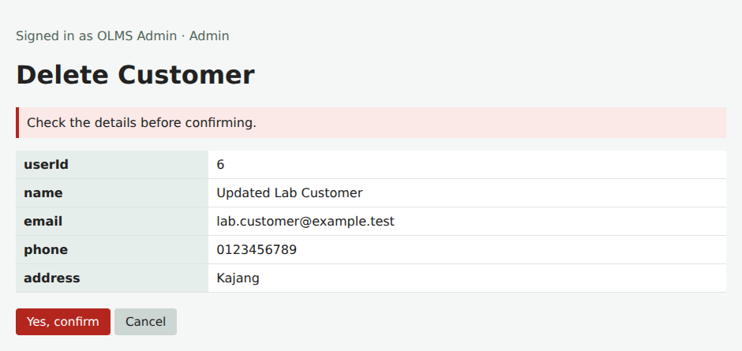
Figure 17: Details shown before deletion.
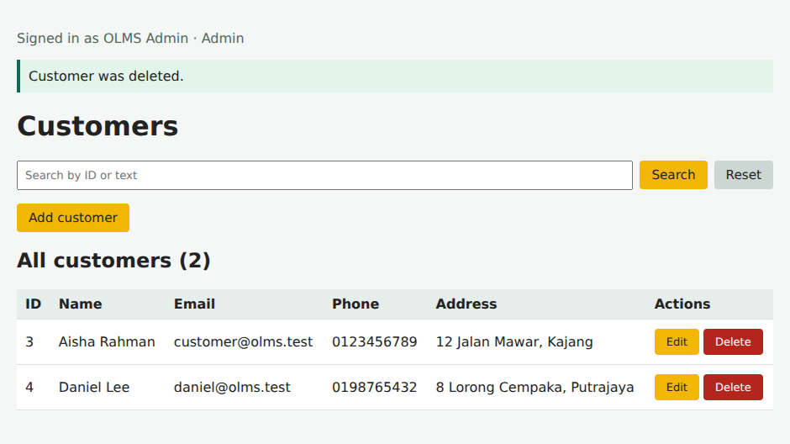
Figure 18: Remaining records after deletion.

5.0 Seller creation and search
Lab Seller is created with Approved status, then renamed Updated Lab Seller.
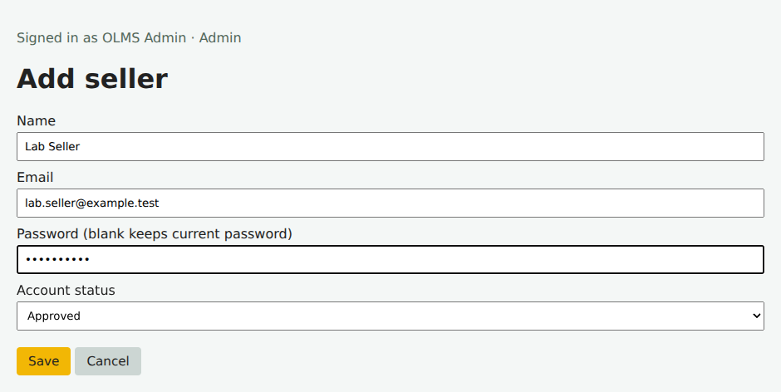
Figure 19: Seller input before saving.
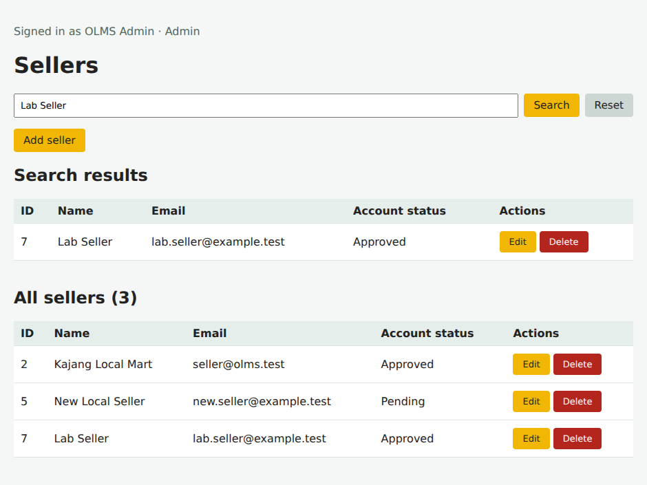
Figure 20: Successful search and the full sellers list.

5.1 Seller editing and unsuccessful search
Public seller registration starts Pending. Administrator edits control approval. Sellers linked to products or orders cannot be deleted.
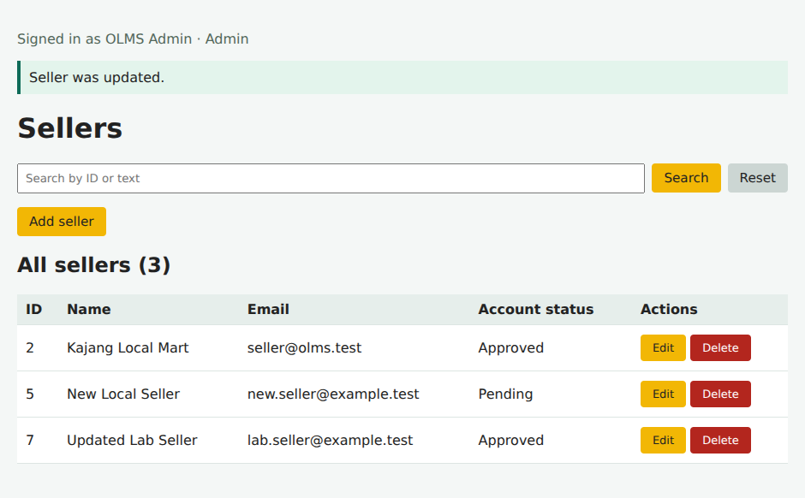
Figure 21: Updated record in the complete list.
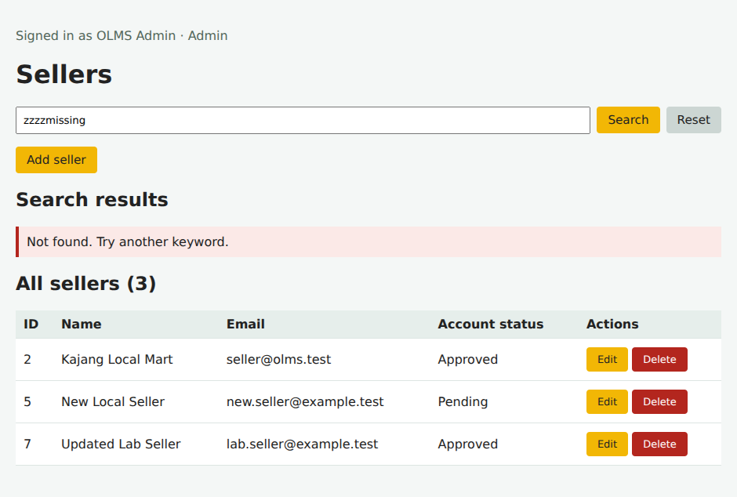
Figure 22: Search with no matching record.

5.2 Seller deletion
The delete page shows the selected record before confirmation. Cancel was checked and kept the record. Confirm removed the temporary record and refreshed the full list. Credential fields are deliberately omitted from account deletion pages.
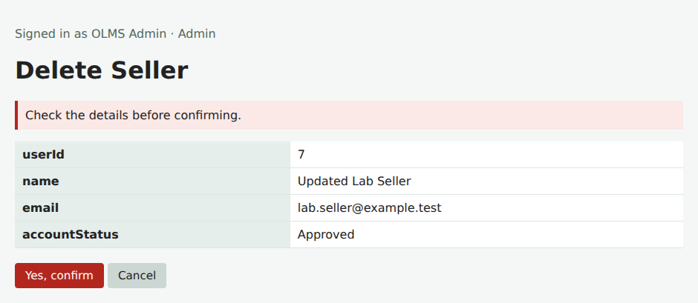
Figure 23: Details shown before deletion.
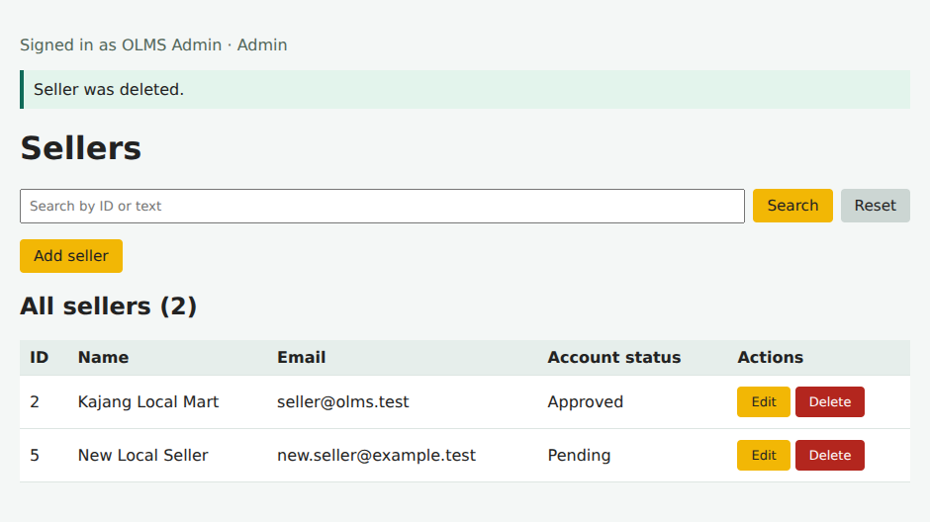
Figure 24: Remaining records after deletion.

6.0 Admin creation and search
Lab Admin is created and renamed Updated Lab Admin. The demonstration then removes this temporary account.
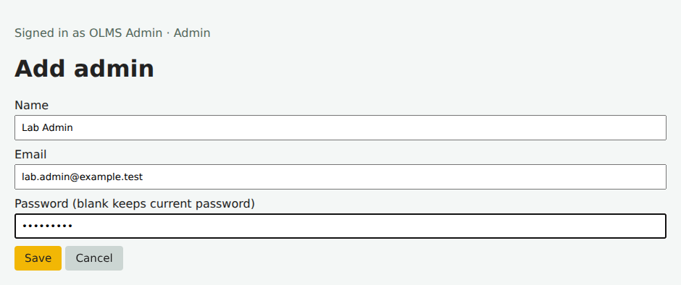
Figure 25: Admin input before saving.
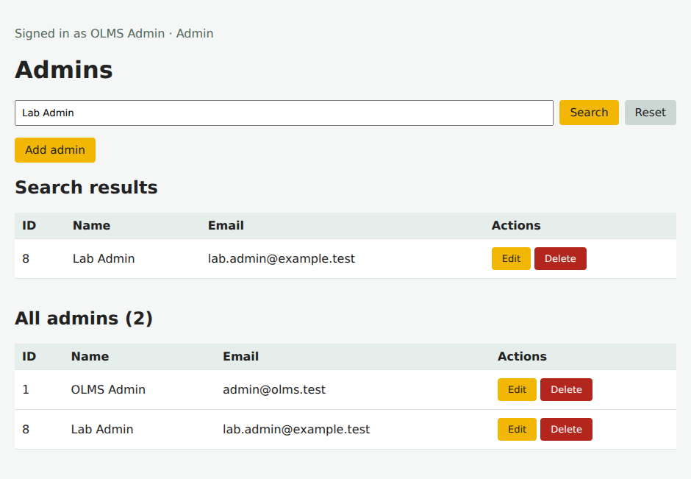
Figure 26: Successful search and the full admins list.

6.1 Admin editing and unsuccessful search
Admin pages require an administrator session. The last administrator cannot be deleted, and the current administrator cannot delete their own signed-in account.
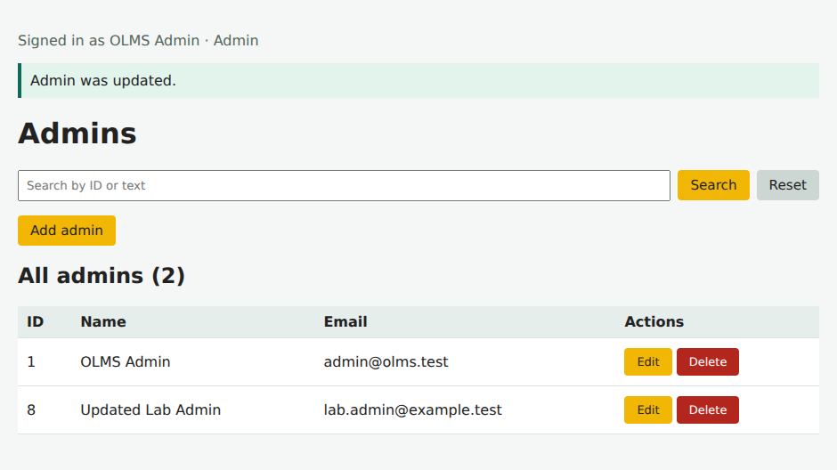
Figure 27: Updated record in the complete list.
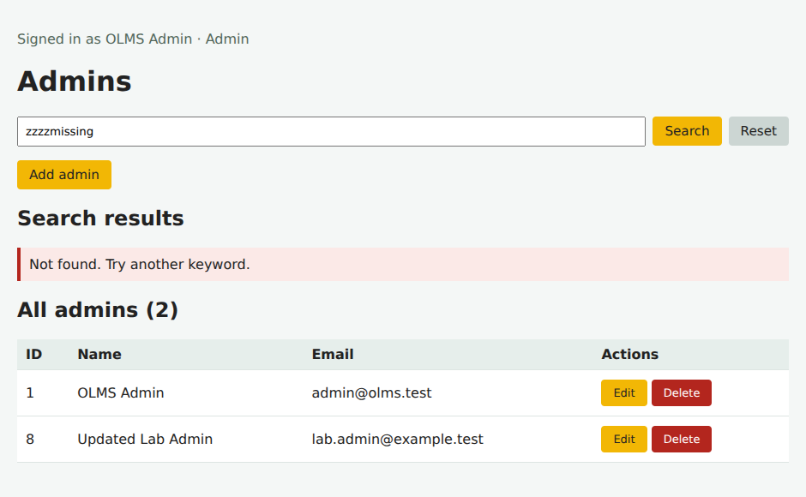
Figure 28: Search with no matching record.

6.2 Admin deletion
The delete page shows the selected record before confirmation. Cancel was checked and kept the record. Confirm removed the temporary record and refreshed the full list. Credential fields are deliberately omitted from account deletion pages.
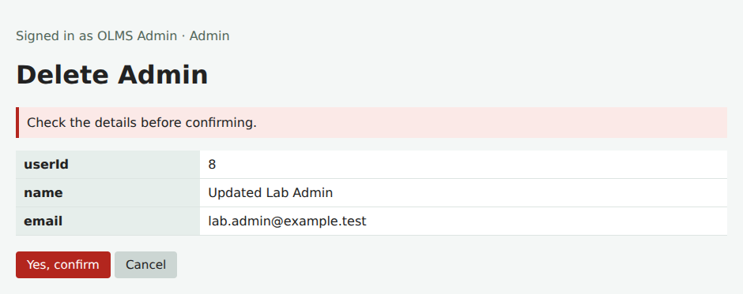
Figure 29: Details shown before deletion.
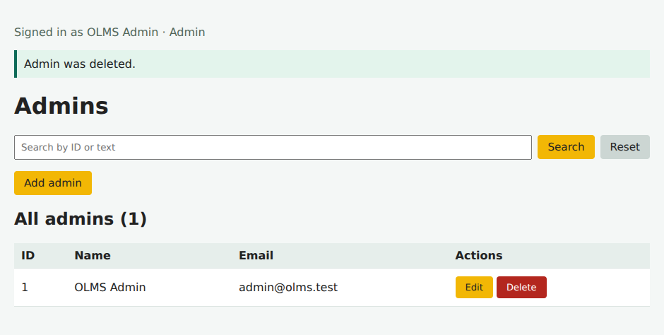
Figure 30: Remaining records after deletion.

7.0 Registration and seller approval
A new seller registers as New Local Seller. The account starts Pending. Admin then opens the seller record and changes its status to Approved. Seller approval connects the account module to product management.
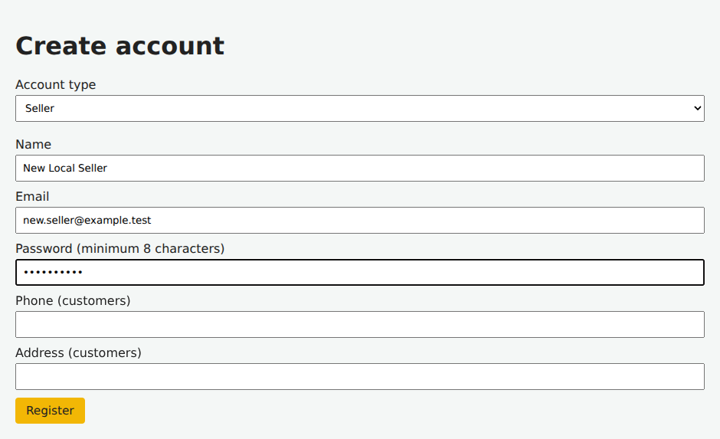
Figure 31: New seller registration input.
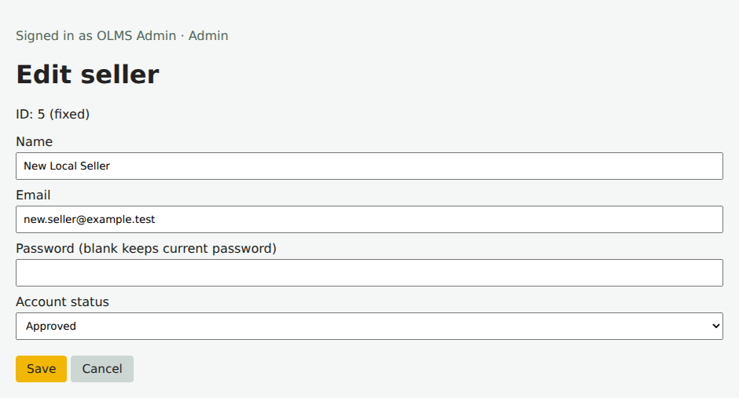
Figure 32: Administrator changes the seller to Approved.

7.1 Approved sellers and customer catalogue
The seller list confirms the approval. Customers see products belonging to approved sellers. Quantity controls add the selected product to the signed-in customer’s cart.
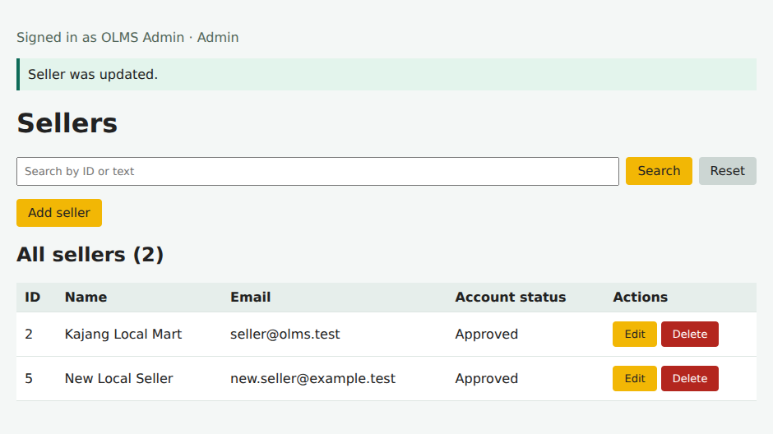
Figure 33: Approved seller appears in the complete list.
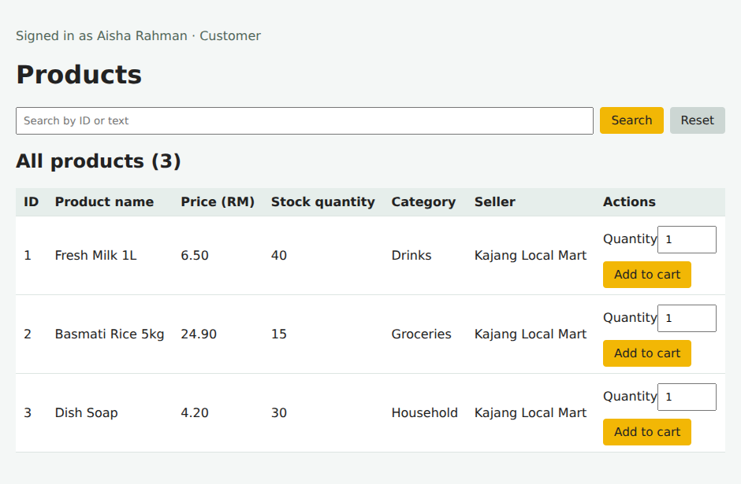
Figure 34: Customer catalogue and add-to-cart controls.

7.2 Cart quantities and profile
Aisha adds Fresh Milk 1L and changes the quantity to two. At RM 6.50 each, the cart total is RM 13.00. Setting an item quantity to zero removes it. Clear cart has a separate confirmation page. Profile edits update the signed-in customer without changing their userId.
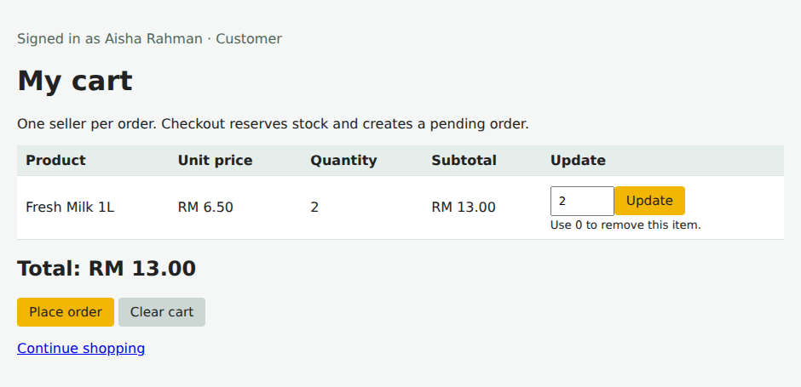
Figure 35: Cart after changing the quantity to two.
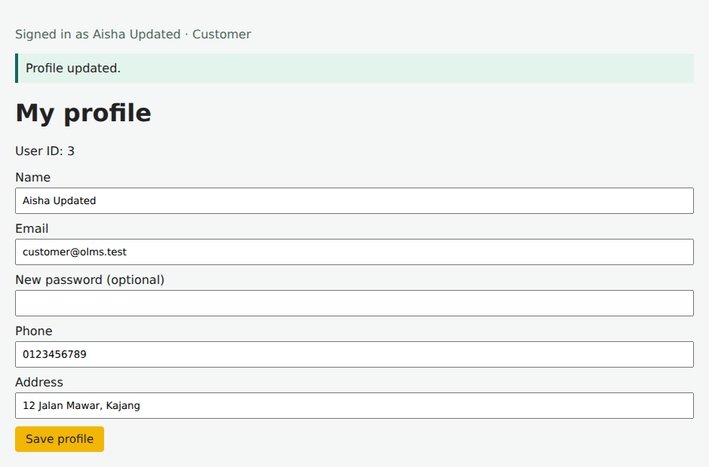
Figure 36: Customer profile after saving a new name.

7.3 Checkout creates a pending order
Place order checks available stock, copies the product name and price, stores the delivery address and reserves two units. Order 1 totals RM 13.00. The cart is cleared only after the order has been created successfully. Later catalogue price changes do not alter this order.
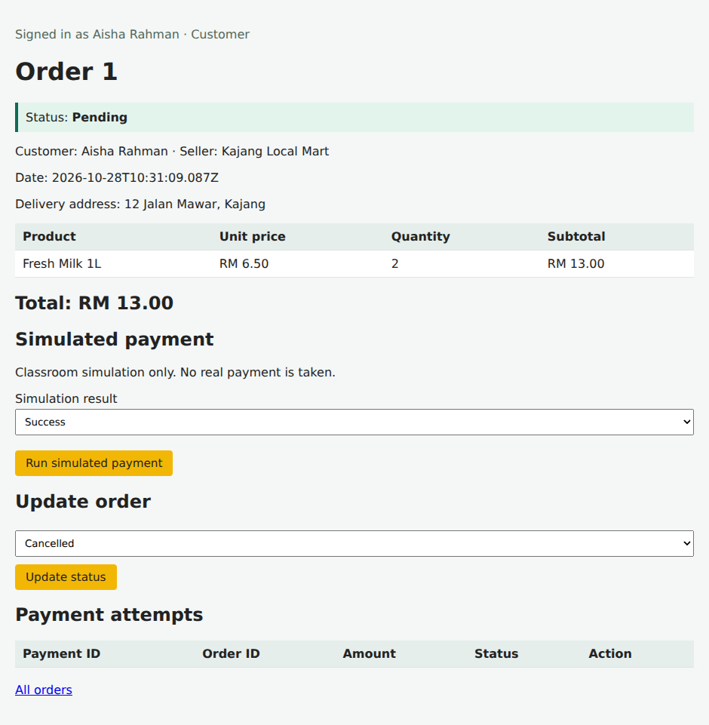
Figure 37: Order 1 after checkout, before payment.

7.4 Failed payment can be retried
Selecting Failed produces a payment attempt but leaves Order 1 Pending. It does not mark the order as paid and does not deduct stock again. The customer can retry from the same order page. This is a local simulation, not a bank response.
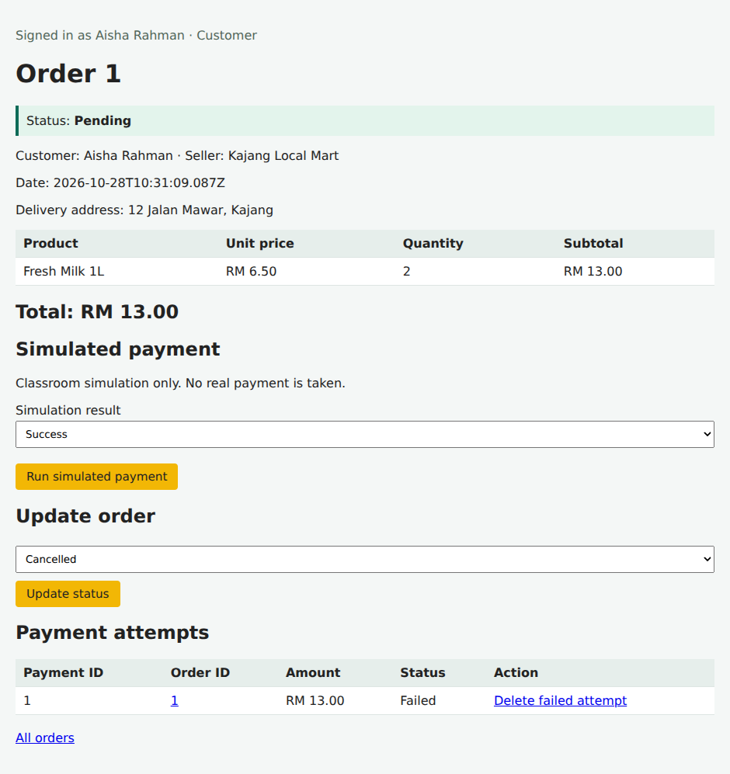
Figure 38: Failed attempt recorded while the order remains Pending.

7.5 Successful payment and history
The next simulated attempt succeeds. Payment 2 records RM 13.00 and Order 1 changes to Paid. Repeating a payment on a paid order is blocked. Successful history is retained; failed attempts may be deleted by the owner or administrator.
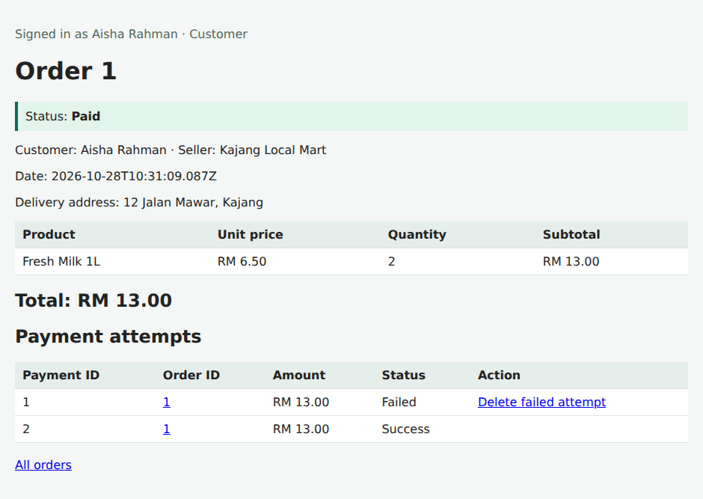
Figure 39: Order status becomes Paid after success.
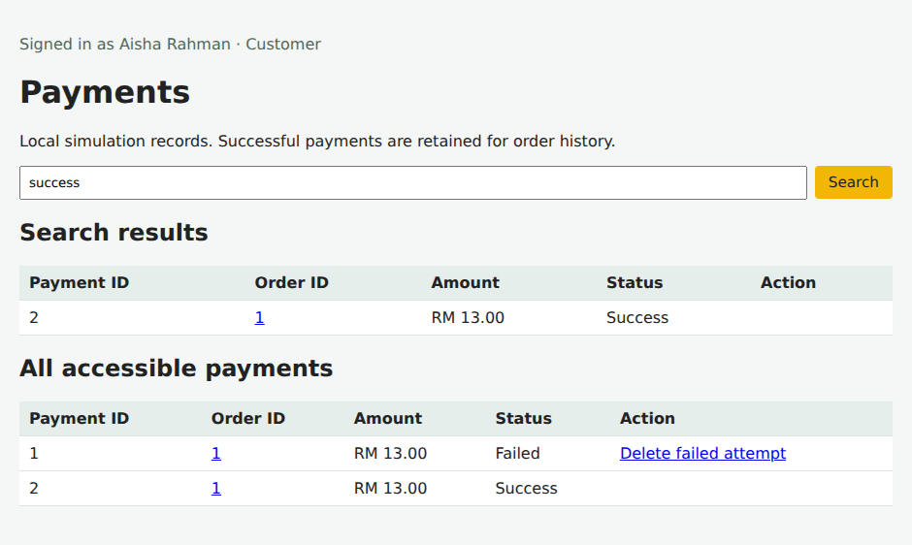
Figure 40: Payment search results and complete accessible history.

7.6 Seller order fulfilment
The seller sees their own order and advances it through Processing, Shipped and Completed. Status transitions must follow this sequence. Customers can view their order but cannot perform seller fulfilment actions.
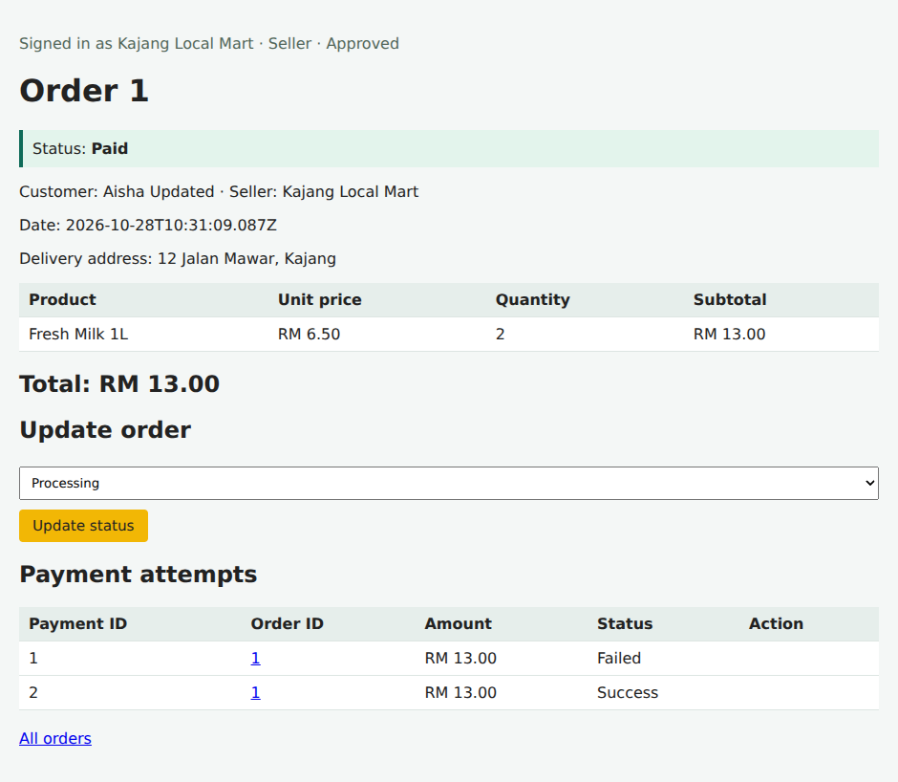
Figure 41: Seller receives the paid order.
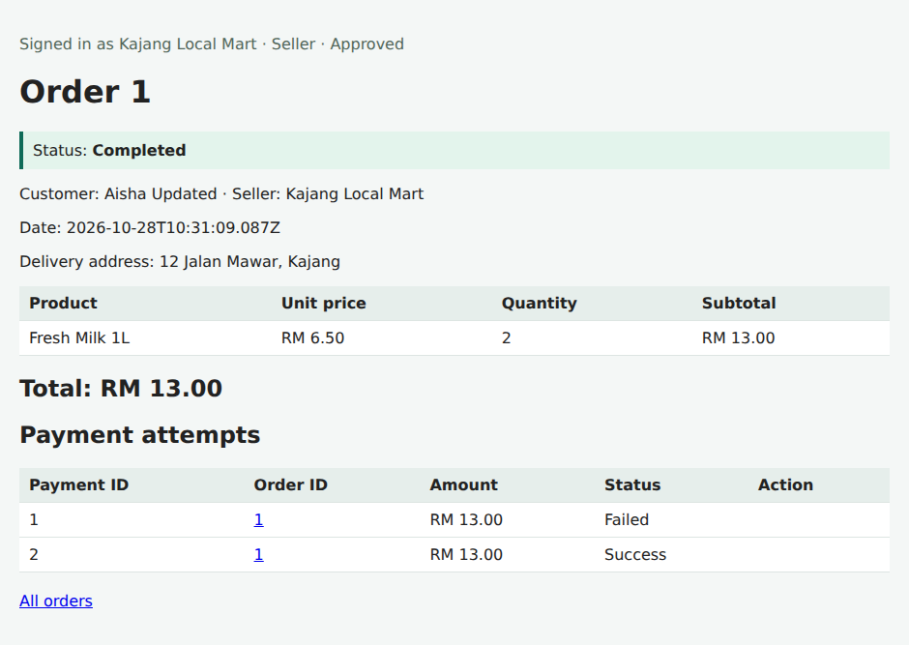
Figure 42: Order after completing the fulfilment sequence.

7.7 Cancellation and order deletion
Daniel creates a separate unpaid order for one milk. Cancelling this Pending order restores that unit exactly once. A second cancellation is rejected. The cancelled order can then be deleted because it has no payment history. Paid orders are not cancellable in this version because refunds are outside the implemented workflow.
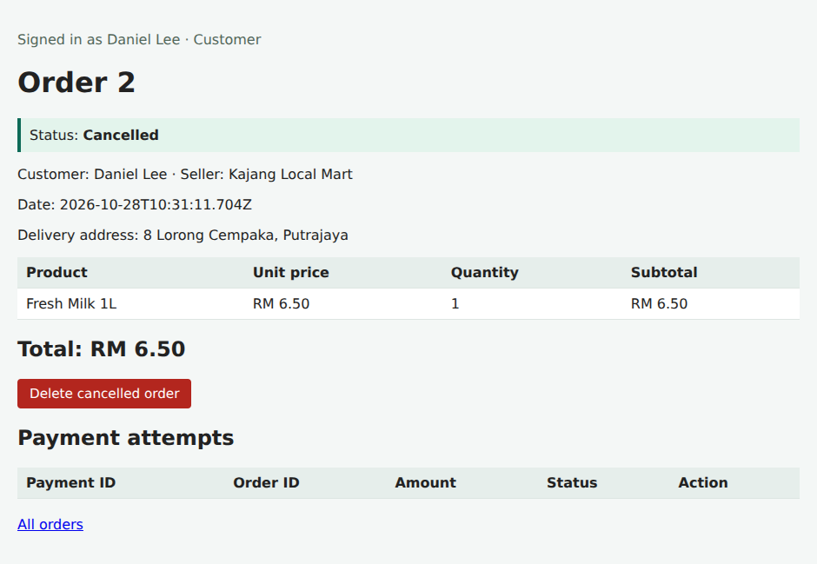
Figure 43: Order 2 after cancellation.
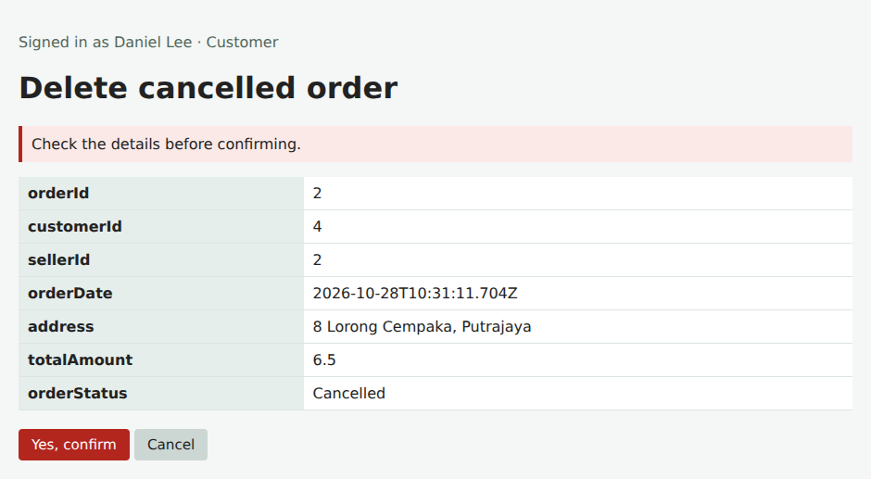
Figure 44: Confirmation before deleting the cancelled order.

7.8 Integrated results
After deletion, Daniel has no remaining orders. The administrator’s catalogue shows milk stock at 38: the original 40 units minus two in Aisha’s completed order. Daniel’s one reserved unit was restored when his order was cancelled.
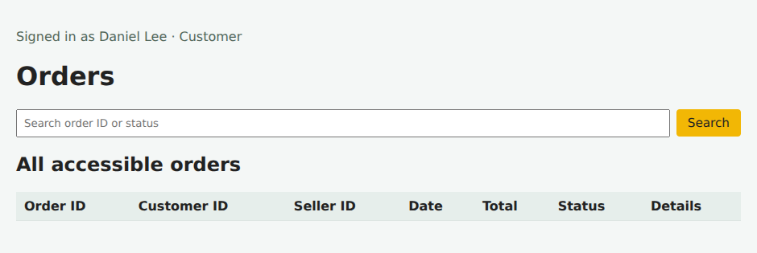
Figure 45: Customer order list after deletion.
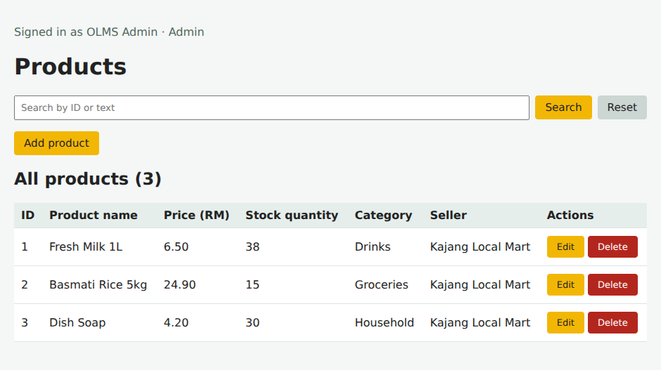
Figure 46: Product stock after payment, fulfilment and cancellation.

8.0 Software construction best practices
Practice | Application and reason
Clear responsibilities | Models describe records, managers handle business operations and app.js handles requests. Views render the output. This makes changes easier to locate.
Naming and consistency | PascalCase classes and matching filenames, camelCase methods/variables, uppercase PORT and standard ID names follow Lab 2. Source indentation is two spaces.
Reuse and inheritance | Customer, Seller and Admin extend User. Shared forms, tables and account management avoid repeating the same code in every role.
Relationship integrity | Products require valid categories and approved sellers. Linked records cannot be deleted. Orders retain product price/address snapshots.
Consistent updates | Checkout updates stock, cart and order within a single store transaction. A failed operation restores the previous in-memory state. Saves use a temporary JSON file followed by rename.
Clear feedback | Lists show search results and all records. Not-found output, update messages and confirmation pages explain each action.
Controlled workflows | Only pending orders can be paid or cancelled. Fulfilment follows valid transitions. Successful payments cannot be deleted or freely edited.
Verification and review | Repeatable integration checks use temporary data. Browser checks exercise role-specific flows. Changes are prepared for a new branch and have not been pushed.

Basic validation, escaped EJS output, password hashes and role checks support the implemented use cases. They do not represent completion of the separate defensive-programming and external-API work required in Labs 7 and 8.

9.0 Verification and current limitations
Verification was performed on 28 October 2026. All 11 supplied integration test groups passed. Browser checks covered ordinary CRUD and the full shopping workflow. No browser script errors were observed. All 41 JavaScript and EJS source files passed ES6 syntax parsing.
Check | Observed result
CRUD and search | Product, Category, Customer, Seller and Admin create/search/edit/delete passed, including no-match searches and cancel/confirm deletion.
Accounts and access | Login, registration, approval and profile edits passed. Customer access to admin pages and another customer’s order was rejected.
Cart and checkout | Add/update/remove/clear checks passed. Checkout cleared the cart, reserved stock and calculated the expected total.
Payment and order status | Failure kept Pending; success changed Paid. Repeated payment and invalid fulfilment transitions were rejected.
Cancellation and history | Cancellation restored stock once. Linked-record restrictions and retained successful payments passed.
Persistence | Reloading the store retained orders, payments, stock values and ID counters. Test data was isolated from packaged data.

Limitations: file storage is intended for one local server process; it is not a production database. Sessions reset on restart. Each order has one seller. Unpaid reservations do not expire automatically. Payments are simulated and refunds are not implemented. Email format checks do not prove mailbox ownership.
Run from the project folder: npm.cmd install, npm.cmd start, then open http://localhost:3000. Use npm.cmd test to repeat the integration checks. Other terminals can use npm instead of npm.cmd. README.md contains demo accounts, setup, data handling and the branch handoff.
Scope stops at Lab 6. No external payment API, remote push, branch creation or submission has been performed. The new branch name and repository location are still required for the GitHub handoff.
Sources: supplied CSEB5223 Lab and Assignment Outline (Labs 5 and 6, pages 3–4); supplied Lab 2 design and standards; supplied Labs 3 and 4 Word report; supplied Project-SCM(1).zip and the revised implementation.

