Quiz Two for Software Engineering Course April 14, 2022

Name: Student ID: Group ID: Score:

- During Scrum (About 15-minute daily meeting), which basic questions should team members answer?

昨天完成了什么，今天计划做什么，遇到了什么困难

2. What does the Rules of Thumb emphasis? Why the level of abstraction should be relatively high?

The model should focus on requirements which are visible with in problem or business domain.

Abstraction levels are high in thumb rule.

New elements added in the analysis model should help in better understanding of the software requirements of the system.

These elements provide better understanding of the functionality, behaviour and information domain of the system.

Coupling should be minimized throughout the system

The model should be simple

The model should focus on requirements that are visible within the problem or business domain.

3、Formal technical review(FTR) is very important for uncovering software errors before the software is released to the end users since errors can be amplified in the latter steps if they cannot be found in the former phase, as shown in the following defect amplification models:
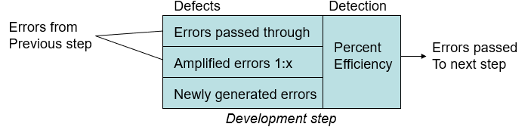
Suppose: (1) the newly generated errors are 20, 60, 60 for the preliminary design, detail design and code/unit test respectively; (2) the errors passing through and that whose being amplified are the same between preliminary and detail design and between detail design and code/unit test; (3) the value of x, which is also the same for detail design and code/unit test, is 3.

If the values of percent efficiency for the whole process without FTR (Formal Technical Review) and with FTR are 0 and 50% respectively, please illustrate the defect amplification process for preliminary design, detail design and code/unit test, and calculate the final errors after code/unit test respectively.

without FTR: 260

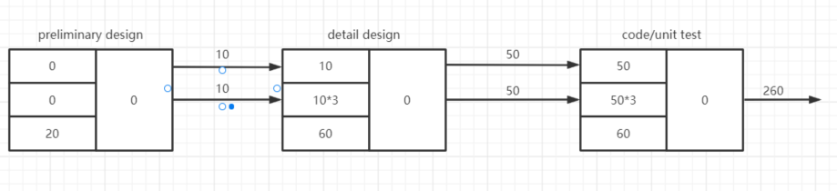

with FTR: 70

